First step is to query the invoice you would like to pay from the invoice workbench. This shows the credit memo selected but i selected the standard invoice with 3M Health Trading partner.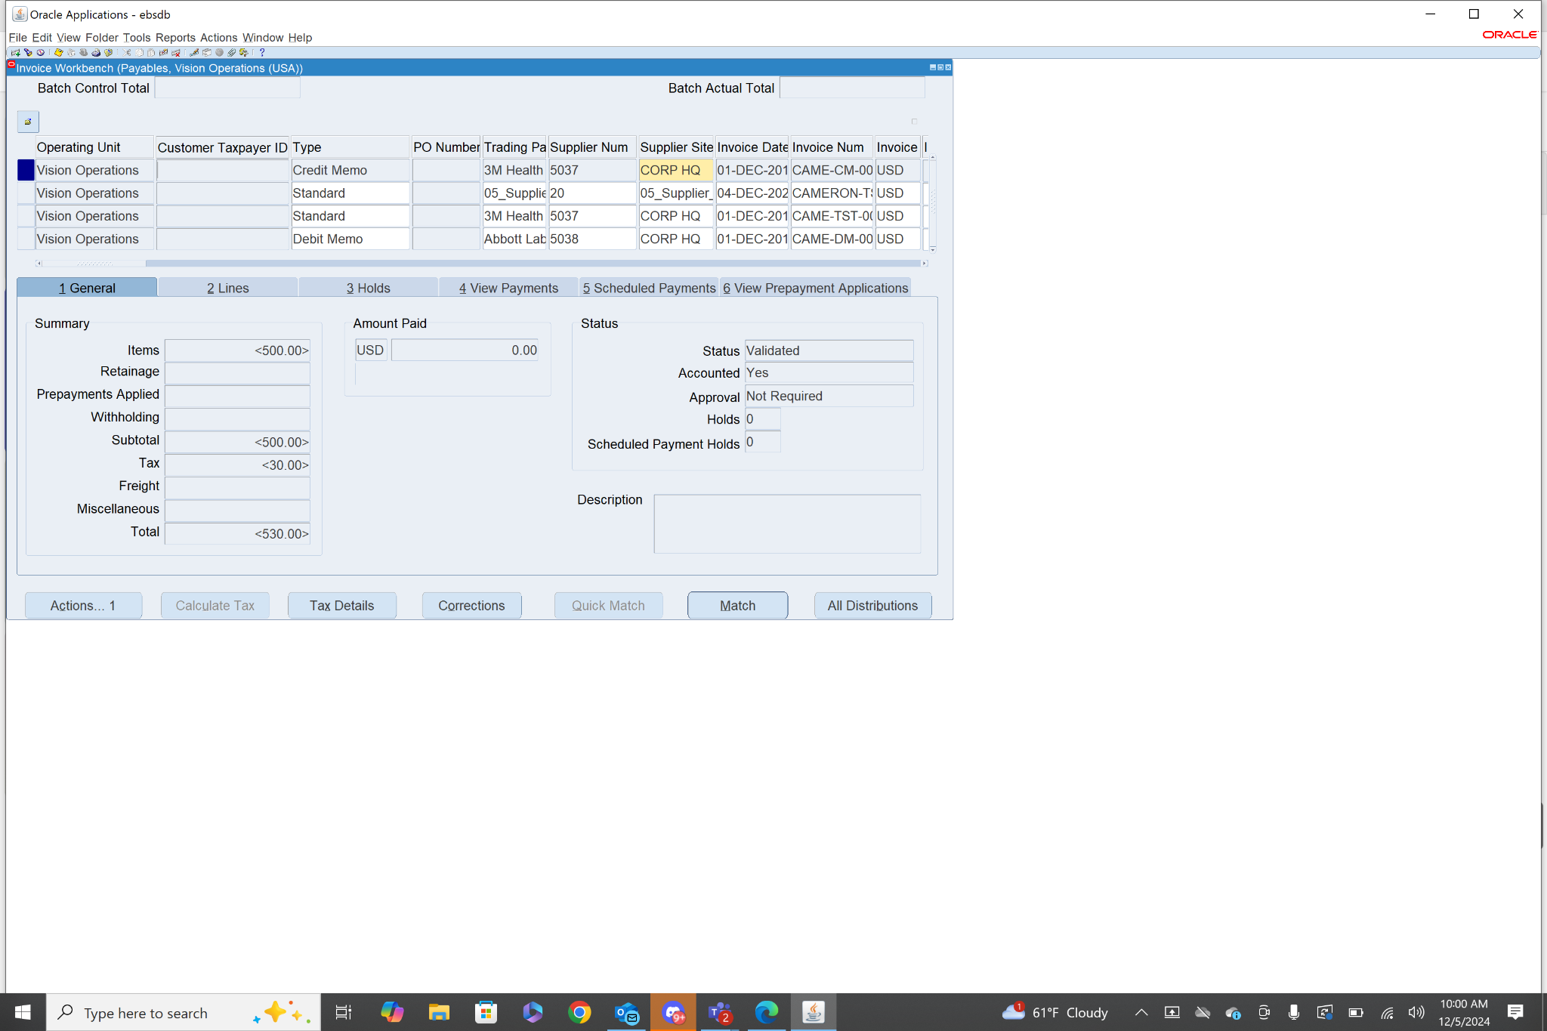

After selecting the invoice, I clicked actions and then pay in full.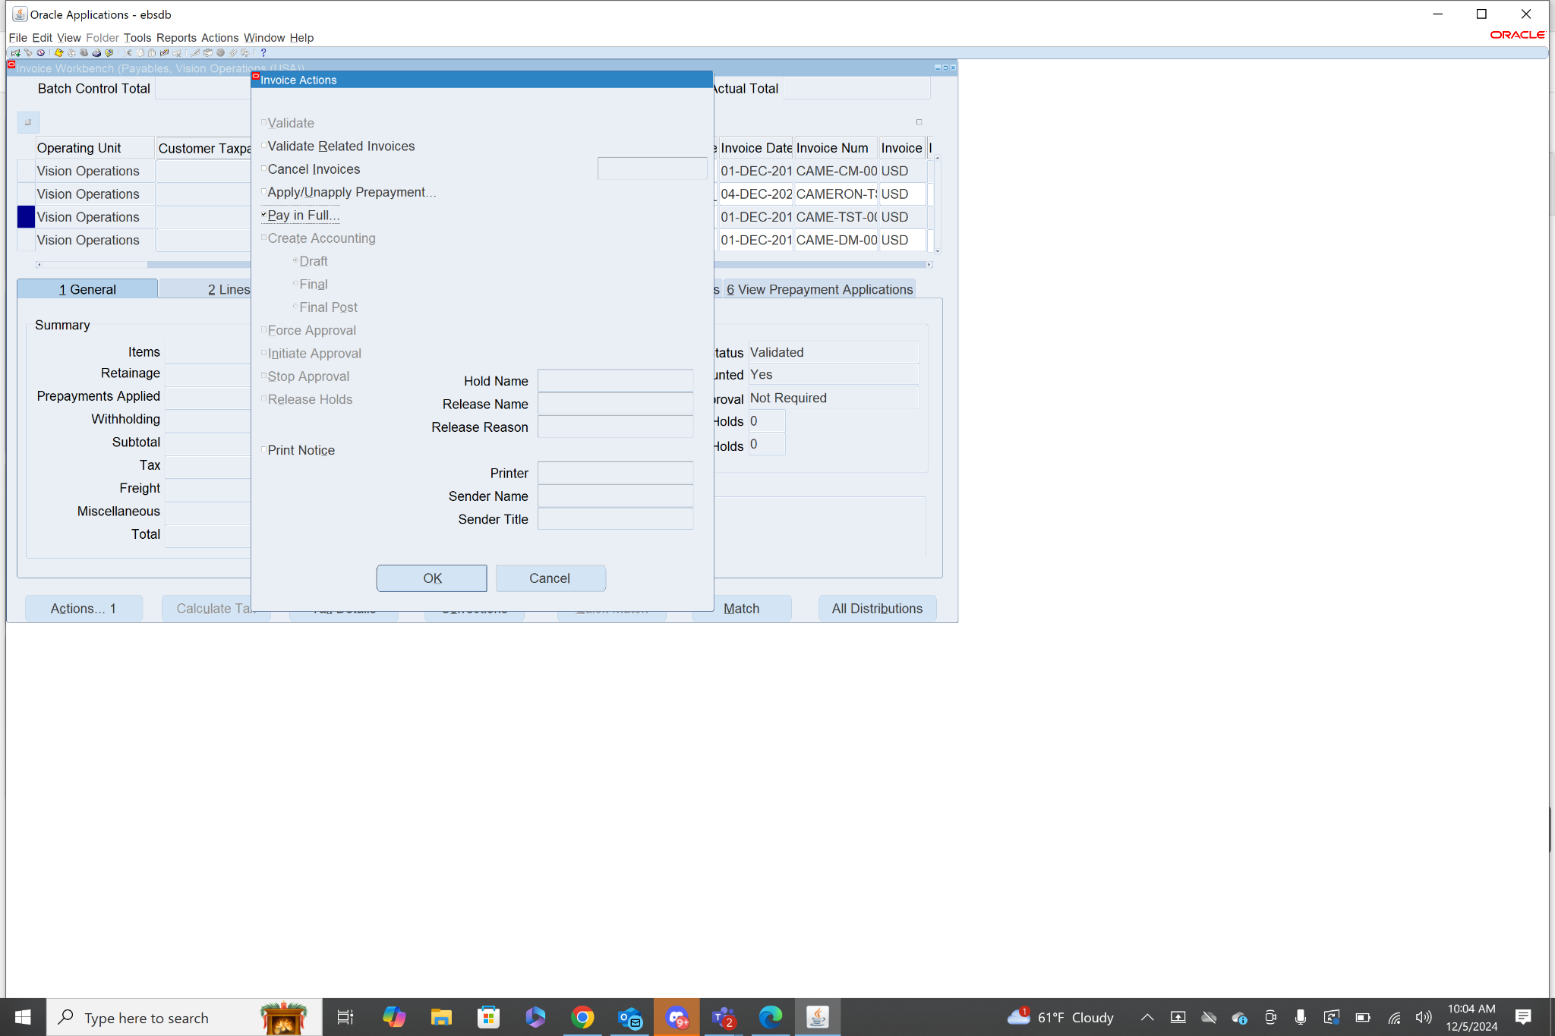

This brings you to the payment workbench menu. I had to fill in the fields payment date, and payment process profile. Bank account, payment method, payment document, and document number are all required as well but they were auto filled.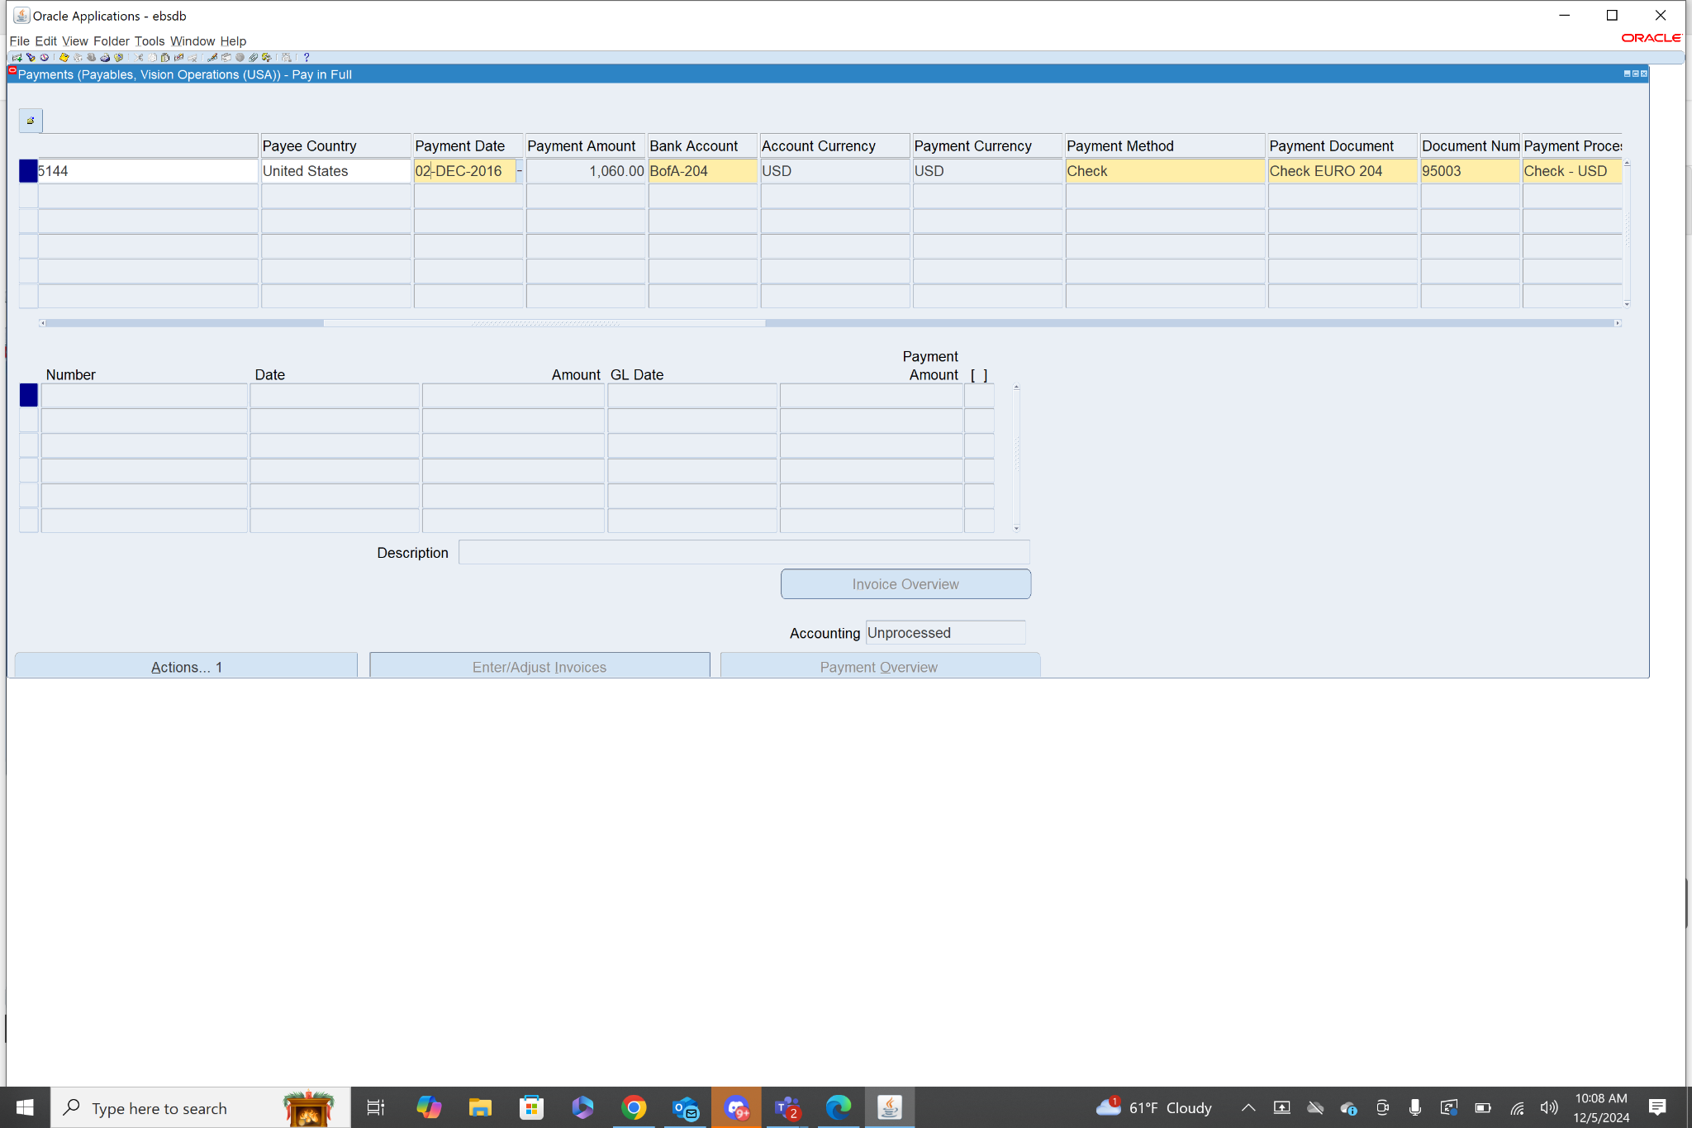After that is filled out go to actions, select create accounting and click ok. After that is created you need to print remittance advice. I selected federal from the drop down.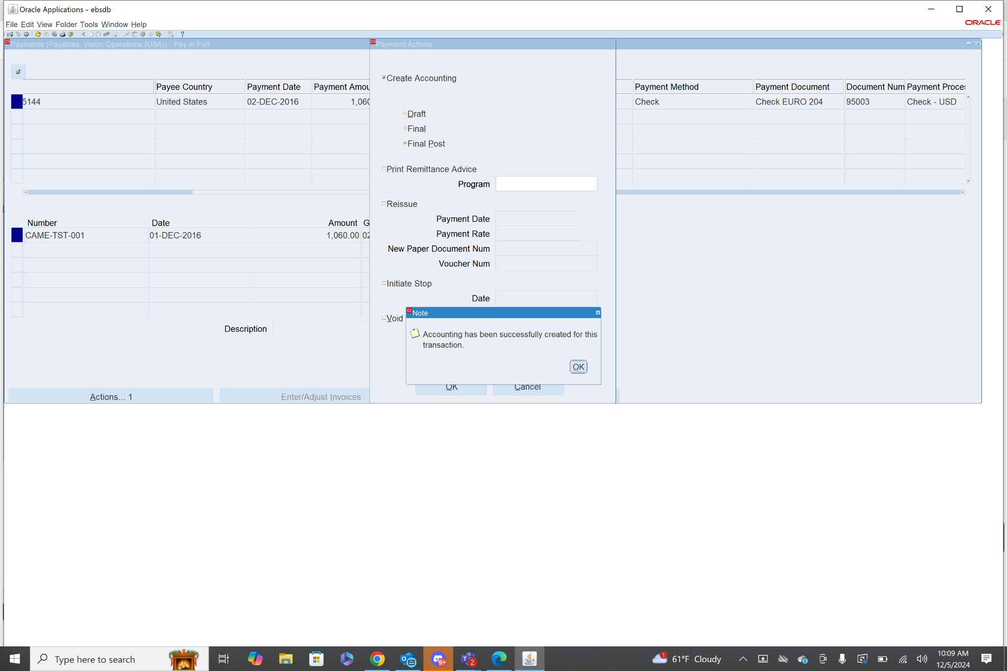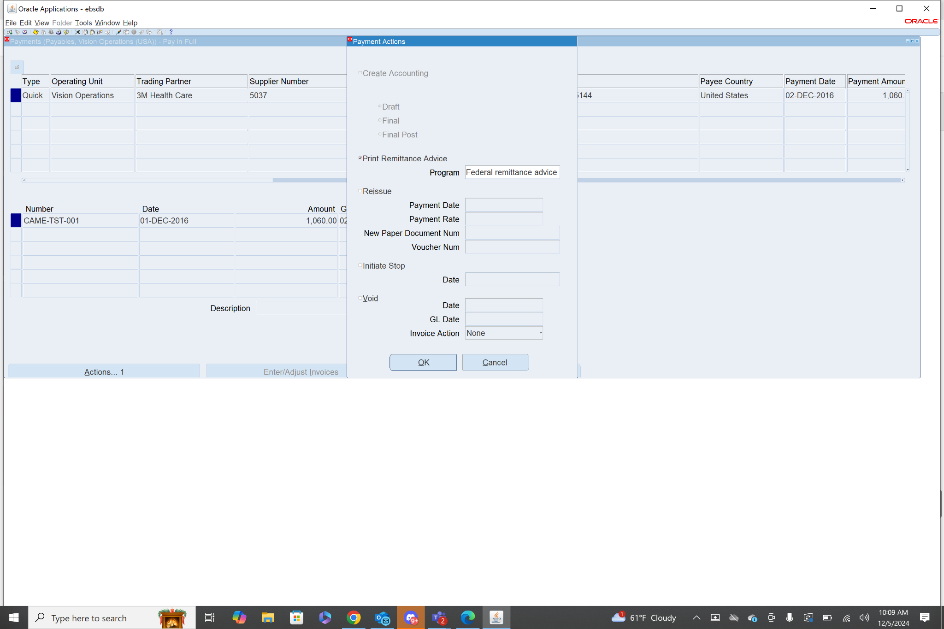

After completing that step I queried the invoices again to check the one I had submitted payment for. You can view it from the view payments tab as well as the general tab. You can also view the detail of the payment by clicking payment overview in the view payments tab.