1. Order Management Setup

•Define Order Management System Parameters

**Navigation: Order Management Super User>Setup>System Parameters>Values**

Make sure you are in the correct operating unit, mine is Vision Operations. Defining these parameters allows you to adjust the behavior of the order management module to fit your organization’s needs. These settings impact how orders are processed, shipped, and billed.

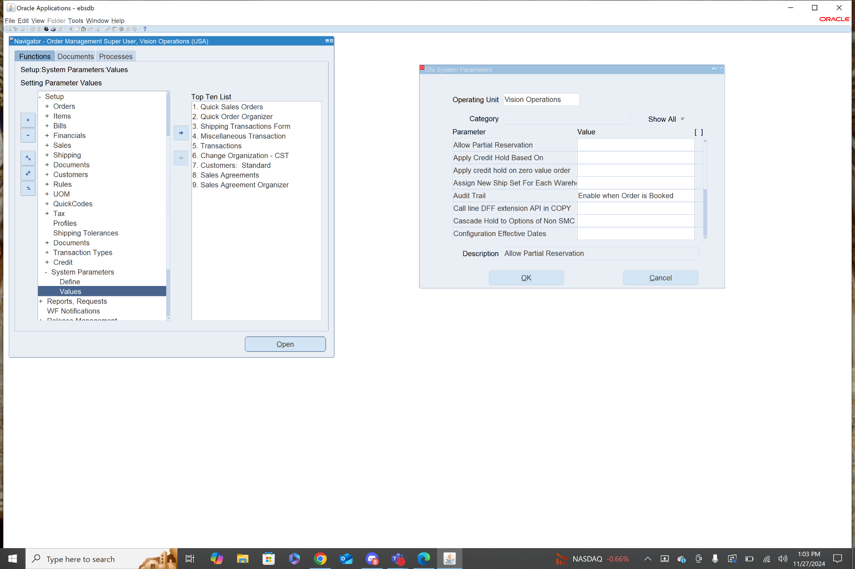

1. Customer Management [Customer Creation]

•Define and Maintain Customer Accounts and Contacts •Setup Customer Shipping and Billing Information •Manage Customer-Specific Pricing and Discounts

**Navigation: Order Management Super User>Customers>Standard**

This page allows you to create customers and add general information like name, account number, tax payer id, and customer type(Org or Person). It also allows you to add in customer address information for shipping and billing purposes.

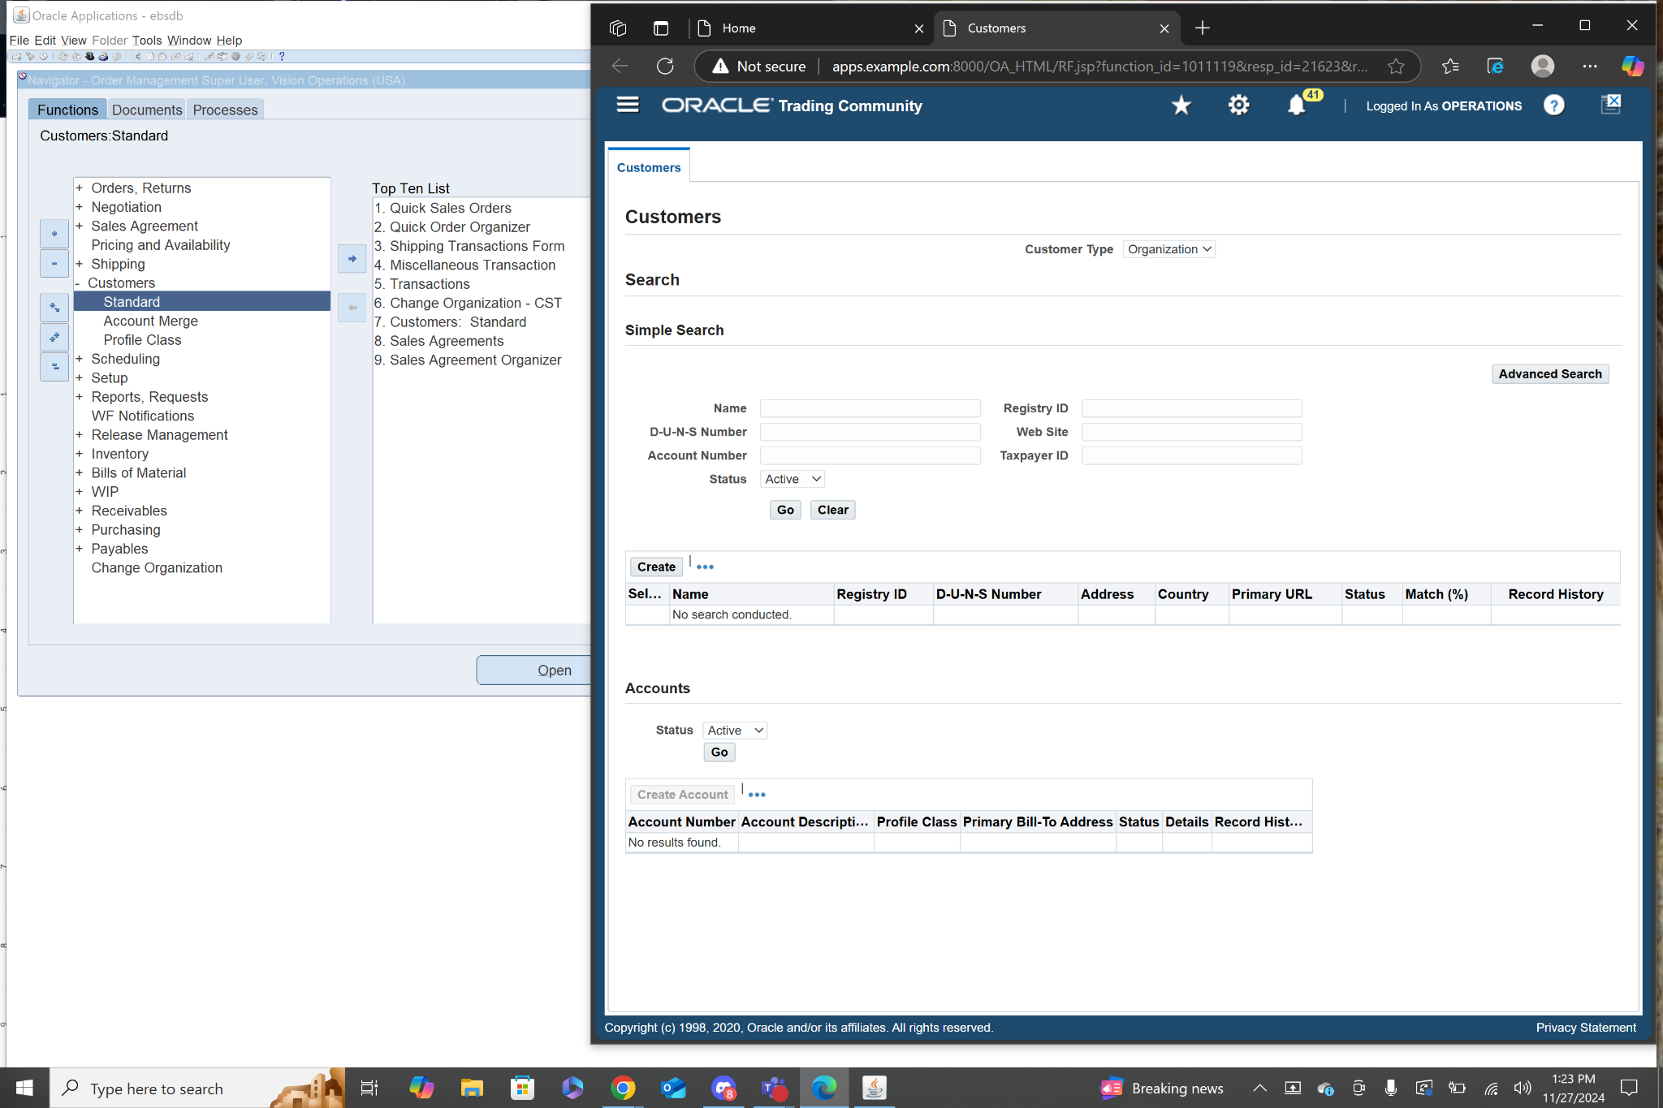

**Navigation: Order Management Super User>Customers>Profile Class**

In this section you can manage customer specific pricing and discounts.

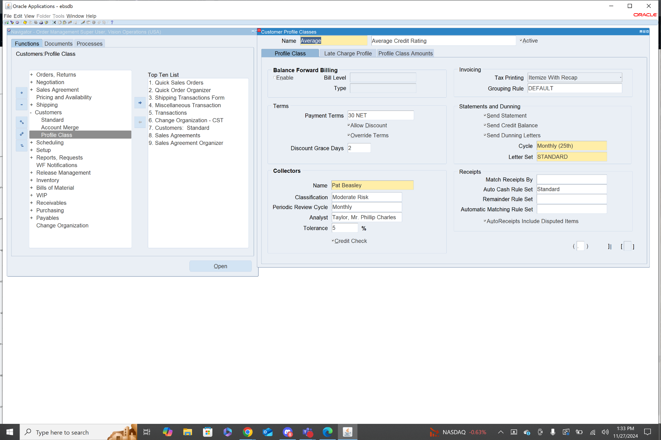

1. Sales Order Creation and Entry

•Create Sales Orders Manually or Import from External Systems

**Navigation: Order Management Super User>Orders, Returns>Sales Orders**

From this menu you can enter basic information like order type, customer name, order date, and currency. You can also enter information about the items being sold like item name, quantity, UOM, price, and shipping details.

