初步结论：

- 基于adrian数据中，在随机抽样十个instance里，rising被正确判断的样本中，包括斜率较大的升起伏，先升后轻微下降但是听感为升，幅度较为平缓但是听感为升，先下降再升有拐点。所以可以初步判断rising的识别正确率较高，与之前的同源测试集结果较为匹配。

2. falling和flat的正确样本里，对于先升后降以及平缓下降的图特征同时存在与falling和flat当中。所以可以判断为两者的数据标注混杂较为严重。另外专属于falling的还有斜率较高的明显下降样本，以及起伏极为平缓的flat样本。这也解释了之前在同源测试集中flat和falling正确率也远低于rising的情况。

Falling样本
13990201 Hmm,【Falling】 when did your pain start?【Falling】
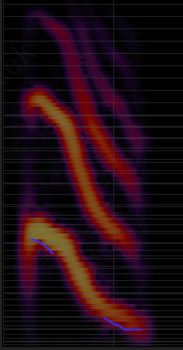
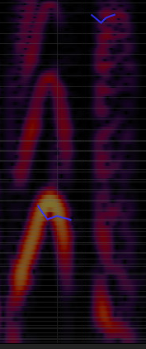
22470701 How much should I pay?【Falling】
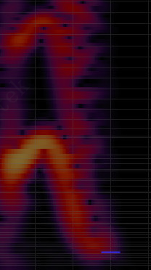

27590188 The style is reminiscent of Hokinson.【Falling】
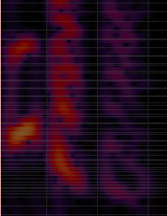

27590257 Clifford the Dog is a children's character.【Falling】
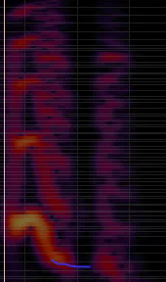

40000318 They need to certificate the electrical installation.【Falling】
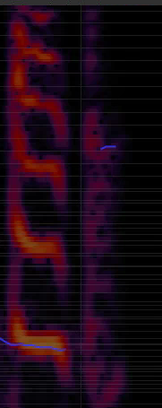

50000041 Find happiness.【Falling】
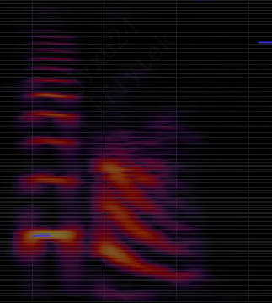

13470101 There's no way I can go swimming this evening.#【Falling】 I brought piles of work home from the office.【Falling】
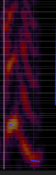
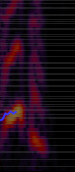

40000622 He did not intimate any plans to resign.【Falling】
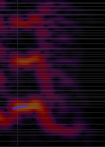

27590106 Jillian is studying to be a doctor.【Falling】
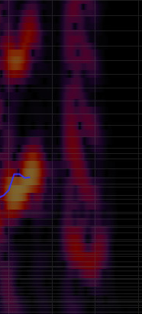

50000415 N U Y B.【Falling】
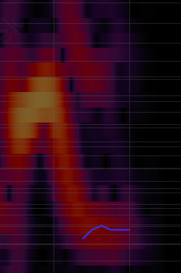

Flat样本
40000734 The village is isolated by the mountains.【Flat】
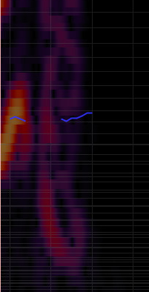

50000258 Bye!【Flat】
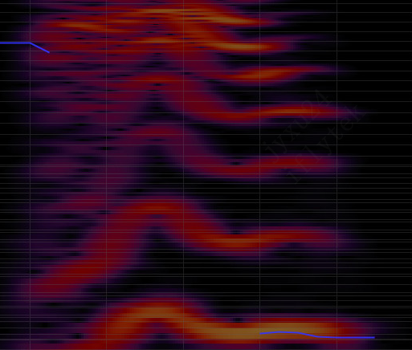

40000381 The clues lead the detective to the suspect.【Flat】
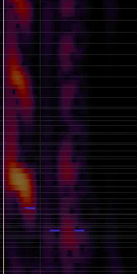

30770015 They produce blue light,#【Flat】 which can prevent you from going to sleep.【Flat】
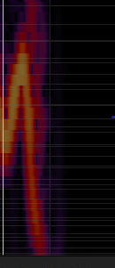
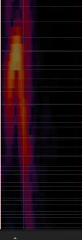

27590262 He restarts the computer every morning.【Flat】
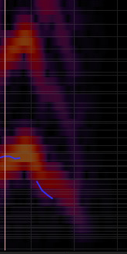

30940002 Good news for our students who are interested in arts.【Flat】
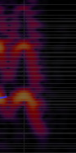

40000538 Do not torment your little sister!【Flat】
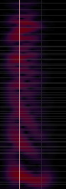

30060013 He spent all day at the hotel talking with each member of the staff from the top guy to the lady who cleaned the toilets.【Flat】
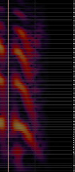

10670301 I'll eat here and here is twenty dollars.【Flat】
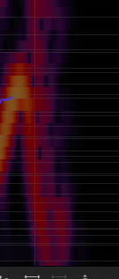

50001367 Two one eight two zero eight.【Flat】
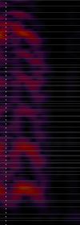

Rising样本
21780719 Too risky?【Rising】
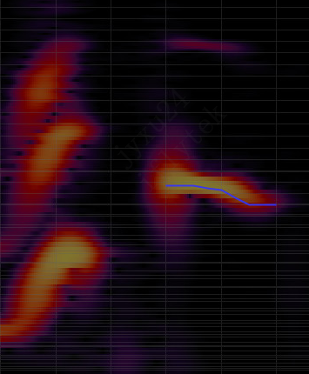

13500301 Including the color?【Rising】
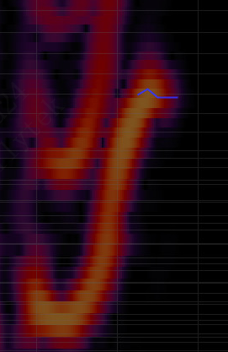

21781063 Just started?【Rising】
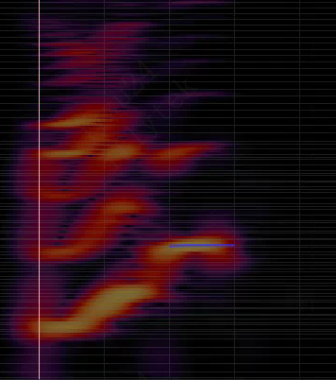

21780999 Your opinion?【Rising】
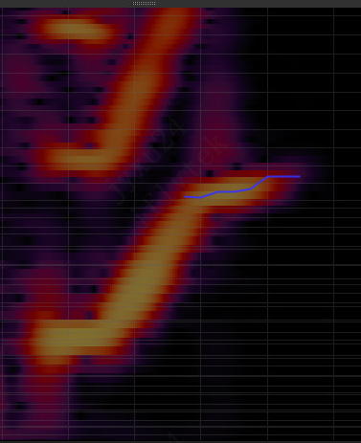

21780953 The main point?【Rising】
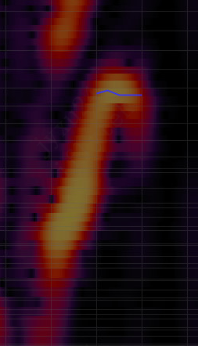

21780777 Our flight?【Rising】
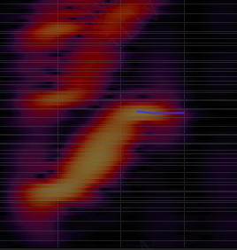

21780699 That simple?【Rising】
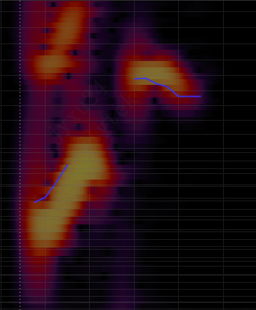

21780663 Already fixed?【Rising】
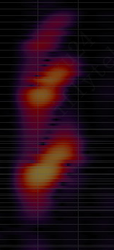

27580355 Him again?【Rising】
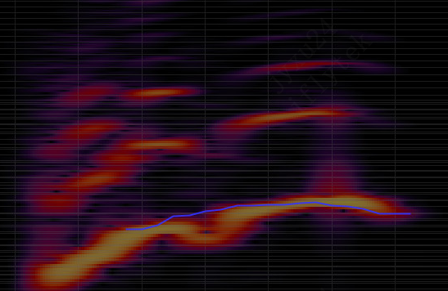

13960101 Can you suggest something good?【Rising】
