**RETROICORplus tutorial**

Step 1: Recording physiological measures using Brainamp

* The setup above consists of: a Brainamp ExG MR amplifier, an ExG AUX set, a pulse sensor coupler, and a respiration belt/coupler. All this equipment is placed inside the scanner room with the participant. The Brainamp ExG is connected using an optical cable to the PC running Brainvision recorder in the console room.
* In Brainvision recorder, use a workspace that includes heart rate and respiration (eg ‘workspace_erno.rwksp’ in the ‘BRAINAMP_data’ folder).
* Preferably, record data throughout full scan sessions without stopping in between. The different EPI scan runs are separated automatically in a later stage.
* 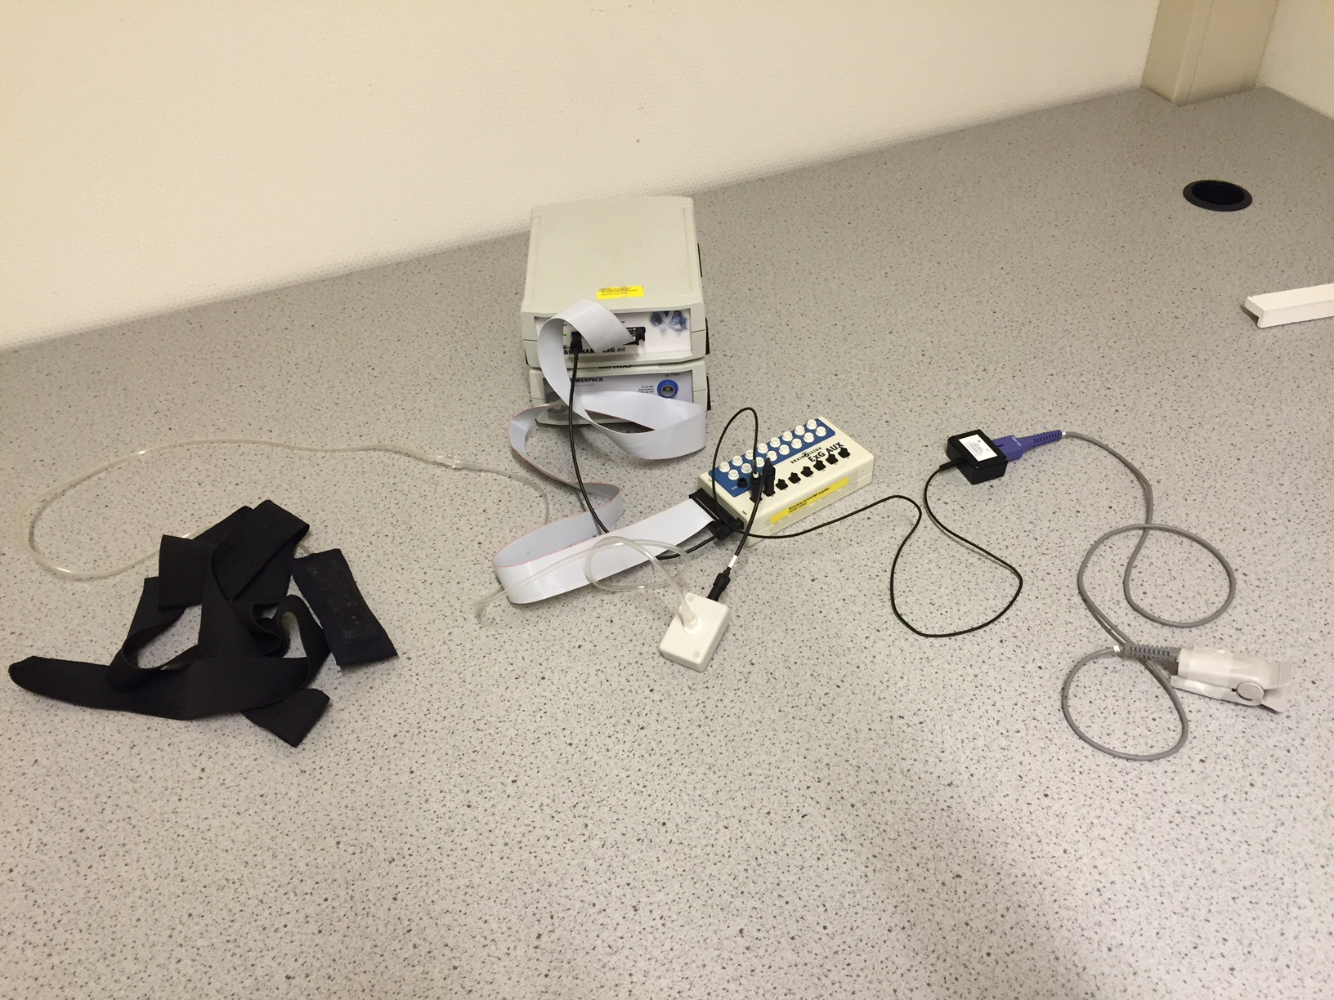The example dataset (in RETROICORplus_example_data.zip) used 5000 Hz. This high frequency recording is used to improve the RF pulse artifact corrections.

Step 2: Converting the EEG files.

* The raw EEG recordings should be converted to HeRa format using Brainampconverter. Make sure the brainampconverter folder is added to your matlab path and run it.
* Point towards the "demo1.eeg" file in the "RETROICORplus_example_data/brainamp" folder.
* The script will (1) convert the data, (2) remove RF frequency pulses for each EPI scan run, (3) detect peaks (heart beats), and (4) create separate mat-files for each EPI scan run that can be loaded by HeRa. For the example data set, brainampconverter should create files called "demo1_fMRI_run_1_TR2560ms_117vols_498-817s_hera.mat" and "... hera.puls", which tells you that this file contains physiological data collected during run 1, that it used a TR of 2.56 s, that the length of the run was 117 volumes, and that the data was collected between 498 and 817 s after the start of the brainamp full recording.

Step 3: Visual inspection / correction in HeRa

* Put the ‘hera’ folder in your matlab path and run it (type ‘hera’).
* Click ‘Open’ and locate your ‘… _hera.puls’ file for the run of interest.
* In the upper figure, you will see the pulse recording (black), the interbeat intervals (red) and the scan trigger pulses (in blue, at the bottom).
* Now inspect and correct the data for the period of interest. You can browse the data using the zoom controllers at the top of the GUI.
* There’s a small vertical line above the middle of the top figure. When you click “insert peak”, a new peak is added at that location. When you click “remove peak”, the peak closest to this point is removed. Periods with bad data recordings that cannot be repaired can be rejected by zooming this period and then clicking “reject zoomed”. These data will later be interpolated by RETROICORplus.
* Click “save” when ready.

Step 4: Creating the RETROICORplus regressors

* The RETROICORplus variables can be created by running "RETROICORplus.m". Make sure the RETROICORplus folder is also in your matlab path.
* In the dialog box, first point to the ‘_hera.mat’ file created by brainampconverter and edited in HeRa (which has the same name as the "... _hera.puls". Second, enter the number of scans removed at the beginning (i.e., enter "5" if you threw away the first five recorded volumes to account for T1 equilibration effects - this is the case for the example dataset). Third, enter the number of scans removed at the end (e.g., this could be "1" if you manually stopped the scanner, which results in a final trigger being recorded by brainamp for which there is no volume - this is the case for the example dataset). You can also use RETROICORplus.m as a function from within your own scripts (see comments at the beginning of the m-file).
* For the example dataset, the output is saved to “demo1_fMRI_run_1_TR2560ms_117vols_498-817s_hera_RETROICORplus_regr.mat". If you load this into matlab you will get a variable R, which is an array with TRs in rows, and columns for:
  + 1-10: Cardiac phase regressors (assuming you use 5th order Fourier modeling for cardiac phase, this is set in RETROICORplus_defaults_setup).
  + 11-20: Respiratory phase regressors (assuming you use 5th order Fourier modeling for cardiac phase, this is set in RETROICORplus_defaults_setup).
  + 21-23: Heart rate frequency (one HR frequency regressor per time lag defined in RETROICORplus_defaults_setup)
  + 24-25 RVT: Respiratory volume per unit time (i.e., frequency times amplitude of respiration, averaged per TR using a 9-s window), with one regressor per time lag defined in RETROICORplus_defaults_setup)

Step 5: Testing the RETROICOR regressors

* To see how much variance is explained by these variables, you can put them into an SPM model and fit the regressors onto the EPI data that was acquired simultaneously.
* The EPI data were acquired using a simple EPI sequence (on Skyra 3T) with a TR of 2 s, and normalized to MNI space. The first five volumes were deleted, so when RETROICORplus asks to remove scans at the beginning, enter "5" (and "0" at the end).
* You can specify your own model in your favorite software package and include the regressors created by RETROICORplus as nuisance variables. An F-test across all cardiac phase regressors, for instance, should give you substantial variance explained around blood vessels (surviving whole-brain correction).