# M06 Chapter 5 Conger Book Practices Assignment

NAME _______Liliana Varela____

The questions below are from the Conger Book Practices Assignment on page 100. Use this Assignment form to enter your answer below each question.

**Before completing this assignment please read the Suggestions for Scenarios in the Conger book on page 81 and 101.**

HINT: This assignment is to expose you to the process of looking for multivalued columns, functional dependencies and themes, and then checking for any additional transitive dependencies.

Description

Charlie has a large book collection. He was keeping track of it in a spreadsheet, but it has grown big enough that he wants to convert it into a real database. Here is a sample from the spreadsheet:

|  |  |  |
| --- | --- | --- |
| **Author** | **Author Country** | **Titles** |
| James Taylor | England | *JavaScript Essentials*, South Tech Books, London, 2010, $14; *HTML5 Exposed*, Webby Books, London, 2012, $15.50 |
| May Norton | United States | *Big Data Big Promise*, Data Press, San Francisco 2012, $25 |
| Jessica Lewis | United States | *Database Development for the Cloud*, Data Press San Francisco, $20.35; *Data Services*, Future Tech Press, New York $12.95 |

1. What are some of the potential problems with this layout if carried directly to the database?

Author’s names could be the same regardless of their country of origin. The database will end up having duplicate information and create anomalies such as insertion anomalies and update anomalies. There needs to be a better way to identify each individual author.

1. Which of the columns in the example are multivalued?

Author

Author 🡪 AuthorCountry

Author 🡪 Titles

1. Create a table that would show how you would convert the sample data into First Normal Form. (Hint: Break the information in the Titles column into separate fields. Books are separated by semicolons.)

AUTHOR_DATA (AuthorFirstName, AuthourLastName, AuthourCountry, AuthourID)

BOOKS (AuthorID, BookTitle, BookISBN)

BOOK_DATA (BookPublisher, BookISBN, BookCost)

*ISBN is the International Standard Book Number

HINT: Students may also want to separate first and last name into their own attributes. This is fine.

1. Create an entity diagram for the table you made in Practice 3.

(You can use Microsoft Visio to create the entity diagram, and then use the Microsoft Snipping tool to copy and paste the diagram into the space below. )

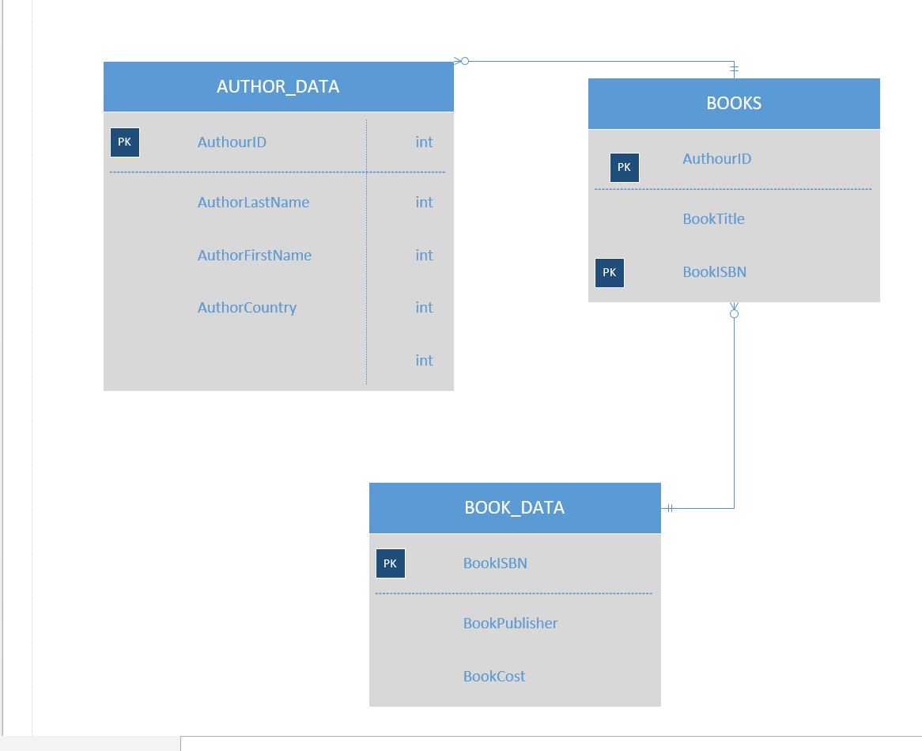

1. List all the functional dependencies you find in the sample data.

(AuthorLastName, AuthorFirstName) 🡪 AuthorID

(AuthorLastName, AuthorFirstName) 🡪 AuthorCountry

AuthorID 🡪 BookTitle

AuthorID 🡪 BookISBN

BookISBN 🡪 BookPublisher

BookISBN 🡪BookCost

1. Identify and list some potential candidate keys for the new entities.

(AuthorLastName, AuthorFirstName)

AuthorID

BookISBN

BookPublisher

1. Create an entity diagram that shows the structure of the data in Second Normal Form.

(You can use Microsoft Visio to create the entity diagram, and then use the Microsoft Snipping tool to copy and paste the diagram into the space below. )

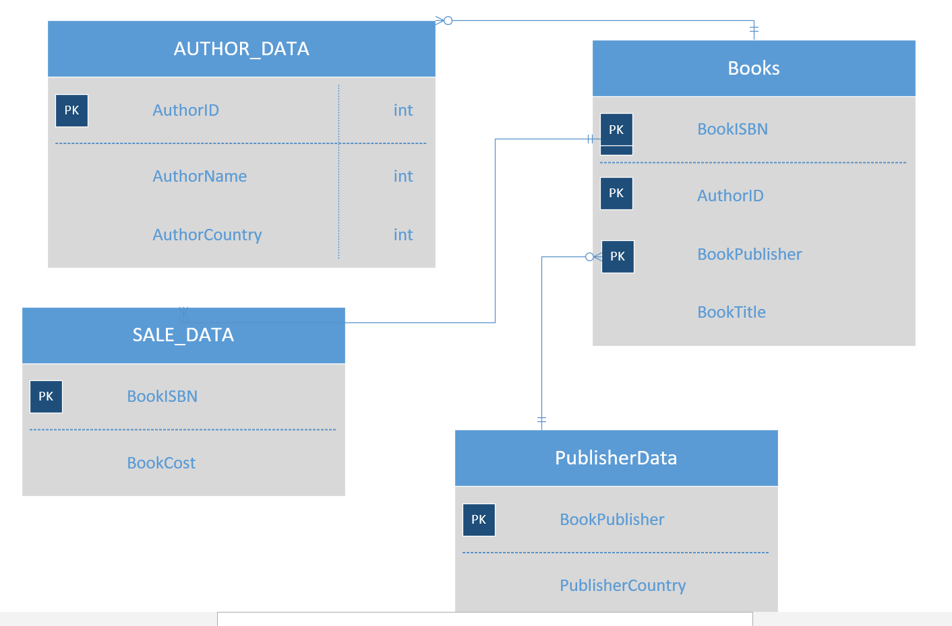

Discussion. Students may leave Author and AuthorName in the book entity. I broke it out here because it is more than a transitive dependency since the values repeat in multiple rows. But if students leave it in here, they can remove it in the next step as a transitive dependency. I would accept this as valid. It is also possible that some students will realize that some books have multiple authors, and that it is therefore necessary to create a linking entity between Book and Author. This should be encouraged as it shows they are understanding relationships and normalization.

1. List any transitive dependencies you find. If the authorname and authorcountry were left in Book, they should be separated into a new entity at this point.

AuthorID 🡪 AuthorCountry

BookData 🡪 PublisherCountry

1. Create an entity diagram that shows the database in Third Normal Form.

