**M09 Chapter 7 Kroenke book Create a Database DDL & DML**

**Name __Liliana Varela______**

Follow the instructions below, to create a Database and Insert Data into it. Paste 2-3 snipped picture, below this sentence to show your work. Attach this document to the assignment link to be graded.

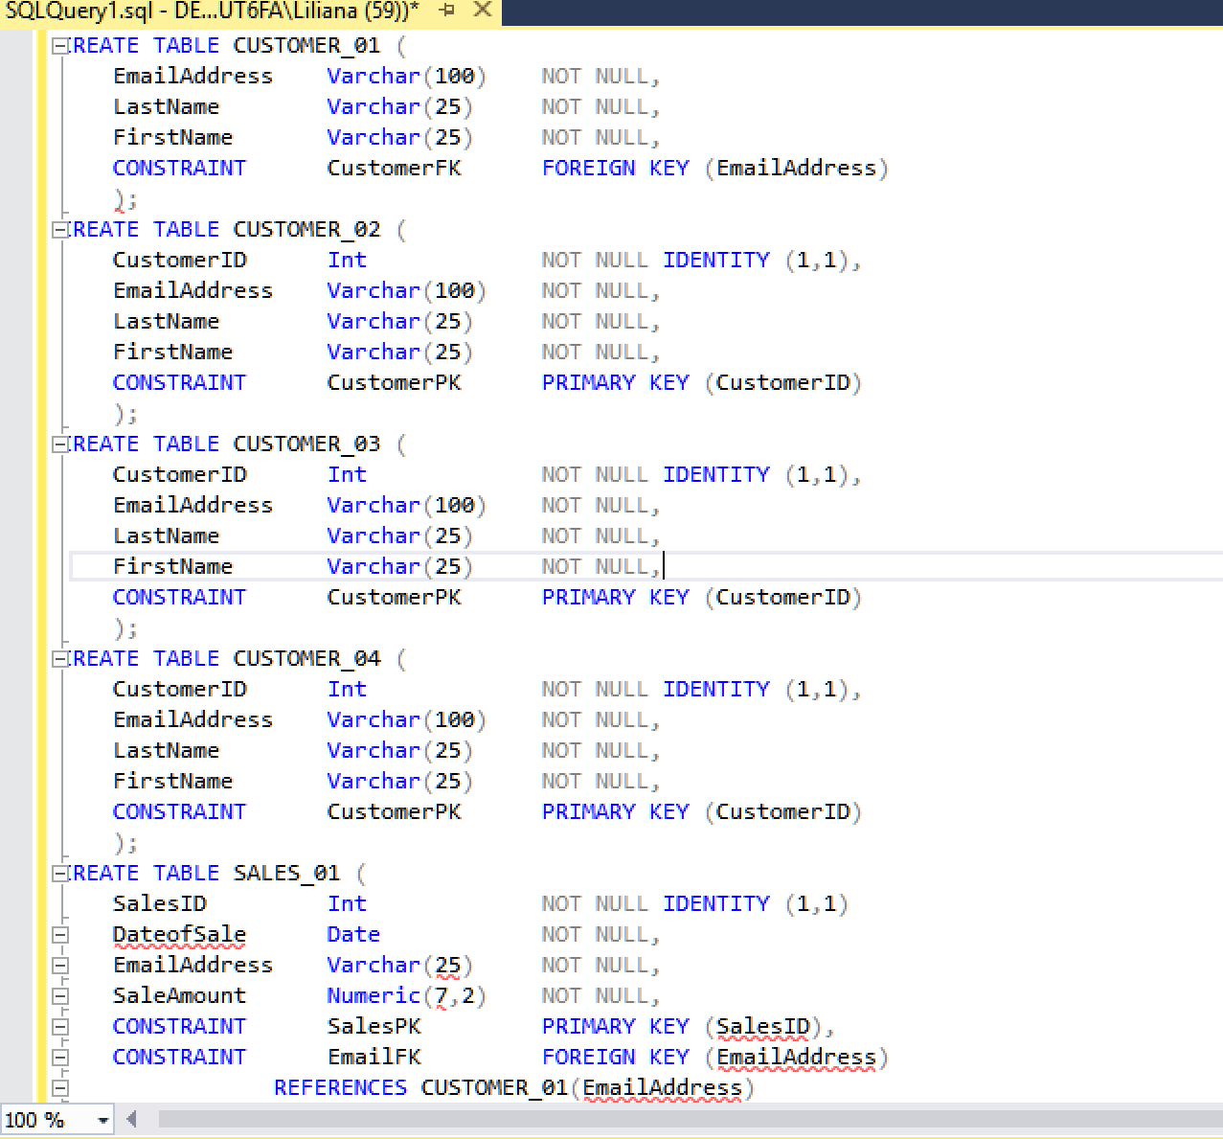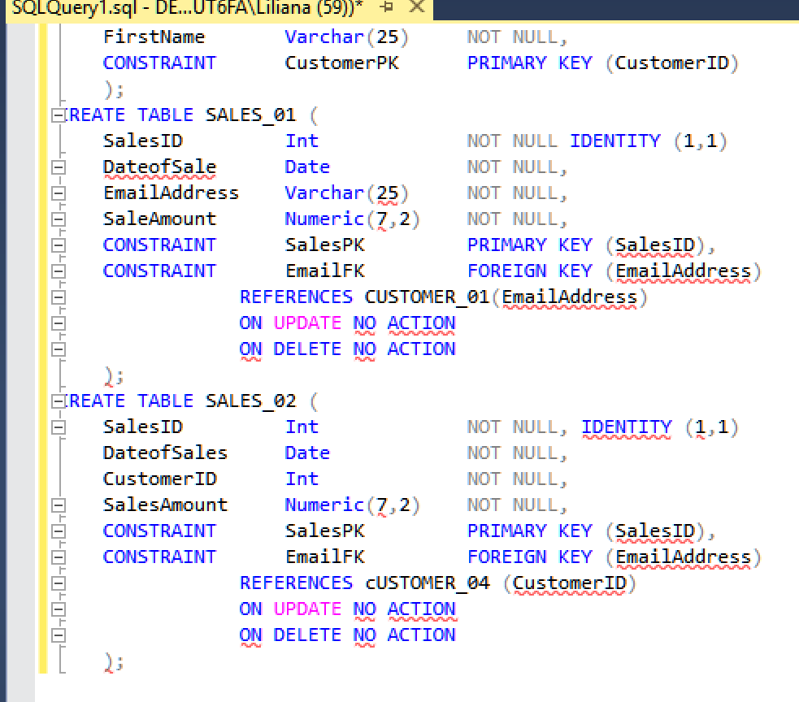

I tried many different things to get my database to create tables without any success. I kept getting errors I didn’t know how to correct like “incorrect syntax around ‘)’ and it would say something along the lines of “expecting reference” on CUSTOMER_01 table. I tried fixing it only to get more and more errors. I kind of ended up giving up after a few hours and this was my where I left off.

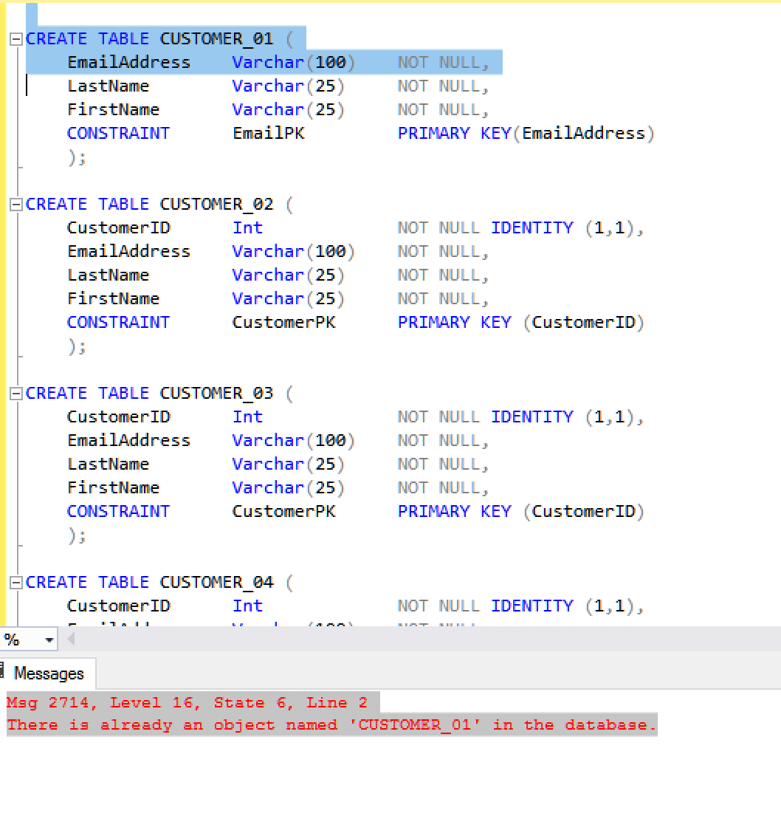

Students will receive a maximum of 20 points for successfully creating and populating the RQ_TABLES database.

**For Class module 09, Kroenke Chap. 7, RQ 7.3 to 7.40, we will create the CH07_RQ_TABLES Database.**

This procedure requires that that the SQL Server 2014 Express with Advanced Services OR SQL Server 2014 Express are downloaded and installed. This was installed in Session 03, when you created the Cape_Codd Database in SQL Server, then import data using two SQL Scripts.

**The pictures, used in these instructions, are a repeat of the process used to create Cape_Codd, except this time you will enter CH07_RQ_TABLES, instead of Cape_Codd. Please Note that the record counts in the pictures/examples are from the Cape_Codd and are only displayed as an example.**

1. Open the SSMS window and log into your account. You should see a window similar to the one displayed below.

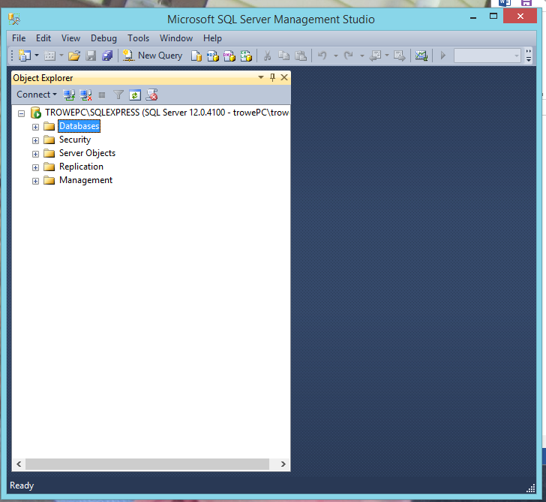

2. Right click on the Database Folder in the Object Explorer, to reveal a short cut menu and select New Database, see picture below.

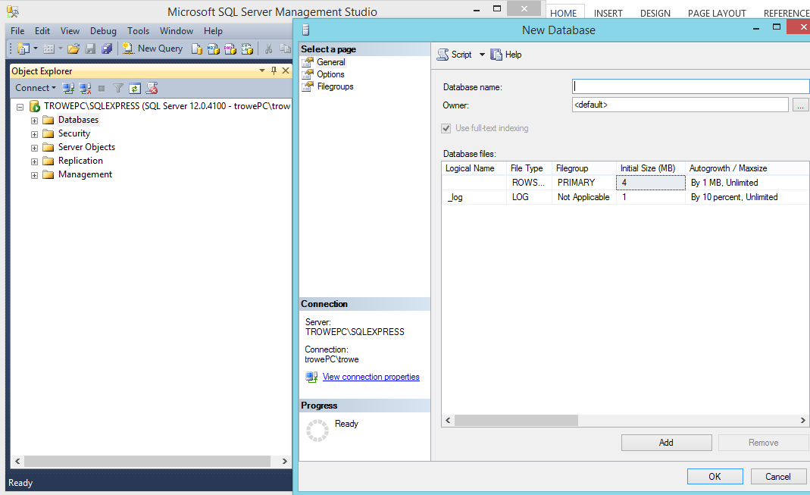

3. Enter **CH07_RQ_TABLES** as the name of the database.

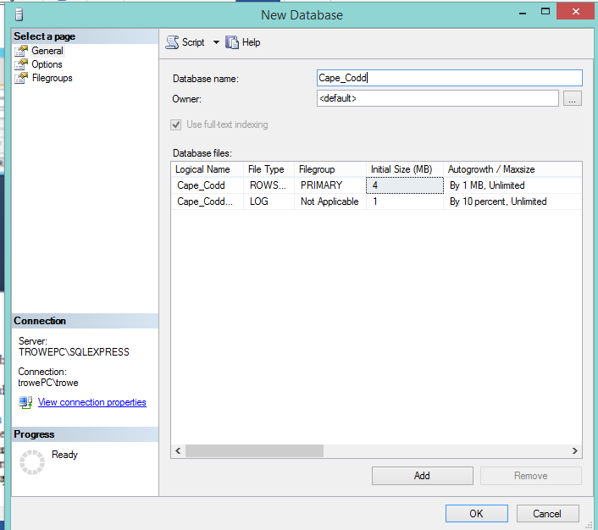

4. To confirm it is there, click Refresh button. Open the Databases folder (click on + before the folder icon), and you will see the Database you created, **CH07_RQ_TABLES**.

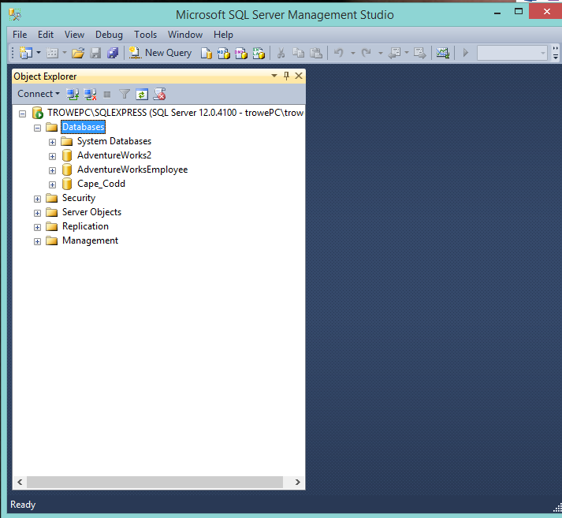

5. Right click on the database name, select Properties from the short cut menu.

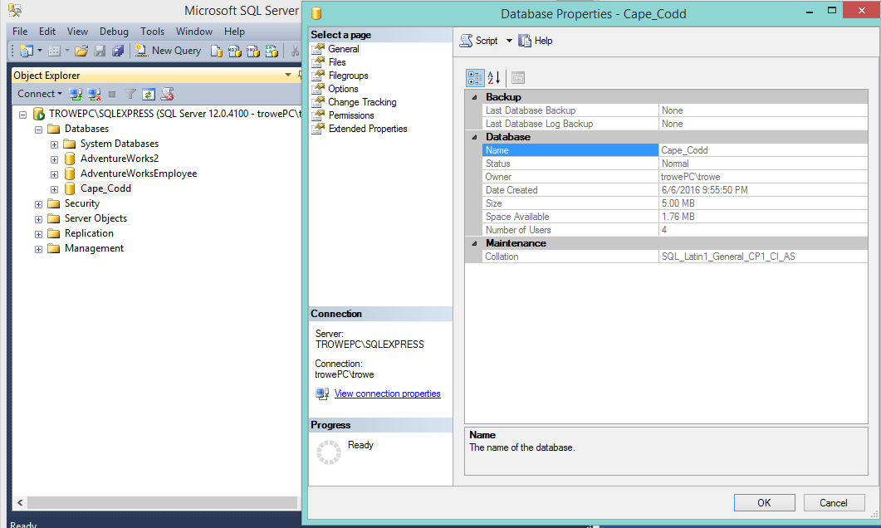

6. In the Database Properties box, select a Page box click on Files, to display the RQ_TABLES files, see picture below.

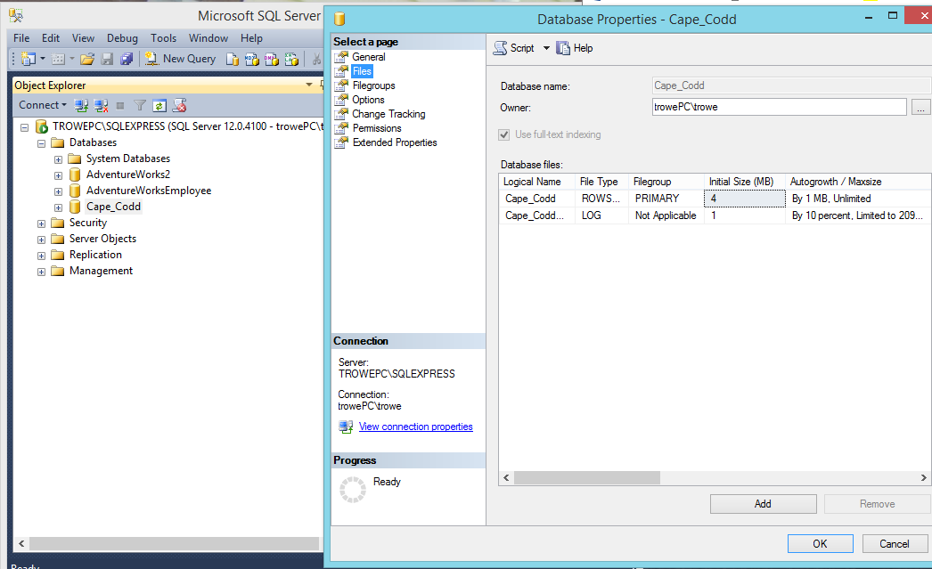

7. You will see two files displayed, see above. When you create a database, SQL Server by default, creates one data file, **CH07_RQ_TABLES** and one Log file for each database.

8. We need to create the files in the database, but do Not want to use the GUI interface or a Command Line Interface, so we will use the SSMS editing environment.

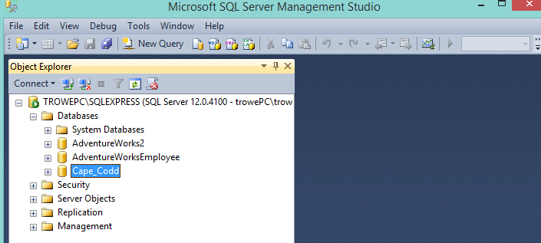

9. Click the New Query icon on the tool bar and you will see a new tabbed SQL Query window is displayed, see picture below. Click the Intellisense Enabled button to disable Intellisense, see arrow below. This is a tool for experienced developers and we are not going to discuss it in this exercise.

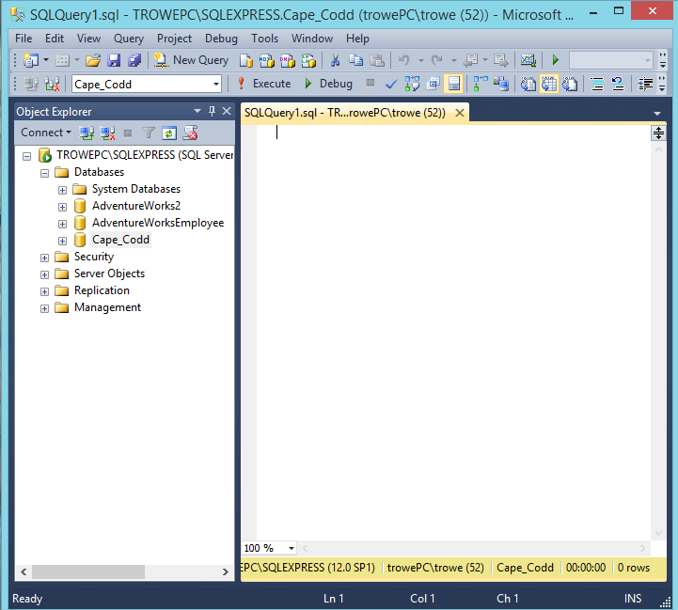

10. Using the File Explorer navigate to the SQL Server Management Studio folder, and create a new folder, named Projects, if needed. You may still have the Projects Folder from when you created the Cape_Codd Database, see below.

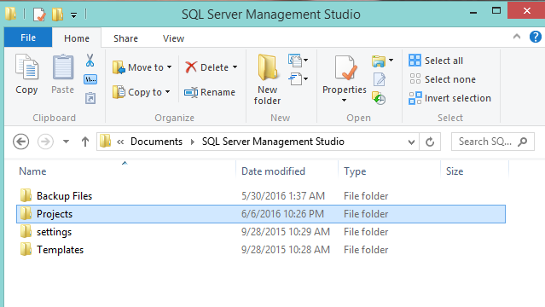

11. You are now ready to answer the Review Questions, starting with 7.3 on page 357 in the Kroenke book.