**Introduction to Programming Using Python,**[**Y. Daniel Liang**](http://www.cs.armstrong.edu/liang)

This quiz is for students to practice. A large number of additional quiz is available for instructors from the Instructor's Resource Website.

**Chapter 1 Introduction to Computers, Programs, and Python**

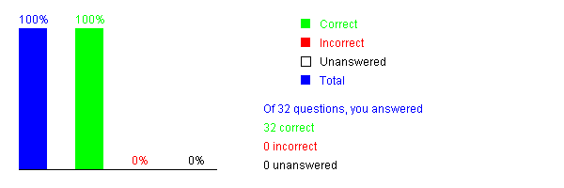

**Introduction to Programming Using Python,**[**Y. Daniel Liang**](http://www.cs.armstrong.edu/liang)

This quiz is for students to practice. A large number of additional quiz is available for instructors from the Instructor's Resource Website.

**Chapter 2 Elementary Programming**

