### Introduction to Programming Using Python, [Y. Daniel Liang](http://www.cs.armstrong.edu/liang)

This quiz is for students to practice. A large number of additional quiz is available for instructors from the Instructor's Resource Website.

### Chapter 3 Mathematical Functions, Strings, and Objects

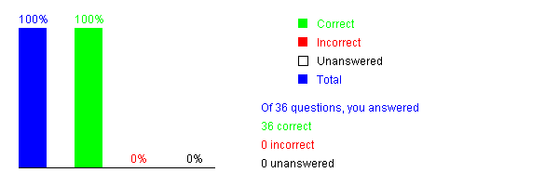

Please send suggestions and errata to Dr. Liang at [y.daniel.liang@gmail.com](mailto:y.daniel.liang@gmail.com). Indicate which book and edition you are using. Thanks!

### Introduction to Programming Using Python, [Y. Daniel Liang](http://www.cs.armstrong.edu/liang)

This quiz is for students to practice. A large number of additional quiz is available for instructors from the Instructor's Resource Website.

### Chapter 4 Selections

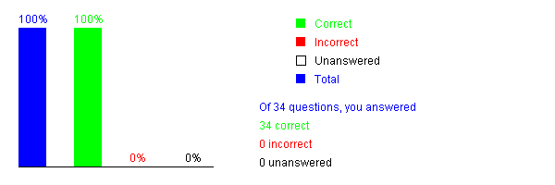

Please send suggestions and errata to Dr. Liang at [y.daniel.liang@gmail.com](mailto:y.daniel.liang@gmail.com). Indicate which book and edition you are using. Thanks!