**Introduction to Programming Using Python,**[**Y. Daniel Liang**](http://www.cs.armstrong.edu/liang)

This quiz is for students to practice. A large number of additional quiz is available for instructors from the Instructor's Resource Website.

**Chapter 5 Loops**

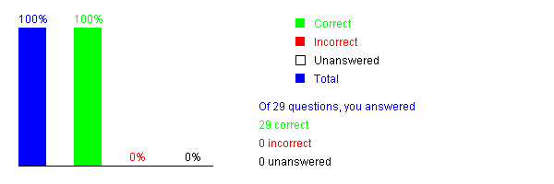

Please send suggestions and errata to Dr. Liang at [y.daniel.liang@gmail.com](mailto:y.daniel.liang@gmail.com). Indicate which book and edition you are using. Thanks!

**Introduction to Programming Using Python,**[**Y. Daniel Liang**](http://www.cs.armstrong.edu/liang)

This quiz is for students to practice. A large number of additional quiz is available for instructors from the Instructor's Resource Website.

**Chapter 6 Functions**



Please send suggestions and errata to Dr. Liang at [y.daniel.liang@gmail.com](mailto:y.daniel.liang@gmail.com). Indicate which book and edition you are using. Thanks!