# Color Contrast Evaluation

## Color Contrast Testers

A quick search of the Internet for “Color contrast test” should turn up a variety of tools you can use to test contrast. Here, we will mention **Juicy Studio Colour Contrast Ratio Analyser**, but if you prefer another, you can add it to your Toolkit. You can find more tools for your tool kit on Section508.gov [Automated Evaluation Tools **(Links to an external site)**](https://section508.gov/content/automated-evaluation-tools).

**Toolkit:** *Bookmark the Juicy Studio* [*Colour Contrast Ratio Analyser* ***(Links to an external site)***](http://juicystudio.com/services/luminositycontrastratio.php)*and add it to your Toolkit.*

## Why Color Contrast is Important

WCAG 2.0 Guideline 1.4.3 address accessibility issues associated with Color contrast. The guideline is presented below.

**SC 1.4.3 Contrast (Minimum) (Level AA):** The visual presentation of text and images of text has a *contrast ratio of at least 4.5:1*, except for the following:

**Large Text:**Large-scale text and images of large-scale text have a *contrast ratio of at least 3:1;*

**Incidental:**Text or images of text that are part of an inactive user interface component, that are pure decoration, that are not visible to anyone, or that are part of a picture that contains significant other visual content, have *no contrast requirement.*

**Logotypes:**Text that is part of a logo or brand name has *no minimum contrast requirement.*

Some accessibility checkers will have Color contrast evaluation built into them (e.g., AChecker), but others will not.

**Technical:**

There are many Color contrast evaluators from which you may choose to support your contrast testing (see some suggestions on the Section508.gov website [Automated Evaluation Tools **(Links to an external site)**](https://section508.gov/content/automated-evaluation-tools)). Using any of these tools requires gathering the Color codes from the elements being evaluated. There are a variety of ways to find these codes, though the easiest is to use a browser's “Inspect” feature. If you are using Firefox with the Firebug plugin installed, you can inspect the Colors in the right frame, as shown in the figure below. Other browser inspector tools will have a similar presentation, though some users find Firebug easier to read with better spacing and use of Color.

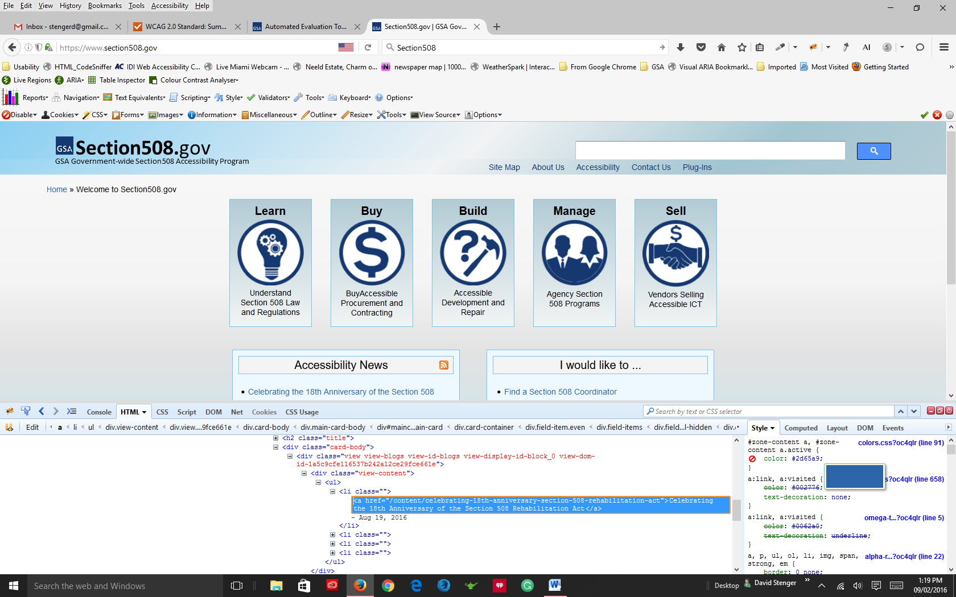

Note the color code

*Figure: Firebug panel showing the Color codes in the Style pane to the right*

Once you’ve tested a few Color combinations you’ll quickly develop a “feel” for good contrast, and be able to quickly scan a page and identify where contrast may not be sufficient. You can test the specific Colors associated with those elements you’ve identified in a scan. There are tools, however, that will evaluate all the Colors on a page (e.g., AChecker, Juicy Studios Firefox plugin) – this may be preferable if you are reviewing a site that seems to have multiple contrast issues.

## The WebAIM Make-up of a Color Contrast Results Screen

In the figure below you can see the foreground Color (#007AC6) and background Color (#FFFFFF) codes entered into the respective fields. Below that you will see the compliance status for Normal and Large text, at Level AA and Level AAA. In this case the Colors contrast well enough to pass at Level AA (4.57:1), but for smaller text the contrast ratio fails at Level AAA. Sites should aim for Level AA contrast, but if feasible try for Level AAA compliance.

Note the lighten and darken links next to the Color input field. You can click these (on the test site) to adjust the Colors so they will pass, then take the resulting Color codes and replace the existing codes to adjust the Color on the site being evaluated so it complies.

**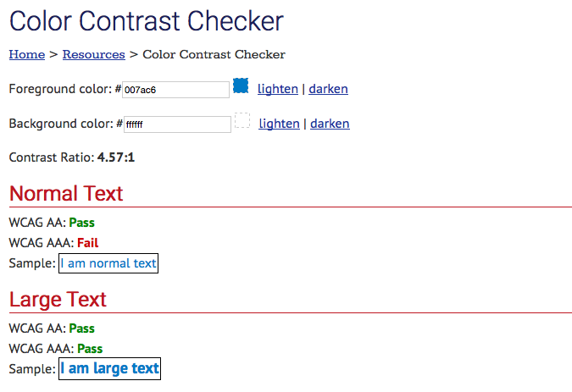***Figure: The WebAIM Color Contrast Checker*