Lab 2: Hidden Markov Models
Duane Johnson
Daniel Challis
Ryan Seamons

Introduction
Only about 4% of the human genome is made up of “coding” DNA that is transcribed to mRNA and then translated into proteins. With the already immense, and ever increasing amount of raw sequence data available, it is becoming more and more important to be able to locate these coding genes in the sequence data. Many methods of identifying these coding genes have been developed, one of these methods that has been shown to be quite effective is the identification of CpG islands inside the sequence. A CpG island is simply a region of the sequence that contains a disproportionate concentration of the nucleotides cytosine and guanine (“C” and “G”). Such a region commonly occurs near the promoter of housekeeping genes of the cell, so finding such an island will often lead to the finding of a gene. Additionally, it can be used to differentiate real genes from pseudo-genes, which usually do not have a CpG island nearby. The reason why these CpG islands are so often found near housekeeping gene promoters is that these regions are highly conserved, so the usually common CG to TG mutation is rarely permitted, resulting in a higher concentration of this subsequence in comparison to the rest of the genome.
While it has been shown that CpG islands can be an effective indicator of housekeeping genes, identifying these islands is unfortunately more difficult than it may seem. One method however, that is very well suited for this kind of problem is a Hidden Markov Model. A Hidden Markov Model is a model in which there are characters, states and the probabilities of state transitions and character output. In our case the characters are the nucleotides, and the states are CpG island or Not CpG island. The model works by examining the characters one at a time and based on its previous state, and the current character it combines the probabilities to determine the most probable state for that character. In order for a Hidden Markov Model to be most effective, it must be trained, meaning you must find appropriate probabilities for the state transitions and character output given the current state. One way of doing this is through supervised training, which consists of calculating the probabilities from previous sequence data that is already annotated with state information.
Procedure or Materials and Methods
We chose to implement our Hidden Markov Model in Perl because the majority of our group was familiar with the language. In retrospect, its strengths fit well with the problem at hand – the support for file processing, simple string access, and lookup tables were all sufficient for the task. In addition, the complexity of the algorithm was not so high that we needed to think deeply about program architecture. Instead, we were able to "hack" the algorithm together in a piecemeal way.
In fact, one of the highlights of this project was the online group "hacking" that was done in a collaborative text editor at etherpad.com. All three of our group members met online at scheduled times and concurrently edited the code until we had produced something we were satisfied with. At first, we built a skeleton of ideas--for example, which subroutines would be needed and what they would be called, as well as global variables and command-line arguments--and then we volunteered to work on various segments. We brought some of our individual work together and then re-integrated the new code during a subsequent live coding session. The result was a codebase that we all understood and that we all contributed to.
The HMM itself was implemented in 2 subroutines: get_states(), and slider(). Essentially, get_states would look at each individual nucleotide in a sequence and then, based on some probability lookup tables, assign a "CpG Island State" or "Non-CpG Island State" to a corresponding sequence. Afterward, the slider would take a look at a fixed-width view of the state sequence and average out the results, cutting things off with a threshold.
We tried the following probability lookup tables, window-sizes and thresholds:

# Look-up table for state transition probabilities
# 0 = non-CpG Island, 1 = CpG Island
0 => 0: 0.7
0 => 1: 0.3
1 => 0: 0.5
1 => 1: 0.5
# Window sizes : 150, 250
# Thresholds : .35, .7
# Look-up table for nucleotide-state probabilities
0, a: 0.251
0, t: 0.400
0, c: 0.098
0, g: 0.251
1, a: 0.250
1, t: 0.250
1, c: 0.250
1, g: 0.250

We also developed an application for the purpose of conducting supervised training for the model. It was also developed using perl, which was found to be quite adequate for the same reasons explained above. The application was built to accept a CpG table and the corresponding raw sequence data from the UCSC Genome Browser, and return all the probabilities needed for the model. The application was split into several methods including: reading in the nucleotide sequence data, parsing each line of the CpG table file, counting the number of nucleotides and state transitions, calculating the probabilities and printing the results.
Results
With the starting parameters, these are the graphs with came up with for different window sizes (50, 150, and 250)
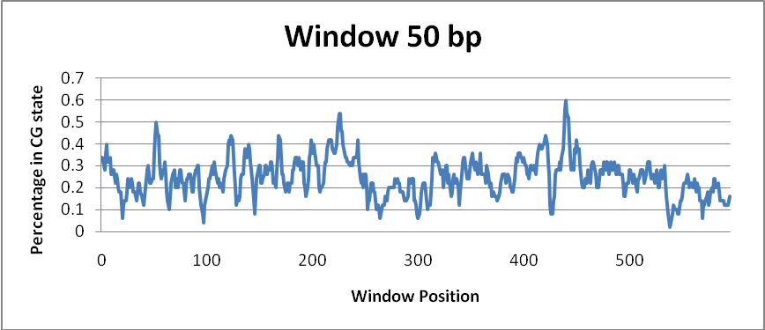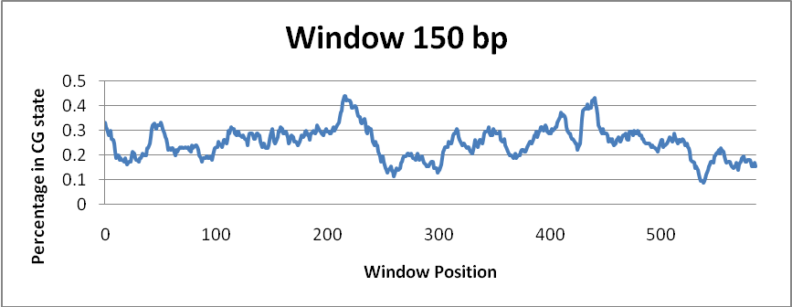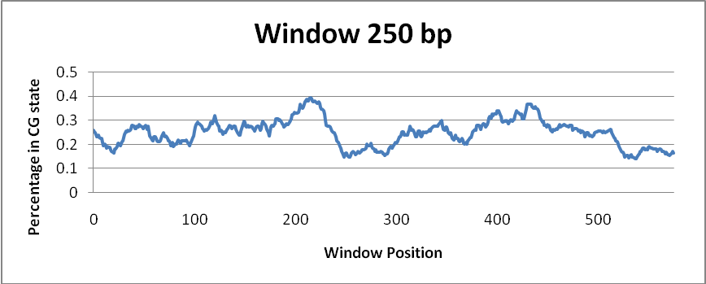
One observation we were happy to see was how the graph stabilized as our window size increased (as we expected). We altered our parameters a little to try and distinguish more where islands were.
When we changed the likelihood of staying in a CpG island state P(1|1) from .5 to .6, and the probability of changing from a CpG state to a non-CpG state P(0|1) from .5 to .4, we found the results we were looking for based on our supervised data:
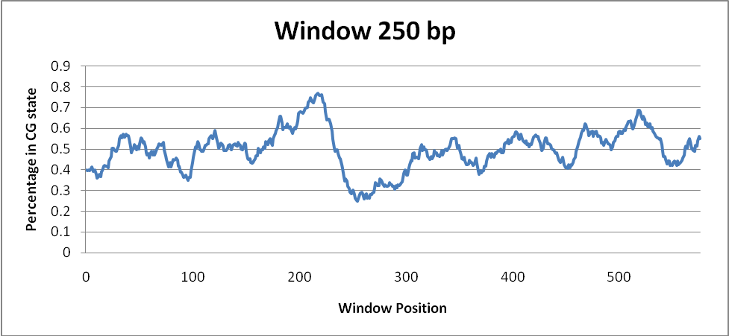
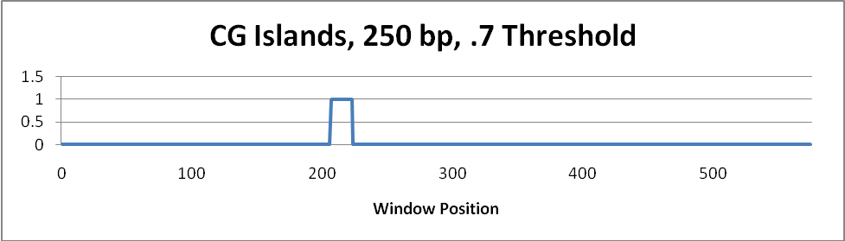
While we adjusted the initial probabilities, we could have reduced our threshold or done a number of other things to refine our CG-island finding capabilities.
Unfortunately, the supervised training application, did not initially function correctly and gave probabilities unacceptably close to 0 or 1 that did not yield any results. We ran it on the first 1.3 million bases of chromosome 1, and then on all of chromosome 8. The application ran in a very practical amount of time, just a few seconds for the smaller set, and under an hour for the full chromosome. Further development identified and fixed an error in calculating the nucleotide probabilities so that those values now appear to be correct, but unfortunately this was discovered too late to be included in the tests for this study. The probabilities from the updated version of the application using the first 1.3 million bases of chromosome 1 are as follows:
A given CpG: 0.190467300624234
T given CpG: 0.197083017326877
G given CpG: 0.305746455866052
C given CpG: 0.306703226182836
A given Non-CpG: 0.253825612979005
T given Non-CpG: 0.246050506533549
G given Non-CpG: 0.248223462046689
C given Non-CpG: 0.251900418440758
CpG to CpG: 0.998973222099061
CpG to non-CpG: 0.00100344203955428
Non-CpG to Non-CpG: 0.99992108354133
Non-CpG to CpG: 8.07517251504918e-05

Discussion
One of the interesting features of the graphs is the asymmetry of the peaks: reading from left to right shows a higher probability of C-G nucleotides before reaching a peak, followed by a precipitous drop in C-G, and a much lower ratio on the right-hand side. This pattern is fairly consistent and is probably indicative of the relatively lower ratios of C-G nucleotides in protein-coding (exon) regions of the genome compared to the non-protein-coding regions that precede CpG islands.
An important lesson we learned from working on the supervised training, is that properly training a Hidden Markov Model is a very difficult problem; perhaps the most difficult since even when it seems to be right, the results are still uncertain since the training CpG data is just the result of some other application. Proper supervised training requires good sequence data, good state data and of course a good training algorithm. It is impressive to note however, that even without adequate training, the Hidden Markov Model was able function as expected and identify CpG islands.
Appendices
Appendix A : Perl Code
#!/usr/bin/perl

use List::Util qw[min max]; #this allows us to use max function

# Command-line Arguments:

# 1. The number of nucleotides in the "window"
$window = shift; #variable to read in window size from command line
# 2. The threshold (in %) of the CpG Island
$cpg_island_threshold = shift;
# 3. The filename containing the nucleotide sequence
$filename = shift;

# Global Variables:

# An array of the nucleotide sequence
@sequence = ();
# An array of states, e.g. 0 for non-CpG and 1 for CpG state
@state_values = ();

@cpg = ();
@cpg_percentage = ();
$threshold = $cpg_island_threshold;

# Global Constants:

# Non CpG Island state:
$no_cpg_state = 0;
# CpG Island state:
$cpg_state = 1;
# Look-up table for p_state_given_state
%sstate = (
0 => {0 => 0.7, 1 => 0.3},
1 => {0 => 0.4, 1 => 0.6}
);
# Look-up table for p_state_given_nucleotide
%nstate = (
0 => {'a' => 0.251, 't' => 0.400, 'c' => 0.098, 'g' => 0.251},
1 => {'a' => 0.250, 't' => 0.250, 'c' => 0.250, 'g' => 0.250}
);

# Here we'll each write our own code to actually use all of the methods
read_nucleotides();
get_states();
slider();
print_islands();

# and this method will loop through the sequence
# giving the probabilityOf method the current base and
# next base?
sub get_states() {
$probability = log(p_initial_state());

# Assume we're not in the middle of an island for starters
$current_state = $no_cpg_state;

# print "sequence: @sequence\n";
foreach( 0..@sequence-1 ) {
# print "Nucleotide: $sequence[$_]\n";
$p1 = p_state_given_nucleotide($cpg_state, lc($sequence[$_]));
$p2 = p_state_given_nucleotide($no_cpg_state, lc($sequence[$_]));
$trans_p1 = p_state_given_state($current_state, $cpg_state);
$trans_p2 = p_state_given_state($current_state, $no_cpg_state);
if( $p1*$trans_p1 > $p2*$trans_p2 ) {
$current_state = $cpg_state;
}
else {
$current_state = $no_cpg_state;
}
push (@state_values, $current_state);
$probability = $probability + log(max($p1*$trans_p1, $p2*$trans_p2));
}
}

# Reads in a text file containing pure nucleotide sequences
# (should we have a read_fasta as well?)
sub read_nucleotides() {
open FILE, $filename or die $!;
read(FILE, $tmp, 100_000);
$tmp =~ s/\s//g;
@sequence = split(//,$tmp); # this should split every character
}
sub slider {
$size = @state_values;
$win = $window;
$win --; #this alters the window size for an array (starts at 0)
$size = $size-$win; # so if the $size is 100, and $win was 20, we get $size = 79 here
for( 0 .. $size/10 ){
$position = $_*10;
@tmp = @state_values[$position .. $win+$position];
$total = 0;
($total+=$_) for @tmp;
$percent = $total/($win+1);
# print "position: $_ Total: $total Percentage: $percent\n";
if($percent >= $threshold){
push(@cpg, 1);
}
else {
push(@cpg, 0);
}
push(@cpg_percentage, $percent);
}
}

sub print_islands() {
print "These are the State Values:\n";
print @state_values;
print "\n\n\n\nThese are the CPG Island Predictions:\n";
print @cpg;

open(OUTPUT, ">cgisland.txt");
foreach(@cpg){
print OUTPUT $_ . "\n";
}
close OUTPUT;
print "\n\n\n\nThese are the percentages:\n";
print @cpg_percentage;

open(OUTPUT, ">percentage.txt");
foreach(@cpg_percentage){
print OUTPUT $_ . "\n";
}
close OUTPUT;
print "\n\n";
print "Threshold: $threshold Window: $window\n";
}

# this is the "beginning state" probability table
sub p_initial_state() {
return 0.5;
}

# this is the "state given a current state" probability table
sub p_state_given_state() {
my $s1 = shift;
my $s2 = shift;
# if ( !exists($sstate{ $s1 }) ) {
# die "(p_state_given_state): unknown states $s1, $s2";
# }
return $sstate{ $s1 }{ $s2 };
}

# this is the "state given a nucleotide" probability table
sub p_state_given_nucleotide() {
my $s1 = shift;
my $n = shift;
# if ( !exists($nstate{ $s1 }) ) {
# die "(p_state_given_nucleotide): unknown state $s1";
# }
# elsif( !exists($nstate{ $s1 }{ $n }) ) {
# die "(p_state_given_nucleotide): unknown nucleotide $n";
# }
return $nstate{ $s1 }{ $n };
}
Appendix B: Actual Results
The actual data is available upon request. (we didn’t include it here because of the overwhelming size)

