Play: Amma Sonna Kathai

This play starts out in present time when a group of friends (Characters: Nithya, Suriya, Nachu, Aashan, Maduvan, and Kannan) are playing together having fun dancing a number from the movie Villu. A casual remark about playing race cars reminds the character, Aashan, that Maduvan did not return his toy. An argument ensues that ends up in a conflict. The character, Kannan, remembers a story that his mom had told him…(this leads to the first mini-play).

Mini-play 1: Ramu asks his friend Somu to safe keep his diamond till his return from a trip. Somu agrees but doesn’t return the diamond saying he already returned it. The case goes to the Queen’s court. Somu sets up 3 false witnesses. The queen asks each person to make a model of the diamond. All witnesses make different models based on their profession while Somu and Ramu make the same shape. The court punishes the false witnesses and the defendant.

After this mini-play 1, Kannan asks if the character, Maduvan, remembers returning the toy. Suriya now says he also knows a story that he wants to say…. (This leads to the second mini-play).

Mini-play 2: Meena’s pet hen strays into her neighbor, Parvathy’s yard. Parvathi gets tempted to turn that chicken into a yummy ‘kozhi kozhumbu’ for lunch and proceeds with her temptation. When Meena comes searching for her pet hen, Parvathy says she didn’t see it. Meena takes Parvathy to the Queen’s court. The court suspects that Parvathy might be lying and the queen adjourns the court till the next day. The Queen plays a trick on Parvathy who falls for it and panics which proves the Queen’s suspicion. The queen sentences Parvathy for stealing the hen.


From the events and lessons of the stories (mini-plays), the character, Maduvan realizes his folly and agrees he won’t put his friends, Nithya and Nachu in the spot and have them support him. Suriya says a Thirukural to signify the lesson learned. Aashan and Maduvan summarize in short the moral learned from the stories.

Date: Sunday, April 19, 2009

Event: Tamil New Year Celebration

Venue: ‘Party Hall’
19 Harrison Garden Blvd
North York, ON
M2N 7J6
CANADA
List of cast members in alphabetical order by last name

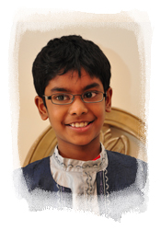  Kannan Alan  Age: 9  “Kannan” | Kannan is a joyful, caring and a friendly person with a strong sense of compassion and generosity. He is caring and helpful to his mom especially when she is sick. As an independent, responsible child, he does his chores like cleaning his room, packing his stuffs and doing his laundry but does require a reminder now and then.  His favorites past times on which he spend endless hours are working/ playing on his computer, playing Lego and DS games. Although, he plays badminton, soccer, piano and skates, he enjoys playing chess, swimming and biking the most. He made into Swimmer 6 lessons within a short period of time. He, however, is less inclined to compete. He spends most of his extra time on TV shows like Pokémon and American Idol.  His favorite movie is Harry Potter and owns the whole collection. He is culturally active and tries to learn Tamil. He enjoys singing and acting. All in all, he has a great personality.
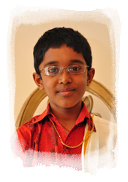  Arun Chinnameyyappan  Age: 8  “Ramu” | Arun is an artistic person who enjoys drawing cars, sea life and  animé characters. He enjoys school and reads series of books. He especially loves to play outside. He likes non-vegetarian food the most. His talent includes speaking Tamil fluently.
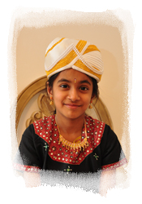  Abirami Iyyappan  Age: 11  “Minister” | Abirami is a talented 11 year old that has performed in 2 dances. During a CNS event, she entertained the crowd with jokes. She enjoys playing with her younger brother. She has a passion for dance and music. Her favorite is musical chairs and she has won 2 times. At school she is very good at math.
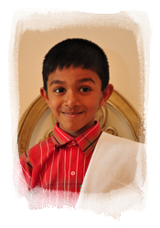  Arun Iyyappan  Age: 7  “Somu” | Arun is a 7 year old who likes to dance and play games. He was born in Canada and is fluent in both English and Tamil. He likes Tamil movies and enjoys playing soccer. At school he likes to read books and he is the fastest in his class in math.
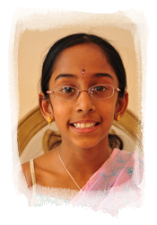  Shangavi Kannan  Age: 9  “Meena” | Shangavi is nine years old she is very much interested in any kind of cultural programs. She has been performing in every CNS get together for past 7 years. When she was two she started performing on stage. She has performed in more than 25 stage programs.  In 2008 for one of the nonprofit organization program, she choreographed a dance in a day and got most applause from the audience for the dance. She has been learning Carnatic vocal music and Bharthanatyam for past 3 years. In Grade one she has been awarded as a role model child for her class.  She always feels cool about having an old brother and her old brother treats her as an angel.
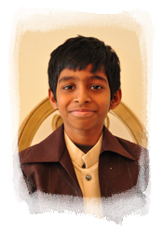  Maduvan Kasi  Age: 10  “Madhuvan” | Maduvan has a keen knowledge in technology, especially in mass media. Whether it is in games or other activities, he makes sure that everyone follows rules/procedures correctly. He can read, write and speak Tamil fluently. He has even participated in Tamil competitions.
  Nachu Kasi  Age: 5  “Nachu” | He is an independent child who likes to explore everything. He has great leadership qualities (his 2 broken teeth goes to show what an adventurous leader he is). He is very affectionate and possessive of his family members. He understands situations and people quickly and loves to be the center of attention.
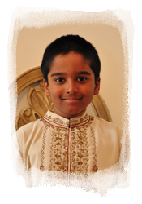  Aashan Meiyappan  Age: 9  “Aashan” | He is 9 years old, studying in Grade 3. He is a good learner. His interests include playing video games like Pokémon, Sonic and Mario. He is good in drawing Pokémon characters and writing stories about Sonic. He is participating in the Spelling Bee Competition. He enjoys Tamil movies and watching game shows. He is learning Abacus and has participated in UCMAS competitions.
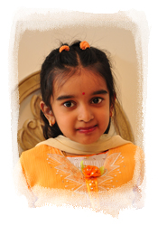  Nithya Meiyappan  Age: 6  “Nithya” | Nithya is in Grade 1. She is participating in the Spelling Bee Competition. She speaks Tamil fluently and loves Tamil movies and watching game shows. She has been taking Bharathanatyam lessons and has performed on stage.
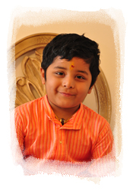  Suriya Nagappan  Age: 4  “Suriya” | Suriya Nagappan is an active and talented 4 ½ year old Junior Kindergartener. He is a good learner who enjoys listening to stories. His favorite activities include playing with cars, watching movies and dancing. He can speak Tamil fluently and has learned a total of 21 Thirukkurals, can recite slogams and is currently taking Carnatic music lessons. He is not a lover of certain foods like Pizza, Bread and Sandwiches. He is a little artist who enjoys painting and coloring.
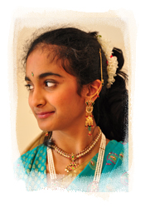  Janani Subramanian  Age: 11  “Queen” | 11 year old Janani is a happy- go- lucky girl! She is a sixth grader and is glad to go to school! She enjoys learning the piano and swimming. Now, she loves to talk to people, gladly accept being an M.C for a function and also participate in social activities. She loves dogs and prays that she could get one soon. She loves her mom and dad and tries to be a wonderful daughter. She likes to travel and try out new things. She actively participates in the composting program and go-green activities at school. She likes to listen to music and watches the Disney channel a lot. Well, she is a SWEEEEEEET HEART!
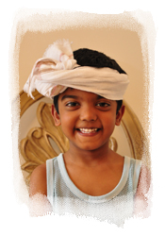  Ramu Valliappan  Age: 5  “Washerman” | Ramu has a great sense of humor who laughs easily to good jokes. He loves swimming and karate. He also enjoys watching Vijay movies with Vadivelu in it. He loves motorcycles. Hip-hop songs are his favorite and enjoys dancing to them.
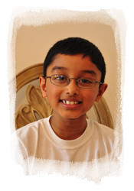  Hari Venkatraman  Age: 7  “Barber” | Hari is an inquisitive 7 year old who has a passion for cars. He loves to read mysteries and adventures. He is actively involved in karate, swimming and anime. Hari is very artistic and enjoys the many different forms (drawing, painting and creating with clay). Above all, Hari has a great sense of humor and loves to spend time with his cousin Ramu. He is also a faithful fan of Spongebob Squarepants.
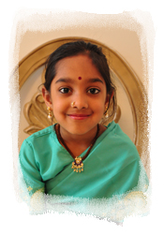  Alagu A. Vishwanathan  Age: 6  “Parvathy” | An adventurous little chemist, this 6-year old once mixed soap water with oil and shampoo to create perfume to impress her dad. Recently, she has finished learning to recite Thiruvasagam in its entirety. A good speller, she is preparing to participate in the Spelling Bee of Canada.  A naughty little tickle monster, she does not miss an opportunity to tickle unsuspecting friends. She loves Chicken as you saw in this play but does not chicken out. Besides being naughty and adventurous, she is a fun loving delight to her parents!!

