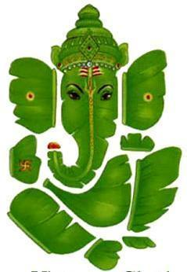BHAJAN SCHEDULE – 2012

*Please* ***confirm attendance*** *with hosts prior to the bhajan*

|  |  |
| --- | --- |
| Month | Hosts |
| JANUARY | **Dr. Aruna Pothapu** |
| FEBRUARY | **Janani Senthilnathan** |
| MARCH | **Uma Anand** |
| APRIL | **Valli Kannan** |
| MAY | **Chittu Pazhaniappan** |
| JUNE | **Renganayaki Kannappan** |
| JULY | **Dr. Muthulakshmi Yegappan** |
| AUGUST | **Valli Iyyappan** |
| SEPTEMBER | **Banu Annamalai** |
| OCTOBER | **Muthu Chockalingam** |
| NOVEMBER | **Meena Suppiah** |
| DECEMBER | **PILLAYAR NONBU** |

Updated: April 28, 2012