H2P – “hymns to presentation”
This version Jan 2026, Chris Jones, chris.jones.europe@gmail.com

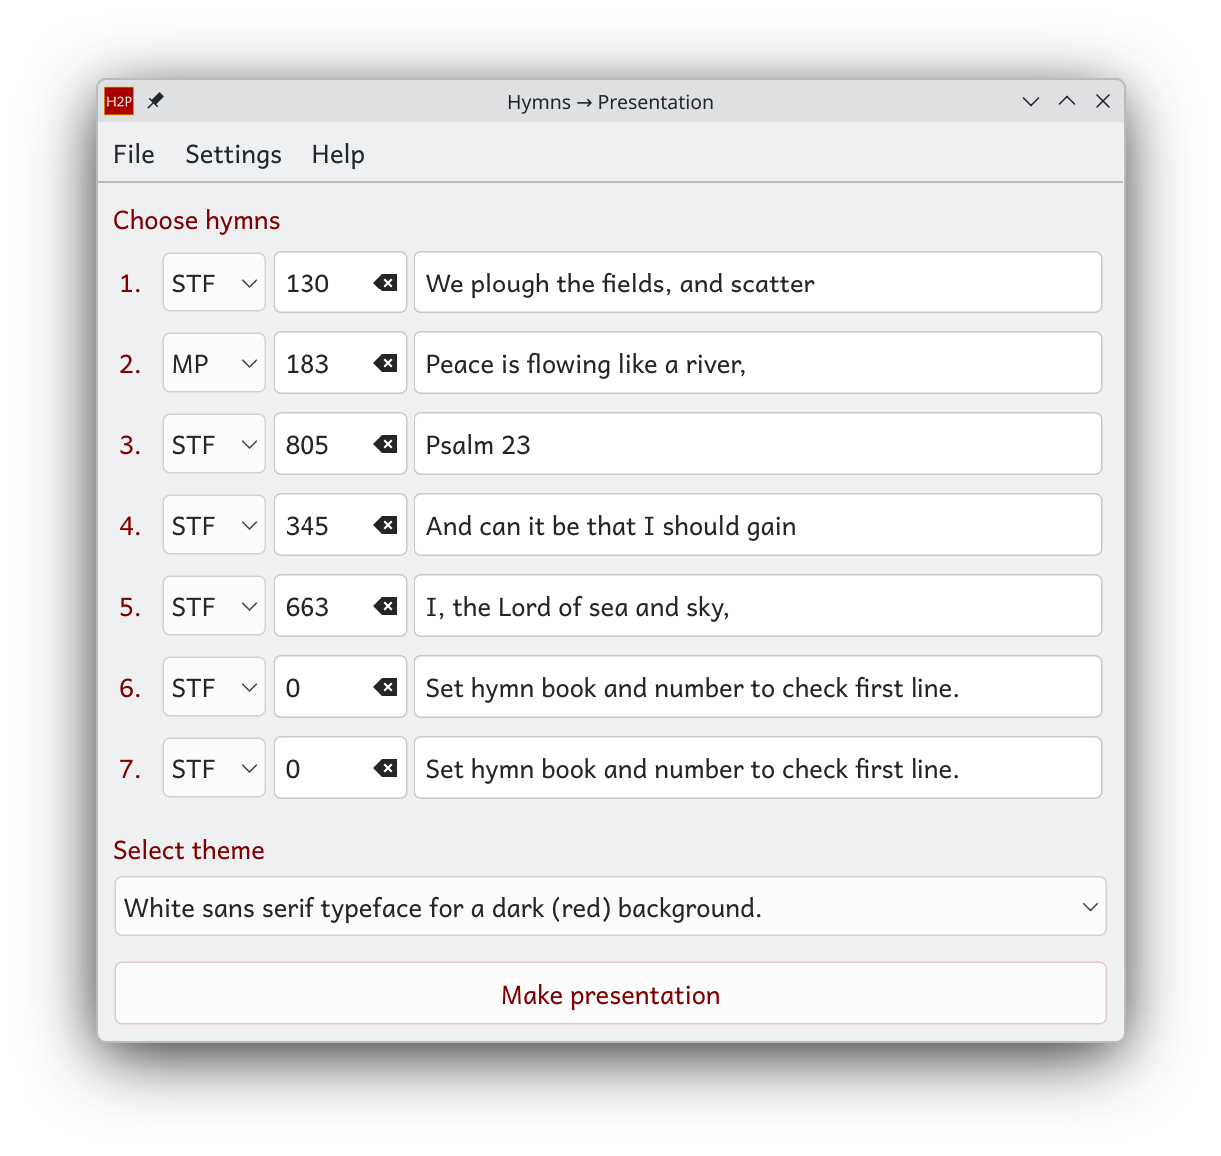
Simple start
Most of the day-to-day use of H2P will be to apply three simple steps.

1 Choose up to 7 hymns – set the source book in the drop-down and the number in the box. Check the first line of the hymn.
2 Select the theme – either white lettering on a dark background or black lettering on a light background, serif typeface/font or sans serif.
3 Make the presentation by pressing the button at the bottom of the panel.

The file ‘hymn-words.pptx’ will appear on your computers Desktop. You can rename the file so that you can produce more than one in a session.

The ‘first line’ box cannot be edited; it cannot be used to find a hymn. To find the number of a hymn either go from the hymnbook or use the index feature under the ‘File’ menu (see below).

Most of the time you will need no more than this. You can now read sections below only as you find you need to.

What is H2P
H2P is short for ‘hymns to presentation’. It generates a PowerPoint presentation file simply by entering the hymn numbers.
H2P:
- is cross-platform (linux®, Mac OS®, Windows® 10, 11);
- produces pptx presentation files for all the hymns of a church service within a few seconds;
- allows hymns to be added to its data base from any hymn book;
- provides a simple mark-up of the hymn to define verse-slide correspondence as well as line-by line of italics (e.g. for choruses/refrains), bold (e.g. for responsive readings) etc.;
- relies on a CCLI licence for the right to project copyrighted hymns.
- intentionally does not do anything that is more easily done in presentation software such as LibreOffice Impress or MS PowerPoint once the basic presentation is produced, e.g. inserting pictorial backgrounds;
- does not act as presentation software.

Background
There is other software that exists to help churches in the presentation of hymns on projector screens; some of it is free, see H2P licence. However, current offerings are sometimes complicated to learn, albeit that they provide many features. Additionally, they leave the user to compile content (or use paid-for online databases) and generally use a format that gives little or no automatic control of the format of a hymn on the slides. In particular ‘Singing The Faith’, the current Methodist hymn Book, is only provided digitally in Windows-only software and delivers hymns as plain text, so that they still have to be inserted into and formatted in a presentation.
The aim of H2P is to inject the words of hymns referenced only by their number in a hymn-book directly into a presentation file (.pptx) – no searching amongst hundreds of files in a directory – no formatting to get the size and position on the screen. A .pptx file for a whole service can be generated in seconds ready to be screened in church using readily available (free) Presentation software .
The principle here is to keep it simple and not introduce functions in H2P that are better provided by LibreOffice Impress or equivalent presentation software.

H2P licence
H2P is issued under an Open Source licence – namely the GNU General Public Licence version 3. A copy of the licence terms is kept in the H2P-private-data directory. Software licenced in this way (and under a small number of similar licences) makes the source code available for all to see and to modify (hopefully improve). This prevents the software being sold for money but, more importantly, it prevents any one organisation controlling access to the software. Software like this is called Free Open Source Software (FOSS).
H2P is written in Python 3, itself FOSS. It uses the python-pptx module, available on Github and the community edition of pyside6. For simplicity, rather than efficiency, I have used pyinstaller to create the executables.

Copyright and the right to project for a service
An author has copyright over their created written work such as a hymn. This confers the right to control, and be paid for, the publication/reproduction of their work until 70 years after the author’s death. When we buy a hymn book, a small part of the price goes in royalties to the author – we have paid for the right to have the words in the hymn book but for the right to reproduce hymns, say for service material. Here, ‘reproduce’ includes projection.
Among other services, CCLI (see ccli.com) provide a licence that extends the right of a church to reproduce and project hymns onto a screen. The CCLI licence is paid annually by churches according to their size of congregation and CCLI divide up the proceeds to pay royalties to the hymn writers. It is part of how hymn writers make a living. A church has a licence number and it is a condition that it should be displayed alongside the projected hymns.
H2P, therefore allows the CCLI number (see Entering CCLI numbers) of a church to be entered in the software and quotes it at the end of each hymn. H2P therefore does not deal with the copyright directly, but the CCLI-conferred right to project it on a screen.
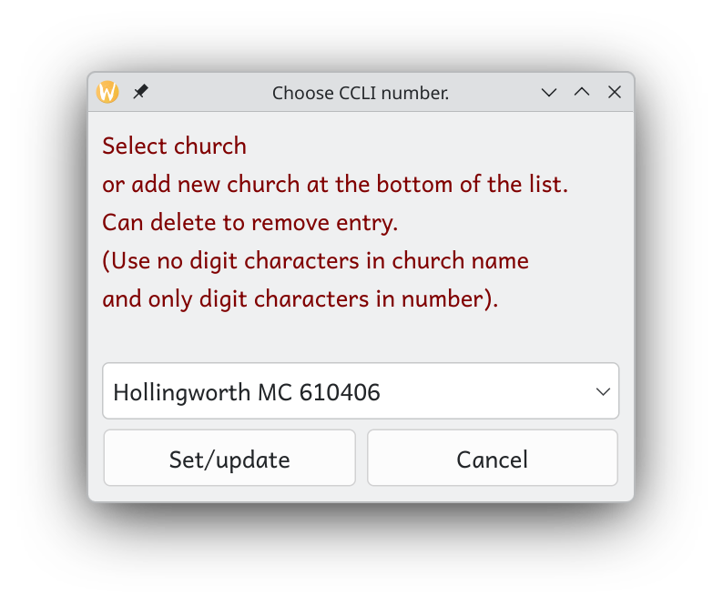
Of course, many of our hymns were written long ago and even the lifetime plus 70 years has elapsed. These hymns are ‘out of copyright’ and can be reproduced or republished by anyone for any purpose without paying royalties.

Entering CCLI numbers
In recognition that a user may want to prepare presentations for services in more than one church (e.g. a Circuit Minister or lay preacher), several CCLI numbers can be recorded in H2P. The option, settings, CCLI presents this dialogue box. The entries in the drop-down menu are editable and will persist between sessions running H2P.

First slide
The first slide of the presentation has a background the same as the hymn verse slides but contains no wording. Instead it contains a ‘placeholder’ ready for the title of the presentation, e.g. ‘Welcome to our morning service’. If wanted, the placeholder should be filled in using presentation software (see below)

Between hymns
H2P puts a single slide after each hymn. There are two options for this. The choice between these two options is made using a tick-box in the settings menu.
- A slide of the same background colour as the hymn verse slides with a placeholder to be filled in with presentation software.
- A plain black slide that, in effect, makes a break from the presentation between hymns.

Presentation software
LibreOffice® (FOSS) and FreeOffice®, OnlyOffice® or WPS Office ®(free for non-commercial use) are all suites of office software that are easily downloaded and installed. They all project a .pptx file perfectly well. You can use MS Office® if you want to pay.
LibreOffice® is widely regarded as the best free office suite. Its presentation program is called Impress. FreeOffice® is perhaps the simplest to use.
Some old versions of MS Powerpoint® that are unlicensed will present pptx file for free but not, the latest, Office 365®. You can still use an online version of Powerpoint 365® for free but that requires both a internet connection and a Microsoft account.

Fonts
Two font options are provided, one sans serif and one serif.
It is well-known that , for short names or phrases, such as signage, a sans serif font is more instantly readable than a serif font. Hence road signs in the UK use the BR (British Rail) sans serif typeface. For prose, books, newspapers, however, a serf font is generally better because it gives the reader more visual clues to distinguish the shape of letters. (A ragged right-hand edge also assists readers to keep to the line they are reading.) Presenting a verse of a hymn is perhaps somewhere between these two cases.
On computers, typefaces, ‘fonts’ are software and subject to a software licence. Microsoft fonts can be used freely but only when running a Windows® operating system. They are not therefore used for cross-platform software. Software generally installs its own fonts on the computer as part of the installation package and that it what we need to do for H2P.
These two H2P fonts have been chosen from a range of fonts provided under the SIL licence (see https://openfontlicense.org/) which is roughly the equivalent of the open software GPL for fonts.
It interesting to me that the SIL ;licence derives from the Summer Institute of Linguistics as the font provider. The SIL was started as a school of linguistics to support the work of the Wycliffe Bible translators whose charitable aim is to codify minority languages into a written form, teach reading and writing, and to translate the bible to be accessible to all. Interesting ‘to me’ because, as a teenager, I used occasionally to help Wycliffe with their computerised mailings – advanced for that time.
The sans serif font also uses a rounded ‘a’ which is preferred for young readers and the dyslexic.
These two font families must be installing on all machines using H2P and its .pptx file. Generally different computers have different sets of fonts, even running the same operating system. (Even Windows ‘core’ fonts changed over the years.) If a font used in pptx file is not on the computer that projects it, the computer will substitute a font it does have. Since characters in different fonts have different sizes this very often does causes words to move, e.g. to the next line, or to overlap text boundaries.
Presentation softwares have a setting to embed the fonts in the .pptx file – then they are carried with the file from the preparation machine to the projection machine. Installing the open fonts with H2P and on the presentation computer avoids needing to do this.

Installing H2P
The software is provided on a USB stick in a directory called ‘H2P’. This contains the single executable file for your operating system: H2P.exe (for Windows®), ‘H2P.lexe’ for Linux [‘H2P.app’ (Mac OS)].
The installation follows the same principles for any of these operating systems.
The whole directory with its subdirectories should be copied to a suitable location in the user’s directory tree. This directory is H2P’s working directory and it find the files its needs in subdirectories its working directory. The hymns are kept in a subdirectory (called ‘hymns’); the user may need to access this at some point to edit/add hymns. For that reason the whole working directory should be placed in the users area, not too deep down.
The Documents directory of the users home directory is a suitable location for the working directory. It is not appropriate/necessary to put it in amongst the operating system’s directory tree. In the case of Windows, no attempt is made or should be made to ‘install’ the software to the (very murky) ‘registry’.
A symbolic link (.desktop) file may be created on the desktop space/directory for ease of access. Alternatively, once H2P is running, desktop softwares will allow the program’s icon to be ‘pinned’ to the task/application bar. (Right click on the icon while H2P is running on the screen.)
Installing the fonts
The two font ‘families’ installation files are provided in the H2P-private-data sub-directory (‘Andika-7.000.zip’ and ‘source-serif-pro.zip’). These fonts should be installed on the computer (an extra copy of the Andika regular font (unzipped) is accessed directly by H2P for its interface panel.
Fonts are installed by navigating into the zip file (file browsers will do this as if it were a normal subdirectory). Each of the font files (representing regular, bold, italic variants of the typeface) should be installed on the computer. This is done by (double) clicking on each of the .ttf files inside the zip, i.e. ‘opening the font in the install program’. Press the install button. This should be done for each font file in the zip archive; .ttf files in the case of the Andika font; .otf files in the case of Source-Serif-Pro.

The contents of the working directory
- The working directory contains the source code files (H2P_main.py, H2P_panel.py, H2P_Classes.py and H2P_cfg.py). These are not normally used – the program is run from its ‘compiled’ binary file.They are left there for the purposes of complete openness of sharing and for anyone to see how it all works. If you can improve the software, go ahead. That’s what open software is about. If you do, please consider sharing your improved code.
- contains the lyrics of each hymn in a separate text file (see The ‘database’ of hymnsbelow). These can be ordered into however many subdirectories of ‘hymns’ in well ordered. The names of the individual hymn files are significant so only change these filenames when you have read ‘The ‘database’ of hymns’ below).
A subdirectory called hymns
- subdirectory contains files essential for the running of the program are kept. The two (zipped) font directories are kept here – you will need to access them to install the fonts on your system.
The H2P-private-data
- A file contains the CCLI numbers stored between sessions of H2P and another preserves the hymn divider option between sessions.
- A file called ‘hymnbook.pickled’ contains all the hymns loaded from the many individual text files in a compact and efficient binary format. It is (re)generated using the Reload file-menu option. When a reload is carried out, it produces a log (in very simple html) to identify any problems with individual hymn files. The log is best viewed via the file menu option in H2P itself. This uses the computers default web browser(see Output shown in the web browser). The ‘search in page’ facilities of the web browser can be useful.
- There may be other .html files containing indexes of the hymns created using the corresponding file menu option. When an index is constructed the html file is presented (like this help text) in the computers default web browser.
- There may be other files and subdirectories only because I have been untidy and not cleared them away.
- Finally, I have four pptx files that act as starters into which the verses of each hymn are ‘injected’. Two are for white lettering on a dark background, the other two for black lettering on a light background. These are special pptx files that I have created, they are not simply generated by PowerPoint or Impress etc. A general pptx file created directly by PowerPoint or Impress, even one that appears only to contain a single blank slide, is actually a rats’ nest of content in no particular order. The two files I have prepared are simplified to allow H2P to find the right places and data structures into which to add slides. Do not edit these files.

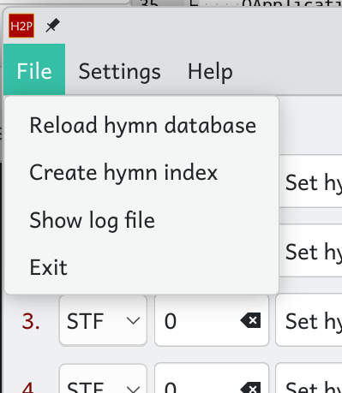
Output shown in the web browser
H2P uses the computer’s default web browser to display output information. Output could be
- an index of each of the source hymn book files
(e.g. of STF or of XTR) in html format, (indexes by number or first line can be produced.
- The log of the hymn-file loading process. This is useful to find messages explaining problems with files, e.g. unbalanced delimiters.
- this help text. Indexes are In either case, the search in page facilities of the web browser can be useful. The help text is in pdf format. Most web browsers will show links to the document structure on the left-hand side.

The ‘database’ of hymns
The words to each hymn are kept in individual text files inside the ‘hymns’ subdirectory of the working directory (see The contents of the working directory). The hymns directory can be split into as many subdirectories as desired in order to organise them. H2P find all .txt files in the hymns sub-directory tree. There should be no other .txt files in the hymns subdirectory tree. However, other file types may be kept there for convenience; e.g. word processing documents of hymn lyrics from which to create the .txt files.
Hymn text files
The name of each hymn file is significant. A single hymn is kept in a filename following the pattern “AAA_nnn.txt” where AAA identifies the source hymn book, it can be two or three letters (e.g. STF stands for ‘Singing The Faith’, MP for Mission Praise.) The nnn represents the hymn number. The filename STF_345.txt therefore contains the words of ‘And can it be’, number 345 in Singing the Faith. Leading zeros in the number part of the file name have no significance STF_1.txt is just as good as STF_001.txt. H2P will tell you if it find two filenames pointing to the same hymn.
The option presented for the source hymn books in the seven drop down menus of the H2P panel are actually derived automatically according to the filenames found (with the most populous book-code as top/default). If therefore anyone want to add files from another hymn book, e.g. Hymns Ancient and Modern, it would only be needed to put the words into files called HAM_124.txt etc.
I have put some hymns in files called XTR_nnn.txt. These contain a few hymns that are not in any hymn book such as ones written by members of the congregation or taken from other sources.

Preparing hymns – the hymn file ‘markup’
Hymns are contained in the text files in the hymns directory structure (see The ‘database’ of hymns). The format on the words on slides is controlled by some simple markup.
Verse and chorus delimiters
- { abc def } marks a verse. Each verse occupies a new slide. See the example below for STF_663.txt. Very long verses (more than 11 lines) may need to be split onto two slides (see Forced numbering below). The lines of a verse should appear between the delimiters as they do in the hymn book.
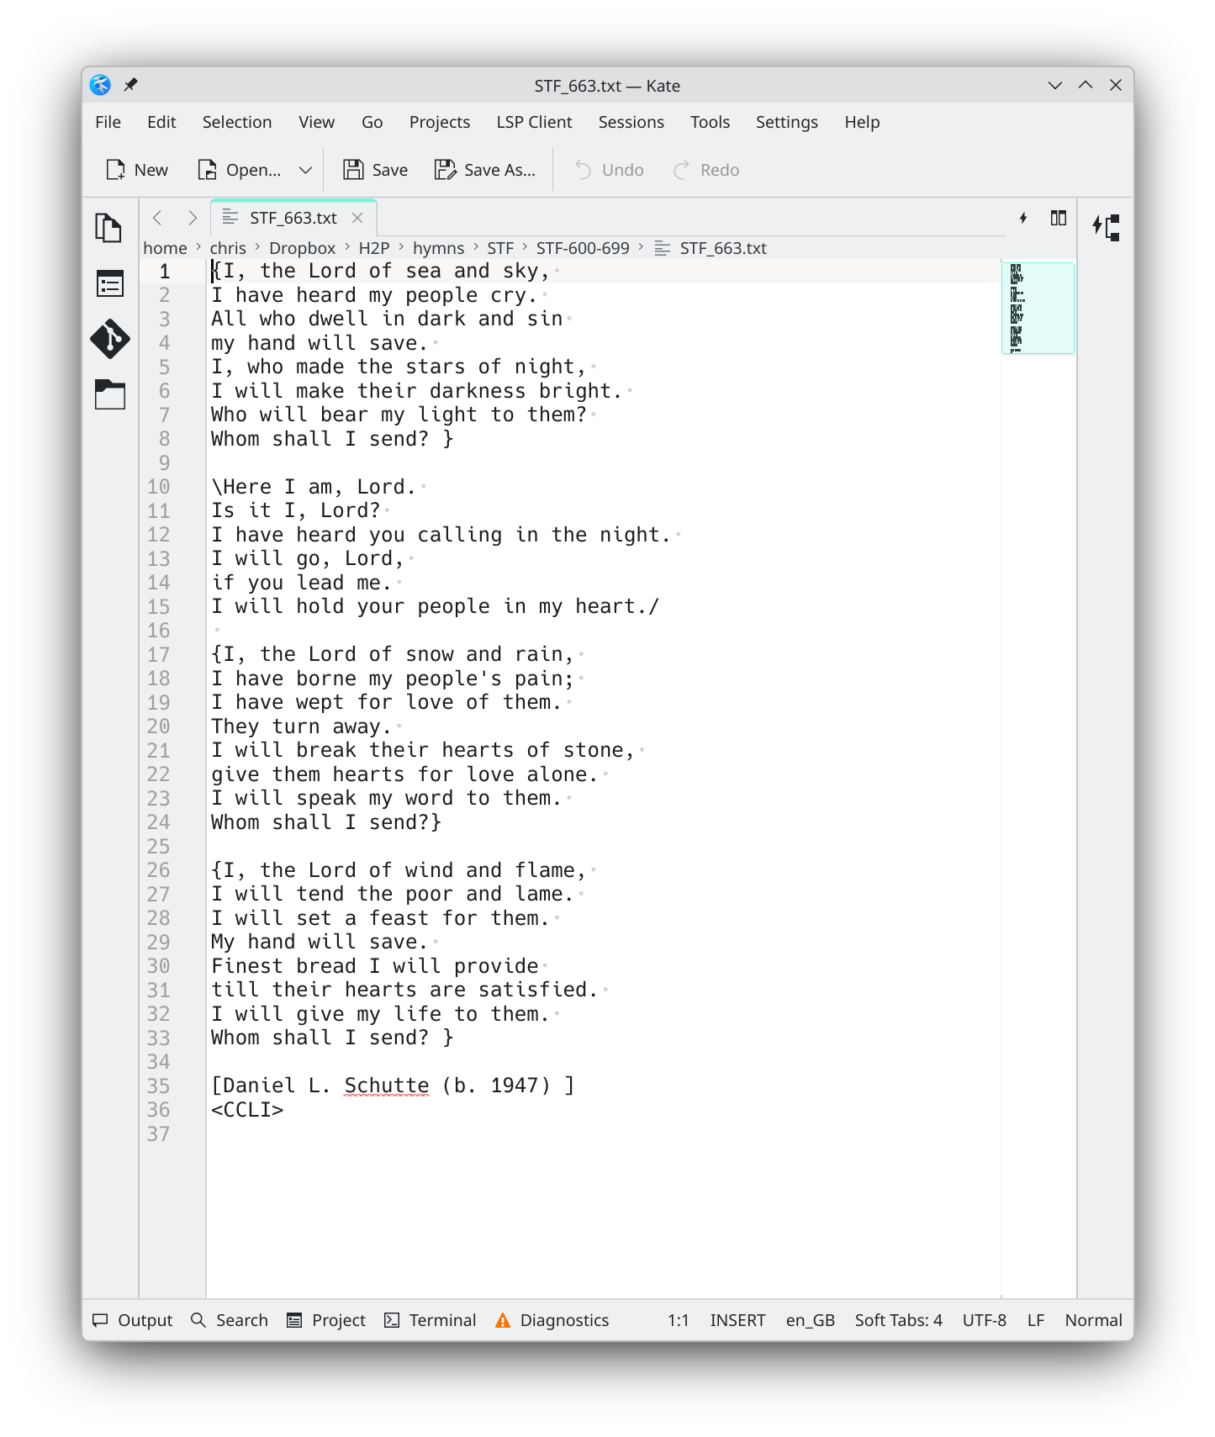
- \ abc def / marks a chorus that also occupies one slide. Only one chorus can be marked in this way (see below for the way to overcome changing choruses). A chorus slide will be inserted after each verse. If the verse is defined before the first {verse} of a hymn it will additionally appear before the first verse (e.g. as in ‘All things bright and beautiful’ – STF_100.txt). A chorus will appear in italics and the verses in regular font – just like the hymn book.
A hymn which obeys the common pattern of verses and a chorus will be numbered automatically. The hymn number and verse number will appear in the top right-hand corner of each slide. A ‘c’ denotes that this is the chorus to the numbered verse. See the example slide of the last verse’s chorus for STF_663.txt, below.
- [ and ] delimit the attribution. It may only contain a single line and only one attribution is allowed in the hymn file. Make sure it is not too long.
- <rights code> –, either <CCLI> or <CC0> are recognised. <CCLI> results in the CCLI number of the church being displayed at the end of the attribution line. <CC0> signifies that the hymn is out of copyright, no CCLI licence number is quoted. In the absence of a rights code in the hymn file, no text is added to the attribution.
H2P will try to choose a font size for a hymn that makes best use of the available space on a slide. Its best guess is based on the maximum number of characters in any line of the hymn and the maximum number of lines in a verse. It will not accept verses with lines longer than 62 characters or more than 11 lines. Such a (rare) hymn would have to have lines continued on the next line (indented with ‘~’ [see Italics, bold, indents (formatting characters)), or the verse to be split onto two slides. In this case the verse numbering would not appear automatically as in the hymn book but this can be remedied using ‘specified verse numbering’ (see Specified verse numbering).
As depicted in the shot of the text editor, above, the hymn files are expected to be encoded as UTF-8 text (which is by default by most ext editors such as Kate, gedit, Notepad, etc.) UTF-8 caters for western European accented characters such as ‘è’ – useful for the 51 ‘blessèd’s in Singing The Faith as well as a few other words – but not for Greek or Cyrillic.

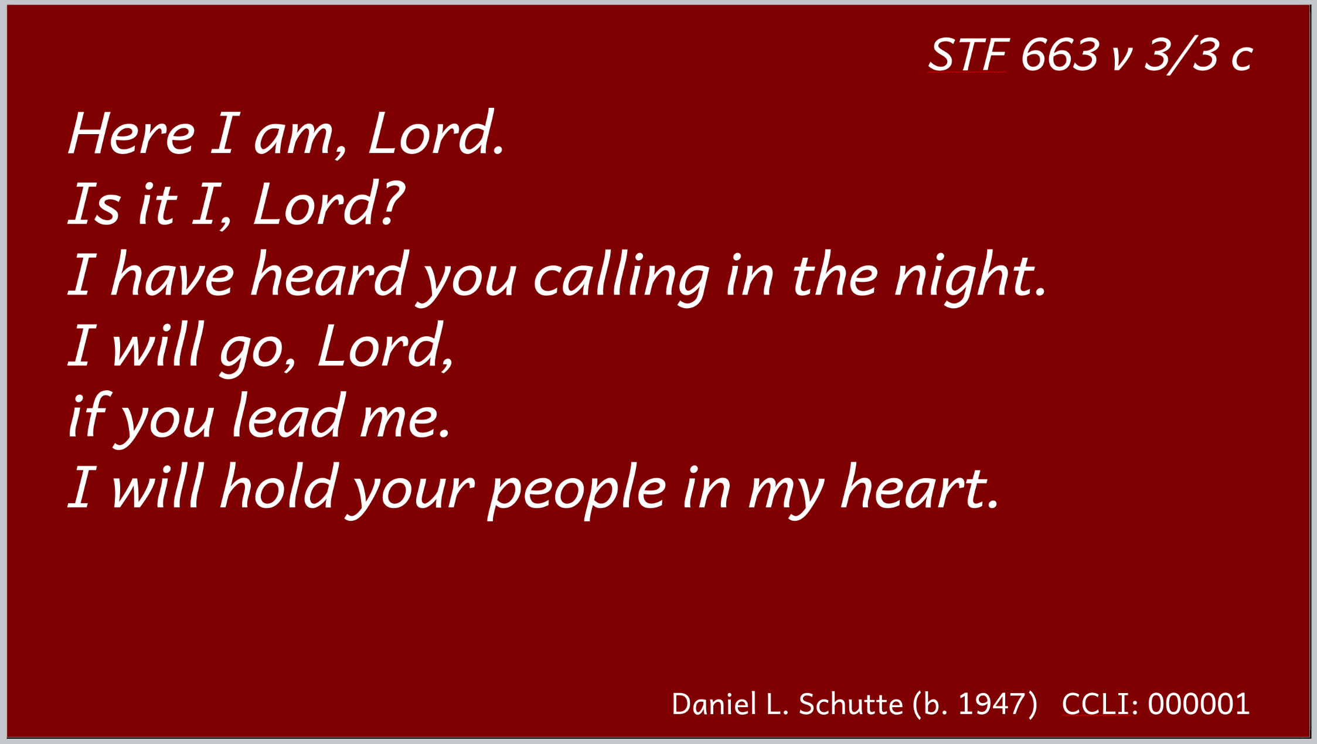

Italics, bold, indents (formatting characters)
In order to provide more control of styles that are used in the hymn book some formatting characters can be used. These special characters may be placed as the first non-white-space character of a line. The formatting characters are:
- ‘#’ – the line is put into italics;
- ‘*’ – the line is put into bold – useful for the responsive pslam readings;
- ‘~’ – the line is
indented (used for continuation lines – used as in the hymn book when libes are very long);
- ‘$’ – forces a blank line, blank lines in the .txt file are otherwise ignored.

Specified verse numbering
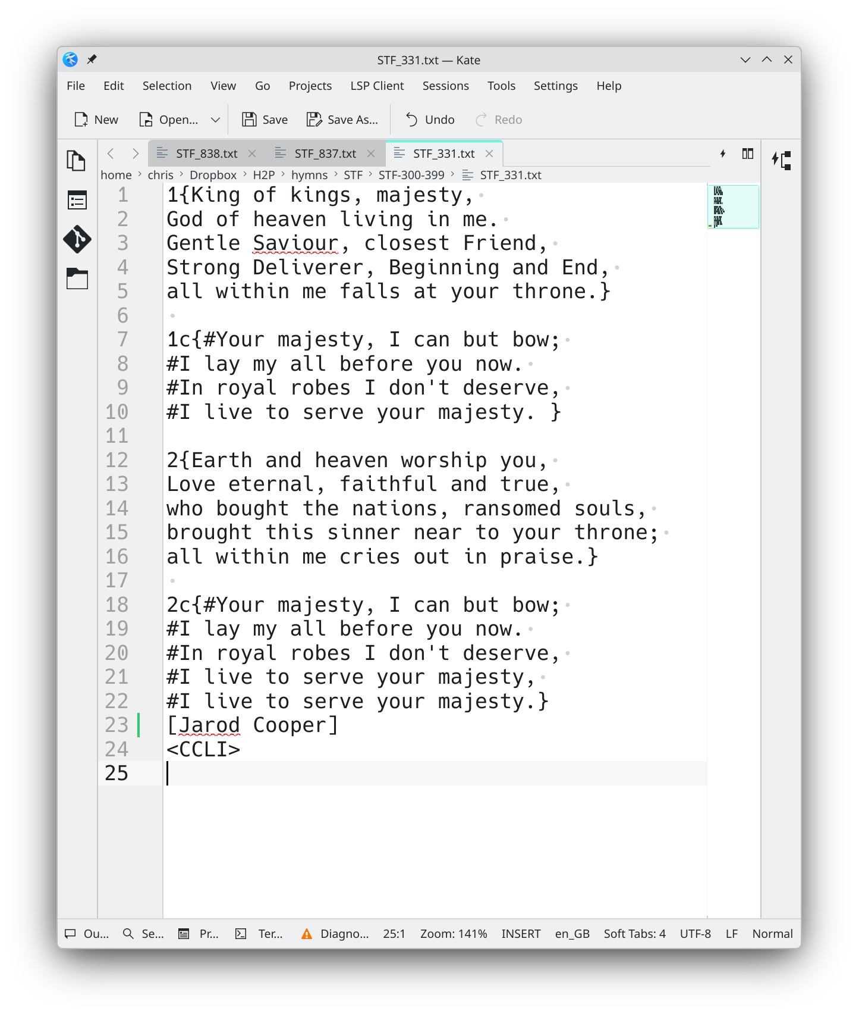
For hymns that do not follow a simple structure, e.g. where the chorus changes after the last verse, or for interludes of alleluia’s etc., some extra control over the verse numbering is required to make the verse numbering make sense. The objective should usually be to make it follow the numbering in the hymn book. (Some hymns in STF are formatted with no verse numbers.)
For ‘specified verse numbering’ advantage is taken of the hidden spaces between the } { delimiters of verses. A numeral before the opening { of a verse sets that number to be displayed as its verse number. Thus the two halves of a long verse that has had to have been split can still have the same number. If a ‘c’ is added after the numeral it will be denoted as the chorus of that verse.
The example below shows how this mechanism, along with the line formatting characters, can be used to cope with the mutating chorus in ‘King of kings’ – STF_331.txt.

Correction of bugs – comments -questions
I have entered all 840 hymns from Singing The Faith – there are bound to be mistakes and certainly some hymns that are not marked up for the best presentation.
Please edit the hymn files, add some more, and share your improvements.
For any issues, problems that may need fixing, you can send e-mail to chris.jones.europe@gmail.com .

I have used pyinstaller to create a binary file in the case as it is simple and compactness and performance are not at issue.
The filename extension .txt is case sensitive, i.e. it must be in lower case for H2P.

