Assignment 2: Monthly Report EXIST July, 2020

Nazli Gul

8/16/2020

# Energy Exchange Istanbul(EXIST)

## 1. Introduction

Energy Exchange Istanbul (EXIST) was established on March 12, 2015 upon the Electricity Market Law and Turkish Trade Law. Main objective and principal business activity is to plan, establish, develop, and manage energy market in a transparent manner that fulfills the requirements of energy market. Energy market in Turkey changes hourly and the related data can be found in the official webpage of EXIST. You can [click](https://rapor.epias.com.tr/rapor/xhtml/ptfSmfListeleme.xhtml), and filter the date you wish to check hourly data. This report has been prepared to examine the month of July 2020 using EXIST data for the electricity market.

The basic approach in electricity energy markets is to ensure that electricity production and electricity consumption are equal. There is a balance that should be struck for this. To preserve this balance, energy markets are conducted and these can be summarized in three groups: **1.Day Ahead Market (DAM):** It is the market created according to the next day’s hourly electricity plan. Transactions are made on the *Market Clearing Price(MCP)*. The second column in the data we use while creating the report gives hourly MCP information. **2.Intraday Market (IDM):** It is the market that continues throughout the day similar to stock exchange. The reason for the creation of this market is that in most cases, the forecast due to previous day’s plan does not fully comply with the actual demand.Transactions are made on the *Weighted Average Price(WAP)*. **3.Balancing Power Market (BPM):** It is the market that is formed due to the electricity energy trade made at the last moment to ensure the balance.Transactions are made on the *System Marginal Price(SMP)*. The third column in the data we use while creating the report gives hourly SMP information.

Before we get into the details of the report, there are a few more terms we should be familiar to. These are **energy deficit** and **energy surplus**. In cases where the actual demand is higher than the predicted demand, energy deficit arises, otherwise energy surplus occurs. System Marginal Price(SMP) is always higher than Market Clearing Price(MCP) if system has Energy Deficit, and lower if there is Energy Surplus. Market operator also penalizes the operations in BPM by 3%. This is called **Imbalance Price**. Negative (Deficit) Imbalance Price is calculated as max(MCP,SMP)1.03 ,and Positive Imbalance Price is calculated as min(MCP,SMP)0.97.

## 2. July, 2020 Report

After downloading the data between 1 July 2020 and 31 July 2020 from the official webpage of EXIST, the analyses can be started. Firstly, a few edits on this data are done in order to have a better comprehension. The basic packages *tidyverse* and *lubridate* are used throughout the report. In addition to these, the *reshape2* package was also useful for the plots.

library(tidyverse)   
library(lubridate)  
library(reshape2)

EXIST_data <- read.csv("ptf-smf.csv")  
EXIST_raw_df <- EXIST_data%>%transmute(Date = gsub(pattern = "\\.","-",Date),  
 MCP,  
 SMP,  
 PositiveIP = Positive.Imbalance.Price..TL.MWh.,  
 NegativeIP = Negative.Imbalance.Price..TL.MWh.,  
 SMPDirection = SMP.Direction)  
  
EXIST_raw_df$Date<-as.POSIXct(EXIST_raw_df$Date,format="%d-%m-%y %H:%M")  
head(EXIST_raw_df)

## Date MCP SMP PositiveIP NegativeIP SMPDirection  
## 1 2020-07-01 11:00:00 329.99 329.99 320.09 339.89 Energy Deficit  
## 2 2020-07-01 12:00:00 324.21 342.80 314.48 353.08 Energy Deficit  
## 3 2020-07-01 13:00:00 327.83 355.83 318.00 366.50 Energy Deficit  
## 4 2020-07-01 14:00:00 332.37 377.37 322.40 388.69 Energy Deficit  
## 5 2020-07-01 15:00:00 331.29 376.29 321.35 387.58 Energy Deficit  
## 6 2020-07-01 16:00:00 331.14 375.00 321.21 386.25 Energy Deficit

We can also use the glimpse function to inspect our data. By using it,each column is represented in a row with its data type and first few entries. We have 744 rows and 6 variables namely Date, MCP, SMP, Positive Imbalance Price, Negative Imbalance Price, and SMP Direction.

EXIST_raw_df%>%glimpse()

## Rows: 744  
## Columns: 6  
## $ Date <dttm> 2020-07-01 11:00:00, 2020-07-01 12:00:00, 2020-07-01 ...  
## $ MCP <dbl> 329.99, 324.21, 327.83, 332.37, 331.29, 331.14, 330.81...  
## $ SMP <dbl> 329.99, 342.80, 355.83, 377.37, 376.29, 375.00, 360.81...  
## $ PositiveIP <dbl> 320.09, 314.48, 318.00, 322.40, 321.35, 321.21, 320.89...  
## $ NegativeIP <dbl> 339.89, 353.08, 366.50, 388.69, 387.58, 386.25, 371.63...  
## $ SMPDirection <fct> Energy Deficit, Energy Deficit, Energy Deficit, Energy...

In order to limit the number of displayed rows, the following global option can be used.

options(tibble.print_max = 5, tibble.print_min = 5)

Before making a more detailed analysis, it would be useful to give the average prices for the full month of July.The average MCP value is **296** and the average SMP value is **299** in July, 2020. These values can be obtained by using commands below:

round(mean(EXIST_raw_df$MCP))  
round(mean(EXIST_raw_df$SMP))

We can check scatter plot in order to see which interval of prices occured more frequently during July, 2020. The plot below shows that for most of the days, MCP lies between 300-330 and SMP lies between 150-350.

ggplot(EXIST_raw_df, aes(x=MCP, y=SMP, color=Date)) + geom_point() + labs(x="MCP", y="SMP", title="MCP and SMP Prices",subtitle=" Energy Exchange Turkey(EXIST), between July 01 and July 31")+theme_test()

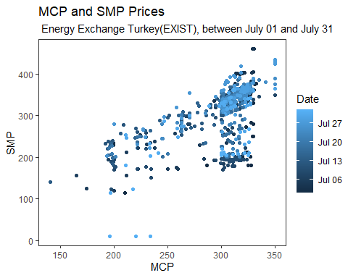

The bar chart showing the daily change of System Marginal Price and Market Clearing Price values is given below.

plot1<-EXIST_raw_df %>% group_by(Day=lubridate::day(Date))%>% summarise(daily_average_MCP = mean(MCP), daily_average_SMP = mean(SMP)) %>%   
 ungroup()%>%select(Day, daily_average_MCP, daily_average_SMP)  
plot2<-melt(plot1, id.vars='Day')  
plot2%>%ggplot(.,aes(x=Day,y=value, fill=variable)) + geom_bar(stat="identity", position="dodge")+theme_test()+  
 labs(x="Day", y="TL/MWh",   
 title="Daily MCP and SMP Change",  
 subtitle=" Energy Exchange Turkey(EXIST), between July 01 and July 31")

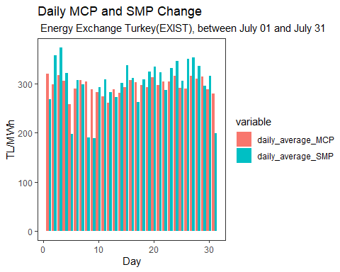

We may be also interested in the daily difference between these prices.

plot3<-EXIST_raw_df %>% group_by(Day=lubridate::day(Date))%>% summarise(daily_average_MCP = mean(MCP), daily_average_SMP = mean(SMP),Difference = abs(mean(MCP)-mean(SMP)))%>%print(plot3)

## # A tibble: 31 x 4  
## Day daily_average_MCP daily_average_SMP Difference  
## <int> <dbl> <dbl> <dbl>  
## 1 1 320. 268. 51.8  
## 2 2 298. 357. 58.6  
## 3 3 317. 373. 56.2  
## 4 4 306. 321. 15.3  
## 5 5 258. 198. 59.8  
## # ... with 26 more rows

plot3%>%ggplot(aes(x=Day)) + geom_line(aes(y = Difference, color = "Difference of average values")) +  
 labs(x = "Day", y = "TL/MWh",  
 title = "Difference between Daily Average MCP and SMP Change",  
 subtitle = " Energy Exchange Turkey(EXIST), between July 01 and July 31")+theme_test()

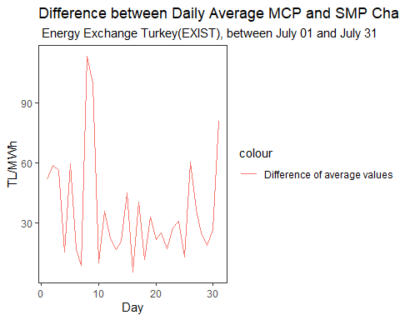

### 2.1. Day Ahead Market (DAM)

#### 2.1.1 Hourly Day Ahead Market

Since the electricity energy market prices are planned on an hourly basis, it will be useful to find the hourly average, minimum, and maximum values in order to gain some insights about the data. Firstly, the plot data is provided, and then the plot is constructed.

plot4<-EXIST_raw_df%>% group_by(Hour=lubridate::hour(Date))%>%summarise(hourly_average_MCP=mean(MCP), hourly_min_MCP=min(MCP), hourly_max_MCP=max(MCP))%>%print()

## # A tibble: 24 x 4  
## Hour hourly_average_MCP hourly_min_MCP hourly_max_MCP  
## <int> <dbl> <dbl> <dbl>  
## 1 0 297. 230. 324.  
## 2 1 306. 293 327.  
## 3 2 298. 230. 324.  
## 4 3 284. 199. 322.  
## 5 4 285. 219. 320   
## # ... with 19 more rows

plot4 %>% pivot_longer(.,-Hour) %>% ggplot(.,aes(x=Hour,y=value,color=name)) + geom_line()+  
 labs(x="Hour", y="MCP (TL/MWh)",   
 title= "Average, Minimum and Maximum Hourly Market Clearing Price(MCP)",  
 subtitle=" Energy Exchange Turkey(EXIST), between July 01 and July 31")+theme_test()

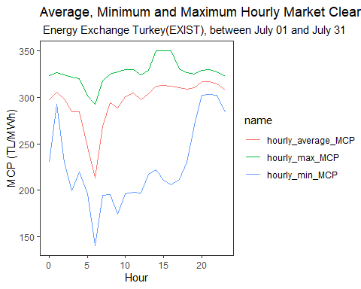

#### 2.1.2 Daily Day Ahead Market

Day Ahead Market daily prices for the minimum, maximum, and average values can be see below.

plot5<-EXIST_raw_df%>% group_by(Day=lubridate::day(Date))%>%summarise(daily_average_MCP=mean(MCP), daily_min_MCP=min(MCP), daily_max_MCP=max(MCP))%>%print()

## # A tibble: 31 x 4  
## Day daily_average_MCP daily_min_MCP daily_max_MCP  
## <int> <dbl> <dbl> <dbl>  
## 1 1 320. 210. 332.  
## 2 2 298. 199. 322.  
## 3 3 317. 293 331.  
## 4 4 306. 238. 314.  
## 5 5 258. 174. 306.  
## # ... with 26 more rows

plot5 %>% pivot_longer(.,-Day) %>% ggplot(.,aes(x=Day,y=value,color=name)) + geom_line()+  
 labs(x="Day", y="MCP (TL/MWh)",   
 title= "Average, Minimum and Maximum Daily Market Clearing Price(MCP)",  
 subtitle=" Energy Exchange Turkey(EXIST), between July 01 and July 31")+theme_test()

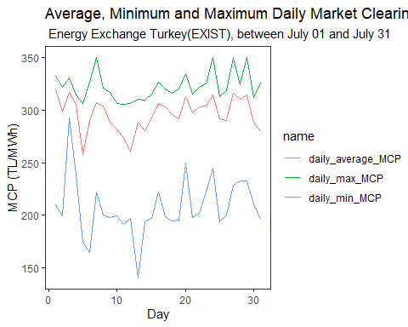

#### 2.1.3 Weekly Day Ahead Market

Day Ahead Market weekly prices for the minimum, maximum, and average values can be seen below. Week numbers correspond to the sequence in a year of 52 weeks.

plot6<-EXIST_raw_df %>% group_by(Week = lubridate::week(Date))%>% summarise(Weekly_average_MCP = mean(MCP),Weekly_min_MCP=min(MCP),Weekly_max_MCP=max(MCP))%>%print()

## # A tibble: 5 x 4  
## Week Weekly_average_MCP Weekly_min_MCP Weekly_max_MCP  
## <dbl> <dbl> <dbl> <dbl>  
## 1 27 299. 165. 350.  
## 2 28 283. 140. 321.  
## 3 29 300. 195. 335.  
## 4 30 304. 193. 350   
## 5 31 294. 196. 350.

plot6 %>% pivot_longer(.,-Week) %>% ggplot(.,aes(x=Week,y=value,color=name)) + geom_line()+  
 labs(x="Week", y="MCP (TL/MWh)",   
 title= "Average, Minimum and Maximum Weekly Market Clearing Price(MCP)",  
 subtitle=" Energy Exchange Turkey(EXIST), between July 01 and July 31")+theme_test()

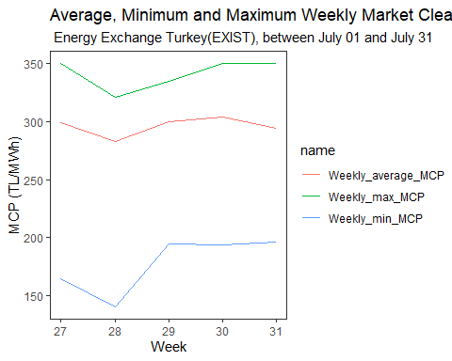

#### 2.1.4 Day of the Week Day Ahead Market

Day Ahead Market prices according to the days of the week can be seen below. It should be noted that weekday 1 is equal to Sunday.

plot7<-EXIST_raw_df %>% group_by(Week_Day= lubridate::wday(Date))%>% summarise(Weekday_average_MCP = mean(MCP),Weekday_min_MCP=min(MCP),Weekday_max_MCP=max(MCP)) %>%print()

## # A tibble: 7 x 4  
## Week_Day Weekday_average_MCP Weekday_min_MCP Weekday_max_MCP  
## <dbl> <dbl> <dbl> <dbl>  
## 1 1 275. 174. 320.  
## 2 2 302. 140. 350   
## 3 3 299. 194. 350.  
## 4 4 307. 197. 350.  
## 5 5 297. 197. 327.  
## # ... with 2 more rows

plot7%>% pivot_longer(.,-Week_Day) %>% ggplot(.,aes(x=Week_Day,y=value,color=name)) + geom_line()+  
 labs(x="Week Day", y="MCP (TL/MWh)",   
 title= "Average, Minimum and Maximum Week Day Market Clearing Price(MCP)",  
 subtitle=" Energy Exchange Turkey(EXIST), between July 01 and July 31")+theme_test()

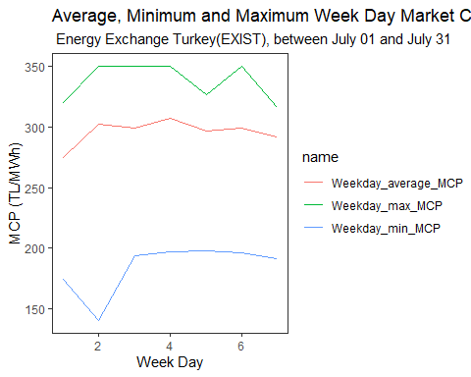

#### 2.1.5 Periodic Day Ahead Market

In the electricity energy market reports, the day is generally divided into three periods. The reason for this is to track and compare time periods in which energy useage is similar. The names of these periods are **day**, **night** and **peak**.

plot8<-EXIST_raw_df %>%   
transmute(MCP,SMP,Hour = as.numeric(lubridate::hour(Date)),Period=ifelse(8<=Hour & Hour<=16,"Day Period",ifelse(17<=Hour & Hour<=22,"Peak Period","Night Period")))%>% group_by(Period)%>% summarise(Period_average_MCP=mean(MCP))%>% print()

## # A tibble: 3 x 2  
## Period Period_average_MCP  
## <chr> <dbl>  
## 1 Day Period 303.  
## 2 Night Period 279.  
## 3 Peak Period 313.

plot8%>% ggplot(.,aes(x=Period,y=Period_average_MCP, fill=Period)) + geom_bar(stat="identity")+theme_test()+  
 labs(x="Periods", y="MCP (TL/MWh)",  
 title= "Average Market Clearing Price(MCP) of different periods",  
 subtitle=" Energy Exchange Turkey(EXIST), between July 01 and July 31")

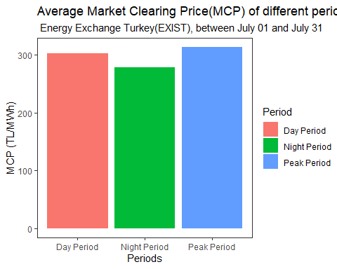

### 2.2. Balancing Power Market (BPM)

#### 2.2.1 Hourly Balancing Power Market

Balancing Power Market hourly prices for the minimum, maximum, and average values can be see below.

plot9<-EXIST_raw_df%>% group_by(Hour=lubridate::hour(Date))%>%summarise(hourly_average_MSMP=mean(SMP), hourly_min_SMP=min(SMP), hourly_max_SMP=max(SMP))%>%print(plot)

## # A tibble: 24 x 4  
## Hour hourly_average_MSMP hourly_min_SMP hourly_max_SMP  
## <int> <dbl> <dbl> <dbl>  
## 1 0 294. 179 365   
## 2 1 308. 180 361.  
## 3 2 297. 180 357.  
## 4 3 283. 176 350   
## 5 4 280. 170 347.  
## # ... with 19 more rows

plot9 %>% pivot_longer(.,-Hour) %>% ggplot(.,aes(x=Hour,y=value,color=name)) + geom_line()+  
 labs(x="Hour", y="SMP (TL/MWh)",   
 title= "Average, Minimum and Maximum Hourly System Marginal Price(SMP)",  
 subtitle=" Energy Exchange Turkey(EXIST), between July 01 and July 31")+theme_test()

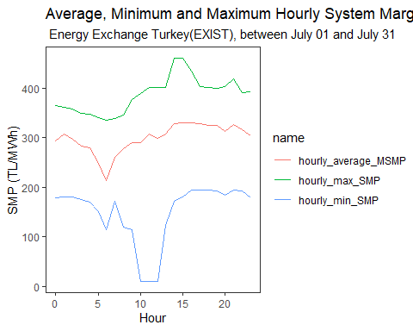

#### 2.2.2 Daily Balancing Power Market

Balancing Power Market daily prices for the minimum, maximum, and average values can be see below.

plot10<-EXIST_raw_df%>%group_by(Day=lubridate::day(Date))%>%summarise(daily_average_SMP=mean(SMP), daily_min_SMP=min(SMP), daily_max_SMP=max(SMP))%>%print()

## # A tibble: 31 x 4  
## Day daily_average_SMP daily_min_SMP daily_max_SMP  
## <int> <dbl> <dbl> <dbl>  
## 1 1 268. 114. 377.  
## 2 2 357. 229. 404.  
## 3 3 373. 335. 460   
## 4 4 321. 235 365   
## 5 5 198. 120 266.  
## # ... with 26 more rows

plot10%>% pivot_longer(.,-Day) %>% ggplot(.,aes(x=Day,y=value,color=name)) + geom_line()+  
 labs(x="Day", y="SMP (TL/MWh)",   
 title= "Average, Minimum and Maximum Daily System Marginal Price(SMP)",  
 subtitle=" Energy Exchange Turkey(EXIST), between July 01 and July 31")+theme_test()

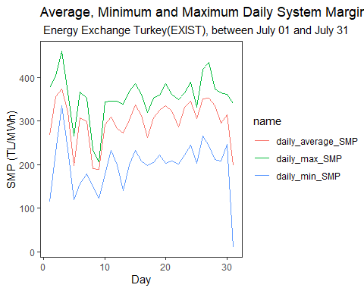

#### 2.2.3 Weekly Balancing Power Market

Balancing Power Market weekly prices for the minimum, maximum, and average values can be see below.Week numbers correspond to the sequence in a year of 52 weeks.

plot11<-EXIST_raw_df%>% group_by(Week=lubridate::week(Date))%>%summarise(weekly_average_SMP=mean(SMP), weekly_min_SMP=min(SMP), weekly_max_SMP=max(SMP))%>%print()

## # A tibble: 5 x 4  
## Week weekly_average_SMP weekly_min_SMP weekly_max_SMP  
## <dbl> <dbl> <dbl> <dbl>  
## 1 27 303. 114. 460   
## 2 28 263. 124. 369.  
## 3 29 315. 199. 386.  
## 4 30 330. 201. 435   
## 5 31 270. 10 365

plot11 %>% pivot_longer(.,-Week) %>% ggplot(.,aes(x=Week,y=value,color=name)) + geom_line()+  
 labs(x="Week", y="SMP (TL/MWh)",   
 title= "Average, Minimum and Maximum Weekly System Marginal Price(SMP)",  
 subtitle=" Energy Exchange Turkey(EXIST), between July 01 and July 31")+theme_test()

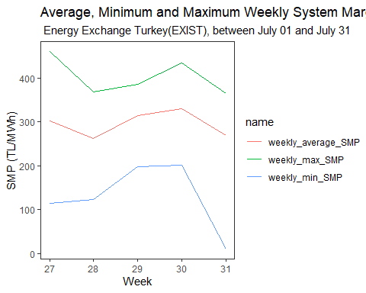

#### 2.2.4 Day of the Week Balancing Power Market

Balancing Power Market prices according to the days of the week can be seen below. It should be noted that weekday 1 is equal to Sunday.

plot12<-EXIST_raw_df%>%group_by(Week_Day=lubridate::wday(Date))%>%summarise(Weekday_average_SMP=mean(SMP),Weekday_min_SMP=min(SMP),Weekday_max_SMP=max(SMP))%>%print()

## # A tibble: 7 x 4  
## Week_Day Weekday_average_SMP Weekday_min_SMP Weekday_max_SMP  
## <dbl> <dbl> <dbl> <dbl>  
## 1 1 289. 120 419.  
## 2 2 317. 140. 435   
## 3 3 314. 179 374.  
## 4 4 276. 114. 386.  
## 5 5 301. 124. 404.  
## # ... with 2 more rows

plot12 %>%pivot_longer(.,-Week_Day) %>% ggplot(.,aes(x=Week_Day,y=value,color=name)) + geom_line()+  
 labs(x="Week Day", y="SMP (TL/MWh)",   
 title= "Average, Minimum and Maximum Week Day System Marginal Price(SMP)",  
 subtitle=" Energy Exchange Turkey(EXIST), between July 01 and July 31")+theme_test()

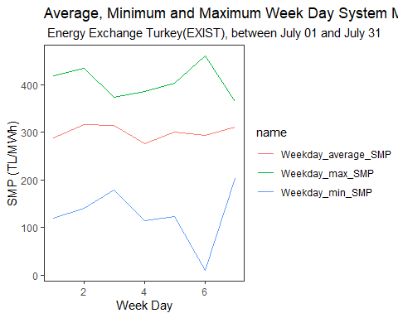

#### 2.2.5 Periodic Balancing Power Market

In the electricity energy market reports, the day is generally divided into three periods. The reason for this is to track and compare time periods in which energy useage is similar. The names of these periods are **day**, **night** and **peak**.

plot13<-EXIST_raw_df %>%   
transmute(MCP,SMP,Hour = as.numeric(lubridate::hour(Date)),Period=ifelse(8<=Hour & Hour<=16,"Day Period",ifelse(17<=Hour & Hour<=22,"Peak Period","Night Period")))%>% group_by(Period)%>% summarise(Period_average_SMP=mean(SMP))%>% print()

## # A tibble: 3 x 2  
## Period Period_average_SMP  
## <chr> <dbl>  
## 1 Day Period 307.  
## 2 Night Period 276.  
## 3 Peak Period 322.

plot13%>% ggplot(.,aes(x=Period,y=Period_average_SMP, fill=Period)) + geom_bar(stat="identity")+theme_test()+  
 labs(x="Periods", y="SMP (TL/MWh)",   
 title= "Average System Marginal Price(SMP) of different periods",  
 subtitle=" Energy Exchange Turkey(EXIST), between July 01 and July 31")

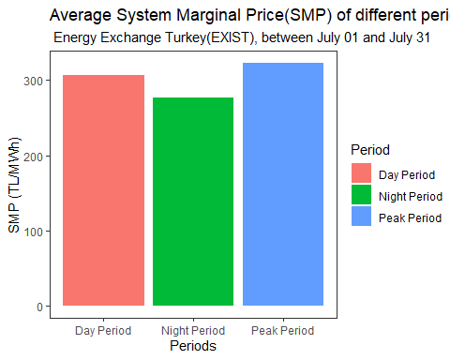

### 2.3. Energy Imbalance

These are **energy deficit**, **energy surplus**, and **energy balance** due to the relationship between actual demand and predicted demand. In the data we examine, there are energy deficit, surplus and balance states on an hourly basis. This information is given in the column called SMP Direction. As we did with the market prices, we can also make an analysis for these states in order to consider how many deficit, surplus, or balance occured.This may be an important insight regarding the prediction reliability.Before making a more detailed analysis, it would be useful to give the overall state of the mont July of 2020.

plot11<-EXIST_raw_df %>% group_by(SMPDirection)%>%summarise(count = n())%>%print()

## # A tibble: 3 x 2  
## SMPDirection count  
## <fct> <int>  
## 1 Energy Deficit 528  
## 2 Energy Surplus 195  
## 3 In Balance 21

plot11%>%ggplot(.,aes(x="", y=count, fill=SMPDirection)) + geom_bar(stat="identity", width=1) + coord_polar("y", start=0)+theme_test()+  
 labs( title= "Energy Imbalance in June 2020",  
 subtitle=" Energy Exchange Turkey(EXIST), between July 01 and July 31")

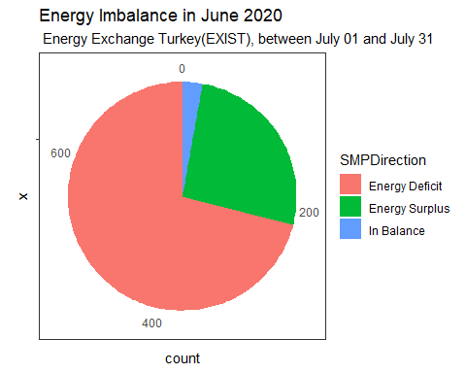

#### 2.3.1 Hourly Energy Deficit, Energy Surplus,and Balance Distribution

Hourly energy deficit, energy surplus, and energy balance bar chart can be seen below.

plot14<-EXIST_raw_df %>% group_by(Hour = lubridate::hour(Date))%>%   
 summarise(Surplus = sum(MCP>SMP), Deficit=sum(MCP<SMP), Balance=sum(MCP==SMP)) %>% ungroup() %>%  
 select(Hour, Surplus, Deficit, Balance)

## `summarise()` ungrouping output (override with `.groups` argument)

plot15 <- melt(plot14, id.vars='Hour')  
plot15%>%ggplot(.,aes(x=Hour,y=value, fill=variable)) + geom_bar(stat="identity", position="dodge")+theme_test()+  
 labs( title= "Hourly Energy Imbalance",  
 subtitle=" Energy Exchange Turkey(EXIST), between July 01 and July 31")

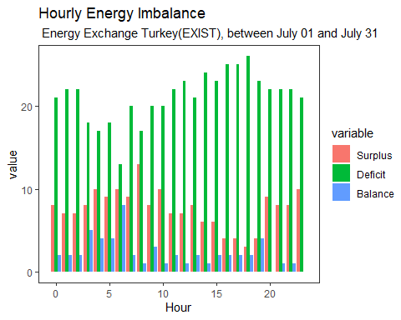

#### 2.3.2 Daily Energy Deficit, Energy Surplus,and Balance Distribution

Daily energy deficit, energy surplus, and energy balance bar chart can be seen below.

plot12<-EXIST_raw_df %>% group_by(Day = lubridate::day(Date))%>% summarise(Surplus = sum(MCP>SMP), Deficit=sum(MCP<SMP), Balance=sum(MCP==SMP)) %>% ungroup() %>%  
select(Day, Surplus, Deficit, Balance)

## `summarise()` ungrouping output (override with `.groups` argument)

plot13 <- melt(plot12, id.vars='Day')  
plot13%>%ggplot(.,aes(x=Day,y=value, fill=variable)) + geom_bar(stat="identity", position="dodge")+theme_test()+  
 labs( title= "Daily Energy Imbalance",  
 subtitle=" Energy Exchange Turkey(EXIST), between July 01 and July 31")

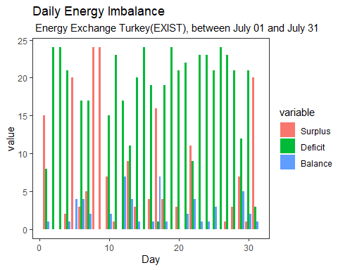

#### 2.3.3 Weekly Energy Deficit, Energy Surplus,and Balance Distribution

Weekly energy deficit, energy surplus, and energy balance bar chart can be seen below.Week numbers correspond to the sequence in a year of 52 weeks.

plot16<-EXIST_raw_df %>% group_by(Week_number = lubridate::week(Date))%>%   
summarise(Surplus = sum(MCP>SMP), Deficit=sum(MCP<SMP), Balance=sum(MCP==SMP)) %>% ungroup() %>%  
select(Week_number, Surplus, Deficit, Balance)

## `summarise()` ungrouping output (override with `.groups` argument)

plot17 <- melt(plot16, id.vars='Week_number')  
plot17%>%ggplot(.,aes(x=Week_number,y=value, fill=variable)) + geom_bar(stat="identity", position="dodge")+theme_test()+  
 labs( title= "Weekly Energy Imbalance",  
 subtitle=" Energy Exchange Turkey(EXIST), between July 01 and July 31")

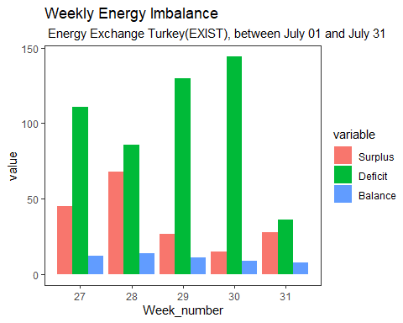

#### 2.3.4 Day of the Week Energy Deficit, Energy Surplus,and Balance Distribution

Energy deficit, energy surplus, and energy balance bar chart according to the day of the week can be seen below.It should be noted that weekday 1 is equal to Sunday.

plot18<-EXIST_raw_df %>% group_by(Week_day = lubridate::wday(Date))%>%   
 summarise(Surplus = sum(MCP>SMP), Deficit=sum(MCP<SMP), Balance=sum(MCP==SMP)) %>% ungroup() %>%  
 select(Week_day, Surplus, Deficit, Balance)

## `summarise()` ungrouping output (override with `.groups` argument)

plot19 <- melt(plot18, id.vars='Week_day')  
plot19%>%ggplot(.,aes(x=Week_day,y=value, fill=variable)) + geom_bar(stat="identity", position="dodge")+theme_test()+  
 labs(title= "Day of the Week Energy Imbalance",  
 subtitle=" Energy Exchange Turkey(EXIST), between July 01 and July 31")

