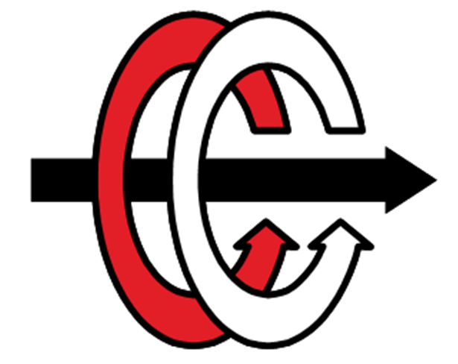

**MIDDLE EAST TECHNICAL UNIVERSITY**

**DEPARTMENT OF ELECTRICAL AND ELECTRONICAL ENGINEERING**

**EE 464 HOMEWORK 1**

**Magnetic Design of the Hardware Project**

**Student 1:** Erkin Atay Toka 2443968

**Student 2:** Canberk Kaçan 2443240

**Student 3:** Erdem Canaz

**GitHub Page:** https://github.com/canberkkacan/EE464_HW1

**Submission Date:** 24.03.2024

**Question 1**

**a)** **Select a duty cycle range for your topology. For this selection, find the turns ratio of transformer.**

The specifications of the hardware project are as follows.

**Minimum Input Voltage:** 20 V

**Maximum Input Voltage:** 40 V

**Output Voltage:** 12 V

**Output Power:** 60 W

Flyback converter is selected as isolated converter for this project. The input output voltage relation for the flyback converter is given below.

For this project is in the range of 0.6 to 0.3. To decide the turns ratio and the duty cycle range these parameters are plotted with respect to each other for maximum and minimum voltage gain. This plot is given in Figure 1.



*Figure 1 Duty Cycle vs Turns Ratio wrt Max and Min Voltage Gain*

Selecting duty cycle high will fail due to the parasitic elements. Moreover, selecting duty cycle small will also fail due to small charging time in the power transformer inductance. This will lead to saturation. Thus, it is safe to choose duty cycle around 0.5. According to Figure 1 turns ratio is selected as 0.5 so that the duty cycle range is between 0.375 to 0.5455 which is shown with yellow dashed line in Figure 1.

**b) Design a transformer and estimate its equivalent circuit parameters. Explain the design procedure in detail. The cores given in the link will be available for you to borrow, but you can use any commercially available core.**

Before selecting the core the magnetizing inductance in the primary side is determined. The decided so that the converter does not work in DCM mode but also the peak inductor current is not too high so that the core is not saturated. For these conditions the average inductor current and the current ripple are important. The average inductor current depends on the average current and duty cycle. To find average input current the efficiency of the converter must be known. For now, efficiency of the converter will be estimated as 83%.

Input current is equal to the primary side inductor current for DTs and zero for the rest of the switching period. The relationship between the primary side inductor current and the input current is given as follows.

Maximum and minimum average primary side inductor current is calculated as 6.6265 A and 4.8193 A respectively.

For current ripple Krf is defined as ripple factor as given in Figure 2.

*Figure 2 Ripple Factor*

In order to avoid DCM operation KRF must be smaller than 1. Also, smaller KRF will decrease the output voltage ripple. However, lower KRF might increase the transformer flux which will lead to the saturation of the core. For safety 0.7 KRF is avoided. The needed inductance can be calculated as follows.

**Primary side inductance is selected as 30 µH.**

The saturation must be avoided. The saturation is determined by the peak current. The primary peak current is plotted with respect to the input voltage in Figure 3.



*Figure 3 Peak Primary Current vs Input Voltage*

From Figure 3 it can be seen that the maximum peak current occurs when the input voltage is minimum. This value is calculated as 8.45 A.

Now it is time for magnetic core selection. For core selection there are two options, a distributed gap core or a ferrite core. Relative permeability of the distributed gap cores is small, the leakage inductance is higher with respect to the ferrite core. Since the leakage inductance is dangerous for the switches a ferrite core 0R45530EC which is available in the laboratory is selected. One of the reasons to select this core is that its cross section area is high thus the saturation of the core can be easily avoided. Also, operating around 100 mT is aimed so that the core losses will be minimized although the volume of the core is increased. Another reason for selecting this core is the fact that its window area is the largest. This will ease the winding procedure. In addition to the primary and secondary windings we will utilize the auxiliary winding to power up the controller.

To decide the number of turns in the primary side the core flux density and the length of the air gap will be considered. Half of the flux passing through the center leg of the core will be passing through the side legs. Nevertheless, the cross section area of the side legs is not exactly the half of the cross section area of the center leg. Therefore, the magnetic field density will not be equal in the center leg and the side legs. It is known that maximum primary current will occur when duty cycle is maximum. Thus, the maximum magnetic field density will occur in maximum duty cycle. The relationship between primary turns number and magnetic field density is given below.

To illustrate the relation between magnetic flux density and primary turns number these two are plotted with respect to each other in Figure 4. It can be seen that the center leg saturates more than the side legs.



*Figure 4 Magnetic Field Density vs Primary Turns Number*

Before selecting the primary turns number, we need to also consider the air gap length. Since the relative permeability of the core is 2300 the reluctance of the core is negligible with respect to air gap reluctance. The magnetic circuit of the transformer is given in Figure 5.

*Figure 5 Magnetic Circuit of the Transformer*

Reluctance of side legs and center leg can be found as follows.

In order to determine the primary turns number, the air gap length is plotted with respect to the primary turns number in Figure 6.

From Figure 5 it can be seen that increasing the primary turns number will decrease the magnetic field density. However, increasing the primary turns number will also increase the air gap length. This is not desired due to the increasing fringing fields with increasing airgap length which can be seen from Figure 6. From both of these figures the primary turns number is selected as 6. It can be seen that maximum magnetic flux density of the center leg is 100.3 mT and air gap length is 3.315 mm for the selected turns number. The peak magnetic flux density is small enough to minimize the core loss and also the air gap length is small enough to ignore the fringing fields.



*Figure 6 Air Gap Length vs Primary Turns Number*

Magnetic field density vs the duty cycle for center and side legs are given in Figure 7.



*Figure 7 B Field vs Duty Cycle*

Now we need to choose an AWG cable for primary and secondary. First the skin depth is calculated for the switching frequency which is 100 kHz.

The copper area must be equal or smaller than the strand area. Hence, AWG26 with 0.129 mm2 is selected as primary and secondary cable.

Now we need to find how many cables to parallel in order to carry primary and secondary currents. Thereby, the rms value of the primary and the secondary currents are calculated. RMS value for a inductor current given in Figure 8 can be calculated as follows.

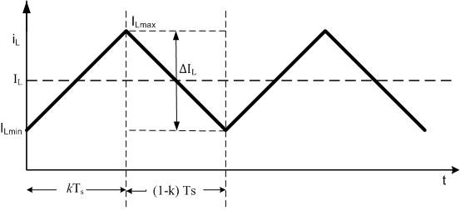

*Figure 8 Typical Inductor Current*

According to this formulation rms primary current vs input voltage is plotted in Figure 9. From Figure 9 it can be seen that the rms primary current reaches its maximum value of 6.71 A at minimum input voltage. The secondary maximum rms current can be found as 13.42 A from the below relation.



*Figure 9 RMS Primary Current vs Input Voltage*

The current carrying capacity of the AWG26 cable is 0.361 A. However, this value is indicated for straight line. Since we will wound the cable, the capacity will drop. For take wounding effect into count, the current carrying capacity will be multiplied with 0.75. Number of parallel cabled can be found as follows.

For primary and secondary the number of parallel cables is calculated as 25 and 50 respectively. The area of an AWG26 cable is 0.129 mm2. Total cable area can be calculated as follows.

The window area of the core is calculated from its dimensions as 375 mm2.

The fill factor is acceptable up to 0.3 to 0.4. Although our choice might seem like an overdesign, we plan to utilize auxiliary winding to power up the controller.

Since the radius of the conductor is chosen smaller than the skin depth both AC resistance is quite same as the DC resistance. This is verified from a website that measures AC resistance of a specified cable [1]. The mean length turn of the core is calculated from the geometry in order to find the length of the wounded cable. Also, a safety factor of 1.15 is taken due to the cable thickness. This mean length turn is multiplied by the turns number to find total length of the cables.

Maximum copper losses can be calculated from the maximum rms current which is found as 6.71 A and 13.42 A for primary and secondary respectively.

For core losses an excel file is obtained for ferrite materials from [2]. In this Excel file Steinmetz coefficients are available. Steinmetz equation and coefficients for the R type material are given below.

*Figure 10 Steinmetz Coefficients for R Material*

For maximum core loss, maximum flux density which is 1.03 T has been chosen. For operating temperature and frequency 60°C and 100kHz is chosen respectively. Core loss density is calculated as 63.53 mW/cm3 for this operation condition. To find the core loss the core loss density is multiplied with twice the volume of the core (volume of the core is 208 cm3). Since two EC cores are used. Total core loss is found to be 6.67 W. Core loss is approximately 20 times higher than the copper loss. Since we operate at high frequencies this is acceptable.

**c) Simulate the converter with ideal switches and transformer (including Lm of course). Calculate the main parameters of the converter and show the relevant graphs.**

After calculating the transformer parameters, as discussed in part b, the output capacitance value must be calculated for the flyback converter. To calculate the output capacitor value, the following equation has been utilized:

After calculating the output capacitor value, the converter has been simulated. The converter circuit can be seen in Figure 11.

Figure 11 Simulated flyback converter

The converter has various parameters. First of all the duty cycle is one of the most important parameters of the converter which changes with the change of the input voltage since we try to supply a constant voltage at the load side. Change of the duty cycle with the input voltage can be seen in Figure 12.



Figure 12 Input voltage vs. duty cycle graph

The second parameter is the load voltage and current. In the project, a constant and nearly ripple free, peak-to-peak ripple must not exceed 3%, load voltage and current must be reached. In the simulation we have seen that we could meet these requirements, as shown in Figure 13.

Figure 13 Output voltage and current waveforms.

The last parameter is the switch voltage. Since high voltage levels on the switch can cause switching failure, the voltage on the switch must be observed. You can see the switch voltage in Figure 14.

Figure 14 Switch voltage waveform.

As you can see, in the ideal case, the switch voltage goes up to approximately 70V, which is a value most of the switches can handle; thus, there is no need to implement a snubber circuit for the ideal case.

**d) Calculate the minimum load current you can work without getting into the DCM, and calculate the min-max transformer current. (Your hardware design may be work in DCM, this question is just for homework).**

At the boundary of DCM and CCM operation, the average current is half of the ripple. The minimum load current without entering DCM for Vin,max and Vin,min can be found as follows.

For :

For :

Maximum input voltage determines the minimum current so that the converter operates at CCM for all input voltage range. Minimum load current that ensures CCM operation is 3.125 A. Primary winding current is calculated as 2.5 A and secondary side current is 5A (primary current is divided by the turns ratio).

**e)** **Simulate the transformer with parasitic components (transformer leakage inductance etc.) and non-ideal switches to observe the voltage-current oscillations in the switches. Although it is encouraged to choose the switch that you will use, you can make the simulations with any non-ideal switches. The idea is just to observe the voltage-current stress in the switches. Design any snubbers if required. You may refer to application notes for this purpose.**

In Fig. 15, The simulated and practically realizable circuit is shown. In this circuit, the leakage is simply assumed to be %5 of the magnetizing inductance and the series winding resistance is assumed to be 0.1 .

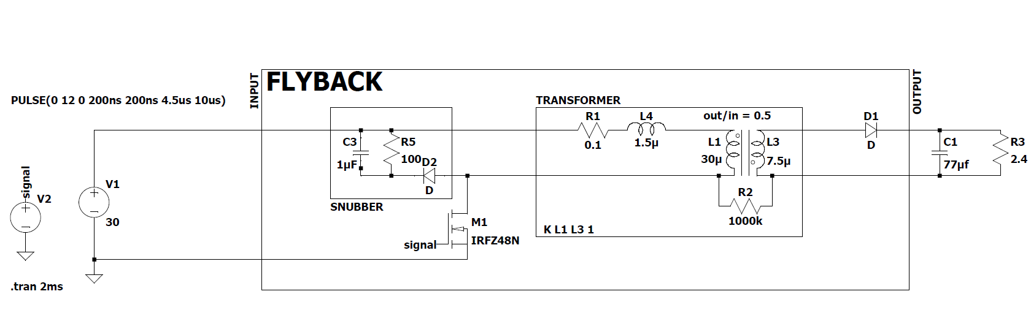

Figure 15 Simulation where parasitic effects of the transformer are considered

When the snubber is used, the drain to source voltage and drain current of the switch is given in Fig. 16

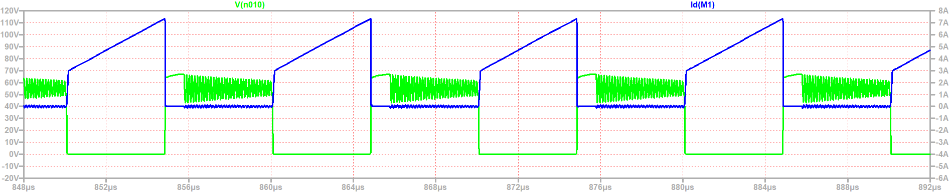

Figure 16 Simulation of the flyback where snubber is utilized

The case where snubber is disconnected (i.e. replace diode with open circuit), the drain to source voltage and drain current of the switch is given in Fig. 17.

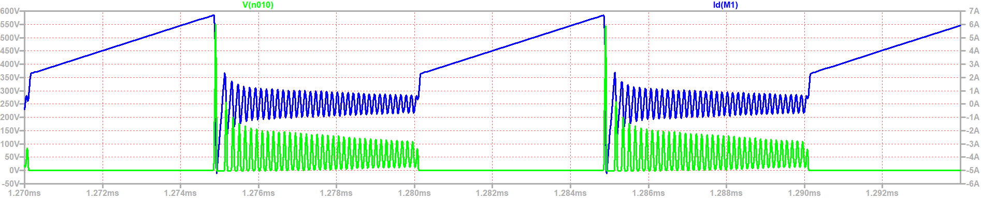

Figure 17 Simulation of the flyback where snubber is not utilized

It's clear that without a snubber circuit, the switch can be exposed to very high voltage levels that it might not be able to handle. This happens because the switch's very low drain-to-source capacity (about 50nC) compared to the transformer's leakage inductance (about 1.5uH), which leads to very strong and rapid voltage swings. Therefore, adding a snubber circuit is critical to keep the switch safe. However, a major downside of using a snubber circuit is that it turns some of the energy into heat. For example, the resistor R5 in Figure 16 uses up 12W of power. Considering the system needs to supply 60W to the load, losing this much power affects efficiency noticeably. In addition to searching for ways to design more efficient snubber, future work will look into topologies that can save this energy by sending it back to the power source or battery instead of turning it into heat, which could make the system more efficient. Regarding current stress, there are no dangerous effects. However, oscillations seen in Fig. 17 may lead to electromagnetic interference (EMI) issues, which can also be effectively addressed by a snubber circuit.

**References**

[1] W. (n.d.). Round Wire ac Resistance Calculator. <https://chemandy.com/calculators/round-wire-ac-resistance-calculator.htm>

[2]“Magnetics - Ferrite Core Loss Calculator.” https://www.mag-inc.com/Design/Design-Tools/Ferrite-Core-Loss-Calculator