CancerGD
Cancer Genetic Dependencies Database

Installation and user manual - version 1.0

29-August-2016
Stephen Bridgett
Colm J Ryan
Contents
1. Introduction 4
2. Installation 7
2.1. Create the project on PythonAnywhere.com 7
2.2 Create a Virtual Environment for Django 1.9 7
2.3 Install python library modules 10
2.4 Using GitHub to install gcdd from github 10
2.5 Configure the MySQL database 11
2.6. Configure other Django options in 'settings.py' file 12
2.7 Build and populate the database 12
2.7.1 Simplest: Use SQLITE: Unzip the Sqlite database file downloaded with the git repository 12
2.7.2 OR: Slower: Use a script to copy data from the sqlite database into MySQL database 12
2.7.3 OR: Slowest: Load the MySQL database from the raw data 13
2.8 Static files (images, CSS, and Javascript files) 14
2.9 Security 15
2.10 Identifying errors 15
3. Admin pages 16
4. Database Model 16
5. Views 17
5.1 “view.py” 17
5.1.1 Displaying the “Home/Search” page with the dependency search box 17
5.1.2 Returning the dependencies which meet the search criteria 18
5.1.3 Downloading the dependencies found as a CSV file 19
5.1.4 Displaying string-db interactions 20
5.1.5 Displaying protein interactions using cystoscape.js 21
5.1.6 Display of other webpages that have links in website header 21
5.2 Templates 21
6. Controller 23
7. Python 24
7.1 Python modules 24
7.2 Python libraries used on server: 25
8. Javascript 25
8.1 Javascript in index.html and cgdd_functions.js 25
8.1.1 Formatting the dependency table 25
8.1.2 Displaying boxplots 25
8.1.3 Displaying string-db interaction networks 26
8.1.4 Displaying drug inhibitors 26
8.2 Javascript libraries used in web-browser: 26
9. Preprocessing and R scripts to create data and boxplot data 26
10. Version control, using github 27
10.1 Version control on your local development PC 27
Appendix 29
References 29

1. Introduction
The Cancer Genetic Dependencies Database (CancerGD) enables users to search data from siRNA and shRNA experiments performed by Campbell et al(2016)^{[1]}, Cowley et al (2014)^{[2]}, and Marcotte et al (2016)^{[3]}.
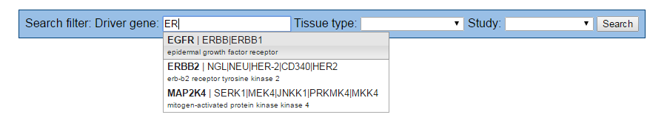
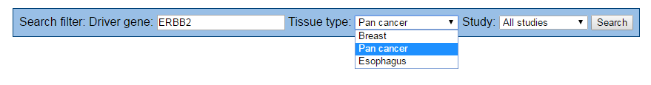
Figure 1.1: (Top) Selecting driver gene from autocomplete menu, then (Bottom) Selecting tissue type.
The user can select a cancer driver (marker) gene, such as “ERBB2”, select the tissue type, and optionally the study (figure 1.1), to display a scrollable table (figure 1.2) of all the target genes that have Wilcox-P value <= 0.05 and Common language effect size (CLES) >= 0.65.
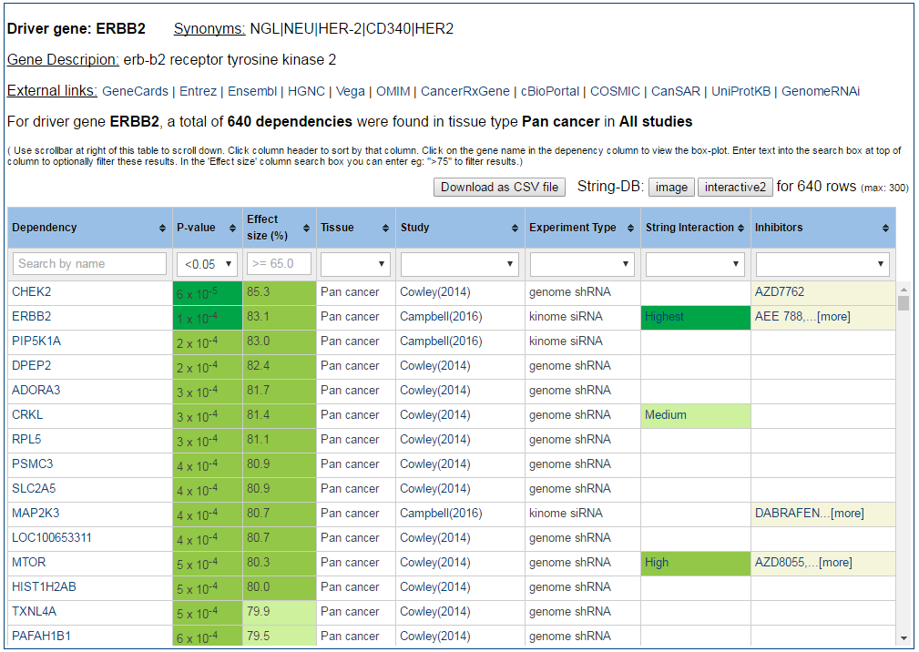
Figure 1.2 Table of dependency genes for the specified driver ERBB2, and Pan-cancer tissue type.

The user can further filter these dependent target genes using filters at top of the table, and click links to display boxplots (figure 1.3) of Z-scores for mutant versus wild-type cell-lines; display String-db interaction network (figure 1.4) between the target genes, and view known drug inhibitors (figure 1.5) for target genes.
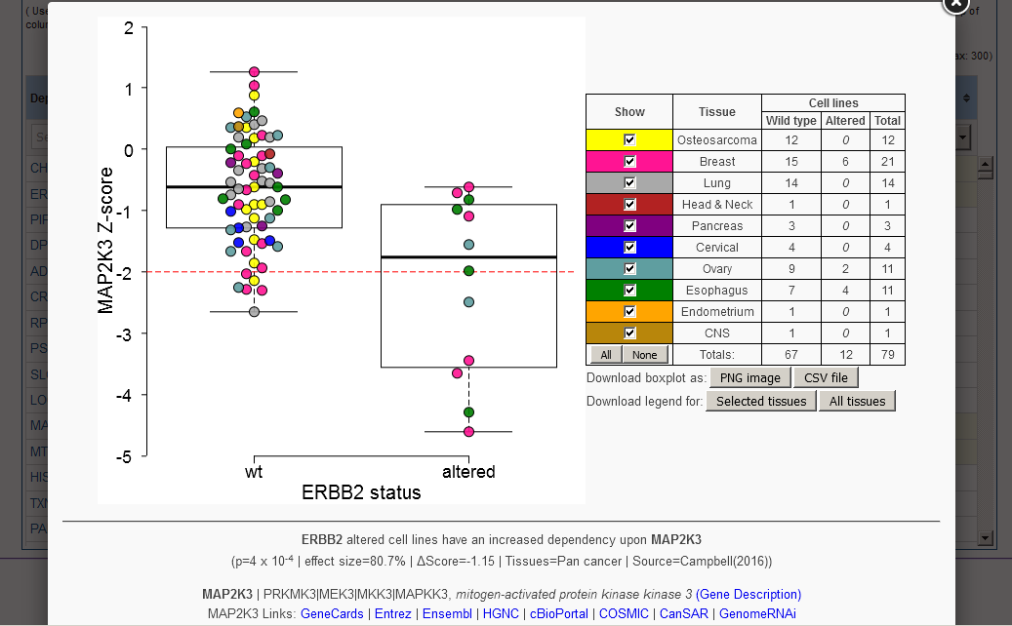
Figure 1.3 Boxplot showing that mutant ERBB2 cell lines have increased dependency on MAP2K3.
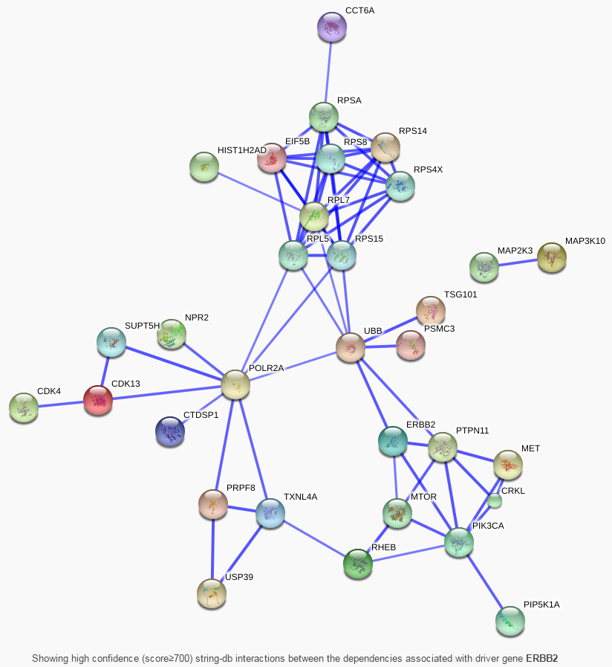
Figure 1.4 String-DB interaction network for the selected dependent genes for ERBB2
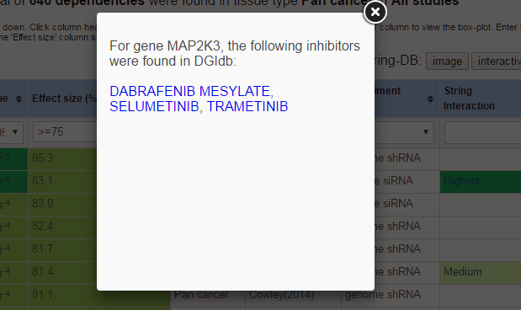
Figure 1.5 Inhibitors of MAP2K3 found in DGIdb.
The CancerGD app uses the “Django” framework^{[4]} currently hosted on a “PythonAwyhere.com” server. Django is a Model-View-Controller (MVC) framework for Python. Javascript libraries, such as jQuery, are used in the webbrowser.

2. Installation
Installing and updating the 'CancerGD' app on the PythonAnywhere.com server.

2.1. Create the project on PythonAnywhere.com
- In your webbrowser goto: http://pythonanywhere.com
- Login (or create a new account if needed)
You will see web interface as shown in figure 2.1
- On the "Web" tab, select "Add a New web app". (The free account only allows one web app)
- Select “Django web framework”.
- Select “Python 3.4” (or 3.5 if available in future)
- For project name, enter: "cgdd"
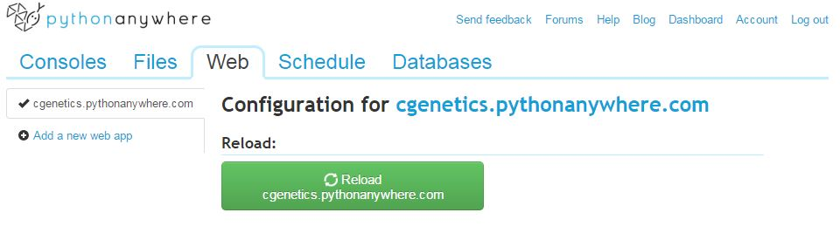
….. further down this webpage is the “Code” section:
Figure 2.1. Configuration of new ‘cgdd’ project on pythonanywhere.com

2.2 Create a Virtual Environment for Django 1.9
PythonAnywhere currently has Django 1.7 pre-installed. To use the latest Django 1.9 (or 1.10), you need to first create a virtual environment (which will be called "djano19"), and will use Python 3.4:
On the PythonAnywhere web interface, select the "Consoles" tab, select "bash" shell, then type:
mkvirtualenv --python=/usr/bin/python3.4 django19
Note: You can copy the commands from this document into your Windows/MacOS/Linux clipboard, by selecting the text then press “[Ctrl] C”, then in the PythonAnywhere console in your web-browser press “[Ctrl] V” to paste this text.
Then select this “django19” virtual environment:
workon django19
The bash prompt should now gain the "(django19)" prefix
Then install Django 1.9 into this virtual environment:
pip install django
This will take several minutes to install - the console may seem to have frozen but is really working ok. After this finishes, you can confirm that Django 1.9 is installed, by typing:
which django-admin.py
django-admin.py --version
In future, when starting a console, you need to reactivate this 'django19' virtual environment using:
workon django19

Optionally: you can put this "workon django19" at the end of your "~/.bashrc" on PythonAnywhere (so that it will automatically run this command each time you log into a bash console). You can do this using either: the “Files” tab, (then click on “.bashrc” in your home directory which is “/home/username” [replacing ‘username’ with your actual pythonanywhere account username, eg. ‘cgenetics’], remember to click the “Save” button after edits); or alternatively using the “nano” editor in a bash console:
nano -w ~/.bashrc
At end of file add the lines:
workon django19
I also add these aliases to this “~/.bashrc” file so that the console will ask me for confirmation before overwriting any existing files:
alias rm='rm -i'
alias mv='mv -i'
alias cp='cp -i'
And the following alias which lists files in order of creation date:
alias lt='ls -altr'
Then to save changes, press: “[Ctrl] o” then “[enter]”
Then to exit nano, press: “[Ctrl] x”
Then 'source' these edited environment settings by typing:
source ~/.bashrc
As we are using this newer version (1.9) of Django, we need to comment/uncomment lines at the bottom of the “WSGI configuration file” (WSGI is “Web Server Gateway Interface”, by which the webserver communicates with Django) by going to the "Web" tab (which from a console tab can be found via the “Dashboard” link at top right), then "Code" subsection, click on the link to your WSGI file, eg: "/var/www/username_pythonanywhere_com_wsgi.py" [where ‘username’ will be your actual pythonanywhere account username, eg. ‘cgenetics’], as in figure 2.2
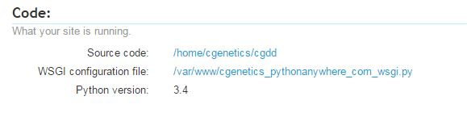
Figure 2.2. The WSGI configuration file link
which will open the file in a web-browser edit window. Then comment lines 20 and 21 by prefixing them with a ‘#’ symbol) and uncomment the final two lines (lines 24 and 25), as shown in figure 2.3
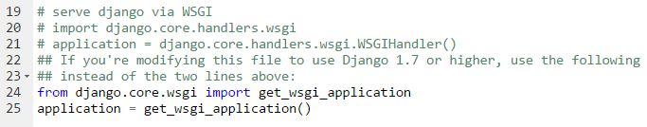
Figure 2.3. Setting the WSGI configuration to Django 1.9
Then click the "Save" button at top right of this editor webpage to save your changes (figure 2.4):
Figure 2.4. Save button is at the top right for saving the WSGI configuration change.
In the “Web” tab, set the Virtualenv path to: “/home/username/.virtualenvs/django19” (replacing 'username' with your account name), by clicking on the path link, edit it, then click the blue tick-mark button to save this change (see figure 2.5).
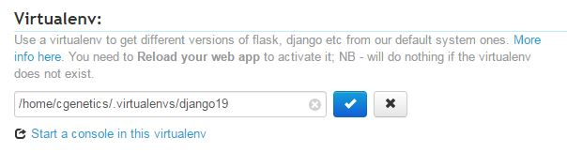
Figure 2.5. Set the virtual environment configuration to “django19”
Then click the green button at the top of the “Web” tab page to "Reload" your web app which activates your app in this new virtual env (figure 2.6). After any future changes are made to the app’s python source code or templates, you need to click this “Reload” button to load the updated modules.
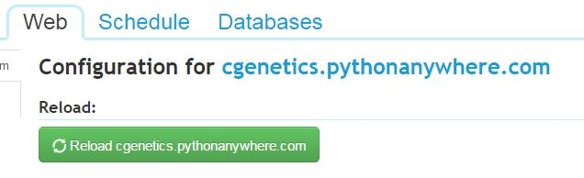
Figure 2.6 Reload App.
(If in future you ever wish to remove a virtualenv, in a bash console you can use: “deactivate django19; rmvirtualenv django19” )
For more details about virtual environments on PythonAnywhere,you can optionally see:
https://help.pythonanywhere.com/pages/VirtualEnvForNewerDjango/
https://help.pythonanywhere.com/pages/Virtualenvs
https://help.pythonanywhere.com/pages/FollowingTheDjangoTutorial/

2.3 Install python library modules
To enable Django to connect to the MySQL database, and to download data in Excel format, install the “mysqlclient”, “xlsxwriter”, “requests” and “pytz” python libraries into the django19 environment (remember to type “workon django19” if that prefix isn’t already present in your pythonanywhere bash console):
pip install mysqlclient xlsxwriter requests pytz

2.4 Using GitHub to install gcdd from github
In a PythonAnywhere “bash” console, clone the github repository, while in your home directory, type:
git clone https://github.com/cancergenetics/cgdd.git
This will create the 'cgdd' project directory in your current (“/home/username”) [replacing ‘username’ with your actual pythonanywhere account username] directory.
Change into that “cgdd” directory:
cd cgdd
You should see “(master)” appear in console prompt:
To reduce typing when doing future updates, set the git origin configuration (This may already have been done automatically by git):
git remote set-url origin https://github.com/cancergenetics/cgdd.git
To update PythonAnywhere after any future changes to the github respository, pull the changes, using:
cd ~/cgdd
git pull origin master
Then click the green “Reload”button (figure 2.6) at the top of the "Web" tab to load the updated modules.

2.5 Configure the MySQL database
When developing CancerGD, the SqLite database engine was used. On the production site the MySQL (or optionally the PostgreSQL) database is used. To configure MySQL, go to the “Databases” tab as shown in figure 2.7.
Enter a database password in the “MySQL password section”, which should be different to the password used to log into your PythonAnywhere site, (as this database password may be in “settings.py” file in the public source code on github).
Create a production database called “gendep” by typing its name “gendep” in the “Create a database” section, and then create a test database called “test_gendep”. These two names match the names used in ‘DATABASE’ dictionary for ‘MYSQL’ in the “settings.py” file.
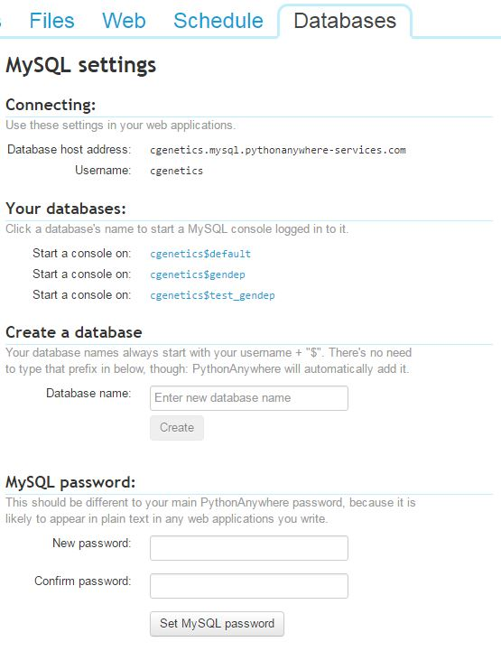
Figure 2.7. MySQL Database configuration
Edit the “settings.py” file in the directory “~/cgdd/cgdd” to set the database password to the password you have entered into the “MySQL password” section.

2.6. Configure other Django options in 'settings.py' file
As mentioned above, in the “~/cgdd/cgdd” directory there is a file “settings.py” that contains settings for the Django server. Most settings are already configured in this file. For the production site, set “DEBUG” to “False” in this “settings.py” file, which will make the app both more secure (as external users wouldn't see the python code in their browser that caused any error) and run faster
To use the MySQL database (or optionally the more advanced Postgres database), edit this “setting.py” file by commenting out the “DB='SQLITE'” line, and uncommenting the “DB='MYSQL'” line.
If need more detail about the MySQL options, see: https://help.pythonanywhere.com/pages/UsingMySQL/

2.7 Build and populate the database
There are three options for building the database:

2.7.1 Simplest: Use SQLITE: Unzip the Sqlite database file downloaded with the git repository
Uncompress the “db_sqlite.zip” file found in the “~/cgdd” directory:
cd cgdd
unzip db_sqlite.zip
In the “settings.py” file, uncomment the line: “DB='SQLITE'”, and comment out “DB='MSQL'”
On the “Web” tab, click the “Reload” button.

2.7.2 OR: Slower: Use a script to copy data from the sqlite database into MySQL database
Unzip the SQLite database as above.
In the “settings.py” file, uncomment the line: “DB='MYSQL'” (or “DB='POSTGRES'”)
If the “(django19)” prefix is missing from the console prompt, type: “workon django19”
Create the MySQL (or Postgres) database schema, using the Django ‘Migrate’ commands. First build the migration commands:
python manage.py makemigrations gendep
Optionally to see the SQL commands for the migration (eg. for migration 0001):
python manage.py sqlmigrate gendep 0001
Do the actual migrations:
python manage.py migrate
(If need more details about migrations, see: https://docs.djangoproject.com/en/1.9/topics/migrations/ )

Create the “cache” table in the MySQL database, which will enable caching of previous views:
python manage.py createcachetable
Run the “sqlite_to_mysql.py” python script which copies the data from SqLite into MySQL (or Postgres):
python sqlite_to_mysql.py
( Optionally: You can use “chmod +x sqlite_to_mysql.py” to mark the script as executable, then Linux will run it without needing the “python” command before the script name, (ie. just: “./sqlite_to_mysql.py”) as the first line of script is “#!/usr/bin/env python” )
On the “Web” tab, click the “Reload” button.
It is possible to dump the SqLite database as SQL insert statements then read these into MySQL, however there are several differences in the SQL statement formats so need to edit the SqLite INSERT statements before importing into MySQL. Using the above “sqlite_to_mysql.py” script is simpler.

2.7.3 OR: Slowest: Load the MySQL database from the raw data
This requires the paid-for pythonanywhere account (or request that pythonanywhere support add BGIdb to their ‘whitelist’ of servers that the free accounts can connect to. ‘string-db.org’ is already in their whitelist).
As in section 2.7.2 above, uncomment the “DB='MYSQL'” option, and create the MySQL database schema.
Obtain the raw data files, then run the following scripts to populate the database from the raw data:
UPDATE 29-Aug-2016: An improved way of adding the annotation information to the Gene table is being tested, using script called “fetch_entrez_full_details.py” which outputs gene annotation file: “entrez_gene_full_details.txt”.
Into a subdirectory called “input_data” download the HGNC gene ids file:
wget ftp://ftp.ebi.ac.uk/pub/databases/genenames/new/tsv/hgnc_complete_set.txt
Add input files generated by R “Intercell_analysis_functions.R” script for the three studies. Then run:
python load_data.py > loaddata.log
Check the output for significant errors, using “less loaddata.log” or “grep ERROR loaddata.log”.
Download the latest gene name to “9606.protein.aliases.v….txt.gz” file for species “Homo sapiens” from:
http://string-db.org/cgi/download.pl?species_text=Homo+sapiens
under the section “Accessory Data” -currently for String-db version 10 this file can be downloaded using:
wget http://string-db.org/download/protein.aliases.v10/9606.protein.aliases.v10.txt.gz
Ungzip this file using:
gunzip 9606.protein.aliases.v10.txt.gz
Add the Ensemble protein Ids use by the string-db
python add_ensembl_proteinids_and_stringdb.py > ensemblids.log
Add the inhibitors (which for a free PythonAnywhere.com account, needs DGIdb in pythonanywhere’s “white list”, as it retrieves drug info directly from DGIdb):
python drug_inhibitors.py > inhibitors.log
Add the Entrez gene summaries (via the Entrez ‘EUtils’ webservice):
python add_entrez_summaries.py > entrez_summaries.log
After making these changes, reload the app using the green “Reload” button on the Web tab.

2.8 Static files (images, CSS, and Javascript files)
For efficiency, static files (ie. as opposed to dynamic data generated by the Django views and templates) should be served by the main webserver, not by the Django WSGI server. During development on local PC, static files are in subdirectory: “cgdd/gendep/static/gendep”, but on the pythonanywhere server, static files need moved to the location “cgdd/static/gendep”. On the “Web” tab are the “Static files” settings (as in figure 2.8). These statics files are linked to by the URL prefix “/static/” and use faster disk space.
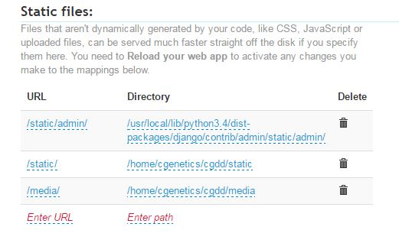
Figure 2.8. Static files settings.
The git repository currently includes statics files for Javascript (jquery-tablesorter, flashbox, cgdd_functions.js, svg_boxplot.js), and CSS (style.css). You need to copy the static files to this static files location, after any change to the statics files (eg. after “git pull” that updated any static files) by running the Django “collectstatic” script:
python manage.py collectstatic
This will copy files from subdirectory “cgdd/gendep/static/gendep” into subdirectory “cgdd/static/gendep”.
For more details:
https://help.pythonanywhere.com/pages/DjangoStaticFiles
https://docs.djangoproject.com/en/1.9/howto/static-files/
https://docs.djangoproject.com/en/1.9/howto/static-files/deployment/

2.9 Security
In the settings.py file on the production PythonAnywhere server, use a different Secret-key from the one in the settings.py file on GitHub repository. The secret key is used for: browser sessions, .cookie messages, password-reset tokens, cryptographic signing. In practice the CancerGD app doesn’t use browser sessions, cookies, or user password. Never-the-less it is a good idea to put a different secret key on the server. The secret key is of the format: “hi0b%owp27jefp==#xz34=3d5x4f3-)0ezh0%o+4ba=8#&apju”, and should be placed in a text file called “key.txt” in directory “~/cgdd/cgdd. To generate a key you can use the script:
python django-secret-keygen.py > cgdd/key.txt
Alternatively a webapp secret key-generator can be used, eg: http://www.miniwebtool.com/django-secret-key-generator/ and the result manually put in the “key.txt” file For more details about secret key, see: https://docs.djangoproject.com/en/1.9/ref/settings/#std:setting-SECRET_KEY
After the above have been set up, the Django check script can be run to check security:
python manage.py check --deploy
The majority of these messages will relate to using secure SSL (“HTTPS” ) connections and to Cookies, neither of which are used by the CancerGD application. The CancerGD site doesn’t allow users to edit the dependency data, just query it, so CSRF (Cross-site request forgery) tokens are only used in the Contacts form, although they can easily be enabled in the search box if denial of service attacks occurred.
For more details, see: https://docs.djangoproject.com/en/1.9/howto/deployment/checklist/

2.10 Identifying errors
To use the CancerGD web-interface, goto: http://username.pythonanywhere.com/gendep/ [replacing ‘username’ with your actual pythonanywhere account username, eg. ‘cgenetics’]
If the web-interface doesn’t appear: first try setting the “DEBUG” option to “True” in the “cgdd/setting.py” file, then click the “Reload” button on the “Web” tab. Then try the CancerGD web-interface again. If no useful debug messages are given, then look at the end of the Django log files, by clicking on the links on the “Web” tab “Log files” section (figure 2.9)
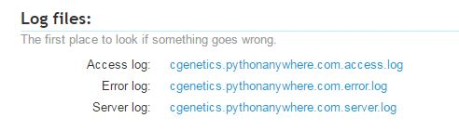
Figure 2.9. Links to Django log files

3. Admin pages
The Admin pages for the 'CancerGD' app on pythonanywhere server, can be accessed at:
http://username.pythonanywhere.com/admin/
[replacing ‘username’ with your actual pythonanywhere account username, eg. ‘cgenetics’]

4. Database Model
The Django database schema is defined in “gendep/models.py”. This consists of three tables (represented in Django as three python classes), which are: “Study”, “Gene”, and “Dependency”, which are linked by foreign keys as shown in figure 4.1
DEPENDENCY
id INT [PK]
driver [FK to Gene]
target [FK to Gene]
study [FK to Study]
mutation_type
histotype
wilcox_p FLOAT
effect_size FLOAT
za, zb, zdelta FLOAT
interaction
STUDY
pmid [PK]
title
authors
description
journal
pub_date

GENE
gene_name [PK]
is_driver BOOL
prevnames_synonyms
ncbi_summary
ensembl_id
entrez_id
ensembl_protein_id
inhibitors
driver_histotype_list

Notes:
‘[PK]’ = Primary Key
‘[FK]’ = Foreign Key into another table
‘INT’ = Integer; FLOAT = Floating point number; BOOL = Boolean (True/False)
The ‘Study’ and ‘Gene’ tables could use an integer ‘id’ primary key column instead of the ‘study’ and ‘gene_name’ primary keys.
The ‘Dependency’ table has a constraint of: unique_together('driver', 'target', 'histotype', 'study'). And in future might add ‘mutation_type’.

Figure 4.1 UML diagram for CancerGD. The three tables linked by foreign keys. Fields are character/text, except if stated otherwise. For simplicity, several less important fields are not shown in this figure.
In the “model.py” script, the field names are all in lower case characters, as some database engines assume lower case. Two lists which rarely change are represented as “choice” lists in within the table class: (a) the experiment types are stored in the “EXPERIMENTTYPE_CHOICES” list in the “Study” class, and (b) the histotypes (tissue types) are represented as the “HISTOTYPE_CHOICES” list in the “Dependency” class.
The database model is stored in “MySQL” on the production PythonAnywhere site. During development “Sqlite3” database was used. Alternatively the “Postgres” database can be selected on the paid PythonAnywhere account. The database used is specified in the “settings.py” file (see section 2.6 above). If changes need to be made to the database schema, after editing the “model.py” file, the Django migration scripts need to be run (see section 2.7.2 above). In the database, Django prefixes the Class names with the app name, so for example “Study” class is table “gendep_study”.
More details about Django:
Database: https://docs.djangoproject.com/ja/1.9/topics/db/
Models: https://docs.djangoproject.com/ja/1.9/topics/db/models/
Fields used in the model classes: https://docs.djangoproject.com/en/1.9/ref/models/fields/

5. Views
Django uses the popular Model-View-Controller (MVC) framework. The “Model” is the database as explained in section 4 above. The “View” is how the data is displayed in the web-browser, or in a file that is downloaded. The “gendep/view.py”script contains a function for each web-page that is displayed or each file downloaded. For webpages an html “template” file is used by the view to format the data for the webpage. Django can also be considered an “MTV” framework – that is: “model”, “template”, and “view.”^{[5]}

5.1 “view.py”
This performs the following functions:

5.1.1 Displaying the “Home/Search” page with the dependency search box
In the “view.py” script, the “index(…)” function:
index(request, search_by = 'driver', gene_name='')
uses the template “index.html” to display the home page text and the dependency search box. The parameter “search_by” defaults to “driver” but can be specified as “target” to optionally search the dependencies by target rather than driver gene. The “gene_name” defaults to empty, unless the page is loaded with URL of the form “gendep/driver/ERBB2/” (from a link from the drivers page) in which case that gene “ERBB2” will be pre-selected in the autocomplete box.
Figure 5.1 the Autocomplete search box
The search box contains a jQuery-UI autocomplete input (figure 5.1) which has drop-down menu populated from an array containing the driver gene names. Typing two characters in this “Driver gene” autocomplete box will display a drop-down menu of any matching driver genes. After the user selects a gene in the autocomplete box, the “tissue_list” and “study_list” properties for that gene in the “driver_array” are used by Javascript to set the appropriate options in the “Tissue type” (figure 5.2) and “Study” menus. Pressing the “Search” button (or pressing “Enter” key with cursor in the autocomplete box) makes an AJAX request to the Django server for the dependencies matching the search criteria.
Figure 5.2 Tissue type menu (and Study menu) options set depending on which Driver gene selected.

5.1.2 Returning the dependencies which meet the search criteria
The “Search” button uses AJAX to call the “get_dependencies()” view function:
get_dependencies(request, search_by, gene_name, histotype_name, study_pmid)
which checks that the parameters are valid, and calls the “build_dependency_query()” function to build the Django ORM query:
build_dependency_query(search_by, gene_name, histotype_name, study_pmid, wilcox_p=0.05, order_by='wilcox_p', select_related=None)
The “wilcox_p” defaults to <= 0.05, and the query sort order defaults to ascending “wilcox_p”value. This query filters the “Dependency” table using these parameters. The optional “select_related” parameter enables specific columns (“ensembl_protein_id” and “inhibitors”) in the related “gene” table (which is. joined to via the “target” foreign key to the “gene” table) to be returned in the same query (ie. an SQL join, rather than doing multiple subsequent subqueries. For more details see: https://docs.djangoproject.com/en/1.9/ref/models/querysets/#select-related ). This has now been implemented as a Raw SQL query to make query more efficient:
build_rawsql_dependency_query(search_by, gene_name, histotype_name, study_pmid, order_by='wilcox_p')

Figure 5.3 Resulting table of dependencies that meet the search criteria.
The view then uses the python “json” module to return the dependency data as a JSON formatted an array of arrays, which is then used by javascript to populate the table in the webbrowser (figure 5.3). This view also uses additional functions in the “view.py” script:
- json_error(message, status_code='0') - returns any error message in JSON format.
- is_search_by_driver(search_by) – checks “search_by”parameter is valid
- get_timing(start_time, name, time_array=None) – gets query timings for profiling
- gene_ids_as_dictionary(gene)- returns python dictionary of gene ids
- gene_info(request, gene_name) - returns the gene ids and synonyms for specified driver gene; and for the tooltip AJAX request when mouse hovers overs over target gen name in dependency table.
- get_drivers(request) – gets list of driver gene names

5.1.3 Downloading the dependencies found as a CSV or Excel (.xlsx) file
Above the dependency table are “Download as CSV file” and “Download as Excel file” buttons (figure 5.4), to download the dependencies found as a comma-separated-value table (that can be imported into a spreadsheet) or an Excel file with some formatting. When importing a CSV file into Excel, some gene names (eg. MARCH10) are automatically inappropriately converted to dates, so it is better to download the Excel file if you plan to use Excel.
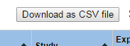
Figure 5.4 Button to download dependency table as a comma-separated-value (CSV) file.
Clicking the “Download as CSV” or “Download as Excel” buttons, calls a function in “view.py” called:
download_dependencies_as_csv_file(request, search_by, gene_name, histotype_name, study_pmid, delim_type='csv')
which is similar to the above “get_dependencies(…)” function, but uses the python “csv” module to create the comma-separated text (including enclosing in quotes any strings that contain commas), or “xlsxwriter” module to write the Excel file.

5.1.4 Displaying string-db interactions
When user clicks the String-db “image” button, a javascript function running in the web-browser creates a list of the Ensembl protein_ids of upto the first 300 filtered genes from the dependency table. To eliminate unconnected proteins, it needs to send an “/api/psi-mi-tab/interactionsList” request to the String-db server. However the AJAX “Same-origin” security policy means that the AJAX request can only be sent to the “PythonAnywhere.com” domain, not directly to “String-db.org”. Hence the request is sent to PythonAnywhere server via a function in “view.py” called:
get_stringdb_interactions(request, required_score, protein_list)
which then calls another function:
stringdb_interactions(required_score, protein_list
which uses python’s “urllib” module to relay this “interactionsList” request to String-db.org, with the specified “required_score>=700”, and parameters for “network_flavor=confidence”, and “limit=0” (which instructs string-db not to add any additional proteins, otherwise by default will add upto 10 more proteins).
String-db returns a tab-delimited text of pairs of protein_ids with their interaction scores. These protein_ids are then returned to original AJAX request from the webbrowser, and used by javascript to form the “/api/image/network” request for the network image from string-db, which is displayed in a “fancybox” (figure 5.5).
For the “interactive” stringdb, a direct request using all of the upto 300 protein ids (ie. including the unconnected proteins) is used to open a new web-browser tab with a POST request to “/newstring_cgi/show_network_section.pl” including the parameter “advanced_menu=yes”.
Figure 5.5 String-DB interaction network image, with the unconnected genes (proteins) removed.

5.1.5 Displaying protein interactions using cystoscape.js
So far this is just a simple display of the string-db interactions using “cytoscape.js”:
cytoscape(request, required_score, protein_list)

5.1.6 Display of the other webpages that have links in website menu bar at top of webpage
The following functions in “view.py” use no, or just simple single table queries, then call the relevant template to display that webpage:
- about(request) – displays the “About” webpage, uses the “about.html” template
- contact(request) – displays “contact” details
- faq(request) – frequently asked questions page
- drivers(request) – displays table of drivers
- targets(request) – displays table of target genes
- tissues(request) – displays table of tissues (histotypes)
- studies(request) – displays table of studies
- show_study(request, study_pmid) – shows details for a specified study
An example of one of these “view.py” functions is:
def drivers(request):
driver_list = Gene.objects.filter(is_driver=True).order_by('gene_name')
context = {'driver_list': driver_list}
return render(request, 'gendep/drivers.html', context)
which first uses the Django ORM (Object-Relational Mapper) query to filter the “gene” table, for driver genes, ordered by gene_name. Note that this query syntax uses single ‘=’, (not the double equal ‘==’ used in python scripts), and for Boolean fields it needs, eg: “(is_driver=True)”, not just: “(is_driver)”. It then returns this “driver_list” as a “context” dictionary to be rendered using the “drivers.html” template, which is subsequently returned to the webbrowser “request”.
More details about Django views and database queries:
Writing Views: https://docs.djangoproject.com/en/1.9/topics/http/views/
Database queries: https://docs.djangoproject.com/ja/1.9/topics/db/queries/

5.2 Templates
There is one template per webpage. The templates contain mainly html markup tags, and Django template tags. The templates are in directory “~/cgdd/gendep/templates/gendep/”. The following templates are used:
- base.html – common formatting (eg. page header and footer) used by the other templates.
- index.html – Home/Search page, and the dependency results table. Uses “cgdd_functions.js”
- about.html – text about the CancerGD app
- contact.html – feedback form and contact email address
- cytoscape.html – to display network interactions using cytoscape .js
- drivers.html – table of driver genes included in the database
- faq.html – frequently asked questions
- studies.html – table of the studies which the data is from
- study.html – displays details of one study
- targets.html – table of target genes included in the database
- tissues.html – table of tissues included in the database
- 404.html – page not found message – if incorrect URL used in webbrowser
The templates consist of standard HTML tags and Django tags – for example to create the HTML for the “drivers” webpage, by looping through the list of driver genes retrieved from the database by the query at the end of section 5.1.6 above, the following is a simplified version of the template “drivers.html”:
<table>
<thead><tr>
<th>Driver gene</th>
<th>Full name</th>
<th>Synonyms</th>
</tr></thead>
<tbody>
{% for driver in driver_list %}
<tr>
<td>{{ driver.gene_name }}</td>
<td>{{ driver.full_name }}</td>
<td>{{ driver.prevname_synonyms }}</td>
</tr>
{% endfor %}
</tbody>
</table>
The Django template command tags are enclosed in “{% %}” and the data values in “{{ }}”.
More details about templates: https://docs.djangoproject.com/en/1.9/ref/templates/
and built-in template tags: https://docs.djangoproject.com/en/1.9/ref/templates/builtins/
The “contact” page logs the comment in database “comments” table, then calls “send_an_email()”function in “view.py”which uses the “mailgun.com” service to forward the feedback comment. You need toyou’re your needs your mailgun.com “API key” to this “send_an_email()”function , or alternatively on the paid pythonanywhere account the “send_an_email()” function can be modified to use an SMTP server.

6. Controller
The third part of the “MVC” framework is the controller. In Django the two “urls.py” files control how the URLs entered in users webbrowser (or javascript AJAX calls) are routed to functions in the “view.py” script.
The main “CancerGD” project “~/cgdd/url.py”file contains routes for the “gendep”application, and for the “admin” interface. The URL pattern matches are specified as regular expressions:
url(r'^gendep/', include('gendep.urls')),
url(r'^admin/', admin.site.urls),
The “admin/” URL directs to the Django Admin interface which is configured for CancerGD .
The “gendep/” URL includes the “gendep/urls.py” controller file, which contains URL patterns to call the functions in the “views.py” views script. For example:
url(r'^about/$', views.about, name='about'),
matches the URL request “about/”, and calls the function “about(request)” in the “views.py” file. This URL pattern is named “about”, and this name is used when referring to it from a link in Django template.
To request “gene_info” for tooltips when mouse hovers over a gene name in the dependency table, AJAX calls “get_gene_info/” with parameter “gene_name” which must match the specified regular expression.
url(r'^get_gene_info/(?P<gene_name>[0-9A-Za-z\-_\.]+)/$', views.gene_info, name='get_gene_info'),
To retrieve the dependency data, the “get_dependencies” URL is requested, with parameters for search_by, gene_name, histotype_name, and study_pmid. The “search_by” allows only “driver”, “target”, or “mysearchby” (which is used in the “index.html” template as a placeholder to form this URL for javascript. The “\_” in the histotype and study regular expressions are needed to match “ALL_STUDIES” and “ALL_HISTOTYPES”:
url(r'^get_dependencies/(?P<search_by>(?:mysearchby|driver|target))/(?P<gene_name>[0-9A-Za-z\-_\.]+)/(?P<histotype_name>[0-9A-Za-z\_]+)/(?P<study_pmid>[0-9A-Za-z\_]+)/$', views.get_dependencies, name='get_dependencies'),
More details about the URL patterns: https://docs.djangoproject.com/en/1.9/topics/http/urls/

7. Python

7.1 Python modules
In addition to the already described python scripts: “models.py”, “urls.py” and “views.py”, the “~/cgdd/gendep” directory also contains:
- __init__.py –can be used for initialisation, but is not used in this CancerGD app.
- admin.py –is used to define and register the “StudyAdmin”, “GeneAdmin”and “DependencyAdmin” classes for the CancerGD Administration views.
- apps.py –contains name of the “gendep” app in the “GendepConfig”class.
- tests.py – can be used for automation of test cases when developing the application.
The main “~/cgdd/” directory contains:
- add_ensembl_proteinids_and_stringdb.py – add ensembl protein ids to the “gene” table, and adds any string-db interaction between driver and target to the “Dependency” table
- drug_inhibitors.py – adds drug inhibitors to the “dependency” table by sending JSON request to the CGIdb.
- fetch_entrez_full_details.py [not needed yet] -for NCBI gene annotations/summaries.
- get_gene_ids_from_biomart.py – [not used] test script for querying BioMart
- get_uniprot_name_mappings.py – [not used] test script for retrieving uniprot names.
- load_data.py – loads the gene, study and dependency data into the database. (While it can be possible to load data into the database using Django’s admin function “loaddata” from data “fixtures” in JSON format, the data in this CancerGD project was more complex, so this “load_data.py” script was written instead)
- manage.py – standard Django script to set the python environment when administrating the project, such as calling database migrations. See: https://docs.djangoproject.com/en/1.9/ref/django-admin/
- parse_Achilles_QC_v243_rnai_Gs_gct.py – to format the Achilles/Cowley^{[2]} data for analysis by the R “Intercell_analysis_functions.R”.
- sqlite_to_mysql.py – convert sqlite database into MySQL for the database server (can be slightly modified to load into Postgres database)

7.2 Python libraries used on server:
The “mysqlclient”, “xlsxwriter” and “requests”are not in the core python libraries, so need installed using “pip install” (see section 2.3)
- json ..- formats .data as JSON to send to browser AJAX requests (for dependency table and tooltip gene-info).
- urllib ..- retrieving data from web services (string-db, DGIdb, MyGene, NCBI)
- csv ...- to format dependency table for download as comma-separate-value (CSV) file
- mysqlclient - for Django to access the MySQL database server
- xlsxwriter – writing text for download in excel format
- requests – for retrieving data from Enrichr

8. Javascript

8.1 Javascript in index.html, cgdd_functions.js and svg_boxplot.js
On the main “Home/Search” webpage, much of the user-interface’s formatting and button-actions are performed by Javascript functions in the “index.html” header and the “cgdd_functions.js” script.

8.1.1 Formatting the dependency table
The function “populate_table(data)” in “cgdd_functions.js” uses the dependency data sent from the server in JSON arrays, to populate the HTML table, adding the links to the box-plots, string-db, inhibitors box, and tooltips.

8.1.2 Displaying boxplots
On clicking a gene name in the “Dependency”column, the Javascript function: “plot(driver, target, histotype, study_pmid, wilcox_p, effect_size, target_variant)” displays the boxplot as an interactive SVG (Scalable Vector Graphics) inside a “fancybox”lightbox, with the appropriate text about driver, target genes, tissue, study,wilcox_p, effect_size and Entrez gene summary.

8.1.3 Displaying string-db interaction networks
When a user clicks the StringDB “image” button, the Javascript function: “show_stringdb(display_callback_function)” in “cgdd_functions.js” retrieves the list of proteins which are connected (see section 5.14 above), then displays the image in a “fancybox” lightbox.

8.1.4 Displaying drug inhibitors
On clicking an inhibitor with a “…[more]” link in the Dependency table, the Javascript function “toggle_show_drugs(obj,drug_names,div,gene)” displays the drug names in a “fancybox”.

8.2 Javascript libraries used in web-browser:
Several Javascript libraries are used in the main “Home/Search” webpage:
- jQuery - hosted from: https://ajax.googleapis.com/ajax/libs/jquery/
- jQuery-UI -(autocomplete, tooltip) hosted from: https://ajax.googleapis.com/ajax/libs/jqueryui/
- Cytoscape.js – hosted from: http://cytoscape.github.io/cytoscape.js/api/
- jQuery-tablesorter (in gendep/static) - from: https://mottie.github.io/tablesorter/docs/index.html
- fancybox (version 2) (in gendep/static) – from: http://fancyapps.com/fancybox/
- SVGtoDataURL – https://github.com/sampumon/SVG.toDataURL
- canvg - canvas2image library: https://github.com/hongru/canvas2image
(In future maybe replace “tablesorter” with “DataTables”: https://datatables.net/ )

9. Preprocessing and R scripts to create data and boxplot data
If you wish to reanalyse the Z-score data you can use the R scripts in the “R_scripts” directory. The original data from the three shRNA studies is reformatted for input into these R scripts. This input data is in the ‘preprocess_genotype_data/rnai_datasets/’directory, and was reformatted using:
Colm’s scripts to transpose…. then:
parse_Achilles_QC_v243_rnai_Gs_gct.py
reformat_latest_colt_data.py
In the ‘R_scripts’ directory, there are modified versions of the following scripts originally from James:
- Intercell_analysis_functions.R -
- run_Intercell_analysis.R -
which now include:
- Colm’s updated “run_univariate_tests(…)” function for effect_size (CLES) and zDelta scores,
- List of 36 selected driver genes (includes James’ 21 “cgc_vogel_genes_with_n7” gene list, except NOTCH1),
- Tissues and legend names for the Cowley^{[2]} and Marcotte^{[3]} studies – ** COULD REMOVE THESE AS ARE IN “svg_boxplot.js” NOW
- Function to write the boxplot data to file (instead of plotting png image files) for drawing in webbrowser using Javascript and SVG (Scalable vector graphics).
To run these R scripts, you need to:
- Install R packages: preprocessCore, mixtools, and gplots whichis just needed for plotting pngs so could remove this gplots.
- Uncomment the appropriate study (eg. data=”Colt” near the start of the “run_Intercell_analysis.R” script).
- Run this “run_Intercell_analysis.R”script, either interactively in an R GUI, or on command-line in terminal console, or R batch mode.

10. Version control, using github
Section 2.4 above, explains how to clone the CancerGD git repository onto the PythonAnywhere server (or your local development PC), and how to pull any subsequent changes.
When developing CancerGD on your local PC, you will also need to commit to the git repository any changes you make.

10.1 Version control on your local development PC
To reduce typing when sending any commits to the git repository, you can configure git on your PC with the remote origin, using:
git remote set-url origin https://[USER]@github.com/cancergenetics/cgdd.git
replacing “[USER]” with your git username. You can optionally also include your git password (providing your local PC is secure!), using:
git remote set-url origin https://[USER]:[PASS] @github.com/cancergenetics/cgdd.git
Replacing “[PASS]” with your git repository password.
To add any new files to the git, use:
git add [file or directory name]
To commit your changes, use:
git commit -am "message"
git push origin master
replacing message with your note describing this commit.
Then update the PythonAnywhere server with these changes as described in section 2.4 above, copy any static files using command “python manage.py collectstatic” (as in section 2.8 above), then reload the app on the pythonanywhere server, by clicking the "Reload username.pythonanywhere.com" button (figure 2.6) on the "Web" tab page.
If another developer has made changes to the git repository, then before making edits, you should pull those changes to your local PC, using:
git pull origin master
For more details (although slightly dated now) of using git for PythonAnywhere: http://tutorial.djangogirls.org/en/deploy/index.html
On the paid PythonAnywhere accounts, “ssh” can also be used for git and uploading data.

Appendix
Some additional links that might be helpful with trouble shooting:
Database Migrations:
If loose migration info: http://stackoverflow.com/questions/29888046/django-1-8-create-initial-migrations-for-existing-schema *
“Run python manage.py migrate --fake-initial. Django will see that the tables for the initial migrations already exist and mark them as applied without running them. (Django won’t check that the table schema match your models, just that the right table names exist). https://docs.djangoproject.com/en/1.9/topics/migrations/#upgrading-from-south

References
[1] Campbell et al (2016), "Large Scale Profiling of Kinase Dependencies in Cancer Cell Line", Cell reports, Mar 2016, URL: http://www.cell.com/cell-reports/fulltext/S2211-1247(16)30126-7
[2] Cowley et al (2014), "Parallel genome-scale loss of function screens in 216 cancer cell lines for the identification of context-specific genetic dependencies", Scientific Data, Sept 2014. URL: http://www.nature.com/articles/sdata201435 and: http://www.broadinstitute.org/achilles/
[3] Marcotte et al (2016), "Functional Genomic Landscape of Human Breast Cancer Drivers, Vulnerabilities, and Resistance", Cell, Vol 164, Issues 1-2, p293–309, Jan 2016, URL: http://www.cell.com/cell/fulltext/S0092-8674(15)01624-4 and:
[4] The Django web framework URL: https://www.djangoproject.com/
[5] Django FAQ – MVC/MTV framework: https://docs.djangoproject.com/en/1.9/faq/general/#django-appears-to-be-a-mvc-framework-but-you-call-the-controller-the-view-and-the-view-the-template-how-come-you-don-t-use-the-standard-names and: http://lukeplant.me.uk/blog/posts/mvc-is-not-a-helpful-analogy-for-django/

