Policy simulations for East Africa and Colombia

## Warning: package 'reshape' was built under R version 3.3.2

## Warning: package 'ggplot2' was built under R version 3.3.2

## Warning: package 'knitr' was built under R version 3.3.2

# Inputs

## Policies to investigate

### East Africa

Note: baseline % advanced = 78%

|  |  |  |  |  |
| --- | --- | --- | --- | --- |
| num | id | name | pairnum | earlydetHR |
| 1 | adv78 | E0: Surgery only | NA | 1.0000000 |
| 2 | adv78.tam | E1: Endocrine for ER+ | NA | 1.0000000 |
| 3 | adv78.tamchemo | E2: E1 plus Chemo for ER- | NA | 1.0000000 |
| 4 | adv78.tamchemoERpos | E3: E2 plus Chemo for Advanced ER+ | NA | 1.0000000 |
| 5 | adv60.tam | E4: E1 plus downstaging to 60% advanced | 2 | 0.7692308 |
| 6 | adv60.tamchemo | E5: E2 plus downstaging to 60% advanced | 3 | 0.7692308 |
| 7 | adv60.tamchemoERpos | E6: E3 plus downstaging to 60% advanced | 4 | 0.7692308 |
| 8 | adv35.tam | E7: E1 plus downstaging to 35% advanced | 2 | 0.4487179 |
| 9 | adv35.tamchemo | E8: E2 plus downstaging to 35% advanced | 3 | 0.4487179 |
| 10 | adv35.tamchemoERpos | E9: E3 plus downstaging to 35% advanced | 4 | 0.4487179 |

### Colombia

Note: baseline % advanced = 45%.

|  |  |  |  |  |
| --- | --- | --- | --- | --- |
| num | id | name | pairnum | earlydetHR |
| 1 | adv45 | C0: Surgery and Endocrine for some ER+ | NA | 1.0000000 |
| 2 | adv45.tam | C1: C0 + Endocrine for all ER+ | NA | 1.0000000 |
| 3 | adv45.tamchemo | C2: C1 plus Chemo for ER- | NA | 1.0000000 |
| 4 | adv45.tamchemoERpos | C3: C2 plus Chemo for Advanced ER+ | NA | 1.0000000 |
| 5 | adv35.tam | C4: C1 plus downstaging to 35% advanced | 2 | 0.7777778 |
| 6 | adv35.tamchemo | C5: C2 plus downstaging to 35% advanced | 3 | 0.7777778 |
| 7 | adv35.tamchemoERpos | C6: C3 plus downstaging to 35% advanced | 4 | 0.7777778 |
| 8 | adv30.tam | C7: C1 plus downstaging to 30% advanced | 2 | 0.6666667 |
| 9 | adv30.tamchemo | C8: C2 plus downstaging to 30% advanced | 3 | 0.6666667 |
| 10 | adv30.tamchemoERpos | C9: C3 plus downstaging to 30% advanced | 4 | 0.6666667 |

## Natural history parameters: incidence

### East Africa

We are using Uganda for our East Africa example. 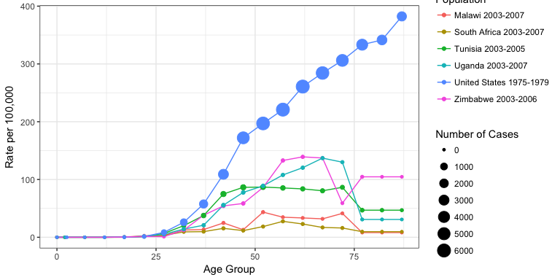

### Colombia

We are using Cali, Colombia for our example. 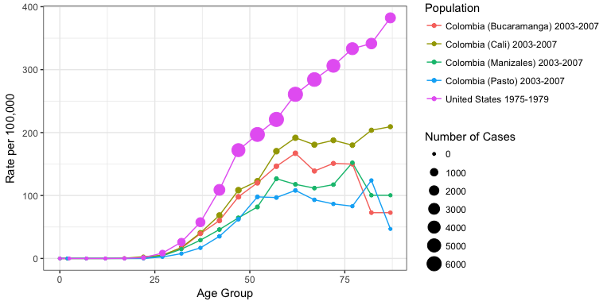

## Natural history parameters: stage and survival

### Solving for survivals without Tamoxifen or Chemo

|  |  |  |  |
| --- | --- | --- | --- |
| Description | Notation | East Africa | Colombia |
| Proportion of all cases that are ER positive | $$p_{i=ER+}$$ | 0.41 | 0.70 |
| Proportion of all cases that are ER negative | $$p_{i=ER-}=1-p_{j=ER+}$$ | 0.59 | 0.30 |
| Within stage and ER group i, proportion treated with treatment j | $$t_{ij}$$ | See table below | See table below |
| Hazard ratio for treatment j | $$h_{j}$$ | See table below | See table below |
| Observed 5-year survival, all ER | $$S_{o}$$ | 0.72 (early) | 0.55 (advanced) or 0.87 (early) |
| Baseline 5-year survival, all ER | $$S_{b}$$ | To be estimated for each stage | To be estimated for each stage |

Using the assumption $S_{b}$ is the same for both ER+ and ER-, observed survival is sum of survivals under each treatment, weighted by the proportion receiving each treatment. For treatment $j$, survival is $(S_{b})^{h_{i}}$

$$S_{o}=\sum_{i}{p_{i}}\sum_{j}{(}t_{ij}S_{b})^{h_{j}}$$

Rearranging terms gives a fractional polynomial for which $S_{b}$ is the root:

$$0=\sum_{i}{p_{i}}\sum_{j}{(}t_{ij}S_{b})^{h_{j}}-S_{o}$$

|  |  |  |  |  |  |
| --- | --- | --- | --- | --- | --- |
| Stage | ER Status $i$ | Treatment $j$ | Hazard ratio $h_{j}$ | East Africa $t_{ij}$, in % | Colombia $t_{ij}$, in % |
| Advanced | Positive | Endocrine | 0.7 |  | 10 |
|  |  | Chemo | 0.775 |  | 38 |
|  |  | Both | 0.5425 |  | 50 |
|  |  | None | 1 |  | 2 |
|  | Negative | Endocrine | 1 |  | 3 |
|  |  | Chemo | 0.775 |  | 85 |
|  |  | Both | 0.775 |  | 10 |
|  |  | None | 1 |  | 2 |
| Early | Positive | Endocrine | 0.7 | 100 | 58 |
|  |  | Chemo | 0.775 |  | 8 |
|  |  | Both | 0.5425 |  | 10 |
|  |  | None | 1 |  | 24 |
|  | Negative | Endocrine | 1 |  | 20 |
|  |  | Chemo | 0.775 |  | 50 |
|  |  | Both | 0.775 |  | 5 |
|  |  | None | 1 |  | 25 |

For example, for the early stage in East Africa:

$$S_{o}=\sum_{i}{p_{i}}\sum_{j}{(}t_{ij}S_{b})^{h_{j}}$$

$$0.72=0.41*({S_{b}}^{0.7})+0.59*({S_{b}}^{1})$$

Whereas for the advanced stage in Colombia:

$$0.55=0.70*(0.10{S_{b}}^{0.7}+0.38{S_{b}}^{0.775}+0.50{S_{b}}^{0.5425}+0.02{S_{b}}^{1})+0.30*(0.03{S_{b}}^{1}+0.85{S_{b}}^{0.775}+0.10{S_{b}}^{0.775}+0.02{S_{b}}^{1})$$

For the ER negative, no treatment and endocrine have the same hazard ratios, as do chemo and both. Those terms can thus be combined:

$$0.55=0.70*(0.10{S_{b}}^{0.7}+0.38{S_{b}}^{0.775}+0.50{S_{b}}^{0.5425}+0.02{S_{b}}^{1})+0.30*(0.05{S_{b}}^{1}+0.95{S_{b}}^{0.775})$$

### East Africa

Advanced-stage is 78% and proportion ER+ is 41%. Advanced-stage 5-year survival is 35%.

#### Solving for baseline survival without endocrine

We do this for **early-stage only**.

For cohort survival of 72% with 100% of the 41% ER+ treated with Tamoxifen (HR=0.7), *baseline* early-stage 5-year survival is (in %):

## [1] 69

Converting from survival to mortality rate gives us:

|  |  |  |  |
| --- | --- | --- | --- |
| stage | subgroup | mortrate | prop |
| Early | ER+ | 0.0752692 | 0.0902 |
| Early | ER- | 0.0752692 | 0.1298 |
| Advanced | ER+ | 0.2099644 | 0.3198 |
| Advanced | ER- | 0.2099644 | 0.4602 |

Other-cause mortality is taken from Ugandan life tables.

### Colombia

Advanced-stage is 45% and proportion ER+ is 70%.

#### Solving for baseline survival without endocrine, chemo or both

# Treated survivals  
early5yr <- 0.87  
adv5yr <- 0.55  
  
# ER positivity  
propERpos <- 0.70  
  
# Treatment proportions: e=endocrine, c=chemo, b=both, pos=ER+, ''=ER-  
  
# Hazard ratios: e=endocrine, c=chemo, b=both  
  
# For chemo, the terms with the same hazards are combined, i.e. chemo and both are tc and none and endocrine are t

** EARLY STAGE ** Baseline survival (in %) is:

## [1] 84

** ADVANCED STAGE ** Baseline survival (in %) is:

## [1] 41

Converting from survival to mortality rate gives us:

|  |  |  |  |
| --- | --- | --- | --- |
| stage | subgroup | mortrate | prop |
| Early | ER+ | 0.0350511 | 0.385 |
| Early | ER- | 0.0350511 | 0.165 |
| Advanced | ER+ | 0.1806737 | 0.315 |
| Advanced | ER- | 0.1806737 | 0.135 |

## Treatment

### East Africa

Treatment proportions for each policy (should sum to 1 within stage-ER groups)

|  |  |  |  |  |  |  |  |  |  |  |  |  |  |  |
| --- | --- | --- | --- | --- | --- | --- | --- | --- | --- | --- | --- | --- | --- | --- |
| txSSid | SSno | SSid | txSSno | txHR | E0: Surgery only | E1: Endocrine for ER+ | E2: E1 plus Chemo for ER- | E3: E2 plus Chemo for Advanced ER+ | E4: E1 plus downstaging to 60% advanced | E5: E2 plus downstaging to 60% advanced | E6: E3 plus downstaging to 60% advanced | E7: E1 plus downstaging to 35% advanced | E8: E2 plus downstaging to 35% advanced | E9: E3 plus downstaging to 35% advanced |
| None | 1 | Early.ER+ | 1 | 1.0000 | 1 | 0 | 0 | 0 | 0 | 0 | 0 | 0 | 0 | 0 |
| Tamoxifen | 1 | Early.ER+ | 2 | 0.7000 | 0 | 1 | 1 | 1 | 1 | 1 | 1 | 1 | 1 | 1 |
| Chemo | 1 | Early.ER+ | 3 | 0.7750 | 0 | 0 | 0 | 0 | 0 | 0 | 0 | 0 | 0 | 0 |
| Tamoxifen+Chemo | 1 | Early.ER+ | 4 | 0.5425 | 0 | 0 | 0 | 0 | 0 | 0 | 0 | 0 | 0 | 0 |
| None | 2 | Early.ER- | 5 | 1.0000 | 1 | 1 | 0 | 0 | 1 | 0 | 0 | 1 | 0 | 0 |
| Tamoxifen | 2 | Early.ER- | 6 | 1.0000 | 0 | 0 | 0 | 0 | 0 | 0 | 0 | 0 | 0 | 0 |
| Chemo | 2 | Early.ER- | 7 | 0.7750 | 0 | 0 | 1 | 1 | 0 | 1 | 1 | 0 | 1 | 1 |
| Tamoxifen+Chemo | 2 | Early.ER- | 8 | 0.7750 | 0 | 0 | 0 | 0 | 0 | 0 | 0 | 0 | 0 | 0 |
| None | 3 | Advanced.ER+ | 9 | 1.0000 | 1 | 0 | 0 | 0 | 0 | 0 | 0 | 0 | 0 | 0 |
| Tamoxifen | 3 | Advanced.ER+ | 10 | 0.7000 | 0 | 1 | 1 | 0 | 1 | 1 | 0 | 1 | 1 | 0 |
| Chemo | 3 | Advanced.ER+ | 11 | 0.7750 | 0 | 0 | 0 | 0 | 0 | 0 | 0 | 0 | 0 | 0 |
| Tamoxifen+Chemo | 3 | Advanced.ER+ | 12 | 0.5425 | 0 | 0 | 0 | 1 | 0 | 0 | 1 | 0 | 0 | 1 |
| None | 4 | Advanced.ER- | 13 | 1.0000 | 1 | 1 | 0 | 0 | 1 | 0 | 0 | 1 | 0 | 0 |
| Tamoxifen | 4 | Advanced.ER- | 14 | 1.0000 | 0 | 0 | 0 | 0 | 0 | 0 | 0 | 0 | 0 | 0 |
| Chemo | 4 | Advanced.ER- | 15 | 0.7750 | 0 | 0 | 1 | 1 | 0 | 1 | 1 | 0 | 1 | 1 |
| Tamoxifen+Chemo | 4 | Advanced.ER- | 16 | 0.7750 | 0 | 0 | 0 | 0 | 0 | 0 | 0 | 0 | 0 | 0 |

### Colombia

In Colombia, when we move from

Treatment proportions for each policy (should sum to 1 within stage-ER groups)

|  |  |  |  |  |  |  |  |  |  |  |  |  |
| --- | --- | --- | --- | --- | --- | --- | --- | --- | --- | --- | --- | --- |
| Move | | SSid affected | | Change in treatment for that SSid | | | | | | | | |
| A -> B (endocrine for all ER+) | | all ER pos | | None --> Endocrine; Chemo --> Both | | | | | | | | |
| B -> C (chemo for all ER-) | | all ER neg | | None --> Chemo; Endocrine --> Chemo; Both --> Chemo | | | | | | | | |
| C -> D (chemo for adv ER+) | | advanced ER pos | | Endocrine --> Both | | | | | | | | |
| txSSid | SSno | | SSid | txSSno | txHR | C0: Surgery and Endocrine for some ER+ | C1: C0 + Endocrine for all ER+ | C2: C1 plus Chemo for ER- | C3: C2 plus Chemo for Advanced ER+ | C4: C1 plus downstaging to 35% advanced | C5: C2 plus downstaging to 35% advanced | C6: C3 plus downstaging to 35% advanced | | C7: C1 plus downstaging to 30% advanced | C8: C2 plus downstaging to 30% advanced | C9: C3 plus downstaging to 30% advanced |
| None | 1 | | Early.ER+ | 1 | 1.0000 | 0.24 | 0.00 | 0.00 | 0.00 | 0.00 | 0.00 | 0.00 | | 0.00 | 0.00 | 0.00 |
| Tamoxifen | 1 | | Early.ER+ | 2 | 0.7000 | 0.58 | 0.82 | 0.82 | 0.82 | 0.82 | 0.82 | 0.82 | | 0.82 | 0.82 | 0.82 |
| Chemo | 1 | | Early.ER+ | 3 | 0.7750 | 0.08 | 0.00 | 0.00 | 0.00 | 0.00 | 0.00 | 0.00 | | 0.00 | 0.00 | 0.00 |
| Tamoxifen+Chemo | 1 | | Early.ER+ | 4 | 0.5425 | 0.10 | 0.18 | 0.18 | 0.18 | 0.18 | 0.18 | 0.18 | | 0.18 | 0.18 | 0.18 |
| None | 2 | | Early.ER- | 5 | 1.0000 | 0.25 | 0.25 | 0.00 | 0.00 | 0.25 | 0.00 | 0.00 | | 0.25 | 0.00 | 0.00 |
| Tamoxifen | 2 | | Early.ER- | 6 | 1.0000 | 0.20 | 0.20 | 0.00 | 0.00 | 0.20 | 0.00 | 0.00 | | 0.20 | 0.00 | 0.00 |
| Chemo | 2 | | Early.ER- | 7 | 0.7750 | 0.50 | 0.50 | 1.00 | 1.00 | 0.50 | 1.00 | 1.00 | | 0.50 | 1.00 | 1.00 |
| Tamoxifen+Chemo | 2 | | Early.ER- | 8 | 0.7750 | 0.05 | 0.05 | 0.00 | 0.00 | 0.05 | 0.00 | 0.00 | | 0.05 | 0.00 | 0.00 |
| None | 3 | | Advanced.ER+ | 9 | 1.0000 | 0.02 | 0.00 | 0.00 | 0.00 | 0.00 | 0.00 | 0.00 | | 0.00 | 0.00 | 0.00 |
| Tamoxifen | 3 | | Advanced.ER+ | 10 | 0.7000 | 0.10 | 0.12 | 0.12 | 0.00 | 0.12 | 0.12 | 0.00 | | 0.12 | 0.12 | 0.00 |
| Chemo | 3 | | Advanced.ER+ | 11 | 0.7750 | 0.38 | 0.00 | 0.00 | 0.00 | 0.00 | 0.00 | 0.00 | | 0.00 | 0.00 | 0.00 |
| Tamoxifen+Chemo | 3 | | Advanced.ER+ | 12 | 0.5425 | 0.50 | 0.88 | 0.88 | 1.00 | 0.88 | 0.88 | 1.00 | | 0.88 | 0.88 | 1.00 |
| None | 4 | | Advanced.ER- | 13 | 1.0000 | 0.02 | 0.02 | 0.00 | 0.00 | 0.02 | 0.00 | 0.00 | | 0.02 | 0.00 | 0.00 |
| Tamoxifen | 4 | | Advanced.ER- | 14 | 1.0000 | 0.03 | 0.03 | 0.00 | 0.00 | 0.03 | 0.00 | 0.00 | | 0.03 | 0.00 | 0.00 |
| Chemo | 4 | | Advanced.ER- | 15 | 0.7750 | 0.85 | 0.85 | 1.00 | 1.00 | 0.85 | 1.00 | 1.00 | | 0.85 | 1.00 | 1.00 |
| Tamoxifen+Chemo | 4 | | Advanced.ER- | 16 | 0.7750 | 0.10 | 0.10 | 0.00 | 0.00 | 0.10 | 0.00 | 0.00 | | 0.10 | 0.00 | 0.00 |

# Results

## Legends and Footnotes

### Tables

Legend: Breast cancer outcomes after 10 years, for 100,000 women ages [insert] at the time of intervention. Results are the average across 100 simulations. Footnote: The ARR for a given strategy is equivalent to the decrease in cumulative BC mortality compared to the P0 policy. Small discrepancies reflect rounding error.

## East Africa, ages 30-49, 100 sims

##   
## Initializing population...  
## Simulating base case stage and subgroup...  
## Determining stage shifts...  
## Simulating treatment received...  
## Simulating cancer mortality...  
## Tabulating time to and cause of death...  
## Summarizing outcomes...

|  |  |  |  |  |  |  |  |  |  |  |  |
| --- | --- | --- | --- | --- | --- | --- | --- | --- | --- | --- | --- |
| Follow-Up Year | Measure | E0: Surgery only | E1: Endocrine for ER+ | E2: E1 plus Chemo for ER- | E3: E2 plus Chemo for Advanced ER+ | E4: E1 plus downstaging to 60% advanced | E5: E2 plus downstaging to 60% advanced | E6: E3 plus downstaging to 60% advanced | E7: E1 plus downstaging to 35% advanced | E8: E2 plus downstaging to 35% advanced | E9: E3 plus downstaging to 35% advanced |
| 5 | Cumulative BC Incidence | 257 (230, 289) |  |  |  |  |  |  |  |  |  |
|  | Cumulative BC Mortality | 79 (64, 98) | 70 (50, 88) | 63 (49, 79) | 59 (46, 72) | 62 (45, 77) | 55 (43, 71) | 53 (42, 67) | 51 (34, 65) | 44 (32, 57) | 43 (33, 56) |
|  | % Incident Surviving | 69.2 (64.2, 73.3) | 72.7 (67.7, 79.3) | 75.7 (70.3, 81) | 76.9 (72.8, 80.7) | 76 (71.4, 81.6) | 78.5 (74.2, 83.4) | 79.4 (75, 83.5) | 80.3 (75.8, 85.3) | 82.9 (78.2, 87.7) | 83.2 (79.1, 86.4) |
|  | MRR | 1 (1, 1) | 0.89 (0.69, 1.12) | 0.8 (0.62, 1.01) | 0.76 (0.6, 0.94) | 0.79 (0.59, 1.01) | 0.7 (0.53, 0.88) | 0.67 (0.53, 0.82) | 0.64 (0.47, 0.81) | 0.56 (0.41, 0.75) | 0.55 (0.42, 0.7) |
|  | ARR | 0 (0, 0) | 9 (-9, 25) | 16 (0, 33) | 20 (4, 35) | 17 (-1, 34) | 24 (7, 40) | 26 (12, 41) | 29 (14, 45) | 35 (17, 52) | 36 (21, 53) |
|  | Years of Life Saved | 0 (0, 0) | 15 (-18, 51) | 29 (-6, 70) | 34 (2, 75) | 30 (-1, 67) | 42 (7, 81) | 46 (11, 86) | 50 (15, 88) | 61 (31, 102) | 62 (30, 102) |
| 10 | Cumulative BC Incidence | 616 (563, 663) |  |  |  |  |  |  |  |  |  |
|  | Cumulative BC Mortality | 277 (244, 303) | 254 (227, 281) | 231 (203, 265) | 217 (190, 247) | 226 (196, 253) | 206 (178, 242) | 195 (167, 224) | 190 (167, 213) | 171 (146, 198) | 164 (139, 186) |
|  | % Incident Surviving | 55 (51.6, 59.6) | 58.8 (55.2, 62.3) | 62.6 (58.8, 66.3) | 64.8 (60.6, 68.2) | 63.3 (59.8, 66.8) | 66.6 (63.1, 70.5) | 68.4 (64.1, 71.1) | 69.2 (66.1, 72.1) | 72.2 (68.6, 75.5) | 73.5 (69.5, 76.6) |
|  | MRR | 1 (1, 1) | 0.92 (0.83, 1.05) | 0.83 (0.74, 0.93) | 0.78 (0.69, 0.89) | 0.82 (0.72, 0.92) | 0.74 (0.66, 0.84) | 0.7 (0.61, 0.8) | 0.69 (0.61, 0.79) | 0.62 (0.54, 0.71) | 0.59 (0.51, 0.68) |
|  | ARR | 0 (0, 0) | 23 (-12, 49) | 46 (16, 74) | 60 (30, 90) | 51 (19, 80) | 71 (42, 98) | 82 (53, 112) | 87 (53, 115) | 106 (74, 132) | 114 (80, 138) |
|  | Years of Life Saved | 0 (0, 0) | 92 (-12, 200) | 179 (64, 298) | 227 (85, 335) | 191 (70, 312) | 268 (177, 380) | 305 (165, 421) | 324 (209, 438) | 395 (280, 523) | 418 (282, 552) |
| 20 | Cumulative BC Incidence | 1584 (1521, 1648) |  |  |  |  |  |  |  |  |  |
|  | Cumulative BC Mortality | 895 (844, 951) | 842 (798, 895) | 789 (736, 846) | 752 (706, 799) | 772 (728, 831) | 716 (667, 770) | 688 (639, 737) | 673 (623, 726) | 618 (567, 663) | 599 (554, 645) |
|  | % Incident Surviving | 43.5 (41.2, 45.7) | 46.8 (44.7, 49.2) | 50.2 (47.7, 52.3) | 52.5 (50.2, 54.8) | 51.2 (49, 53.6) | 54.8 (52.5, 56.8) | 56.5 (54.5, 58.8) | 57.5 (54.9, 59.6) | 61 (58.5, 63.4) | 62.1 (60.1, 63.9) |
|  | MRR | 1 (1, 1) | 0.94 (0.9, 0.98) | 0.88 (0.84, 0.92) | 0.84 (0.8, 0.88) | 0.86 (0.82, 0.9) | 0.8 (0.76, 0.84) | 0.77 (0.73, 0.81) | 0.75 (0.71, 0.79) | 0.69 (0.65, 0.73) | 0.67 (0.64, 0.7) |
|  | ARR | 0 (0, 0) | 53 (16, 95) | 106 (67, 141) | 143 (106, 183) | 123 (86, 165) | 179 (141, 215) | 207 (166, 248) | 222 (178, 274) | 277 (237, 322) | 296 (259, 333) |
|  | Years of Life Saved | 0 (0, 0) | 442 (87, 696) | 887 (605, 1167) | 1155 (916, 1437) | 997 (672, 1269) | 1419 (1143, 1708) | 1623 (1350, 1922) | 1752 (1351, 2040) | 2155 (1821, 2495) | 2290 (2019, 2591) |

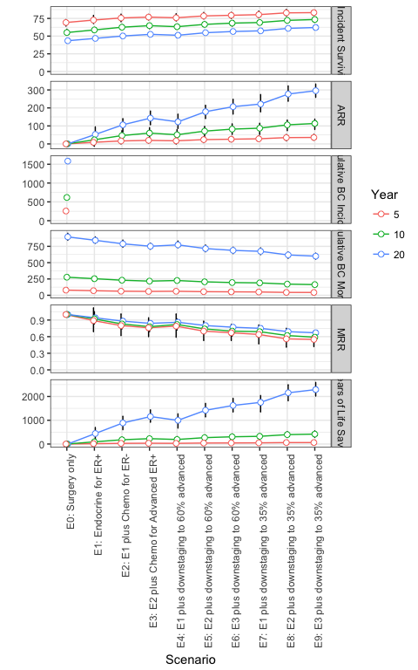

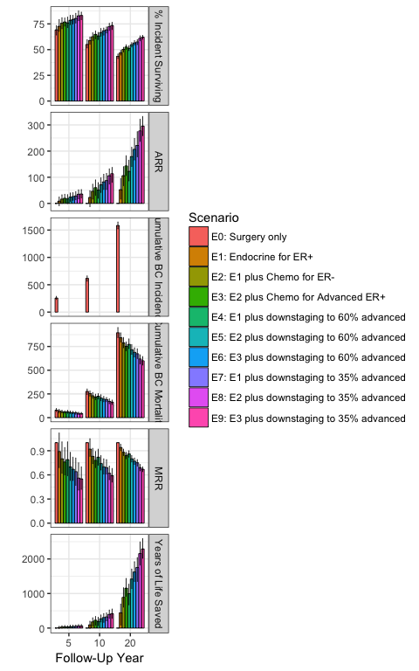

## Colombia, ages 50-69, 100 sims

##   
## Initializing population...  
## Simulating base case stage and subgroup...  
## Determining stage shifts...  
## Simulating treatment received...  
## Simulating cancer mortality...  
## Tabulating time to and cause of death...  
## Summarizing outcomes...

|  |  |  |  |  |  |  |  |  |  |  |  |
| --- | --- | --- | --- | --- | --- | --- | --- | --- | --- | --- | --- |
| Follow-Up Year | Measure | C0: Surgery and Endocrine for some ER+ | C1: C0 + Endocrine for all ER+ | C2: C1 plus Chemo for ER- | C3: C2 plus Chemo for Advanced ER+ | C4: C1 plus downstaging to 35% advanced | C5: C2 plus downstaging to 35% advanced | C6: C3 plus downstaging to 35% advanced | C7: C1 plus downstaging to 30% advanced | C8: C2 plus downstaging to 30% advanced | C9: C3 plus downstaging to 30% advanced |
| 5 | Cumulative BC Incidence | 864 (808, 907) |  |  |  |  |  |  |  |  |  |
|  | Cumulative BC Mortality | 126 (105, 145) | 114 (92, 130) | 115 (94, 136) | 113 (97, 128) | 100 (81, 116) | 100 (82, 120) | 98 (81, 114) | 93 (77, 108) | 92 (76, 113) | 91 (77, 106) |
|  | % Incident Surviving | 85.4 (83.1, 87.7) | 86.8 (84.9, 89.1) | 86.7 (84.5, 88.7) | 86.9 (84.9, 88.6) | 88.4 (86.5, 90.4) | 88.4 (86.4, 90.3) | 88.7 (86.8, 90.2) | 89.2 (87.1, 91.1) | 89.3 (87.2, 90.9) | 89.4 (87.5, 91) |
|  | MRR | 1 (1, 1) | 0.91 (0.71, 1.13) | 0.92 (0.72, 1.19) | 0.9 (0.73, 1.12) | 0.8 (0.64, 0.99) | 0.8 (0.63, 1.02) | 0.78 (0.61, 0.95) | 0.74 (0.58, 0.92) | 0.74 (0.58, 0.98) | 0.73 (0.56, 0.96) |
|  | ARR | 0 (0, 0) | 12 (-14, 40) | 12 (-20, 39) | 14 (-14, 37) | 26 (1, 51) | 26 (-3, 52) | 28 (5, 53) | 33 (8, 60) | 34 (2, 58) | 35 (5, 60) |
|  | Years of Life Saved | 0 (0, 0) | 24 (-38, 86) | 23 (-39, 79) | 26 (-33, 75) | 47 (-16, 105) | 48 (-13, 101) | 51 (-2, 101) | 60 (-4, 120) | 61 (6, 113) | 62 (6, 110) |
| 10 | Cumulative BC Incidence | 1767 (1691, 1854) |  |  |  |  |  |  |  |  |  |
|  | Cumulative BC Mortality | 424 (377, 456) | 393 (355, 437) | 394 (360, 432) | 388 (351, 422) | 347 (316, 386) | 348 (313, 385) | 343 (306, 375) | 325 (292, 362) | 325 (293, 359) | 319 (289, 356) |
|  | % Incident Surviving | 76 (74.5, 78.4) | 77.8 (75.7, 79.7) | 77.7 (76.1, 79.7) | 78 (76.5, 79.7) | 80.4 (78.3, 82.1) | 80.3 (78.4, 82.5) | 80.6 (79, 82.1) | 81.6 (79.8, 83.4) | 81.6 (80, 83.3) | 81.9 (79.9, 83.4) |
|  | MRR | 1 (1, 1) | 0.93 (0.84, 1.07) | 0.93 (0.83, 1.03) | 0.92 (0.83, 1.02) | 0.82 (0.73, 0.95) | 0.82 (0.75, 0.91) | 0.81 (0.73, 0.9) | 0.77 (0.69, 0.9) | 0.77 (0.69, 0.88) | 0.75 (0.68, 0.85) |
|  | ARR | 0 (0, 0) | 32 (-29, 70) | 30 (-11, 70) | 36 (-6, 73) | 77 (19, 122) | 76 (34, 111) | 81 (38, 118) | 99 (39, 135) | 100 (47, 135) | 105 (61, 141) |
|  | Years of Life Saved | 0 (0, 0) | 122 (-68, 302) | 116 (-100, 307) | 139 (-53, 308) | 286 (100, 462) | 283 (46, 468) | 304 (96, 463) | 367 (152, 548) | 371 (128, 574) | 387 (183, 551) |
| 20 | Cumulative BC Incidence | 3578 (3481, 3691) |  |  |  |  |  |  |  |  |  |
|  | Cumulative BC Mortality | 1181 (1100, 1250) | 1115 (1047, 1183) | 1106 (1045, 1172) | 1097 (1042, 1161) | 1003 (939, 1068) | 991 (932, 1052) | 985 (930, 1041) | 947 (886, 1002) | 936 (884, 998) | 929 (871, 983) |
|  | % Incident Surviving | 67 (65, 68.8) | 68.8 (67.5, 70.7) | 69.1 (67.8, 70.4) | 69.3 (67.7, 70.9) | 72 (70.6, 73.6) | 72.3 (70.9, 73.7) | 72.5 (70.9, 73.8) | 73.5 (72.1, 75.1) | 73.8 (72.7, 75.2) | 74 (72.3, 75.6) |
|  | MRR | 1 (1, 1) | 0.94 (0.89, 1) | 0.94 (0.89, 0.99) | 0.93 (0.88, 0.99) | 0.85 (0.8, 0.9) | 0.84 (0.79, 0.89) | 0.83 (0.79, 0.88) | 0.8 (0.75, 0.85) | 0.79 (0.76, 0.84) | 0.79 (0.74, 0.84) |
|  | ARR | 0 (0, 0) | 66 (-1, 134) | 75 (11, 128) | 84 (15, 146) | 179 (114, 244) | 190 (121, 252) | 197 (131, 250) | 234 (170, 307) | 246 (178, 294) | 252 (178, 316) |
|  | Years of Life Saved | 0 (0, 0) | 537 (98, 1072) | 566 (-3, 1106) | 669 (208, 1068) | 1396 (837, 1953) | 1435 (832, 1992) | 1518 (996, 1959) | 1795 (1294, 2321) | 1865 (1237, 2340) | 1940 (1443, 2349) |

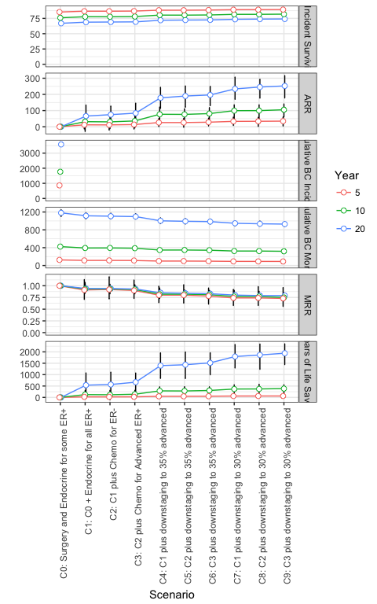

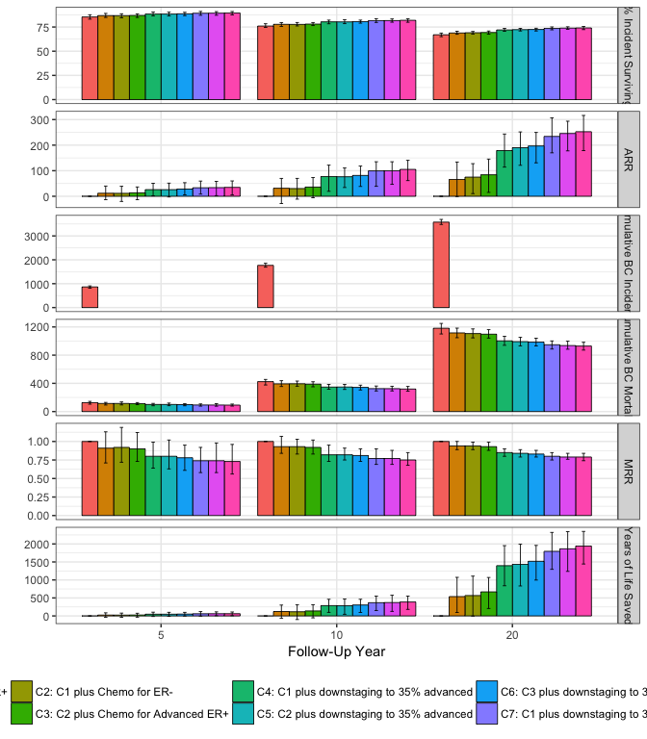

# Combined Results

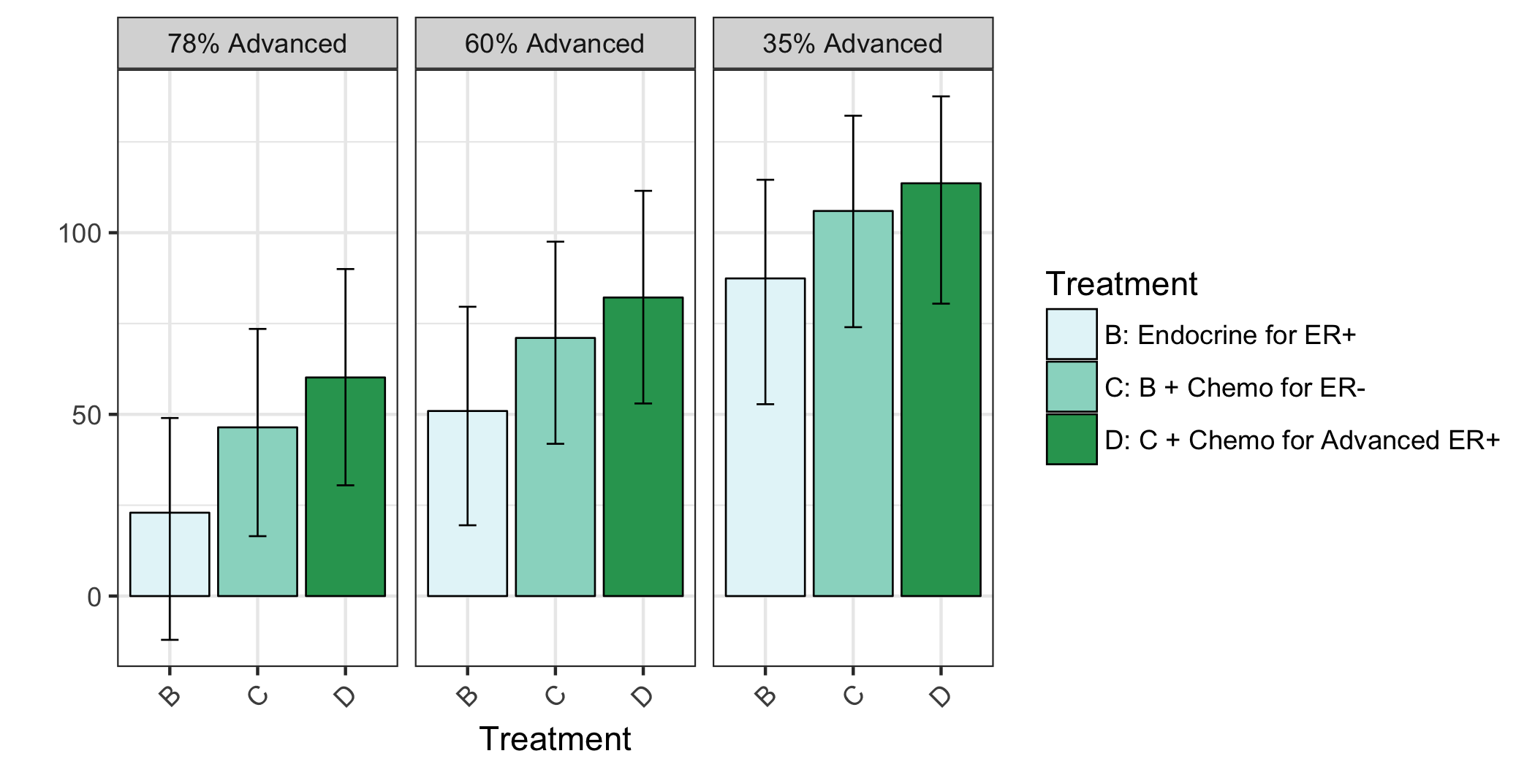

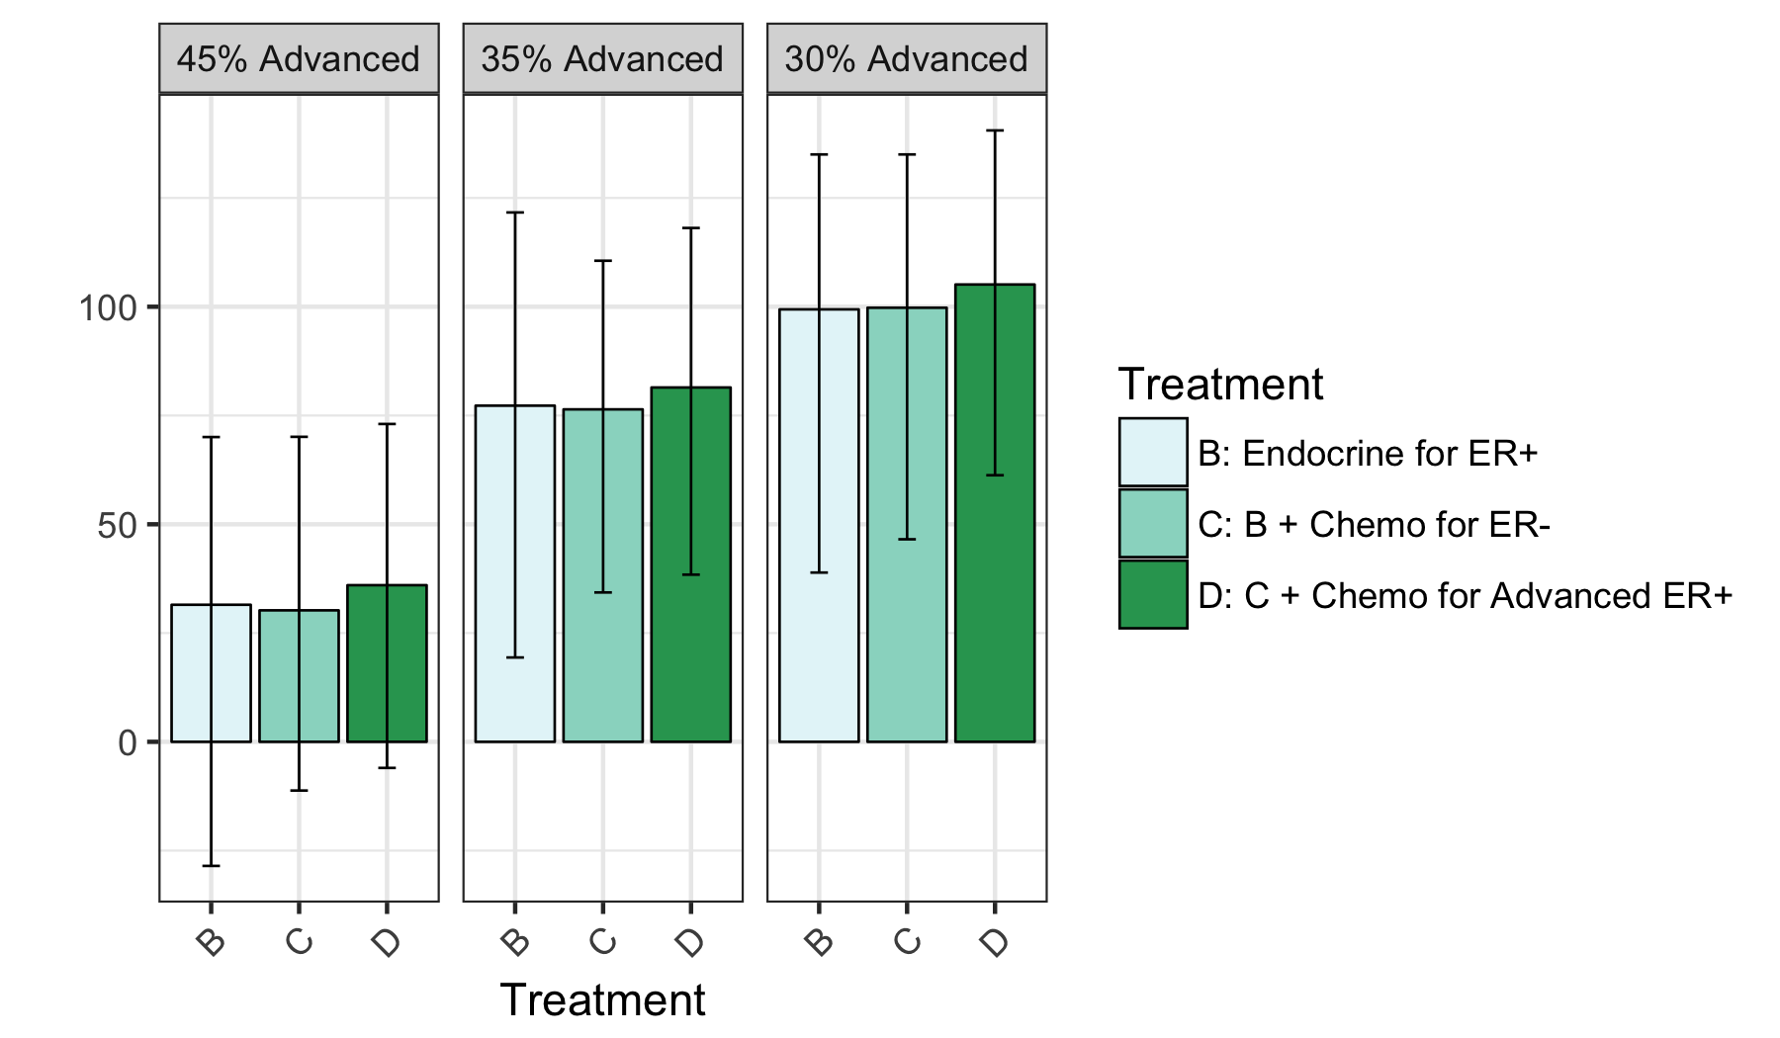 # Comments