Policy simulations for East Africa and Colombia

## Warning: package 'reshape' was built under R version 3.3.2

## Warning: package 'ggplot2' was built under R version 3.3.2

## Warning: package 'knitr' was built under R version 3.3.2

# Inputs

## Policies to investigate

### East Africa

Note: baseline % advanced = 78%

|  |  |  |  |  |
| --- | --- | --- | --- | --- |
| num | id | name | pairnum | earlydetHR |
| 1 | adv78 | E0: Surgery only | NA | 1.0000000 |
| 2 | adv78.tam | E1: Endocrine for ER+ | NA | 1.0000000 |
| 3 | adv78.tamchemo | E2: E1 plus Chemo for ER- | NA | 1.0000000 |
| 4 | adv78.tamchemoERpos | E3: E2 plus Chemo for Advanced ER+ | NA | 1.0000000 |
| 5 | adv60.tam | E4: E1 plus downstaging to 60% advanced | 2 | 0.7692308 |
| 6 | adv60.tamchemo | E5: E2 plus downstaging to 60% advanced | 3 | 0.7692308 |
| 7 | adv60.tamchemoERpos | E6: E3 plus downstaging to 60% advanced | 4 | 0.7692308 |
| 8 | adv35.tam | E7: E1 plus downstaging to 35% advanced | 2 | 0.4487179 |
| 9 | adv35.tamchemo | E8: E2 plus downstaging to 35% advanced | 3 | 0.4487179 |
| 10 | adv35.tamchemoERpos | E9: E3 plus downstaging to 35% advanced | 4 | 0.4487179 |

### Colombia

Note: baseline % advanced = 45%.

|  |  |  |  |  |
| --- | --- | --- | --- | --- |
| num | id | name | pairnum | earlydetHR |
| 1 | adv45 | C0: Surgery and Endocrine for some ER+ | NA | 1.0000000 |
| 2 | adv45.tam | C1: C0 + Endocrine for all ER+ | NA | 1.0000000 |
| 3 | adv45.tamchemo | C2: C1 plus Chemo for ER- | NA | 1.0000000 |
| 4 | adv45.tamchemoERpos | C3: C2 plus Chemo for Advanced ER+ | NA | 1.0000000 |
| 5 | adv35.tam | C4: C1 plus downstaging to 35% advanced | 2 | 0.7777778 |
| 6 | adv35.tamchemo | C5: C2 plus downstaging to 35% advanced | 3 | 0.7777778 |
| 7 | adv35.tamchemoERpos | C6: C3 plus downstaging to 35% advanced | 4 | 0.7777778 |
| 8 | adv30.tam | C7: C1 plus downstaging to 30% advanced | 2 | 0.6666667 |
| 9 | adv30.tamchemo | C8: C2 plus downstaging to 30% advanced | 3 | 0.6666667 |
| 10 | adv30.tamchemoERpos | C9: C3 plus downstaging to 30% advanced | 4 | 0.6666667 |

## Natural history parameters: incidence

### East Africa

We are using Uganda for our East Africa example. 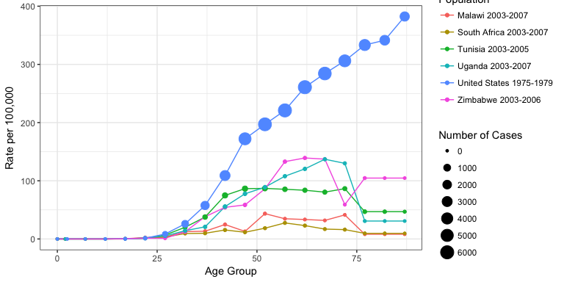

### Colombia

We are using Cali, Colombia for our example. 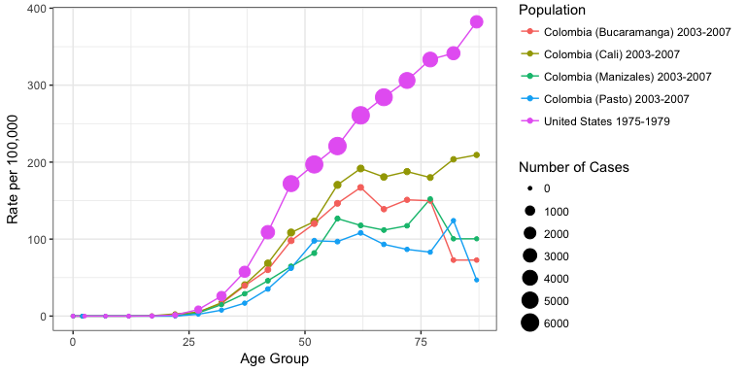

## Natural history parameters: stage and survival

### Solving for survivals without Tamoxifen or Chemo

|  |  |  |  |
| --- | --- | --- | --- |
| Description | Notation | East Africa | Colombia |
| Proportion of all cases that are ER positive | $p_{i=ER+}$ | 0.41 | 0.70 |
| Proportion of all cases that are ER negative | $p_{i=ER−}=1−p_{j=ER+}$ | 0.59 | 0.30 |
| Within stage and ER group i, proportion treated with treatment j | $t_{ij}$ | See table below | See table below |
| Hazard ratio for treatment j | $h_{j}$ | See table below | See table below |
| Observed 5-year survival, all ER | $S_{o}$ | 0.72 (early) | 0.55 (advanced) or 0.87 (early) |
| Baseline 5-year survival, all ER | $S_{b}$ | To be estimated for each stage | To be estimated for each stage |

Using the assumption $S_{b}$ is the same for both ER+ and ER-, observed survival is sum of survivals under each treatment, weighted by the proportion receiving each treatment. For treatment $j$, survival is $(S_{b})^{h_{i}}$

$$S_{o}=\sum_{i}{p_{i}}\sum_{j}{(}t_{ij}S_{b})^{h_{j}}$$

Rearranging terms gives a fractional polynomial for which $S_{b}$ is the root:

$$0=\sum_{i}{p_{i}}\sum_{j}{(}t_{ij}S_{b})^{h_{j}}−S_{o}$$

|  |  |  |  |  |  |
| --- | --- | --- | --- | --- | --- |
| Stage | ER Status $i$ | Treatment $j$ | Hazard ratio $h_{j}$ | East Africa $t_{ij}$, in % | Colombia $t_{ij}$, in % |
| Advanced | Positive | Endocrine | 0.7 |  | 10 |
|  |  | Chemo | 0.775 |  | 38 |
|  |  | Both | 0.5425 |  | 50 |
|  |  | None | 1 |  | 2 |
|  | Negative | Endocrine | 1 |  | 3 |
|  |  | Chemo | 0.775 |  | 85 |
|  |  | Both | 0.775 |  | 10 |
|  |  | None | 1 |  | 2 |
| Early | Positive | Endocrine | 0.7 | 100 | 58 |
|  |  | Chemo | 0.775 |  | 8 |
|  |  | Both | 0.5425 |  | 10 |
|  |  | None | 1 |  | 24 |
|  | Negative | Endocrine | 1 |  | 20 |
|  |  | Chemo | 0.775 |  | 50 |
|  |  | Both | 0.775 |  | 5 |
|  |  | None | 1 |  | 25 |

For example, for the early stage in East Africa:

$$S_{o}=\sum_{i}{p_{i}}\sum_{j}{(}t_{ij}S_{b})^{h_{j}}$$

$$0.72=0.41*({S_{b}}^{0.7})+0.59*({S_{b}}^{1})$$

Whereas for the advanced stage in Colombia:

$$0.55=0.70*(0.10{S_{b}}^{0.7}+0.38{S_{b}}^{0.775}+0.50{S_{b}}^{0.5425}+0.02{S_{b}}^{1})+0.30*(0.03{S_{b}}^{1}+0.85{S_{b}}^{0.775}+0.10{S_{b}}^{0.775}+0.02{S_{b}}^{1})$$

For the ER negative, no treatment and endocrine have the same hazard ratios, as do chemo and both. Those terms can thus be combined:

$$0.55=0.70*(0.10{S_{b}}^{0.7}+0.38{S_{b}}^{0.775}+0.50{S_{b}}^{0.5425}+0.02{S_{b}}^{1})+0.30*(0.05{S_{b}}^{1}+0.95{S_{b}}^{0.775})$$

### East Africa

Advanced-stage is 78% and proportion ER+ is 41%. Advanced-stage 5-year survival is 35%.

#### Solving for baseline survival without endocrine

We do this for **early-stage only**.

For cohort survival of 72% with 100% of the 41% ER+ treated with Tamoxifen (HR=0.7), *baseline* early-stage 5-year survival is (in %):

## [1] 69

Converting from survival to mortality rate gives us:

|  |  |  |  |
| --- | --- | --- | --- |
| stage | subgroup | mortrate | prop |
| Early | ER+ | 0.0752692 | 0.0902 |
| Early | ER- | 0.0752692 | 0.1298 |
| Advanced | ER+ | 0.2099644 | 0.3198 |
| Advanced | ER- | 0.2099644 | 0.4602 |

Other-cause mortality is taken from Ugandan life tables.

### Colombia

Advanced-stage is 45% and proportion ER+ is 70%.

#### Solving for baseline survival without endocrine, chemo or both

# Treated survivals  
early5yr <- 0.87  
adv5yr <- 0.55  
  
# ER positivity  
propERpos <- 0.70  
  
# Treatment proportions: e=endocrine, c=chemo, b=both, pos=ER+, ''=ER-  
  
# Hazard ratios: e=endocrine, c=chemo, b=both  
  
# For chemo, the terms with the same hazards are combined, i.e. chemo and both are tc and none and endocrine are t

** EARLY STAGE ** Baseline survival (in %) is:

## [1] 84

** ADVANCED STAGE ** Baseline survival (in %) is:

## [1] 41

Converting from survival to mortality rate gives us:

|  |  |  |  |
| --- | --- | --- | --- |
| stage | subgroup | mortrate | prop |
| Early | ER+ | 0.0350511 | 0.385 |
| Early | ER- | 0.0350511 | 0.165 |
| Advanced | ER+ | 0.1806737 | 0.315 |
| Advanced | ER- | 0.1806737 | 0.135 |

## Treatment

### East Africa

Treatment proportions for each policy (should sum to 1 within stage-ER groups)

|  |  |  |  |  |  |  |  |  |  |  |  |  |  |  |
| --- | --- | --- | --- | --- | --- | --- | --- | --- | --- | --- | --- | --- | --- | --- |
| txSSid | SSno | SSid | txSSno | txHR | E0: Surgery only | E1: Endocrine for ER+ | E2: E1 plus Chemo for ER- | E3: E2 plus Chemo for Advanced ER+ | E4: E1 plus downstaging to 60% advanced | E5: E2 plus downstaging to 60% advanced | E6: E3 plus downstaging to 60% advanced | E7: E1 plus downstaging to 35% advanced | E8: E2 plus downstaging to 35% advanced | E9: E3 plus downstaging to 35% advanced |
| None | 1 | Early.ER+ | 1 | 1.0000 | 1 | 0 | 0 | 0 | 0 | 0 | 0 | 0 | 0 | 0 |
| Tamoxifen | 1 | Early.ER+ | 2 | 0.7000 | 0 | 1 | 1 | 1 | 1 | 1 | 1 | 1 | 1 | 1 |
| Chemo | 1 | Early.ER+ | 3 | 0.7750 | 0 | 0 | 0 | 0 | 0 | 0 | 0 | 0 | 0 | 0 |
| Tamoxifen+Chemo | 1 | Early.ER+ | 4 | 0.5425 | 0 | 0 | 0 | 0 | 0 | 0 | 0 | 0 | 0 | 0 |
| None | 2 | Early.ER- | 5 | 1.0000 | 1 | 1 | 0 | 0 | 1 | 0 | 0 | 1 | 0 | 0 |
| Tamoxifen | 2 | Early.ER- | 6 | 1.0000 | 0 | 0 | 0 | 0 | 0 | 0 | 0 | 0 | 0 | 0 |
| Chemo | 2 | Early.ER- | 7 | 0.7750 | 0 | 0 | 1 | 1 | 0 | 1 | 1 | 0 | 1 | 1 |
| Tamoxifen+Chemo | 2 | Early.ER- | 8 | 0.7750 | 0 | 0 | 0 | 0 | 0 | 0 | 0 | 0 | 0 | 0 |
| None | 3 | Advanced.ER+ | 9 | 1.0000 | 1 | 0 | 0 | 0 | 0 | 0 | 0 | 0 | 0 | 0 |
| Tamoxifen | 3 | Advanced.ER+ | 10 | 0.7000 | 0 | 1 | 1 | 0 | 1 | 1 | 0 | 1 | 1 | 0 |
| Chemo | 3 | Advanced.ER+ | 11 | 0.7750 | 0 | 0 | 0 | 0 | 0 | 0 | 0 | 0 | 0 | 0 |
| Tamoxifen+Chemo | 3 | Advanced.ER+ | 12 | 0.5425 | 0 | 0 | 0 | 1 | 0 | 0 | 1 | 0 | 0 | 1 |
| None | 4 | Advanced.ER- | 13 | 1.0000 | 1 | 1 | 0 | 0 | 1 | 0 | 0 | 1 | 0 | 0 |
| Tamoxifen | 4 | Advanced.ER- | 14 | 1.0000 | 0 | 0 | 0 | 0 | 0 | 0 | 0 | 0 | 0 | 0 |
| Chemo | 4 | Advanced.ER- | 15 | 0.7750 | 0 | 0 | 1 | 1 | 0 | 1 | 1 | 0 | 1 | 1 |
| Tamoxifen+Chemo | 4 | Advanced.ER- | 16 | 0.7750 | 0 | 0 | 0 | 0 | 0 | 0 | 0 | 0 | 0 | 0 |

### Colombia

In Colombia, when we move from

Treatment proportions for each policy (should sum to 1 within stage-ER groups)

|  |  |  |
| --- | --- | --- |
| Move | SSid affected | Change in treatment for that SSid |
| A -> B (endocrine for all ER+) | all ER pos | None --> Endocrine; Chemo --> Both |
| B -> C (chemo for all ER-) | all ER neg | None --> Chemo; Endocrine --> Chemo; Both --> Chemo |
| C -> D (chemo for adv ER+) | advanced ER pos | Endocrine --> Both |

|  |  |  |  |  |  |  |  |  |  |  |  |  |  |  |
| --- | --- | --- | --- | --- | --- | --- | --- | --- | --- | --- | --- | --- | --- | --- |
| txSSid | SSno | SSid | txSSno | txHR | C0: Surgery and Endocrine for some ER+ | C1: C0 + Endocrine for all ER+ | C2: C1 plus Chemo for ER- | C3: C2 plus Chemo for Advanced ER+ | C4: C1 plus downstaging to 35% advanced | C5: C2 plus downstaging to 35% advanced | C6: C3 plus downstaging to 35% advanced | C7: C1 plus downstaging to 30% advanced | C8: C2 plus downstaging to 30% advanced | C9: C3 plus downstaging to 30% advanced |
| None | 1 | Early.ER+ | 1 | 1.0000 | 0.24 | 0.00 | 0.00 | 0.00 | 0.00 | 0.00 | 0.00 | 0.00 | 0.00 | 0.00 |
| Tamoxifen | 1 | Early.ER+ | 2 | 0.7000 | 0.58 | 0.82 | 0.82 | 0.82 | 0.82 | 0.82 | 0.82 | 0.82 | 0.82 | 0.82 |
| Chemo | 1 | Early.ER+ | 3 | 0.7750 | 0.08 | 0.00 | 0.00 | 0.00 | 0.00 | 0.00 | 0.00 | 0.00 | 0.00 | 0.00 |
| Tamoxifen+Chemo | 1 | Early.ER+ | 4 | 0.5425 | 0.10 | 0.18 | 0.18 | 0.18 | 0.18 | 0.18 | 0.18 | 0.18 | 0.18 | 0.18 |
| None | 2 | Early.ER- | 5 | 1.0000 | 0.25 | 0.25 | 0.00 | 0.00 | 0.25 | 0.00 | 0.00 | 0.25 | 0.00 | 0.00 |
| Tamoxifen | 2 | Early.ER- | 6 | 1.0000 | 0.20 | 0.20 | 0.00 | 0.00 | 0.20 | 0.00 | 0.00 | 0.20 | 0.00 | 0.00 |
| Chemo | 2 | Early.ER- | 7 | 0.7750 | 0.50 | 0.50 | 1.00 | 1.00 | 0.50 | 1.00 | 1.00 | 0.50 | 1.00 | 1.00 |
| Tamoxifen+Chemo | 2 | Early.ER- | 8 | 0.7750 | 0.05 | 0.05 | 0.00 | 0.00 | 0.05 | 0.00 | 0.00 | 0.05 | 0.00 | 0.00 |
| None | 3 | Advanced.ER+ | 9 | 1.0000 | 0.02 | 0.00 | 0.00 | 0.00 | 0.00 | 0.00 | 0.00 | 0.00 | 0.00 | 0.00 |
| Tamoxifen | 3 | Advanced.ER+ | 10 | 0.7000 | 0.10 | 0.12 | 0.12 | 0.00 | 0.12 | 0.12 | 0.00 | 0.12 | 0.12 | 0.00 |
| Chemo | 3 | Advanced.ER+ | 11 | 0.7750 | 0.38 | 0.00 | 0.00 | 0.00 | 0.00 | 0.00 | 0.00 | 0.00 | 0.00 | 0.00 |
| Tamoxifen+Chemo | 3 | Advanced.ER+ | 12 | 0.5425 | 0.50 | 0.88 | 0.88 | 1.00 | 0.88 | 0.88 | 1.00 | 0.88 | 0.88 | 1.00 |
| None | 4 | Advanced.ER- | 13 | 1.0000 | 0.02 | 0.02 | 0.00 | 0.00 | 0.02 | 0.00 | 0.00 | 0.02 | 0.00 | 0.00 |
| Tamoxifen | 4 | Advanced.ER- | 14 | 1.0000 | 0.03 | 0.03 | 0.00 | 0.00 | 0.03 | 0.00 | 0.00 | 0.03 | 0.00 | 0.00 |
| Chemo | 4 | Advanced.ER- | 15 | 0.7750 | 0.85 | 0.85 | 1.00 | 1.00 | 0.85 | 1.00 | 1.00 | 0.85 | 1.00 | 1.00 |
| Tamoxifen+Chemo | 4 | Advanced.ER- | 16 | 0.7750 | 0.10 | 0.10 | 0.00 | 0.00 | 0.10 | 0.00 | 0.00 | 0.10 | 0.00 | 0.00 |

# Results

## Legends and Footnotes

### Tables

Legend: Breast cancer outcomes after 10 years, for 100,000 women ages [insert] at the time of intervention. Results are the average across 100 simulations. Footnote: The ARR for a given strategy is equivalent to the decrease in cumulative BC mortality compared to the P0 policy. Small discrepancies reflect rounding error.

## East Africa, ages 30-49, 100 sims

##   
## Initializing population...  
## Simulating base case stage and subgroup...  
## Determining stage shifts...  
## Simulating treatment received...  
## Simulating cancer mortality...  
## Tabulating time to and cause of death...  
## Summarizing outcomes...

|  |  |  |  |  |  |  |  |  |  |  |  |
| --- | --- | --- | --- | --- | --- | --- | --- | --- | --- | --- | --- |
| Follow-Up Year | Measure | E0: Surgery only | E1: Endocrine for ER+ | E2: E1 plus Chemo for ER- | E3: E2 plus Chemo for Advanced ER+ | E4: E1 plus downstaging to 60% advanced | E5: E2 plus downstaging to 60% advanced | E6: E3 plus downstaging to 60% advanced | E7: E1 plus downstaging to 35% advanced | E8: E2 plus downstaging to 35% advanced | E9: E3 plus downstaging to 35% advanced |
| 5 | Cumulative BC Incidence | 260 (235, 283) |  |  |  |  |  |  |  |  |  |
|  | Cumulative BC Mortality | 79 (65, 99) | 72 (59, 94) | 63 (48, 76) | 60 (48, 75) | 63 (52, 84) | 55 (39, 67) | 54 (43, 67) | 52 (41, 69) | 45 (34, 56) | 44 (31, 58) |
|  | % Incident Surviving | 69.5 (64, 73.7) | 72.3 (66.8, 76.2) | 75.9 (71.5, 80.9) | 76.8 (71.3, 81.2) | 75.7 (70.2, 79) | 79 (74.5, 83.8) | 79.2 (74.6, 84.2) | 80 (75.5, 83.6) | 82.8 (78.3, 87.1) | 83.2 (77.7, 87.9) |
|  | MRR | 1 (1, 1) | 0.91 (0.71, 1.17) | 0.79 (0.65, 0.99) | 0.77 (0.62, 0.97) | 0.8 (0.63, 1.02) | 0.69 (0.54, 0.88) | 0.69 (0.54, 0.89) | 0.66 (0.51, 0.87) | 0.57 (0.45, 0.73) | 0.56 (0.39, 0.76) |
|  | ARR | 0 (0, 0) | 7 (-13, 28) | 17 (1, 32) | 19 (2, 34) | 16 (-1, 35) | 25 (9, 41) | 25 (8, 42) | 27 (9, 48) | 35 (18, 53) | 36 (17, 52) |
|  | Years of Life Saved | 0 (0, 0) | 15 (-42, 53) | 33 (-4, 67) | 37 (-7, 77) | 28 (-25, 63) | 47 (9, 84) | 49 (5, 90) | 50 (-3, 86) | 65 (29, 105) | 65 (22, 105) |
| 10 | Cumulative BC Incidence | 619 (581, 661) |  |  |  |  |  |  |  |  |  |
|  | Cumulative BC Mortality | 278 (250, 305) | 258 (230, 288) | 233 (206, 254) | 223 (192, 251) | 230 (204, 259) | 208 (185, 226) | 200 (172, 230) | 193 (167, 215) | 173 (150, 194) | 169 (137, 195) |
|  | % Incident Surviving | 55.1 (51.3, 59) | 58.4 (53.4, 62.1) | 62.4 (60, 65.2) | 64 (60, 68) | 62.9 (58.6, 66.1) | 66.5 (63.5, 69.4) | 67.7 (64.2, 71.5) | 68.8 (65.1, 71.8) | 72.1 (68.9, 74.7) | 72.8 (68.7, 76.9) |
|  | MRR | 1 (1, 1) | 0.93 (0.85, 1.03) | 0.84 (0.75, 0.91) | 0.8 (0.72, 0.88) | 0.83 (0.75, 0.93) | 0.75 (0.69, 0.82) | 0.72 (0.64, 0.81) | 0.7 (0.61, 0.78) | 0.62 (0.56, 0.68) | 0.61 (0.53, 0.68) |
|  | ARR | 0 (0, 0) | 21 (-9, 44) | 45 (23, 74) | 55 (35, 79) | 48 (17, 74) | 71 (47, 95) | 78 (53, 98) | 85 (56, 114) | 105 (82, 129) | 110 (87, 136) |
|  | Years of Life Saved | 0 (0, 0) | 83 (-55, 223) | 178 (84, 264) | 219 (103, 344) | 182 (44, 331) | 269 (162, 354) | 297 (171, 420) | 314 (200, 448) | 396 (302, 503) | 412 (282, 534) |
| 20 | Cumulative BC Incidence | 1585 (1533, 1655) |  |  |  |  |  |  |  |  |  |
|  | Cumulative BC Mortality | 898 (833, 946) | 839 (788, 890) | 787 (734, 840) | 758 (694, 812) | 766 (717, 819) | 717 (667, 764) | 693 (636, 746) | 671 (624, 709) | 618 (571, 670) | 604 (546, 651) |
|  | % Incident Surviving | 43.4 (41.2, 46.2) | 47.1 (44.5, 49.8) | 50.3 (48.1, 52.6) | 52.2 (49.8, 55.2) | 51.7 (49.3, 54) | 54.8 (52.8, 56.8) | 56.3 (54, 58.9) | 57.7 (55.8, 60.5) | 61 (58.6, 63.3) | 61.9 (60, 64.5) |
|  | MRR | 1 (1, 1) | 0.94 (0.9, 0.97) | 0.88 (0.84, 0.92) | 0.84 (0.79, 0.89) | 0.85 (0.82, 0.89) | 0.8 (0.76, 0.84) | 0.77 (0.72, 0.82) | 0.75 (0.72, 0.78) | 0.69 (0.65, 0.72) | 0.67 (0.63, 0.71) |
|  | ARR | 0 (0, 0) | 58 (27, 94) | 110 (71, 149) | 140 (95, 185) | 131 (98, 169) | 180 (140, 220) | 205 (154, 246) | 226 (194, 266) | 279 (239, 324) | 293 (246, 326) |
|  | Years of Life Saved | 0 (0, 0) | 432 (93, 682) | 887 (632, 1299) | 1098 (867, 1385) | 990 (629, 1265) | 1409 (1164, 1814) | 1575 (1292, 1834) | 1726 (1395, 2017) | 2152 (1851, 2522) | 2239 (1967, 2514) |

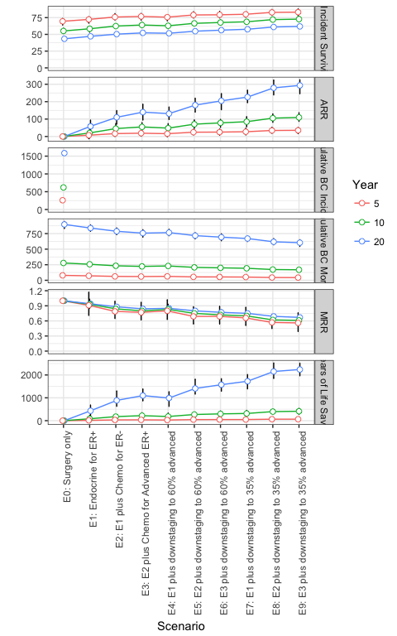

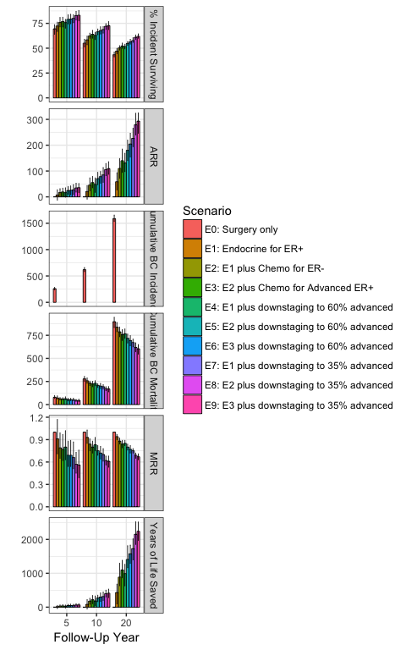

## Colombia, ages 50-69, 100 sims

##   
## Initializing population...  
## Simulating base case stage and subgroup...  
## Determining stage shifts...  
## Simulating treatment received...  
## Simulating cancer mortality...  
## Tabulating time to and cause of death...  
## Summarizing outcomes...

|  |  |  |  |  |  |  |  |  |  |  |  |
| --- | --- | --- | --- | --- | --- | --- | --- | --- | --- | --- | --- |
| Follow-Up Year | Measure | C0: Surgery and Endocrine for some ER+ | C1: C0 + Endocrine for all ER+ | C2: C1 plus Chemo for ER- | C3: C2 plus Chemo for Advanced ER+ | C4: C1 plus downstaging to 35% advanced | C5: C2 plus downstaging to 35% advanced | C6: C3 plus downstaging to 35% advanced | C7: C1 plus downstaging to 30% advanced | C8: C2 plus downstaging to 30% advanced | C9: C3 plus downstaging to 30% advanced |
| 5 | Cumulative BC Incidence | 868 (828, 925) |  |  |  |  |  |  |  |  |  |
|  | Cumulative BC Mortality | 129 (104, 148) | 116 (98, 136) | 112 (93, 136) | 114 (93, 135) | 102 (84, 123) | 98 (80, 117) | 99 (85, 118) | 93 (80, 109) | 91 (72, 109) | 93 (76, 112) |
|  | % Incident Surviving | 85.2 (83.4, 87.7) | 86.6 (84.7, 88.9) | 87 (84.5, 89.1) | 86.9 (84.7, 89.1) | 88.3 (86.3, 90.5) | 88.8 (87, 90.6) | 88.5 (86.7, 90.1) | 89.2 (87.8, 90.9) | 89.5 (87.9, 91.5) | 89.2 (87.5, 91.1) |
|  | MRR | 1 (1, 1) | 0.91 (0.71, 1.13) | 0.88 (0.71, 1.12) | 0.89 (0.72, 1.11) | 0.79 (0.6, 1.02) | 0.76 (0.6, 1) | 0.78 (0.59, 0.95) | 0.73 (0.57, 0.91) | 0.71 (0.56, 0.92) | 0.73 (0.6, 0.91) |
|  | ARR | 0 (0, 0) | 13 (-14, 41) | 16 (-15, 39) | 15 (-12, 40) | 27 (-2, 55) | 31 (0, 58) | 29 (5, 54) | 35 (9, 58) | 38 (10, 61) | 35 (10, 58) |
|  | Years of Life Saved | 0 (0, 0) | 25 (-23, 74) | 29 (-29, 109) | 28 (-22, 85) | 50 (3, 100) | 55 (-7, 130) | 53 (1, 120) | 64 (18, 111) | 68 (6, 142) | 63 (19, 122) |
| 10 | Cumulative BC Incidence | 1767 (1711, 1817) |  |  |  |  |  |  |  |  |  |
|  | Cumulative BC Mortality | 428 (392, 461) | 397 (369, 430) | 393 (355, 430) | 393 (364, 423) | 352 (325, 383) | 346 (315, 371) | 346 (323, 381) | 327 (299, 363) | 321 (289, 349) | 323 (297, 353) |
|  | % Incident Surviving | 75.8 (74.3, 77.8) | 77.5 (75.9, 79.1) | 77.8 (76.3, 79.3) | 77.8 (76, 79.1) | 80.1 (78.5, 81.5) | 80.4 (79, 81.9) | 80.4 (78.4, 81.9) | 81.5 (79.7, 83) | 81.8 (80.3, 83.4) | 81.7 (80, 83.1) |
|  | MRR | 1 (1, 1) | 0.93 (0.85, 1.01) | 0.92 (0.84, 1.01) | 0.92 (0.86, 1.07) | 0.82 (0.75, 0.9) | 0.81 (0.75, 0.9) | 0.81 (0.74, 0.93) | 0.77 (0.7, 0.84) | 0.75 (0.67, 0.84) | 0.76 (0.71, 0.86) |
|  | ARR | 0 (0, 0) | 31 (-4, 67) | 35 (-5, 70) | 35 (-26, 65) | 76 (38, 111) | 82 (41, 114) | 81 (26, 112) | 100 (65, 133) | 106 (64, 142) | 104 (54, 133) |
|  | Years of Life Saved | 0 (0, 0) | 120 (-49, 272) | 159 (-23, 307) | 148 (-90, 317) | 285 (120, 433) | 328 (142, 458) | 312 (99, 496) | 377 (231, 517) | 412 (232, 578) | 392 (193, 574) |
| 20 | Cumulative BC Incidence | 3588 (3477, 3674) |  |  |  |  |  |  |  |  |  |
|  | Cumulative BC Mortality | 1192 (1138, 1256) | 1121 (1056, 1173) | 1117 (1057, 1187) | 1103 (1032, 1165) | 1010 (947, 1053) | 1000 (938, 1066) | 991 (933, 1047) | 952 (886, 1009) | 940 (877, 989) | 934 (872, 998) |
|  | % Incident Surviving | 66.8 (65.2, 68.2) | 68.8 (67.7, 69.9) | 68.9 (67.4, 70.4) | 69.2 (67.8, 71) | 71.8 (70.8, 73) | 72.1 (70.8, 73.4) | 72.4 (71.2, 74) | 73.5 (72.1, 74.7) | 73.8 (72.7, 75.4) | 74 (72.6, 75.3) |
|  | MRR | 1 (1, 1) | 0.94 (0.9, 0.99) | 0.94 (0.88, 1) | 0.93 (0.88, 0.98) | 0.85 (0.81, 0.89) | 0.84 (0.79, 0.89) | 0.83 (0.79, 0.88) | 0.8 (0.75, 0.85) | 0.79 (0.74, 0.85) | 0.78 (0.74, 0.83) |
|  | ARR | 0 (0, 0) | 71 (9, 115) | 75 (-5, 145) | 89 (27, 146) | 181 (128, 229) | 192 (122, 254) | 201 (134, 253) | 240 (171, 301) | 251 (170, 320) | 258 (199, 314) |
|  | Years of Life Saved | 0 (0, 0) | 560 (105, 962) | 617 (-2, 1101) | 678 (-4, 1157) | 1405 (991, 1802) | 1498 (930, 2025) | 1532 (936, 1988) | 1843 (1299, 2244) | 1952 (1323, 2476) | 1949 (1402, 2375) |

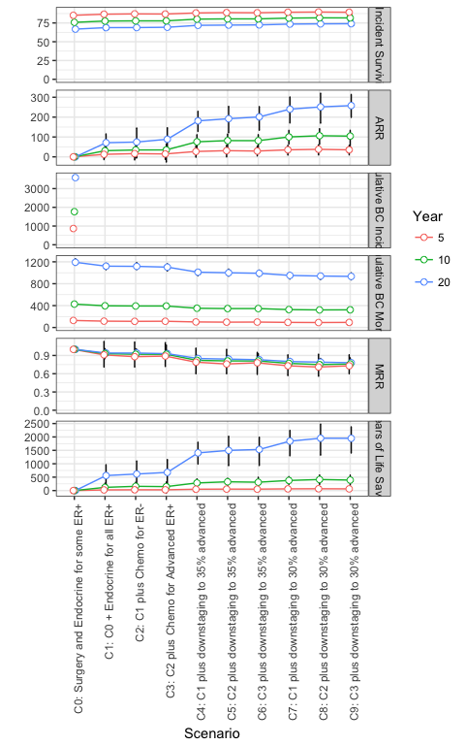

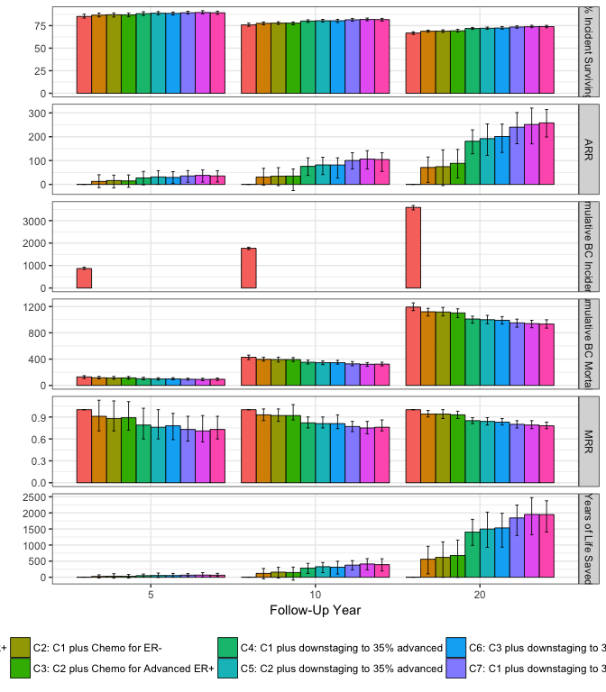

# Combined Results

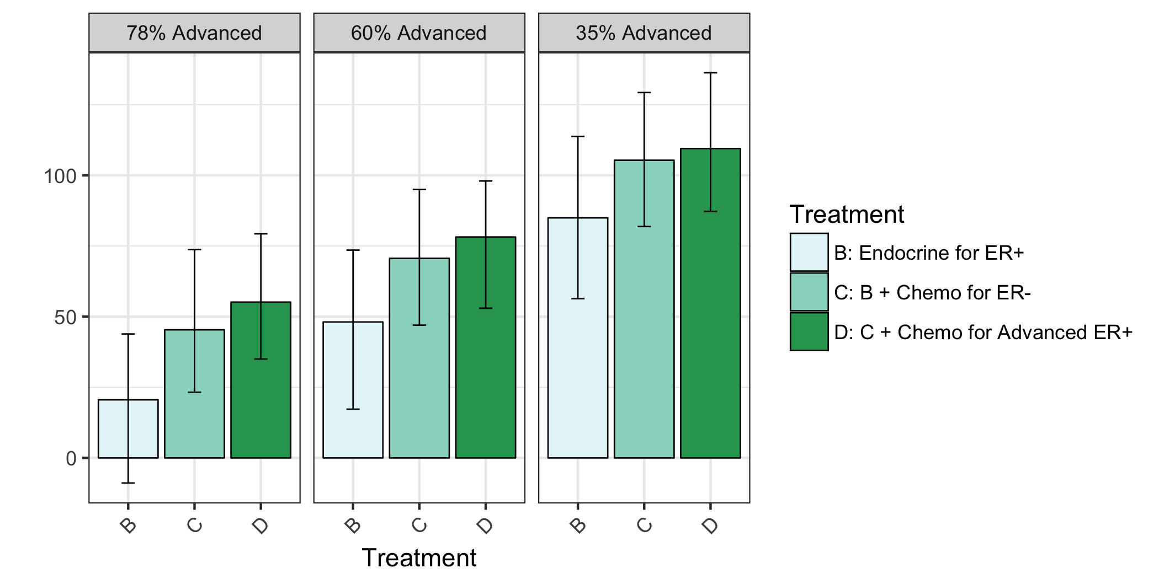

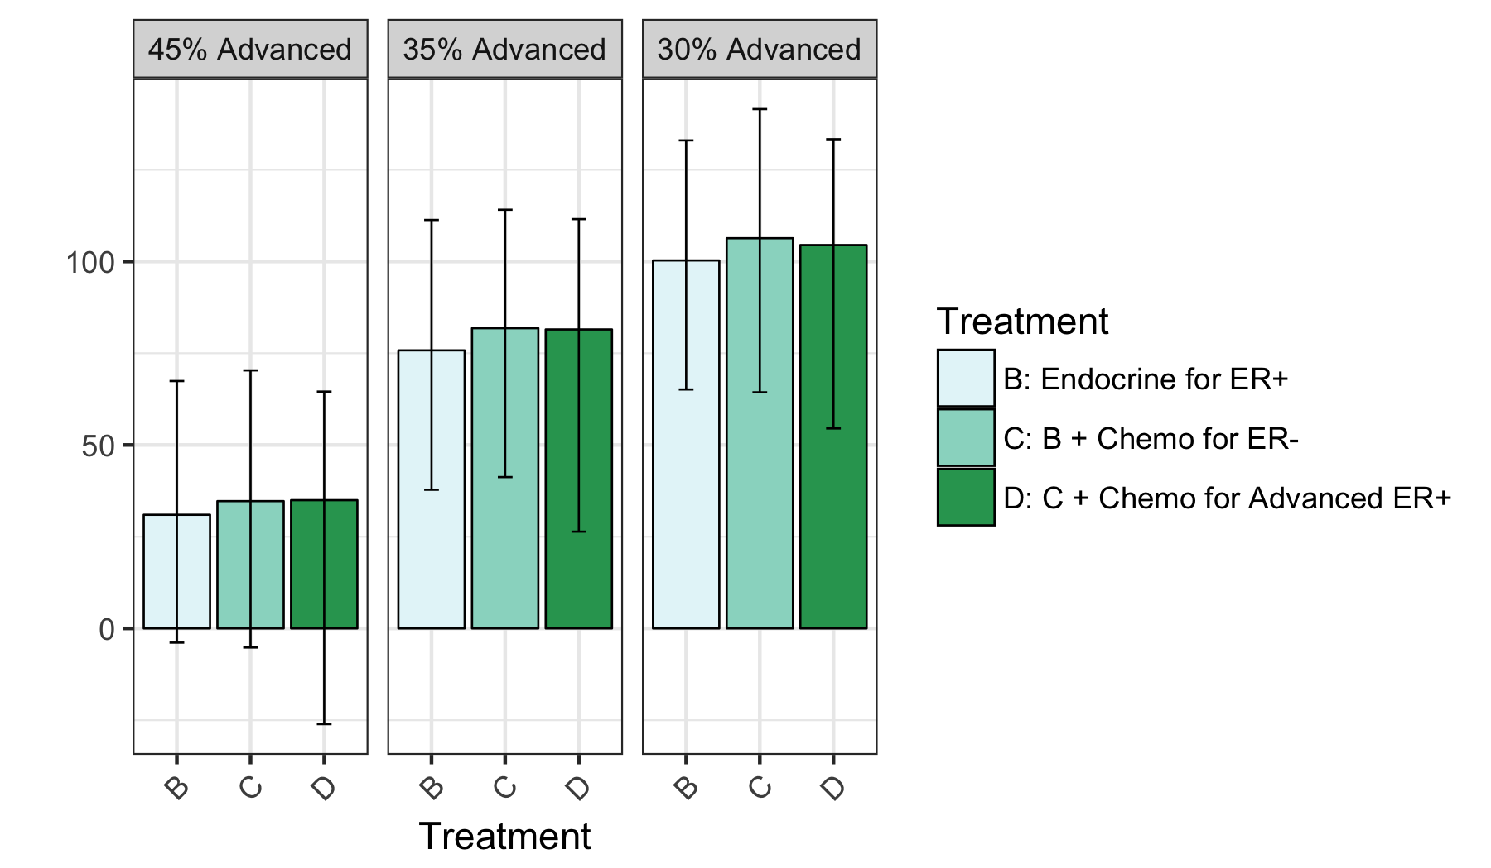 # Comments