CSCI 3308 Software Development Methods and Tools

Project Final Submission

**Title:** Robotic Arm

**Who:** Bradley Arnot

Andrew Candelaresi Kelsey Dowd

Lauren Mitchell

**Project Tracking Software:** Freedcamp, and Slack for communication <https://freedcamp.com/Laurens_Projects_Dz5/Software_Method_3iw/todos>

In order to gain access to our Freedcamp, we have invited you to make an account and view our project tracker. If this doesn’t work, we also exported our tasks to an excel document and that is also on GitHub.

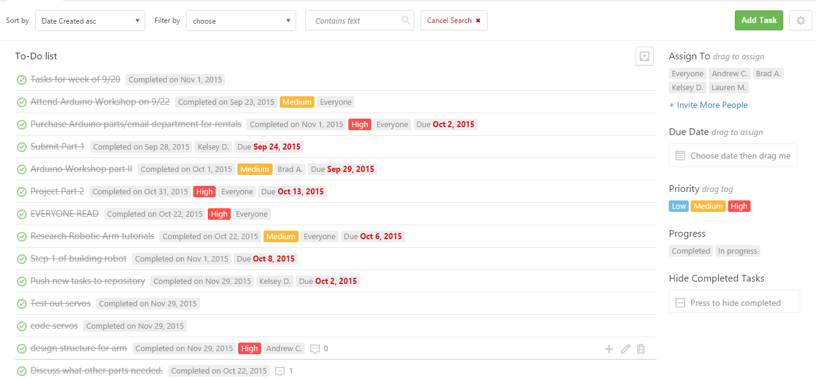

**Freedcamp screenshot: part of our ToDo list**

**Video:**

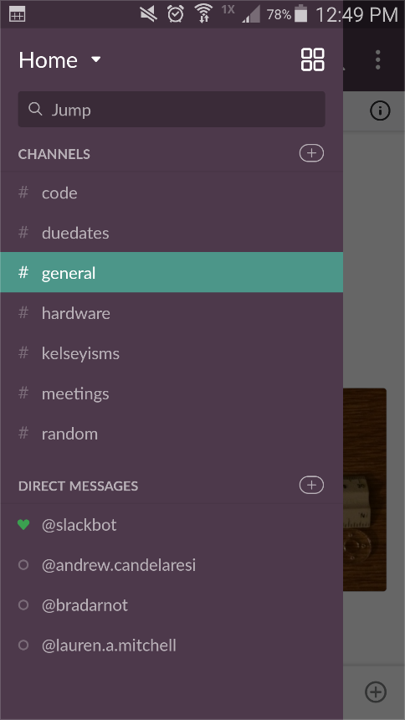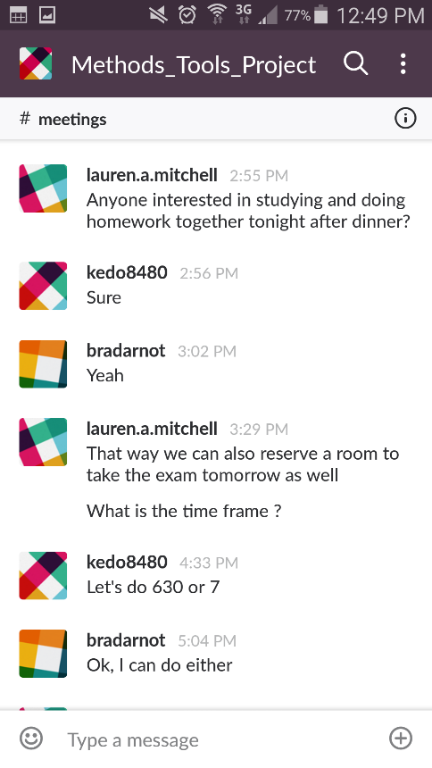

**Some example Slack screenshots: Left are all of our channels, Right is an example conversation**

Final Demo Video: <https://www.youtube.com/watch?v=jfNERC8yszY>

The rest of the videos for our project are on the video document on github.

**Deployment:** Since this is a hardware project, you need to have the robot arm set up with you to use it. Once you have the robot, you can plug it in to use it. You must plug in both the power to the Arduino and the power to the shield (explained in the demo video). Finally, the Arduino code is already uploaded to the Arduino, but if the user would like to change the code or functionality of the robot, they must download and install the Arduino IDE (open source).

**Auto-documentation:** For auto-documentation, we used ArduinoDocs with Doxygen.

**VCS:** github

<https://github.com/candeladd/Methods-Tools_ProjectFall2015.git>

Kelsey’s commits: kedo8480

Brad’s commits: arcticwaffle

Lauren’s commits: laurenmitchell

Andrew’s commits: candeladd

