On the origin of citations

Caitlin Anderson

September 15, 2015

# Load the data

counts_raw <- read.delim("data/counts-raw.txt.gz")  
counts_norm <- read.delim("data/counts-norm.txt.gz")

# Data exploration

What's the distribution of authors in all articles of our data set?

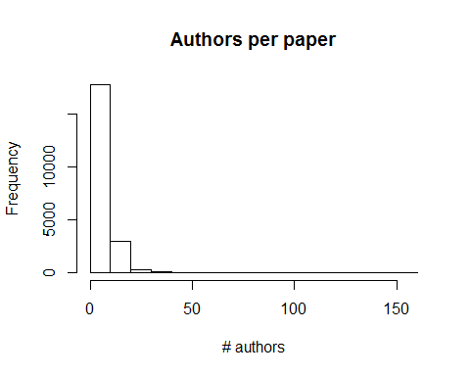

How popular are articles on Facebook? 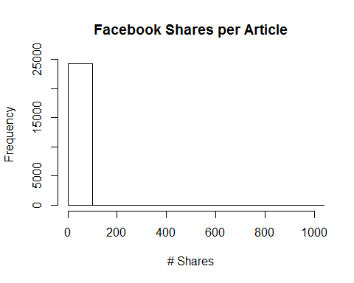

The average number of Facebook shares per paper in the data set is 0.6524187.