**PyCitySchools Analysis**

Documents:

1. PyCitySchools.ipynb
2. schools_complete.csv
3. students_complete.csv

We analyze data from schools and their students based on their math and reading scores. The schools and the students are identified by ID, grades, gender, both reading and math scores, the type of school, size and budget.

We can see that the district summary (*See exhibit A)* allows us to review the total of students per schools the average of their scores as a hole and overall passing rate for all the schools combined. By calculating the averages and overall passing rate per school (*See exhibit B)* we were able to find the five highest-performing schools by the percent overall passing (*See exhibit C)* and the five bottom performing schools by percent overall passing (*See exhibit D)*. Notice the Cabrera High School was the highest-performing school and the Rodriguez High School was the bottom performing school.

Finally, notice that by school type, Charter schools had the best percent overall passing with 90.43% (*See exhibit E).* However, Bailey High School is a District school type with the highest of spending ranges per student (*See exhibit F)* but it is also in the group of Large School Size along with the Total School Budget of $3,124,928.00 (*See Exhibit G).*

**EXHIBITS**

Exhibit A



Exhibit B

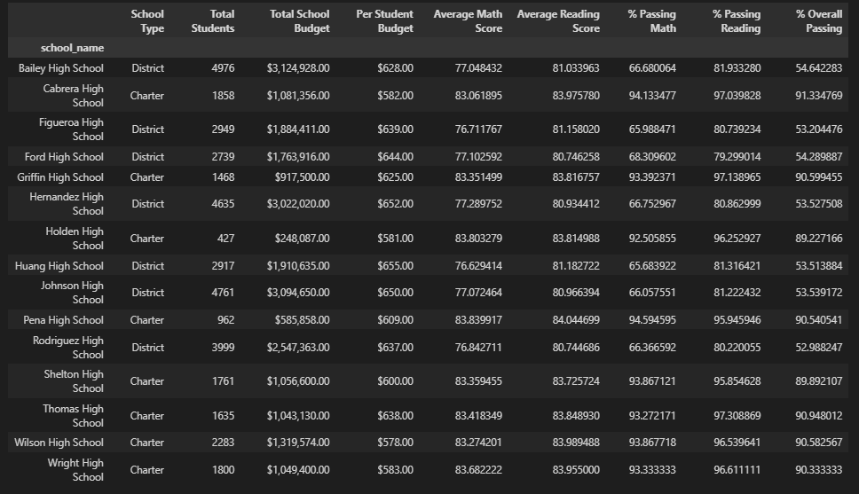

Exhibit C

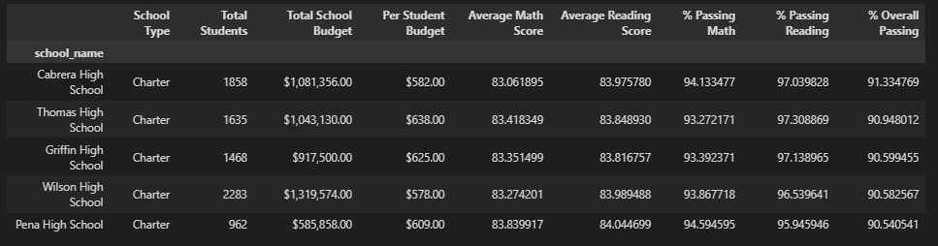

Exhibit D

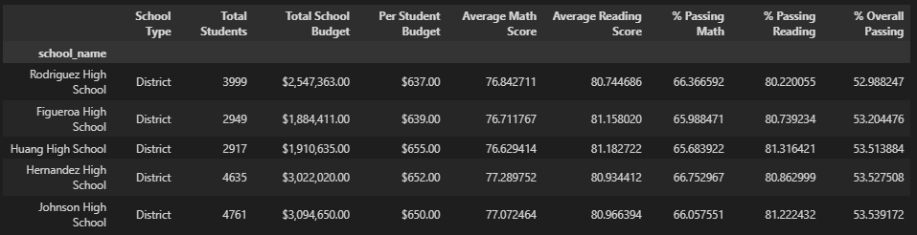

Exhibit E

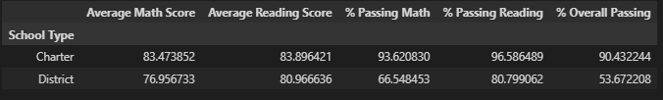

Exhibit F

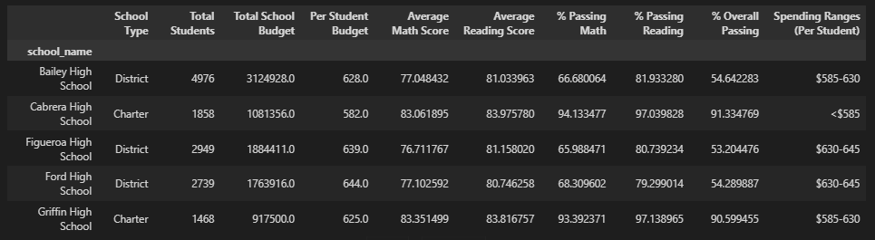

Exhibit G

