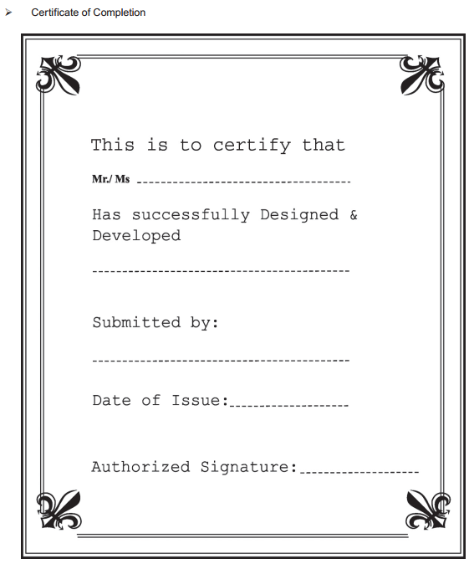

**Problem Definition:**

Problem Statement

La Imperial is into selling Appliances. Company has been selling these products for last 20 years. They have a wide range of Appliances. The company advertises by distributing the pamphlets, advertising on television and so on. Due to rapid development in internet field, the company decides to launch a website where people will get all the information about the various products available with them easily.

Client/Project Undertaken: La Imperial Companyhas been selling Appliances.

1. **List of input to the system.**

- Brand: name, brand id.

- Category: id, Category name.

- Product: name, id, image,description, price,……

1. **List of outputs expected form the system.**

- Detailed features products.

- Compare two products.

1. **Overview of processes involved in the system.**

- Display list of product based on particular brand.

- Display detail.

- Dowload detail product feature.

- Link other companies products.

- Link.

**Expected Delivery Dates: 25-11-2019.**

- List of Deliverables: The website of La Imperial company..

- {design document + source code + installation manual+

user guide}.

1. **Hardware and software required for implementing the project.**

|  |  |  |
| --- | --- | --- |
|  | Hardware | Software |
| Client | - A minimum computer system that will help you access all the tools in the courses is a Pentium 166 or better. | Browsers support HTML5 such as Google Chrome, Mozilla Firefox, Microsoft  Edge,... |
| - 64 Megabytes of RAM or better. |
| Server | Intel core 5 processor or higher. 4 GB of RAM or higher. |  |

|  |  |
| --- | --- |
| S.No | Customer’s Acceptance Criteria |
| 1. | Home Page should contain logo of the site |
| 2. | The site should display a menu which will contain the options for brief introduction about the various appliances available |
| 3. | The information should be categorized according to the brand names of the products |
| 4. | Another category option for different appliances |
| 5. | Have a word files about detail of product for customer can download. |
| 6. | The user should also be able to compare the various products of different as well as similar brands. |
| 7. | “Contact Us” page which will have the Address of the Company which is as follows and the mail address |

Architecture and Design of the Project

The application will have a client-server architecture

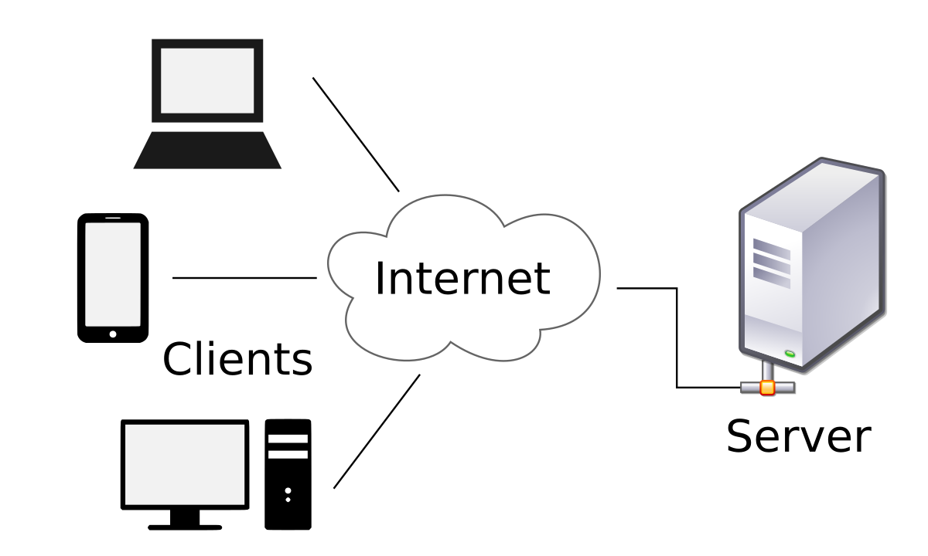

Site map

The sample site map illustrates the navigation flow of the objects of the web portal.

Twitter

Products 1, Products 2,…

Home

Category

Contact Us

View cart

Brands

Products 1, Products 2,…

Login

Instagram

Products 1, Products 2,…

Products 1, Products 2,…

Footer

Products 1, Products 2,…

TV, Audio & Electronics

Jenn Air

Amana

Register

Products 1, Products 2,…

LG

Products 1, Products 2,…

SamSung

Frides & Freezer

Heating & Beauty

Heating & Cooling

Laundry Appliances

Small Appliances

Products 1, Products 2,…

View Cart

Products 1, Products 2,…

FaceBook

Products 1, Products 2,…

|  |  |  |  |  |  |  |  |
| --- | --- | --- | --- | --- | --- | --- | --- |
| Project Re.No | | Project Title: | Activity Plan Prepare By: | Dete of Preparation of Activity Plan: | | | |
| Sr.No | Task | Actual Start Date | Actucal Days | Team Member Names | Status |
| 1 | Problem defination | La Imperial store | Nguyễn Thiện Nhơn | 26/10 | 2 | Nguyễn Bá Lương | 100% |
| 2 | Customer Requirement | 26/10 | 2 | Nguyễn Thiện Nhơn | 100% |
| 3 | Architecture and Design of the  Project | 4/11 | 2 | NguyễnThiện Nhơn | 100% |
| 4 | Site Map | 4/11 | 2 | Nguyễn Ngọc Vy Thanh | 100% |