Charles Andre

EE 599

HW1

01/27/20

1. Proof that FindMax always finds the max value in the input vector for non empty input vectors

Proof by contradiction:

Is the following true?

“FindMax always finds the non-max value for non empty input vectors”

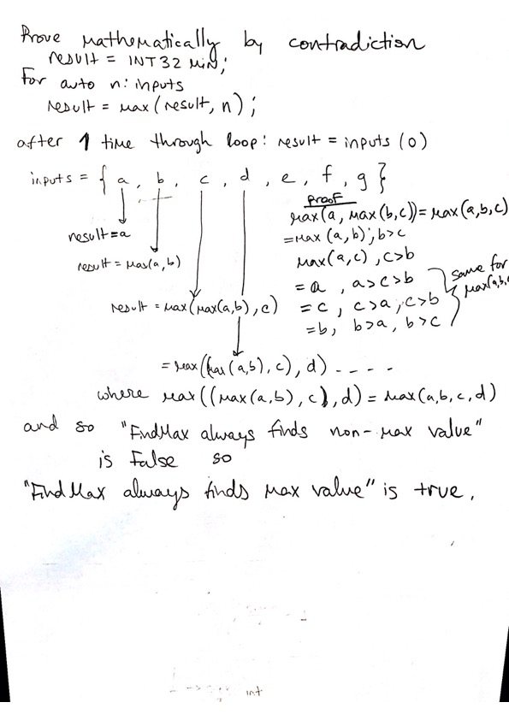

1. Github: <https://github.com/candre97>

Stackoverflow: <https://stackoverflow.com/users/12720784/charles-andre>

1. <https://github.com/candre97/EE599-HW1/tree/master/HW1_Q3>

* Tests are included for some normal cases and corner cases
* Runtime is O(n log(n))
  + <https://stackoverflow.com/questions/4484900/what-is-the-time-complexity-of-stdsort-in-the-c-standard-library>
  + The only thing that my code runs through all inputs for is std::sort

1. -r : recursive

-f : force

Available here: <https://github.com/candre97/EE599-HW1/tree/master/HW1_Q4>

1. I only see two functions here… Example1 and Example2
   1. 2n – 1 = O(n)
   2. log n
2. code attached with tests for recursive and non-recursive versions
   1. both implementations have runtime = O(n)
   2. proof (see scan below)

