Chrona User Manual
A friendly guide for time tracking, expenses, project billing, approvals, and reports

Field | Details
Product | Chrona
Document type | User Manual
Version | 1.0
Primary users | Team members, project managers, administrators, finance and operations teams
Recommended reading path | Start with the Quick Start, then read the module sections that match your role

How to use this manual
This guide is organized around real user goals. Each module includes what the feature is for, when to use it, step-by-step instructions, important rules, and practical tips.

Table of Contents
1. Product overview
2. User roles and permission basics
3. Quick start by role
4. Team management
5. Client management
6. Project management
7. Task management
8. Time entry
9. Expenses
10. Time and expense approvals
11. Reports
12. Administration, security, and data hygiene
13. Troubleshooting and FAQ
14. Appendix: rules, glossary, and checklists

1. Product overview
Chrona helps service organizations manage the full cycle from team setup and client/project configuration to time tracking, expense submission, approval, and operational reporting.

What Chrona helps you do
Area | What you can do | Typical owner
Team | Invite users, manage roles, set rates, assign projects, define managers, and reset passwords. | Administrator
Clients | Create client records, contacts, currencies, invoice due dates, and tax settings. | Administrator, finance, operations
Projects | Create client projects, choose billing models, assign team members and tasks, and configure invoice values. | Administrator, project manager
Tasks | Maintain common tasks that appear on new projects and other tasks added manually as needed. | Administrator
Time | Enter hours by day, week, or calendar view, add notes, edit entries, and submit time for approval. | Team member
Expenses | Submit project expenses and manage expense categories. | Team member, administrator
Approvals | Review submitted time and expenses, approve them, request changes, and withdraw approvals when needed. | Project manager
Reports | Analyze time, profitability, detailed time, and detailed expenses using filters by client, project, task, and team. | Manager, administrator, finance

Best for
Chrona is designed for organizations that sell time-based or project-based work, such as consulting teams, agencies, software delivery teams, implementation teams, design studios, and internal shared-service teams.

2. User roles and permission basics
Chrona uses system-level permissions and configurable roles to keep daily work simple while protecting administrative and financial settings.
Role | Primary responsibilities | Common permissions
Member | Track own time, submit expenses, and submit time or expenses for approval. | Create and edit own unapproved entries; view assigned projects and tasks.
Manager | Manage assigned people or projects, review submissions, and use operational reports. | Approve time and expenses for managed projects or people; view relevant project/team data.
Administrator | Configure the company workspace and maintain master data. | Manage all people, roles, clients, projects, tasks, rates, categories, and high-level reports.

Key rules to remember
Permissions are cumulative
A user may have system permissions plus additional configurable roles. The most permissive valid access normally applies.

Project access matters
Team members can only enter time and expenses for projects and tasks they are assigned to or allowed to use.

Approved periods are locked
Once a submitted time or expense period is approved, the approved entries become read-only until approval is withdrawn.

3. Quick start by role
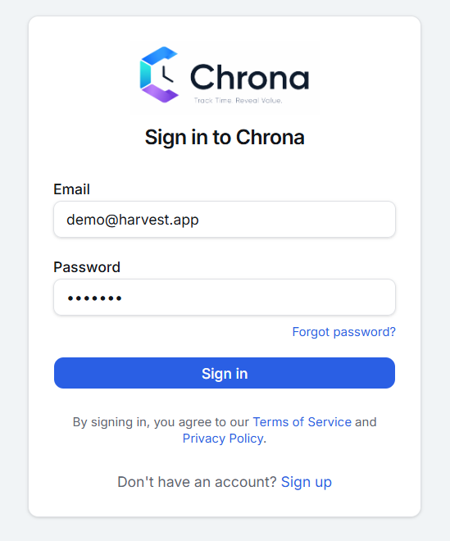
Figure 1. Sign in to Chrona with your work email and password.
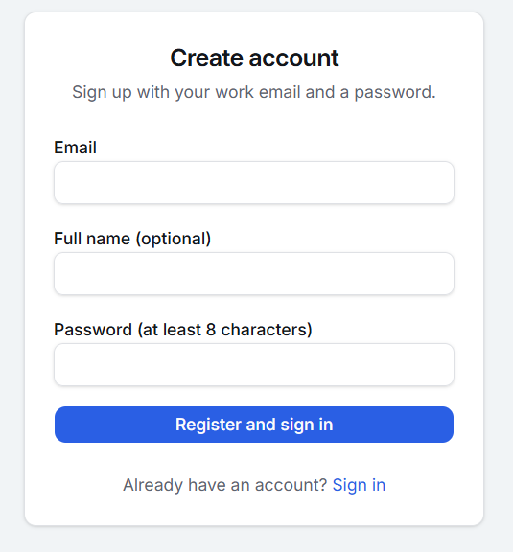
Figure 2. Create an account after receiving an invitation.
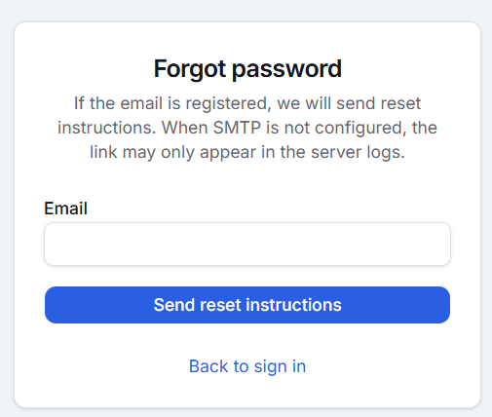
Figure 3. Reset a forgotten password from the sign-in flow.
Use the checklist that matches your role to complete the most common work quickly.
If you are a... | Start here | Then do this
Team member | Open Time or Expenses. | Enter your work, review it, and submit it for approval by day, week, or custom date range.
Project manager | Open Approvals and Reports. | Review submitted entries, approve clean submissions, and use reports to monitor workload and project health.
Administrator | Open Team, Clients, Projects, and Tasks. | Set up master data before inviting everyone to track time and expenses.
Finance or operations user | Open Clients, Projects, Expenses, and Reports. | Maintain billing settings, tax settings, cost visibility, and profitability review workflows.

Recommended first-time workspace setup
Step | Action | Expected result
1 | Create or review system roles. | Your team has the right access model before member invitations are sent.
2 | Invite members and assign roles. | Users can sign in and see only the work that applies to them.
3 | Set default billable and cost rates for members. | Time and profitability calculations have a fallback rate.
4 | Create clients and contacts. | Projects can be connected to the right client and billing contact.
5 | Create common tasks. | New projects inherit standard tasks automatically.
6 | Create projects and choose billing models. | Team members can track time against configured project work.
7 | Assign team members and tasks to projects. | The time-entry dropdowns show accurate choices.
8 | Confirm approval managers. | Submitted time and expenses route to the right reviewer.
Result
After setup, members can track time, submit expenses, and managers can approve submissions and run reports.

4. Team management
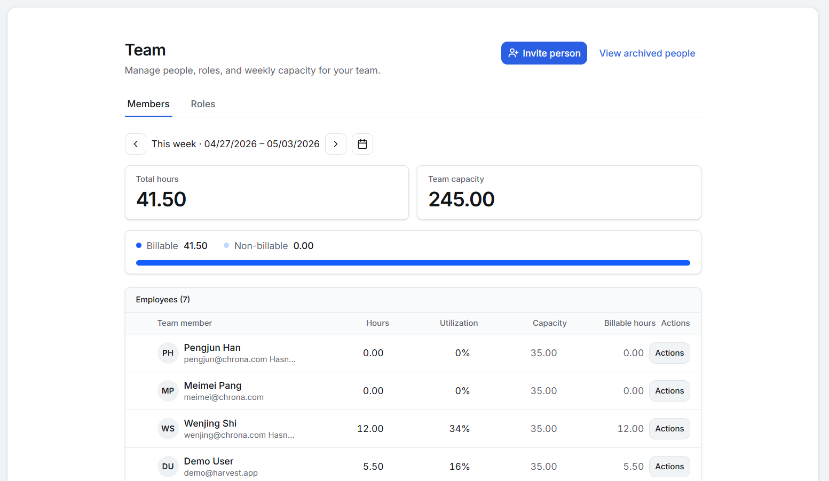
Figure 4. Team overview with Members and Roles tabs, weekly capacity, utilization, and member actions.
Use Team to manage people, system permissions, configurable roles, default rates, assigned projects, assigned people, profile settings, and account security.

Invite a new team member
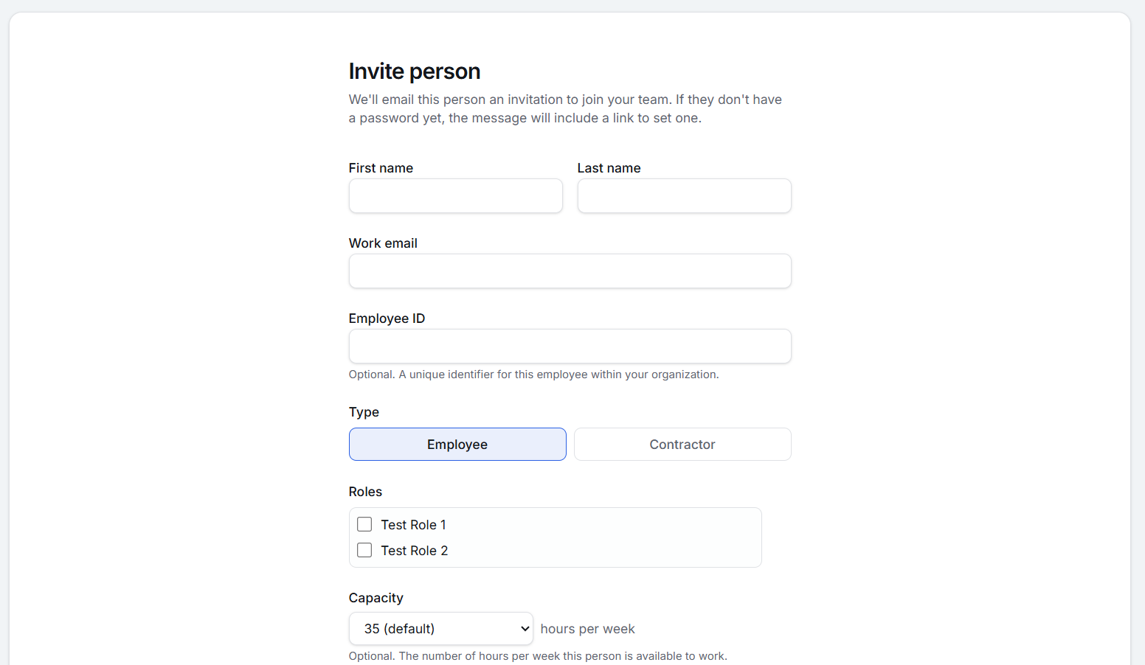
Figure 5. Invite person form with required identity fields, type selection, role assignment, and invitation action.
Step | Action | Expected result
1 | Go to Team > Members and select Invite person. | The invitation form opens.
2 | Enter First Name, Last Name, Work Email, and Type. | Required identity fields are complete.
3 | Select one or more roles from the Roles dropdown. | The person receives the intended role assignments.
4 | Review the work email address carefully. | The email is unique and ready for invitation delivery.
5 | Select Invite and continue. | Chrona sends the invitation email and keeps you in the invitation flow.
Helpful tips
Work Email must be unique. Roles shown in the dropdown are configured under Team > Roles.

Edit a member profile
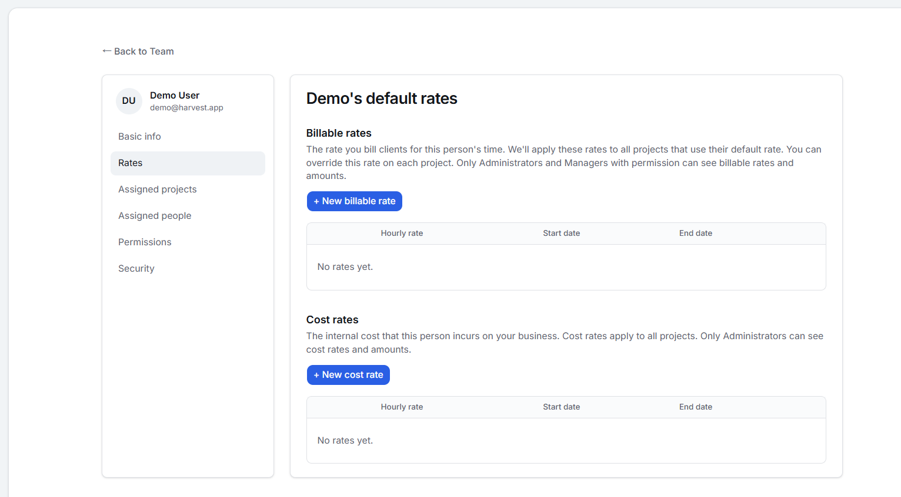
Figure 6. Member default rates page for maintaining billable and cost rates over time.
Step | Action | Expected result
1 | Go to Team > Members. | The member list is visible.
2 | Find the member and select Edit. | The member details page opens.
3 | Update Basic Info such as timezone, photo, and notification preferences. | Profile data is accurate for daily use and notifications.
4 | Save changes. | Updated details are available across Chrona.
Helpful tips
Use timezone settings carefully for distributed teams so time views and reminders align with each user.

Set member billable and cost rates
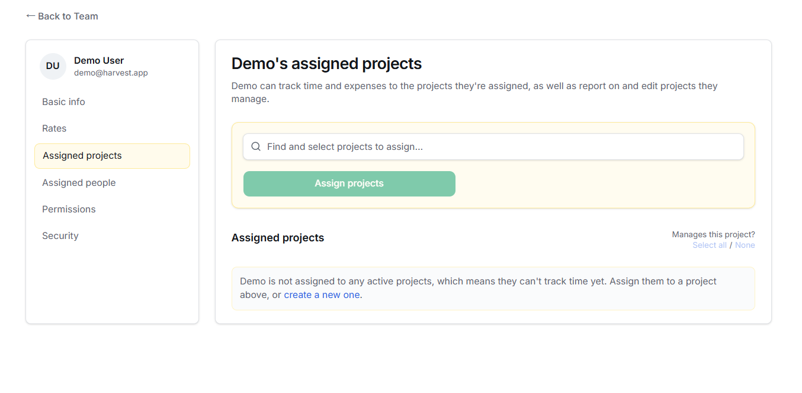
Figure 7. Assigned projects page showing which projects a member can access and manage.
Step | Action | Expected result
1 | Open the member details page and select Rates. | The rate history area is displayed.
2 | Add a billable rate and cost rate with an effective date range. | Chrona can calculate revenue and cost for the valid period.
3 | Check existing date ranges before saving. | The new rate period does not overlap with any existing rate period.
4 | Save the rate. | The default member rate becomes available for project and report calculations.
Helpful tips
If a project has a project-specific person rate, that project rate overrides the member default rate for that project.

Assign projects to a member
Step | Action | Expected result
1 | Open the member details page and select Assigned projects. | Existing project assignments are listed.
2 | Select a project to assign. | The member becomes eligible for that project.
3 | Choose whether the member manages the project. | Project management permissions are applied for approval and oversight workflows.
4 | Save the assignment. | The project becomes available where appropriate, including time and expense entry.

Assign people to a manager
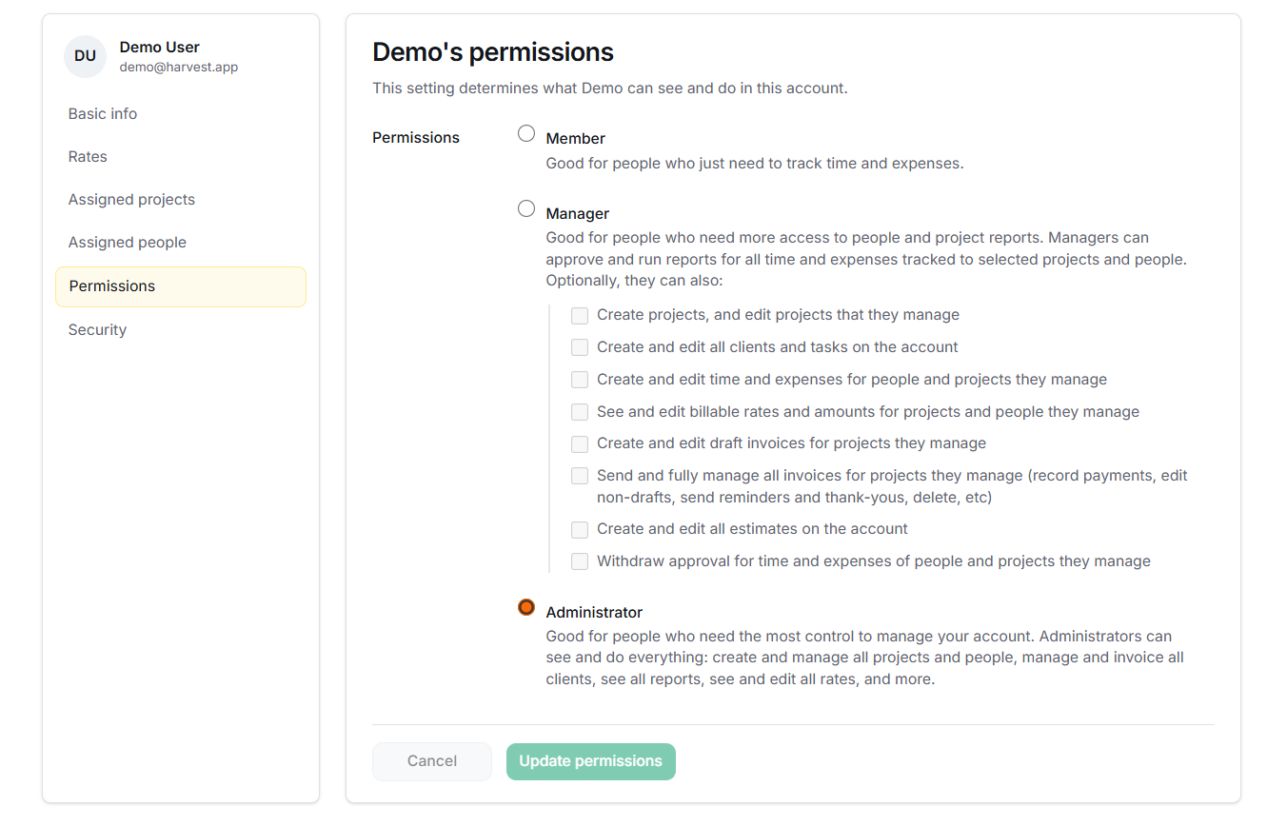
Figure 8. Permissions page used to assign the member system role and control what the person can access.
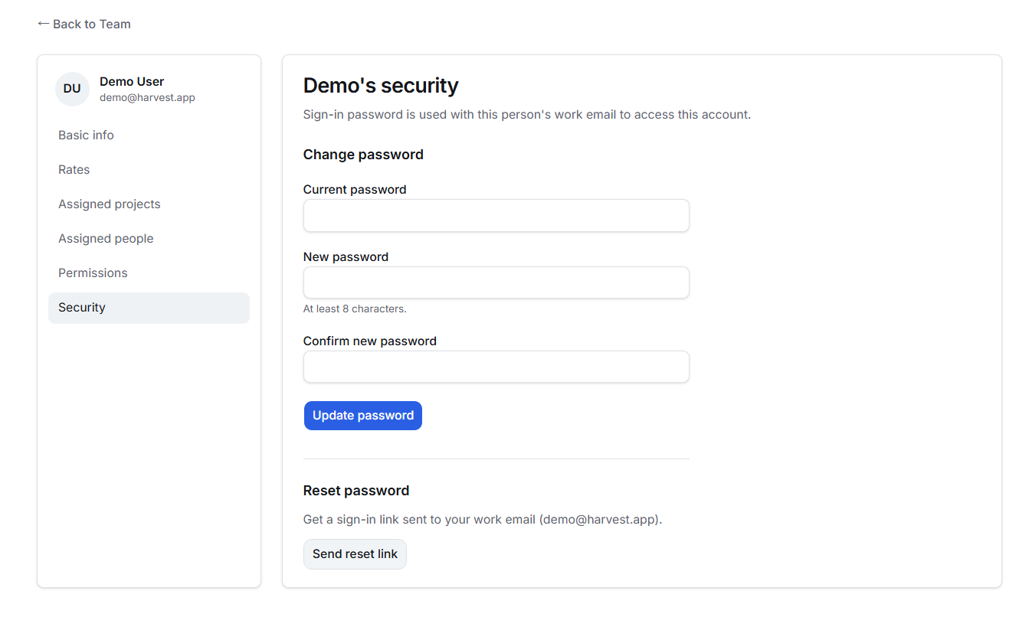
Figure 9. Security page where an authorized administrator can change a member password.
Step | Action | Expected result
1 | Open the member details page and select Assigned People. | The people managed by this member are listed.
2 | Add or remove people as needed. | The manager relationship reflects the current organization structure.
3 | Save changes. | Manager-based views and approval responsibilities are updated.

Create a configurable role
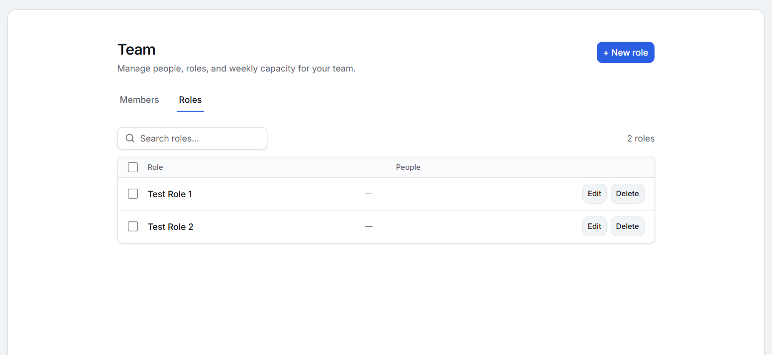
Figure 10. Roles list with configurable roles and role-level actions.
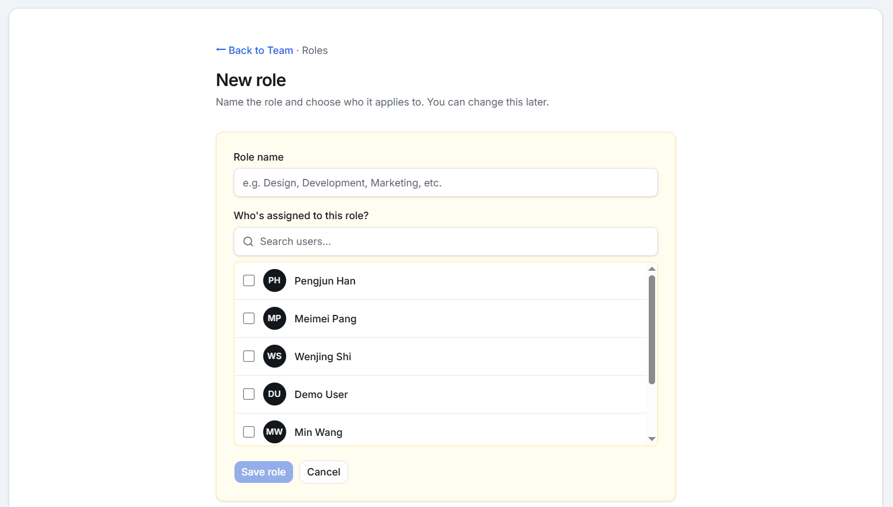
Figure 11. New role form for naming a role and assigning people to it.
Step | Action | Expected result
1 | Go to Team > Roles and select New role. | The new role form opens.
2 | Enter a unique Role Name. | The role can be saved without name conflict.
3 | Assign members to the role, if needed. | Selected members receive the role.
4 | Save the role. | The role becomes available for future member invitations and edits.
Helpful tips
Role names must be unique. Delete a role only when it is no longer required and safe to remove from all users.

Key rules to remember
Member list actions
Administrators can invite, edit, pin, archive, or delete members according to permission and data-dependency rules.

Security tab
Administrators can reset a member password from the Security section when policy allows.

Archive versus delete
Archive users or roles when historical data must remain intact. Delete only when no required history or dependencies exist.

5. Client management
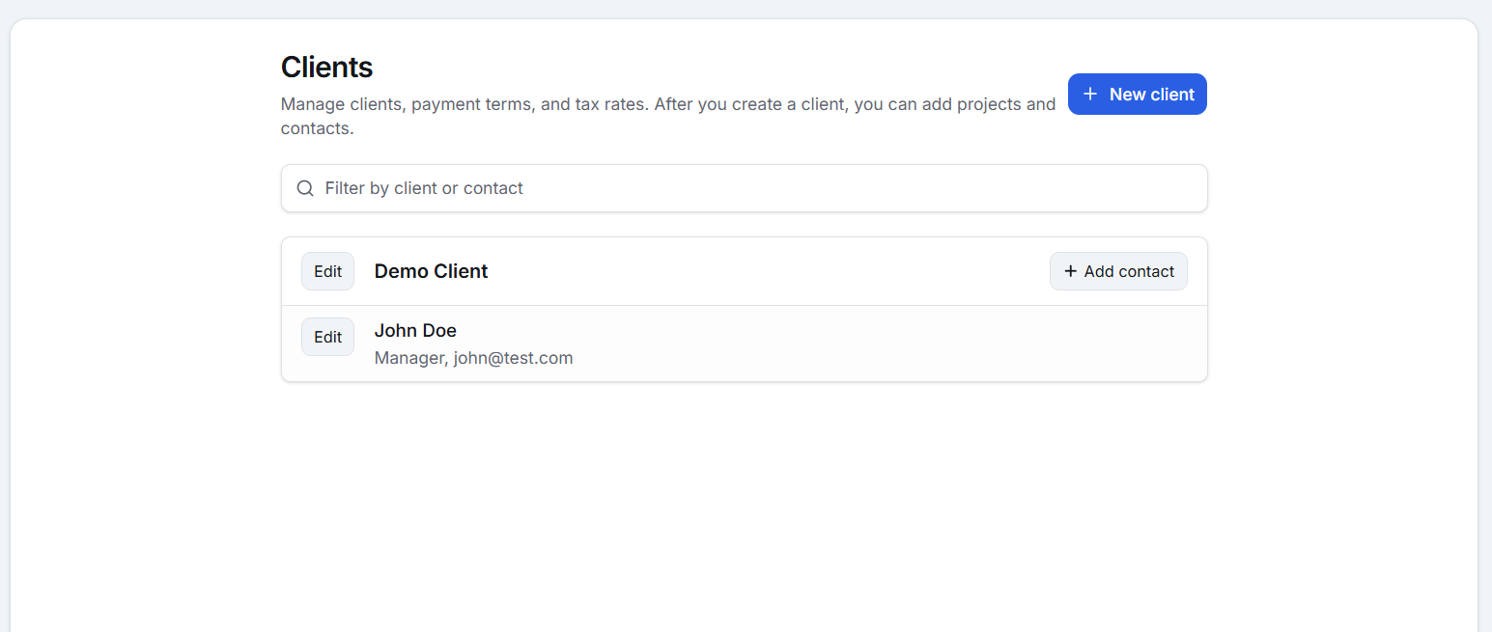
Figure 12. Clients list with search, edit actions, and contact management shortcuts.
Clients are the organizations or customers that own projects. Keep client settings accurate so projects, invoices, and reports are consistent.

Create a client
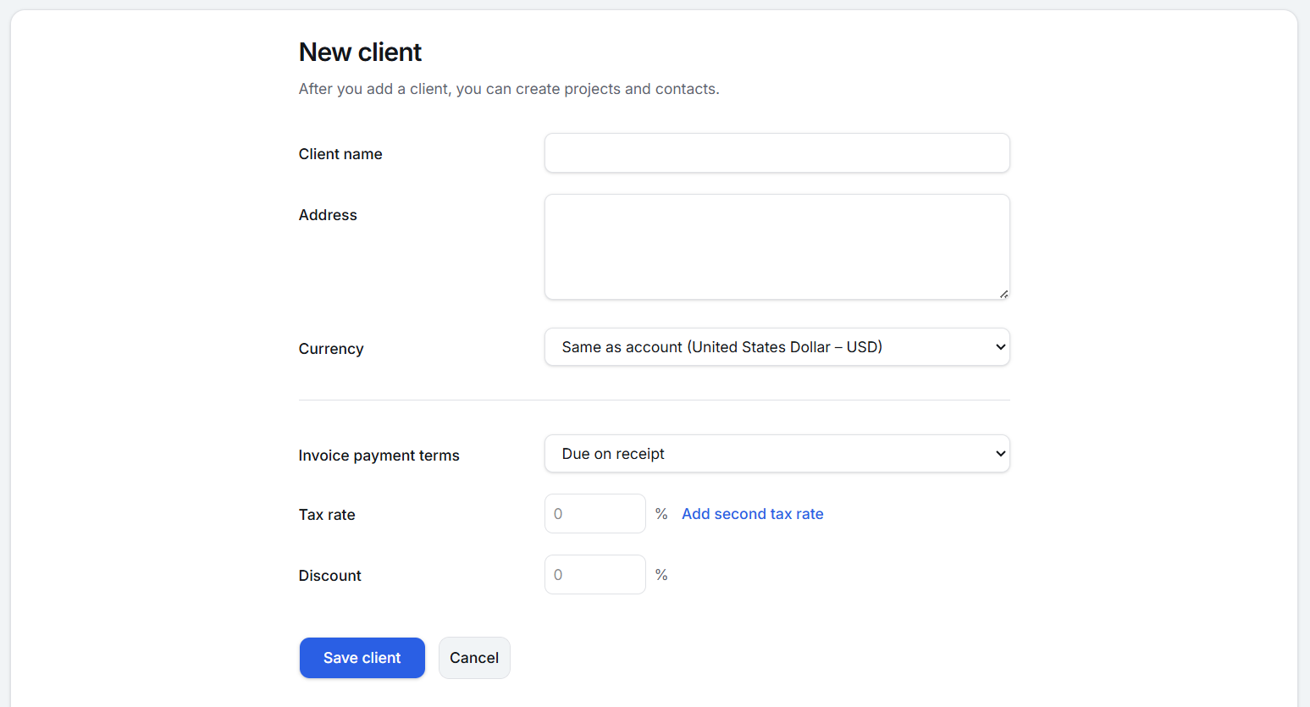
Figure 13. New client form for client name, address, currency, payment terms, tax, and discount values.
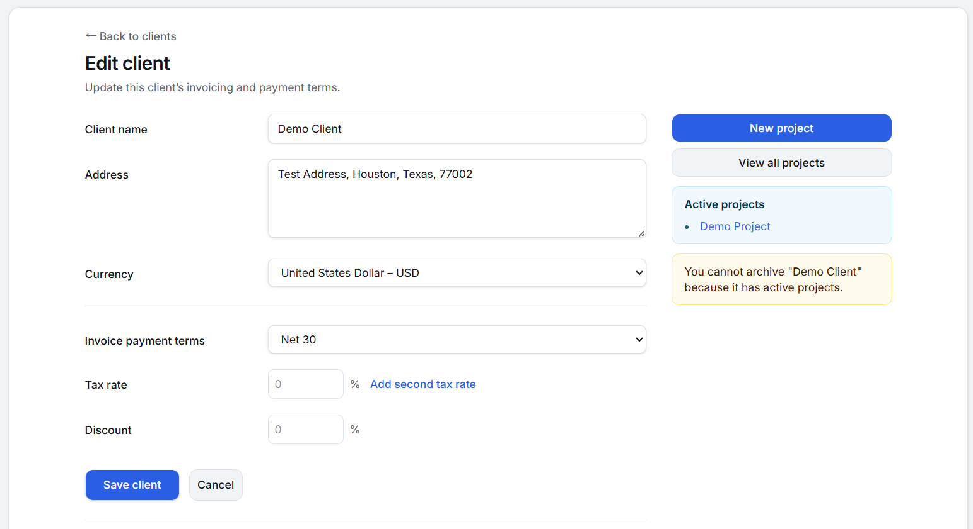
Figure 14. Edit client form with invoicing defaults and linked active projects.
Step | Action | Expected result
1 | Go to Clients and select New client. | The new client form opens.
2 | Enter the client name and required business details. | The client record has the minimum information needed for projects.
3 | Choose Preferred currency. | Projects and billing views use the correct currency context.
4 | Choose Invoice due date. | Chrona calculates invoice timing using the selected setting.
5 | If Custom is selected, enter the number of days after invoice issue date. | The custom payment term is complete.
6 | Configure tax settings, including second tax if applicable. | Billing-related values are ready for finance review.
7 | Save the client. | The client can be selected when creating projects.

Manage client contacts
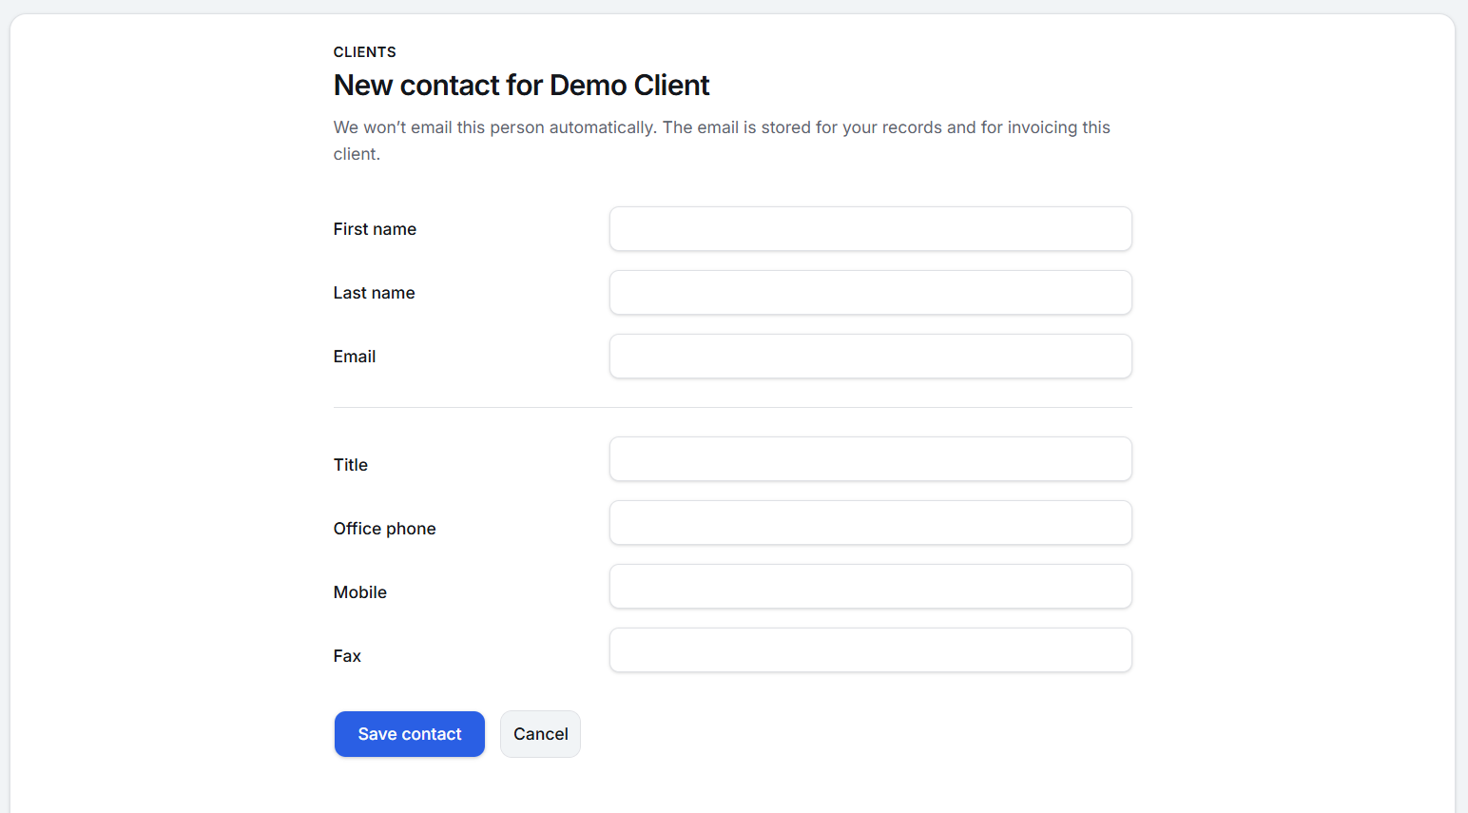
Figure 15. New client contact form for storing contact details used for invoicing and client records.
Step | Action | Expected result
1 | Open a client and select Contacts. | The contacts list opens for that client.
2 | Select New contact. | The contact form opens.
3 | Enter the contact name, email, phone, and role details. | The contact can be used for communication and billing workflows.
4 | Save the contact. | The contact appears under the client.
5 | Use Edit or Delete when details change. | The contact list stays current.

Key rules to remember
Currency selection
Use the client preferred currency as the default business context for projects and billing discussions.

Invoice due dates
Custom due dates require an explicit number of days after invoice issue date.

Tax settings
Second tax is available for regions or billing scenarios that require it.

Archiving clients
Archive clients that should no longer be used for new work but must remain available for history and reports.

6. Project management
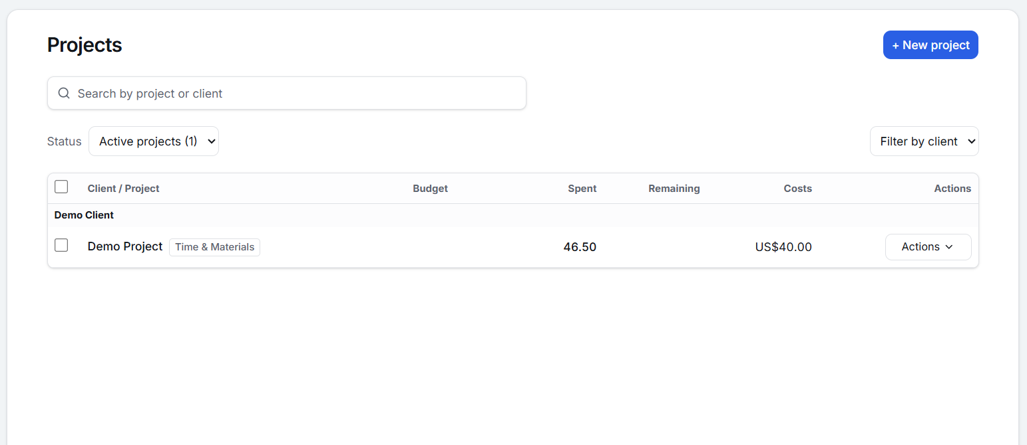
Figure 16. Projects list with project status, client filter, budget, spent, remaining, costs, and actions.
Projects connect clients, team members, tasks, billing model, rates, fees, invoice values, time entries, expenses, approvals, and reports.
Project type | Use when | Required billing setup
Time & Materials | The client is billed by tracked time. | Choose a billable-rate model: no rate, project rate, person rate, or task rate.
Fixed Fee | The client is billed a set price regardless of time tracked. | Enter the project fee.
Non-Billable | The work is internal or not billed to a client. | No rates or fees are required.

Rate model | How it works | Where to configure
No billable rate | Time can be tracked without a revenue rate. | Project type billing section.
Project billable rate | All billable time uses one hourly project rate. | Project billing section; enter amount per hour.
Person billable rate | Each project member has their own hourly rate. | Project Team section; defaults may copy from member rates.
Task billable rate | Each billable task has its own hourly rate. | Project Tasks section; only billable tasks require rates.

Create a project
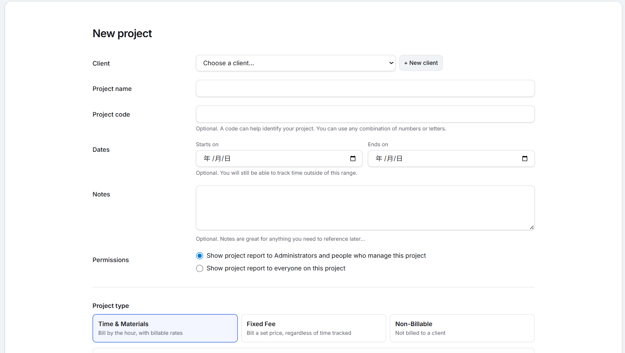
Figure 17. New project form for client selection, project name, project code, and project dates.
Step | Action | Expected result
1 | Go to Projects and select New project. | The new project form opens.
2 | Choose the client and enter basic project information. | The project is linked to the correct client.
3 | Select the project type. | Chrona displays the appropriate billing setup fields.
4 | Configure rates or fees based on the project type. | Revenue calculations can be performed correctly.
5 | Add team members. | Assigned members can track time and expenses for the project.
6 | Add tasks. | Team members can classify time accurately.
7 | Configure invoice values if required. | Billing-related values are available for downstream finance workflows.
8 | Save the project. | The project is ready for use.
Helpful tips
Use Duplicate for projects with a similar setup. Use Pin to keep important projects easy to find. Use Archive when a project is no longer active but history must remain available.

Configure team members on a project
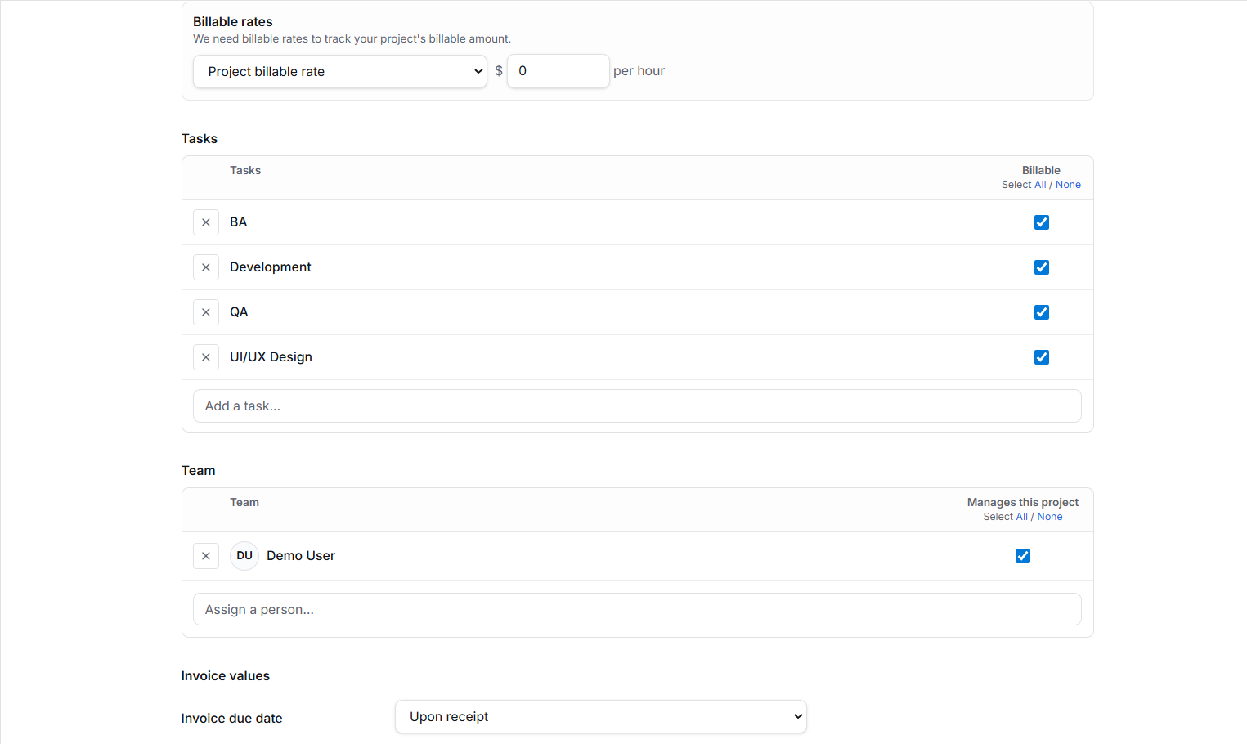
Figure 18. Project setup sections for billable rates, tasks, and team members.
Step | Action | Expected result
1 | Open the project and go to the Team section. | Current project members are listed.
2 | Add or remove members. | The project team matches the actual delivery team.
3 | If the rate model is Person billable rate, review each member rate. | Each member has the correct project-specific billing rate.
4 | Save changes. | Time and revenue calculations use the latest assignments and rates.
Helpful tips
When a person rate is required, Chrona may bring in the member default billable rate first. Review and adjust it for the project before launch.

Configure tasks on a project
Step | Action | Expected result
1 | Open the project and go to the Tasks section. | Current project tasks are listed.
2 | Add or remove tasks as needed. | The task list matches the project scope.
3 | If the rate model is Task billable rate, enter rates for billable tasks. | Task-based revenue calculations can be performed.
4 | Save changes. | The updated task list becomes available for time entry.

Key rules to remember
Project rate precedence
Project-specific person rates override member default rates for the project. If no project person rate exists, member defaults can be used.

Task visibility
A task must be available on a project before members can normally select it for time entry on that project.

Non-billable projects
Non-billable projects do not require billing rates or project fees, but time and expenses may still be tracked for management visibility.

7. Task management
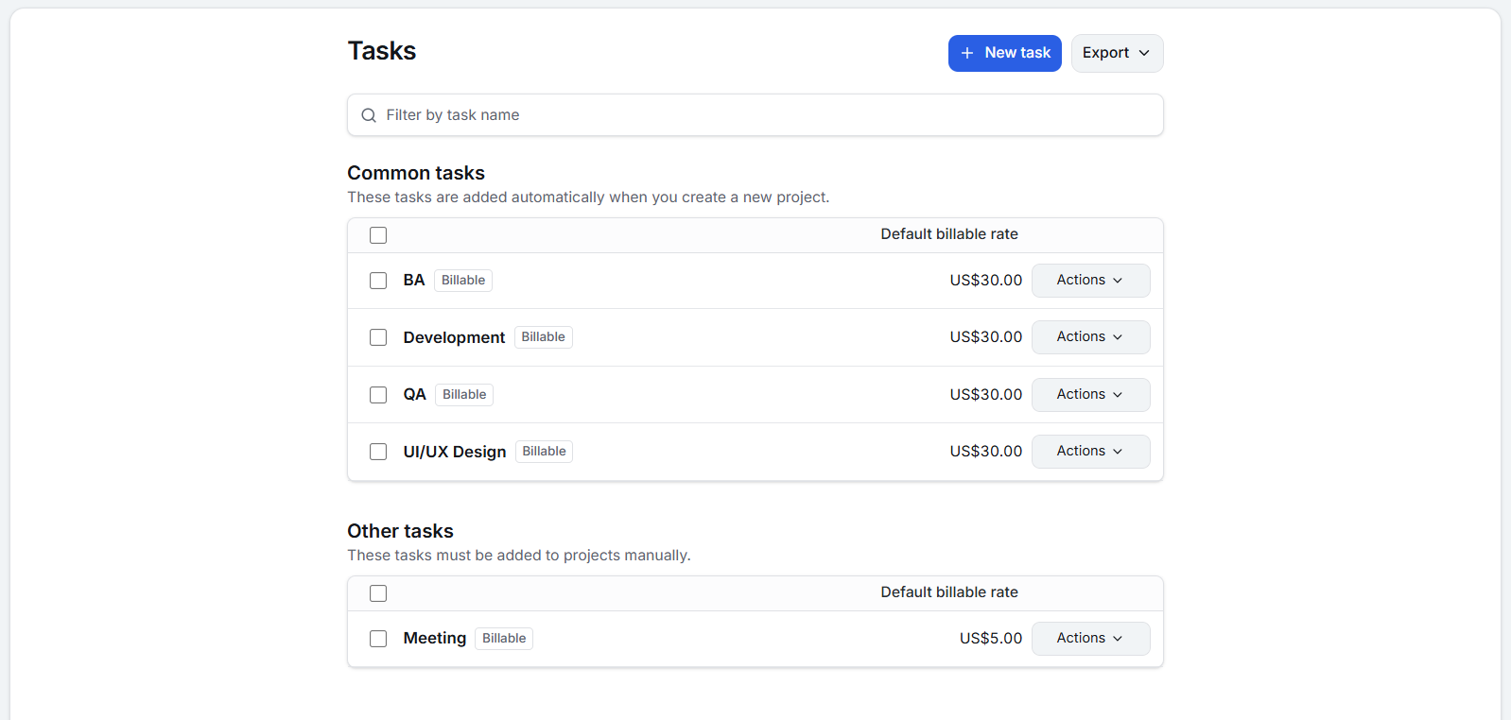
Figure 19. Tasks list showing Common tasks, Other tasks, default billable rate, and actions.
Tasks describe the type of work being tracked. Good task hygiene makes reports more accurate and easier to understand.
Task group | Behavior | When to use
Common tasks | Automatically added to new projects. | Use for standard work categories that most projects need.
Other tasks | Added manually to projects. | Use for specialized work categories that only some projects need.

Create a task
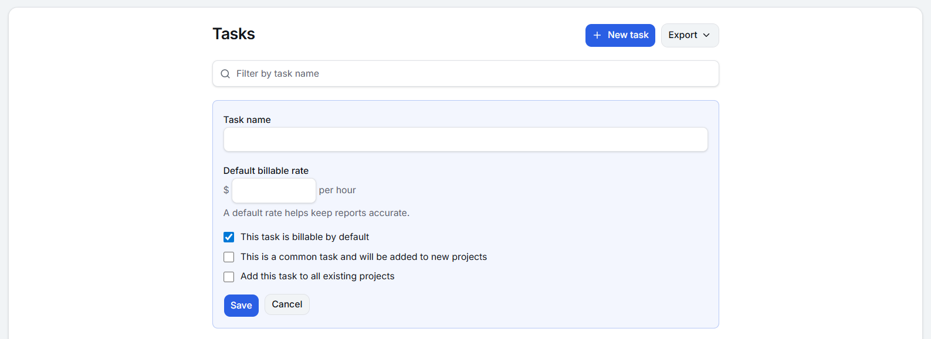
Figure 20. New task form for task name, default billable rate, billable default, and common-task behavior.
Step | Action | Expected result
1 | Go to Tasks and select New task. | The new task form opens.
2 | Enter the task name and required details. | The task can be saved and used on projects.
3 | Choose whether the task should be common or other. | Chrona knows whether to add it automatically to future projects.
4 | Save the task. | The task becomes available according to its group.

Move a task between Common and Other
Step | Action | Expected result
1 | Go to Tasks. | The Common tasks and Other tasks lists are visible.
2 | Find the task to move. | The task action menu is available.
3 | Choose the action to move it to the other group. | The task behavior changes for future project setup.
4 | Review affected project templates or setup expectations. | Future projects receive the intended task defaults.

Key rules to remember
Common task automation
Common tasks are automatically added when a new project is created.

Manual task assignment
Other tasks must be added to projects manually.

Archiving tasks
Archive old tasks that should not be used going forward but may still appear in historical data.

8. Time entry
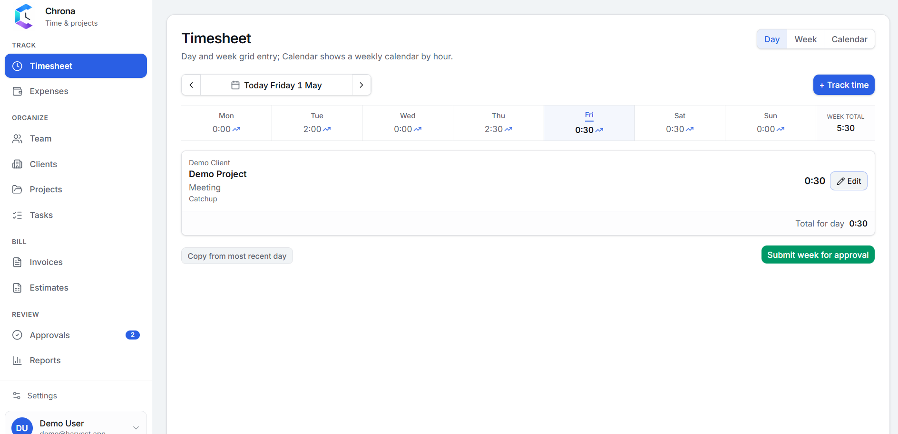
Figure 21. Time and projects workspace with Day, Week, and Calendar timesheet views.
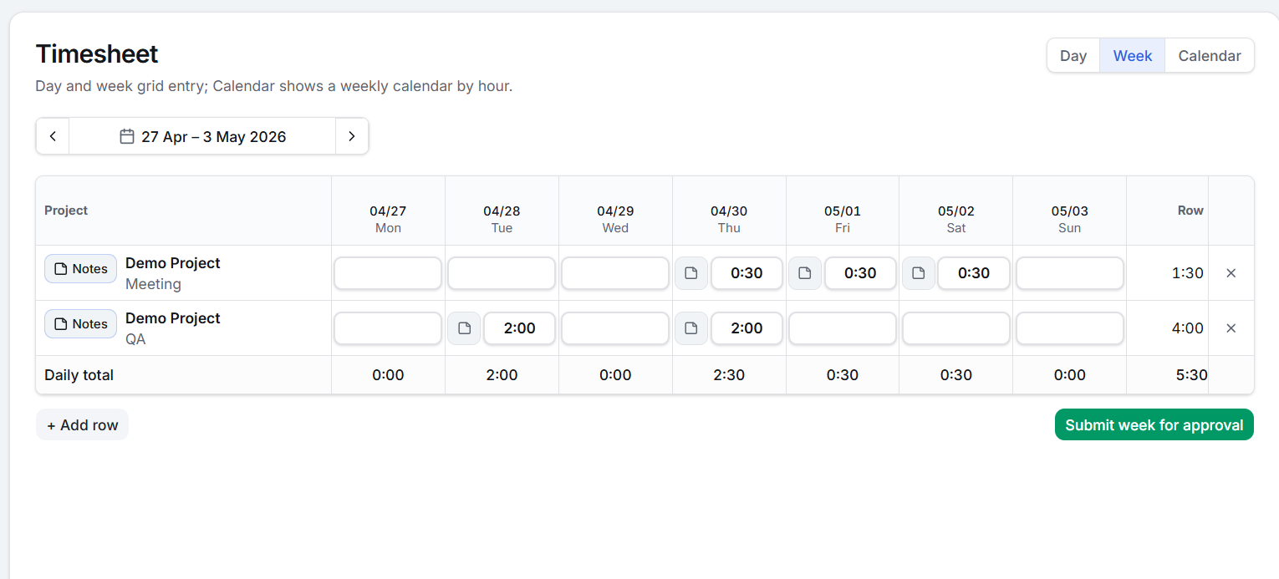
Figure 22. Week view for grid-style entry across project/task rows and weekday columns.
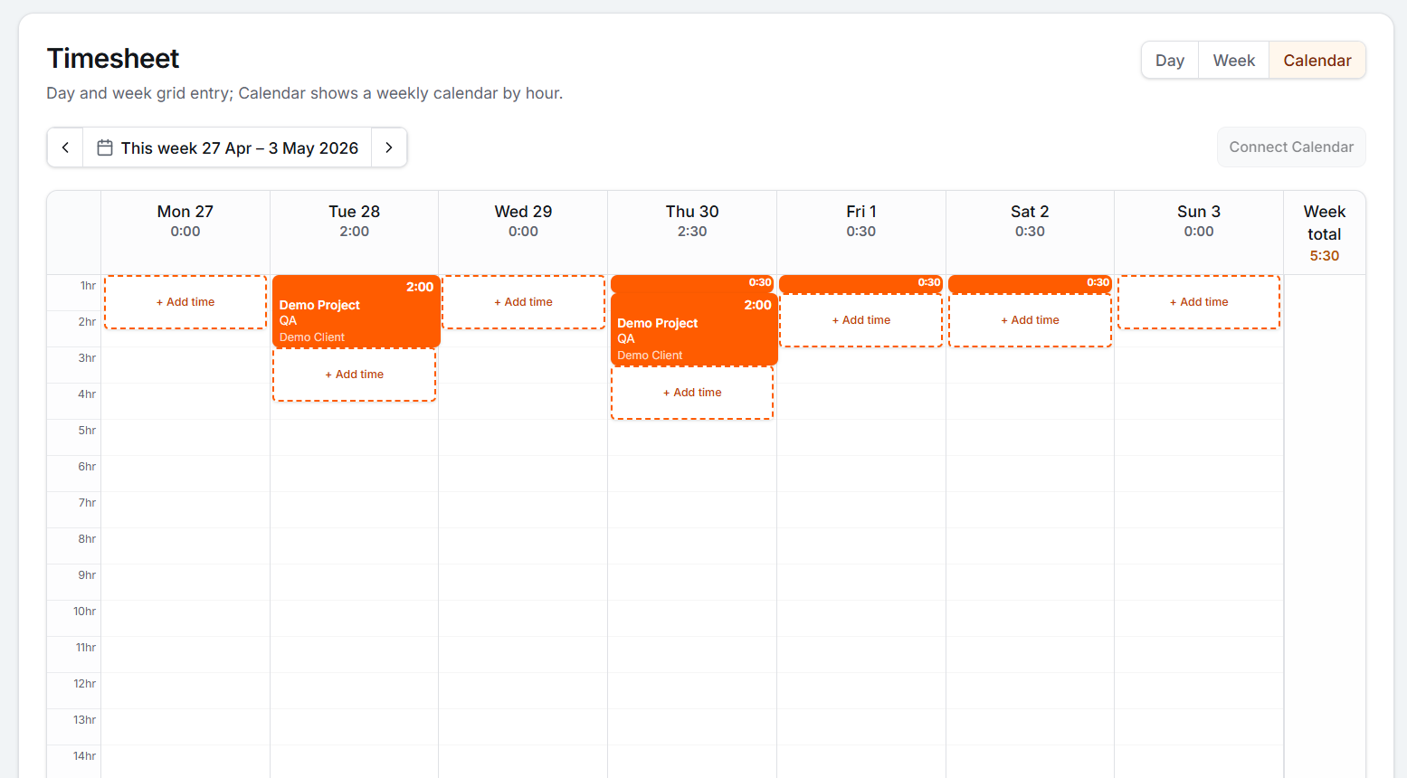
Figure 23. Calendar view for reviewing tracked time in a weekly calendar layout.
Use Time Entry to record project work. Chrona supports Day, Week, and Calendar views so users can choose the view that fits their working style.
View | Best for | Typical workflow
Day | Entering detailed work for a single day. | Add one or more entries for selected projects and tasks.
Week | Reviewing and filling a weekly timesheet quickly. | Enter hours across the week and check totals before submission.
Calendar | Visualizing work across dates. | Navigate dates visually and add or review entries in context.

Enter time
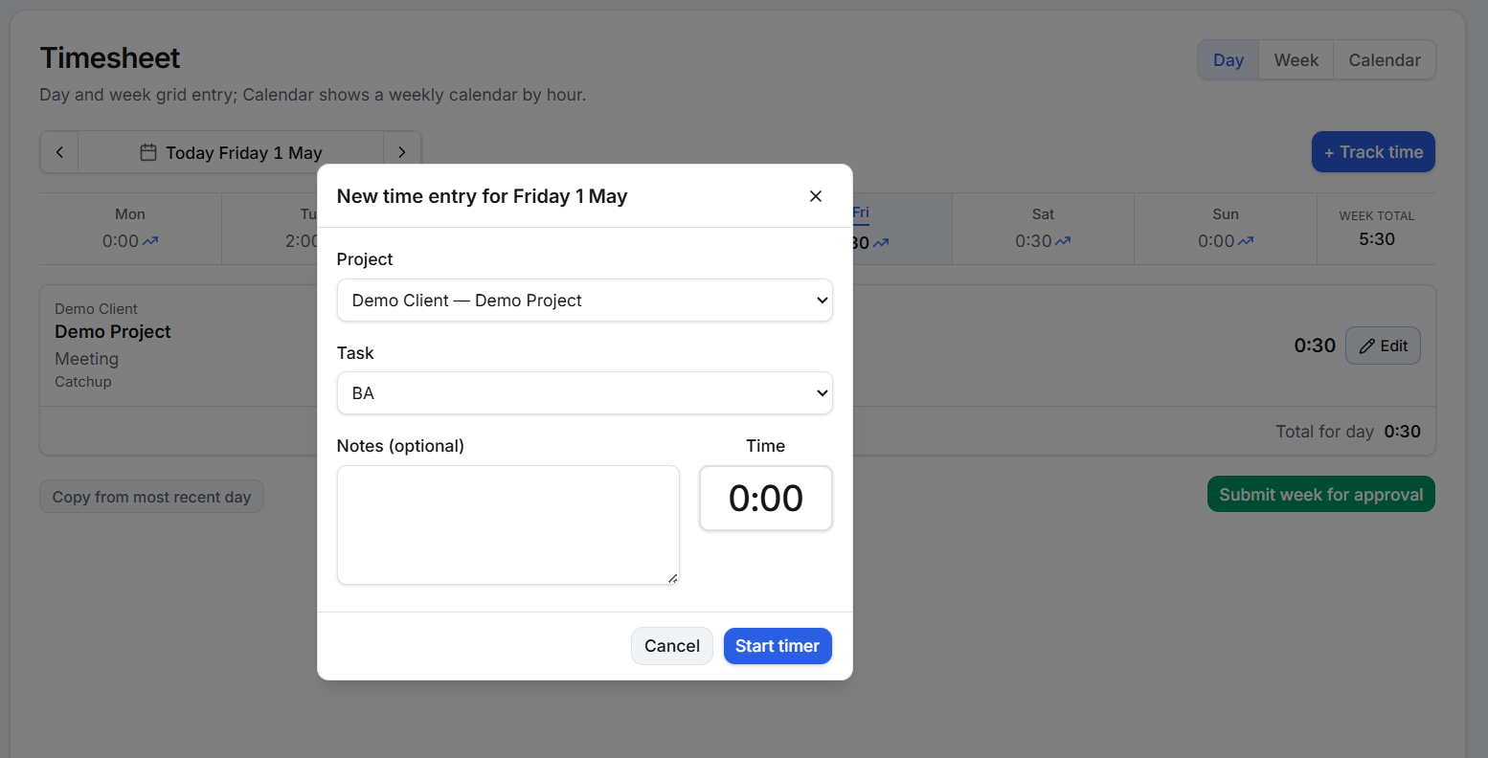
Figure 24. New time entry window for selecting project, task, optional notes, and time value.
Step | Action | Expected result
1 | Open Time Entry and choose Day, Week, or Calendar view. | The selected time view is displayed.
2 | Select Add time or open the entry window. | The time entry form appears.
3 | Choose a project. | Only eligible projects are available.
4 | Choose a task. | Tasks available for the selected project are displayed.
5 | Enter notes if helpful. | The entry contains work context for managers and reporting.
6 | Enter hours. | Chrona can include the entry in totals, approvals, and reports.
7 | Save the entry. | The row appears in the selected time view.

Edit or delete a time entry
Step | Action | Expected result
1 | Find the entry in Day, Week, or Calendar view. | The entry action options are available.
2 | Select Edit to update details or Delete to remove the entry. | The selected action is opened.
3 | Make the change and confirm. | The time entry is updated or removed.
4 | Review daily and weekly totals. | Totals reflect the latest entries.
Helpful tips
You cannot edit or delete entries that belong to an approved locked period unless approval is withdrawn by an authorized manager.

Submit time for approval
Step | Action | Expected result
1 | Review the period you want to submit. | Your hours are complete and accurate.
2 | Choose a submission period: day, week, or custom date range. | The intended entries are selected for submission.
3 | Submit the entries. | The entries move into the approval workflow.
4 | Wait for manager review. | Your manager can approve or send a message requesting changes.
Result
After approval, submitted time for the period is locked and cannot be changed by the member unless approval is withdrawn.

Key rules to remember
Required fields
Project, task, and hours are required for time entry. Notes are optional unless your company policy requires them.

Submission scope
Members can submit time by day, week, or custom date range.

Locked approved time
Approved time entries are locked to protect reporting and billing integrity.

9. Expenses
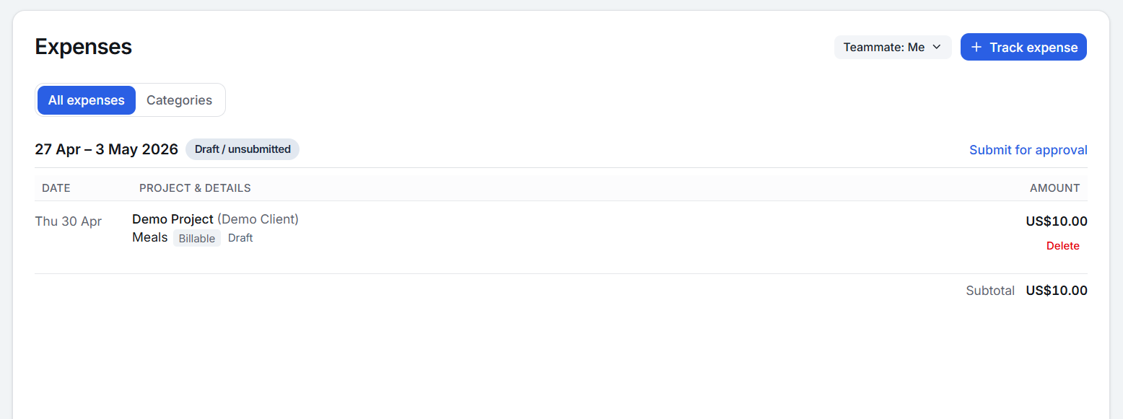
Figure 25. Expenses list showing expense entries for the selected period and submission status.
Use Expenses to record project-related costs. Administrators maintain categories so submitted expenses are consistent and easy to report.

Submit an expense
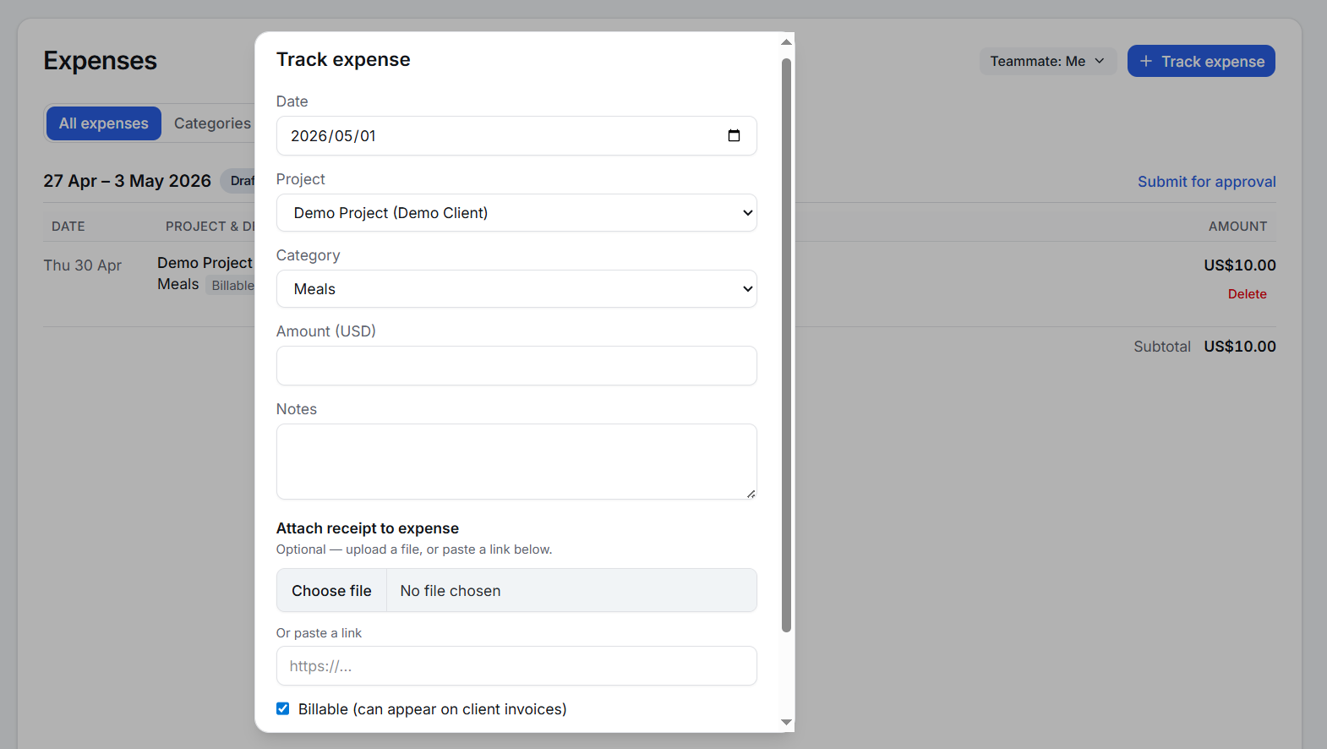
Figure 26. Track expense form with project, category, amount, notes, receipt attachment, and billable options.
Step | Action | Expected result
1 | Open Expenses. | The expense list or entry area is visible.
2 | Select New expense or Add expense. | The expense form opens.
3 | Choose the project. | The expense is connected to the correct client work.
4 | Choose the category. | The expense is classified for reporting.
5 | Enter the amount. | The cost is available for approval and profitability calculations.
6 | Add notes or attachments if required by policy. | Reviewers have the context needed to approve.
7 | Save or submit the expense. | The expense enters the correct state for review.

Manage expense categories
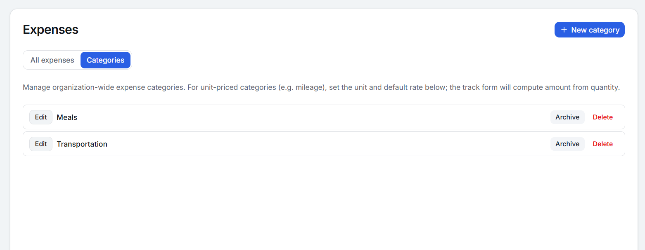
Figure 27. Expense categories list with edit, archive, and delete actions.
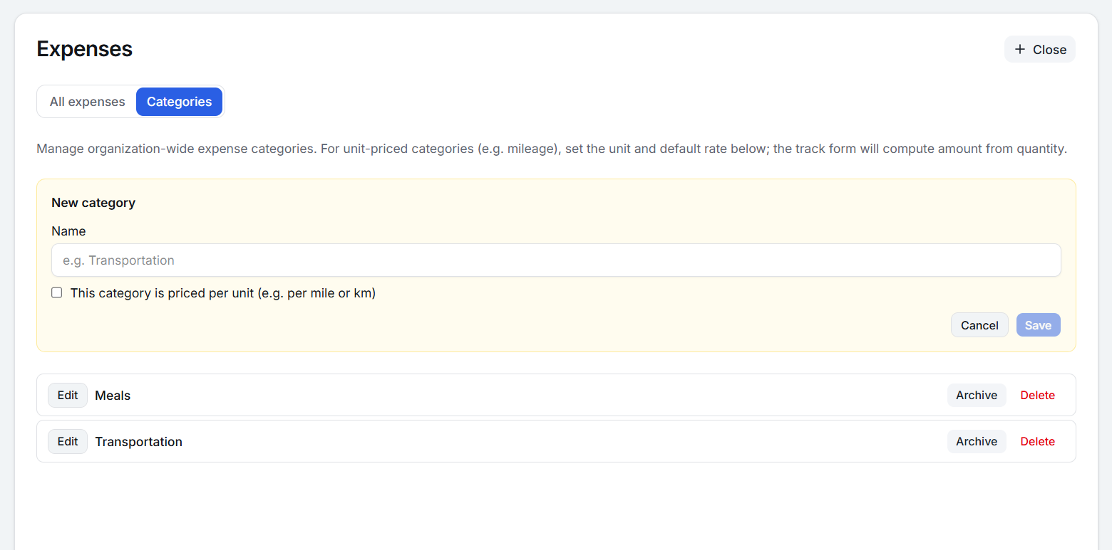
Figure 28. New expense category form including unit-priced category settings.
Step | Action | Expected result
1 | Go to the expense category administration area. | Existing categories are listed.
2 | Select New category. | The category form opens.
3 | Enter category details. | The category can be used for future expenses.
4 | Save the category. | The category becomes available for expense submission.
5 | Use Edit, Archive, or Delete for existing categories. | The category list stays clean and accurate.
Helpful tips
A category with existing expense data cannot be deleted. Archive it instead so historical reporting remains intact.

Key rules to remember
Project and category required
Every expense should be tied to a project and category so it can be reviewed and reported correctly.

Category deletion rule
Categories with existing expenses cannot be deleted and should be archived when retired.

Profitability impact
Approved expenses are included in cost visibility and can reduce project profitability.

10. Time and expense approvals
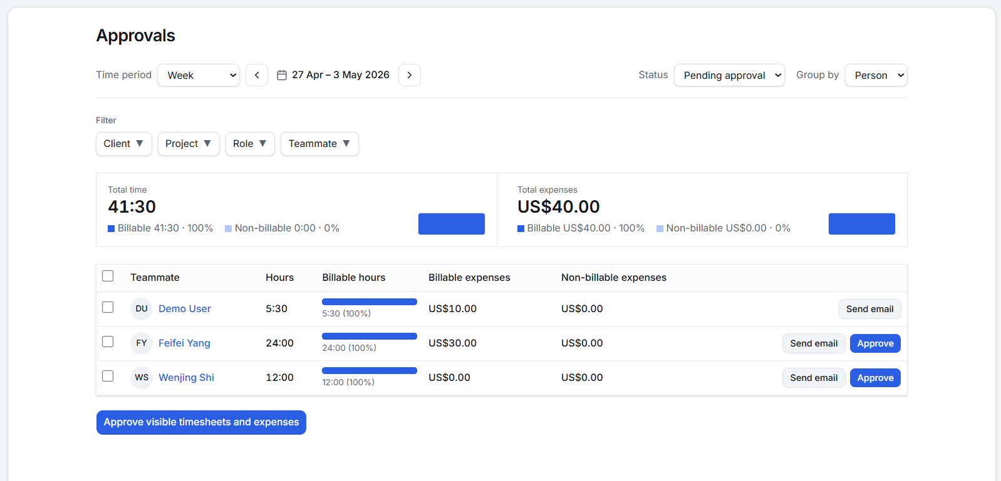
Figure 29. Approvals dashboard with period, status, grouping, filters, total time, and total expense summaries.
Approvals help managers review submitted time and expenses before the data is locked for reporting and downstream finance processes.

Review submitted time and expenses
Step | Action | Expected result
1 | Open Approvals. | Submitted items are listed by member and period.
2 | Select a team member name. | The detailed submission view opens.
3 | Review time entries, expense entries, notes, projects, tasks, categories, and totals. | The submission can be evaluated for accuracy.
4 | Decide whether to approve or request changes. | The workflow moves forward based on your decision.

Approve a submission
Step | Action | Expected result
1 | Open the submission detail. | The submitted time and expenses are visible.
2 | Confirm entries are complete and correct. | No obvious issues remain.
3 | Select Approve. | Chrona marks the submission as approved.
4 | Confirm the approval if prompted. | The approved period is locked for the member.
Result
After approval, the member cannot edit the approved time or expenses for that period.

Send a message requesting changes
Step | Action | Expected result
1 | Open the submission detail. | The submitted entries are visible.
2 | Select Send email or the request-change action. | A communication form opens.
3 | Explain what needs to be corrected. | The member receives clear instructions.
4 | Send the message. | The member can make the needed updates if the entries are not locked.

Withdraw approval
Step | Action | Expected result
1 | Open the approved submission or approval history. | The approved period is visible.
2 | Select Withdraw approval. | Chrona prepares to unlock the period.
3 | Confirm the action. | The approval is removed.
4 | Notify the member if changes are needed. | The member can edit and resubmit the entries.
Helpful tips
Use withdrawal carefully. It reopens a period that may already have been used in reports or downstream processes.

Key rules to remember
Approval locks data
Approved time and expenses are locked to preserve reporting accuracy.

Withdrawal unlocks data
Withdrawing approval allows the member to change and resubmit the entries.

Manager responsibility
Managers should review notes, tasks, project selection, expense category, and totals before approving.

11. Reports
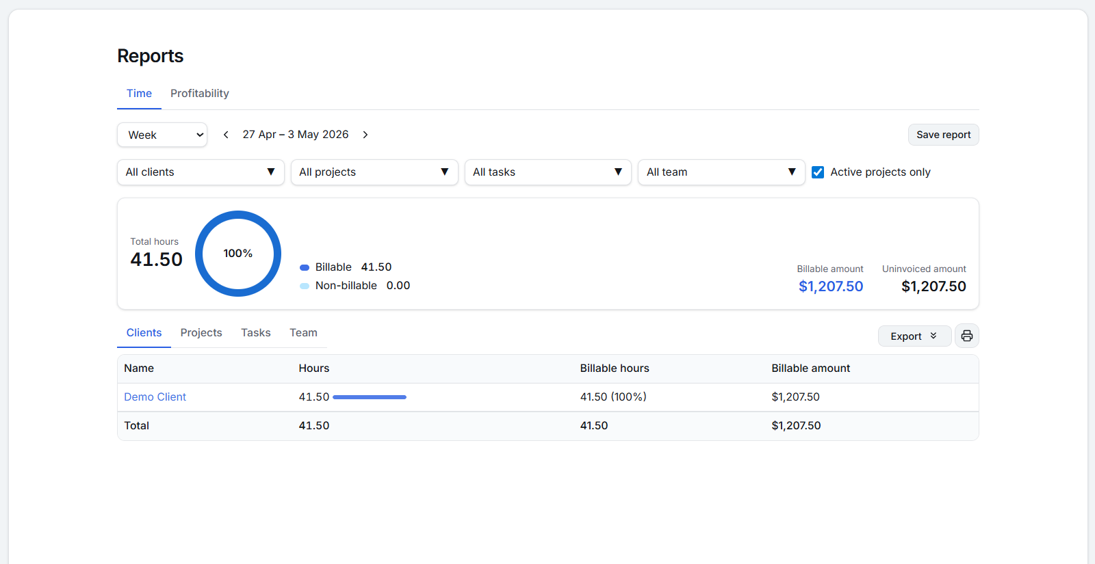
Figure 30. Time report with filters, billable totals, uninvoiced amount, and grouping tabs.
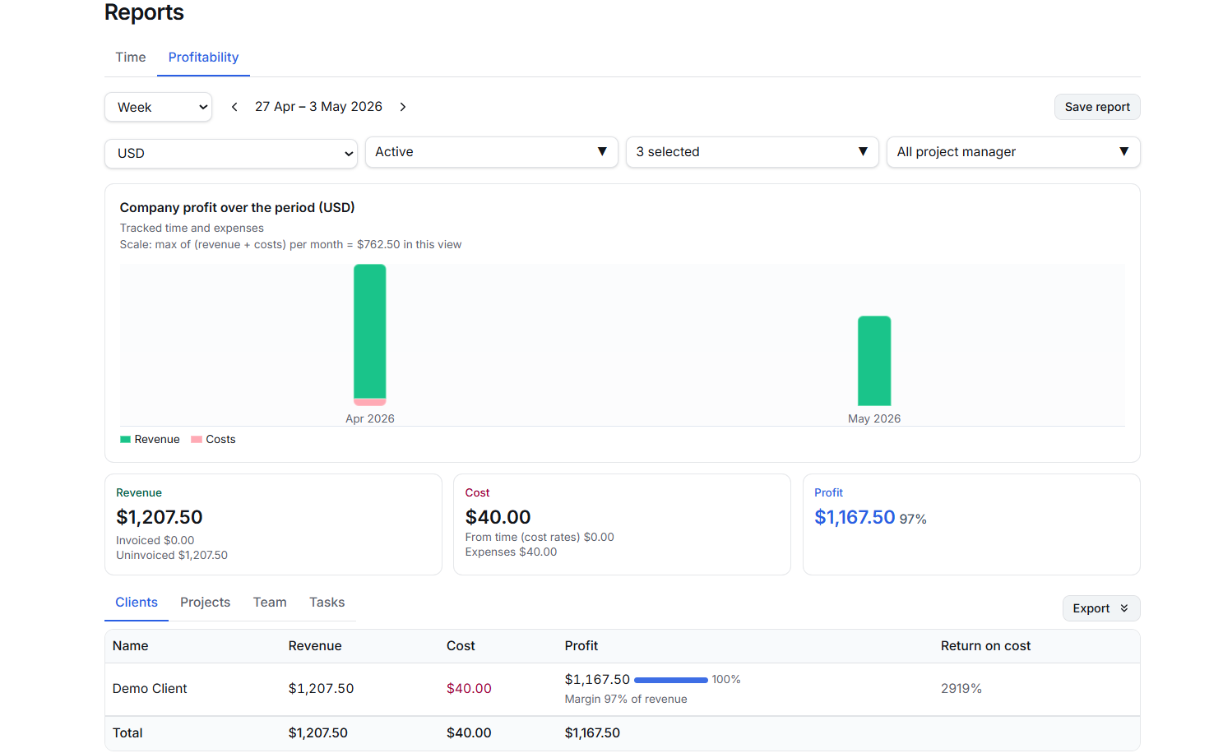
Figure 31. Profitability report showing company profit across the selected period.
Reports convert tracked work and expenses into operational insight. Use filters to answer questions by client, project, task, team member, and date range.
Report | Use it to answer | Common filters
Time | How much time was spent and where? | Client, project, task, team member, date range.
Profitability | Are projects generating enough revenue compared with costs? | Client, project, team, date range, billable status.
Detailed time | Which individual time entries make up the totals? | Client, project, task, member, date range, approval status.
Detailed expenses | Which expense items were submitted and approved? | Client, project, category, member, date range, approval status.

Run a time report
Step | Action | Expected result
1 | Open Reports > Time. | The time report page opens.
2 | Choose the desired date range. | The report focuses on the right time period.
3 | Select grouping such as Clients, Projects, Tasks, or Team. | The report summarizes time in the chosen structure.
4 | Apply filters as needed. | Only relevant data is included.
5 | Review totals and drill into details if available. | You can explain the source of the summarized time.

Run a profitability report
Step | Action | Expected result
1 | Open Reports > Profitability. | The profitability report page opens.
2 | Choose the target client, project, team, or date range. | The report scope is defined.
3 | Review revenue, costs, and profit. | Project financial health is visible.
4 | Investigate low-margin or negative-profit items. | You can decide whether rates, scope, staffing, or expenses need attention.

Run detailed time or expense reports
Step | Action | Expected result
1 | Open Reports > Detailed time or Reports > Detailed expenses. | The detailed report page opens.
2 | Apply filters such as client, project, task, category, team member, and date range. | The report displays targeted entries.
3 | Review line-level data. | You can audit the details behind totals.
4 | Export or share according to your company process if the feature is enabled. | Stakeholders can review the underlying data.

Key rules to remember
Profit formula
Profit equals revenue minus costs.

Revenue formula
Revenue is calculated from hours multiplied by the applicable billable rate, depending on project rate setup.

Cost formula
Costs include expenses and may include labor cost rate calculations depending on reporting configuration.

Filter discipline
Always confirm date range and filters before using a report for decisions.

12. Administration, security, and data hygiene
A clean Chrona workspace depends on consistent master data, thoughtful permission management, and careful handling of archived or deleted records.
Admin area | Recommended cadence | What to check
Members and roles | Monthly or during team changes. | Inactive users, role accuracy, manager assignments, password reset requests.
Rates | When contracts or compensation assumptions change. | Non-overlapping date ranges, default rates, project-specific rates.
Clients and contacts | Before new projects and quarterly cleanup. | Currency, invoice due date, tax settings, contact details.
Projects | At kickoff and closure. | Project type, team, tasks, billing setup, invoice values, archive status.
Tasks | Monthly or during process changes. | Common task set, outdated tasks, billable task rates when needed.
Expense categories | Quarterly or when policy changes. | Obsolete categories, categories with historical data that should be archived.

Data hygiene principle
Prefer archiving over deleting whenever a record has historical time, expense, approval, report, or billing relevance. Deleting should be limited to records that are safe to remove permanently.

Prepare a project for closeout
Step | Action | Expected result
1 | Confirm all time and expenses have been submitted. | No unsubmitted work remains for the project period.
2 | Confirm approvals are complete. | Approved data is locked and ready for reporting.
3 | Run final time, expense, and profitability reports. | Final project history is available.
4 | Archive the project if no future entries are expected. | The project no longer appears as an active work option.

13. Troubleshooting and FAQ
Use this section when something does not appear as expected or a user cannot complete a common action.
Issue | Likely cause | What to do
A project is missing from time entry. | The member is not assigned to the project, or the project is archived. | Check project assignment, project status, and permissions.
A task is missing from a project. | The task was not added to the project or is archived. | Add the task to the project or restore an active task as appropriate.
A user cannot edit time or expenses. | The period may already be approved and locked. | Ask an authorized manager to withdraw approval if changes are valid.
A role does not appear during invitation. | The role may not exist or may have been deleted/archived. | Create or reactivate the role under Team > Roles.
A rate cannot be saved. | The date range may overlap another rate period. | Adjust the effective dates so rate periods do not overlap.
An expense category cannot be deleted. | The category has existing expenses. | Archive the category instead of deleting it.
Profitability looks unexpected. | Rates, project type, expenses, or date filters may be incorrect. | Check rate setup, project billing model, approved expenses, and report filters.
A client contact is outdated. | The client contact details changed. | Open Clients > Contacts and edit or delete the contact.

Frequently asked questions
Can I track time on a non-billable project?
Yes. Non-billable projects can still accept time entries if you are assigned to the project and the tasks are available.
What happens after my time is approved?
Approved entries are locked. You cannot edit them unless approval is withdrawn by an authorized manager.
What is the difference between Common tasks and Other tasks?
Common tasks are automatically added to new projects. Other tasks must be added manually to projects.
Why do I see different rates in reports?
Chrona applies the rate model configured on each project. Project-specific person or task rates may override defaults.
Should I delete or archive old records?
Archive records when history must remain available. Delete only when the record has no business or reporting dependency.

14. Appendix: rules, glossary, and checklists

A. Status and action reference
Object | Common actions | Notes
Member | Invite, edit, pin, archive, delete, reset password. | Archive instead of delete when historical data must remain intact.
Role | Create, edit, delete, assign members. | Role name must be unique.
Client | Create, edit, archive, delete, manage contacts. | Client settings influence projects and reporting.
Project | Create, edit, pin, duplicate, archive, delete. | Billing model controls rates, fees, and report calculations.
Task | Create, edit, move group, archive, delete. | Common tasks are added automatically to new projects.
Time entry | Create, edit, delete, submit. | Approved entries are locked.
Expense | Create, edit, submit, approve. | Expenses are categorized and can affect costs.
Category | Create, edit, archive, delete. | Cannot delete if existing expenses use the category.

B. Glossary
Term | Meaning
Billable rate | Hourly rate used to calculate revenue for billable time.
Cost rate | Internal cost rate used to estimate delivery cost.
Project billable rate | One hourly rate applied to billable time on a project.
Person billable rate | A project-specific hourly rate assigned to each member on the project.
Task billable rate | A rate assigned to a task for task-based revenue calculation.
Fixed fee | A set project price that does not depend on the number of hours tracked.
Non-billable | Work that is tracked but not billed to a client.
Common task | A task automatically added to new projects.
Other task | A task manually added to specific projects.
Approval withdrawal | A manager action that removes approval and unlocks a period for corrections.

C. Administrator launch checklist
Done? | Checklist item | Why it matters
 | Create system and configurable roles. | Prevents incorrect access during rollout.
 | Invite members with correct work emails. | Ensures unique accounts and successful invitation delivery.
 | Set member default billable and cost rates. | Supports revenue and cost reporting.
 | Create clients with currency, due date, and tax settings. | Keeps project billing context consistent.
 | Create common tasks. | Speeds up project setup.
 | Create projects with correct billing model. | Ensures accurate time, revenue, and profitability workflows.
 | Assign team members and tasks. | Makes projects available for time and expense entry.
 | Confirm approval managers. | Ensures submissions are reviewed by the right people.
 | Run sample reports. | Validates data setup before full rollout.

D. Team member weekly checklist
Done? | Checklist item
 | Enter time daily or update the weekly timesheet before submission.
 | Choose the correct project and task for every entry.
 | Add useful notes for work that may need manager context.
 | Submit reimbursable or project expenses with the correct category and amount.
 | Review totals before submitting time and expenses for approval.
 | Respond promptly if a manager requests changes.

E. Manager approval checklist
Done? | Checklist item
 | Review submitted time by person and period.
 | Check project and task selections for obvious misclassification.
 | Review notes when context is needed.
 | Review expenses for correct project, category, amount, and policy fit.
 | Approve clean submissions.
 | Send a clear message for submissions that need correction.
 | Withdraw approval only when a valid correction is required.

End of manual
Keep this manual updated whenever Chrona navigation, permissions, billing logic, approval policy, or reporting definitions change.

