Service Blueprint, SLOs & Cloud Cost Envelope
Cloud Computing & DevOps — operational contract before infrastructure/deployment automation
This submission turns the supplied three-scenario CSV into a complete operational contract. The design uses a two-tier web service: a stateless application tier and a managed PostgreSQL data tier. The cost figures are planning envelopes, not vendor quotations.

1. Executive architecture
Primary request path: Client → HTTPS load balancer/reverse proxy → stateless application tier → PostgreSQL. The application tier reads runtime secrets from Secrets Manager and emits metrics/logs to CloudWatch. Database backups are retained through managed database backup facilities and/or AWS Backup.
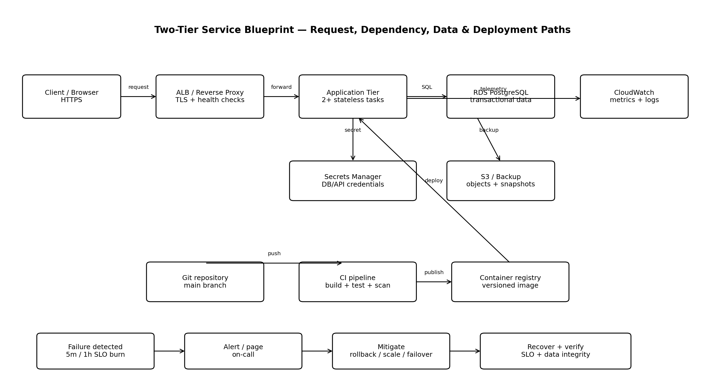

2. Service blueprint
Path | Flow | Control / proof
Request | Client → ALB → app task → DB → app → ALB → client | TLS, health checks, request IDs, structured errors, timeout budget
Dependency | App → PostgreSQL; App → Secrets Manager; App → CloudWatch | Connection pool, dependency timeouts, retries only for safe/idempotent operations
Deployment | Git → CI test/scan → container image → registry → rolling deployment | Immutable version/tag, automated tests, health checks, rollback procedure
Data | Transactional data → PostgreSQL; backups → managed backup/S3 | Encryption at rest/in transit, backup retention, periodic restore test
Failure | Detect → page → mitigate → recover → verify | SLO burn alerts, runbook, rollback/scale/failover, post-incident review

3. SLO contract
Availability is defined as successful service time / total service time. For this project, the availability SLI is measured from valid HTTP requests: successful responses divided by total valid requests, with 5xx responses and timeouts counted as failures. P95 latency is measured server-side from request receipt to response completion.
Scenario | Availability | Error budget / 30d | P95 latency | RPO | RTO
Lean | 99.0% | 432.0 min | 800 ms | 1440 min | 240 min
Balanced | 99.5% | 216.0 min | 500 ms | 60 min | 60 min
Resilient | 99.9% | 43.2 min | 300 ms | 15 min | 30 min

4. Paging thresholds
- Page when HTTP error rate exceeds 5% for 5 minutes, or exceeds 1% for 1 hour.
- Page when P95 latency exceeds 1.5× the scenario target for 10 consecutive minutes.
- Page when application CPU/memory or database CPU/connections exceed 85% for 15 minutes and capacity is not recovering.
- Page after two consecutive failed backup jobs; a single failed backup is a warning.
- Warning-level alerts should be used below these thresholds so the team can act before the error budget is materially consumed.

5. Three-scenario cost envelope
The following allocation preserves the monthly budgets in the supplied CSV while making the cost drivers explicit. It is suitable for design review; before deployment, replace these planning numbers with a region-specific cloud pricing-calculator estimate.
Scenario | Compute | DB | Storage | Transfer | Logging | Backup | Support/Ops | Total
Lean | ₹900 | ₹500 | ₹150 | ₹250 | ₹150 | ₹150 | ₹400 | ₹2,500
Balanced | ₹2,200 | ₹1,800 | ₹400 | ₹900 | ₹500 | ₹500 | ₹1,700 | ₹8,000
Resilient | ₹7,000 | ₹6,000 | ₹1,000 | ₹2,500 | ₹1,500 | ₹1,500 | ₹5,500 | ₹25,000
Interpretation: Lean minimizes recurring spend but accepts a longer RTO/RPO; Balanced adds managed database capacity and autoscaling; Resilient spends more on redundancy, backup/recovery capability and operational headroom.

6. Architecture Decision Records
ADR-001 — Region
Use AWS Asia Pacific (Hyderabad) as the primary region for an India-focused service. Maintain a documented restore path to a second region for the resilient scenario. The choice reduces expected network distance to the target population while keeping disaster recovery explicit.
ADR-002 — Two-tier architecture
Use a stateless application tier plus managed PostgreSQL. This separates horizontally scalable compute from persistent state and reduces operational database burden.
ADR-003 — Recovery objectives
Adopt the CSV targets: Lean RPO 24h/RTO 4h; Balanced RPO 1h/RTO 1h; Resilient RPO 15m/RTO 30m. These targets drive backup frequency, redundancy and testing.
ADR-004 — Secrets
Store DB credentials, API keys and tokens in AWS Secrets Manager. Applications retrieve secrets at runtime; secrets are not stored in Git, container images or plaintext configuration.
ADR-005 — Least privilege
Use IAM roles rather than long-lived access keys for workloads. Separate runtime, deployment and read-only operational permissions; scope resource access to the specific service resources.
ADR-006 — Failure management
Treat failures as expected operational events: detect with SLO/health signals, page on actionable thresholds, mitigate with rollback/scale/failover, and verify recovery with service and data checks.

7. Recovery and failure runbook
Failure | Response
Application failure | Check ALB health and application error rate → stop/rollback bad deployment → scale healthy tasks → verify 2xx and P95.
Database failure | Check DB availability/connections → fail over if Multi-AZ is enabled → otherwise restore according to RTO/RPO → verify schema/data integrity.
Traffic spike | Check P95, CPU and request rate → allow autoscaling → protect DB with connection limits/pooling → confirm error rate returns below threshold.
Bad deployment | Freeze further deployments → identify version → rollback to last known-good image → verify health checks and SLOs → record incident.
Backup failure | Treat first failure as warning → retry/repair → page on second consecutive failure → run a restore validation if backup integrity is uncertain.

8. Definition of done / expected proof
- Service blueprint diagram showing request, dependency, deployment, data and failure paths.
- SLO workbook with availability, P95 latency, RPO/RTO, error budgets and paging thresholds.
- Three-scenario cost model with monthly envelopes and explicit cost categories.
- Architecture Decision Records covering region, recovery objectives, secrets and least privilege.
- Evidence to attach after implementation: dashboard screenshot, alert rules, successful deployment/rollback log, and backup restore-test record.

9. Official references
- AWS Well-Architected Reliability Pillar — reliability, availability, recovery and failure-management guidance.
- Amazon ECS Service Auto Scaling — autoscaling and deployment behavior.
- Amazon RDS backups — automated backups and point-in-time recovery.
- AWS IAM security best practices — temporary credentials and least privilege.
- AWS Secrets Manager best practices — secret storage, rotation and access control.
- Amazon CloudWatch pricing — usage-based monitoring/logging pricing.
- Amazon S3 pricing — storage, request and transfer cost components.
- Amazon RDS pricing — managed database pricing model.
- AWS Backup pricing — backup storage, transfer and restore pricing.

Submission note: The workbook and blueprint image are separate proof artifacts. Use the DOCX as the main report and attach the XLSX and PNG alongside it.

