**Computer Vision Report\_ HW2**

**605415032 楊方寧**

**Email: candy46410330@gmail.com**

* **Experiment name**

**1. Image filter**

a) Mean filter( windows size : 7x7 )

b) Median filter( windows size : 7x7 )

c) Gaussian 2D filter( windows size : 7x7)

**2. Edge Detection**

a) Canny edge detection

b) Robert edge detection

c) Prewitt edge detection

d) Sobel edge detection

* **Describe the main part of your method**

**1. Image filter**

**a) Mean filter:** The starting pixel starts at (3,3), each time with the current pixel as the base, and a 7 \* 7 mask is created, all of the 49 pixels are added and the final pixel value is divided by 49.

**b) Median filter:** The starting pixel starts from (3,3), each time with the current pixel as the base, to create the 7 \* 7 mask, and the 49 pixels are arranged from small to large, and the middle value is the final pixel value.

**c) Gaussian 2D filter:** The starting pixel starts at (3,3), each time with the current pixel as the base, and a 7 \* 7 mask is created, and these 49 pixels are multiplied by the Gaussian matrix, divided by the total number in the Gaussian matrix is the final pixel value.

**2. Edge Detection**

**a) Canny edge detection:**Smoothing the image with a Gaussian filter

The magnitude and direction of the gradient are calculated using the finite difference of the first order partial derivative. The non-maximum value of the gradient amplitude is suppressed

I2 Threshold value=100

I3 Threshold value=210

b)**Robert edge detection:** according this mask, do the operation

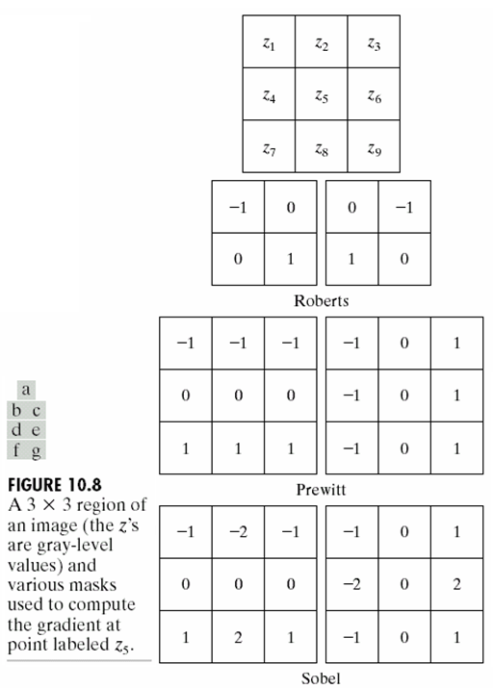

And then

 ,

I2 Threshold value=30

I3 Threshold value=70

c) **Prewitt edge detection:** according this mask, do the operation



And then

, 

I2 Threshold value=55

I3 Threshold value=130

d) **Sobel edge detection:** according this mask, do the operation



And then

 ,

I2 Threshold value=75

I3 Threshold value=180

* **Result image:**

**(1) I1:**

|  |  |
| --- | --- |
| **I1\_ Mean filter:** | **I1\_Median filter:** |
| **C:\Users\方寧\Desktop\I1_Mean.jpg** | **C:\Users\方寧\Desktop\I1_Median.jpg** |
| **I1\_Gaussian 2D filter:** |  |
| **C:\Users\方寧\Desktop\I1_Gaussian.jpg** |  |

**Next page ☺**

**(2) I2:**

|  |  |
| --- | --- |
| **I2\_ Canny edge detection :** | **I2\_Robert edge detection:** |
| **C:\Users\方寧\Desktop\I2_Canny.jpg** | **C:\Users\方寧\Desktop\I2_Robert.jpg** |
| **I2\_Prewitt edge detection:** | **I2\_Sobel edge detection:** |
| **C:\Users\方寧\Desktop\I2_Prewitt.jpg** | **C:\Users\方寧\Desktop\I2_Sobel.jpg** |

**N****ext page ☺**

**(2) I3:**

|  |  |
| --- | --- |
| **I3\_ Canny edge detection :** | **I3\_Robert edge detection:** |
| **C:\Users\方寧\Desktop\I3_Canny.jpg** | **C:\Users\方寧\Desktop\I3_Robert.jpg** |
| **I3\_Prewitt edge detection:** | **I3\_Sobel edge detection:** |
| **C:\Users\方寧\Desktop\I3_Prewitt.jpg** | **C:\Users\方寧\Desktop\I3_Sobel.jpg** |