**Computer Vision Report\_ HW3**

**605415032 楊方寧**

**Email: candy46410330@gmail.com**

* **Experiment name**

1. Hough transform in the **rectangular coordinate system**

2. Hough transform using **polar coordinate system**

* **Describe the main part of your method**

1. Hough transform in the **rectangular coordinate system**

1.) In the image space to determine all possible feature points, usually the edge point or skeleton point. .

2.) Find a feature point (x, y) of the image space, calculated

2.1) For each of a, calculate (a & apos ;, b & apos;) for all lines passing through (x, y)

2.2) Accumulate once at the (a ', b') position of the accumulator

Find the next feature point, repeat steps 2.1 and 2.2 until all the feature points are calculated.

3.) Find the sum of all the regions of the accumulator.

4.) Map each maxima back to the image space for each line.

T1\_Threshold = 160

T2\_Threshold = 130

T3\_Threshold = 350

2. Hough transform using **polar coordinate system**

Hough transform uses the polar coordinates (ρ, θ) instead of (a, b). The conversion formula of the polar coordinates and the orthogonal coordinates is: cos (θ) + y sin (θ) = r

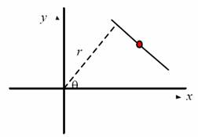

Each line on the image space is mapped to a point in the (?,?) Parameter space, and each point on the image space is mapped to a curve in the (?,?) Parameter space, as shown in the following figure:

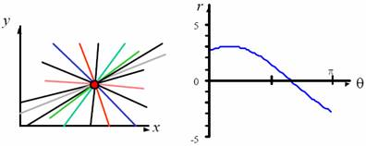

If there are three points on the same line in the image space, then the three curves of the (ρ, θ) parameter space will intersect at one point, that is, the accumulator accumulates at this position.

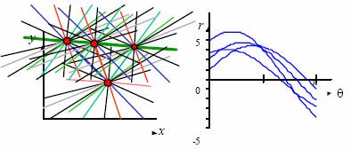

T1\_Threshold = 200

T2\_Threshold = 100

T3\_Threshold = 250,

* **Result image:**

**(1) T1:**

|  |  |
| --- | --- |
| **T1\_RectangularCoordinates** | **T1\_PolarCoordinates** |
| C:\Users\ya fa\Documents\Visual Studio 2013\Projects\CV_hw3\CV_hw3\T1_rectangularCoordinates.jpg | C:\Users\ya fa\Documents\Visual Studio 2013\Projects\CV_hw3\CV_hw3\T1_polarCoordinates.jpg |

**(2 )T2:**

|  |  |
| --- | --- |
| **T2\_RectangularCoordinates** | **T2\_PolarCoordinates** |
| C:\Users\ya fa\Documents\Visual Studio 2013\Projects\CV_hw3\CV_hw3\T2_rectangularCoordinates.jpg | C:\Users\ya fa\Documents\Visual Studio 2013\Projects\CV_hw3\CV_hw3\T2_polarCoordinates.jpg |

**(3) T3:**

|  |
| --- |
| **T3\_RectangularCoordinates** |
| C:\Users\ya fa\Documents\Visual Studio 2013\Projects\CV_hw3\CV_hw3\T3_rectangularCoordinates.jpg |
| **T3\_PolarCoordinates** |
| C:\Users\ya fa\Documents\Visual Studio 2013\Projects\CV_hw3\CV_hw3\T3_polarCoordinates.jpg |