**Comp 2322 Computer Networking**

**Project: Multi-thread Web Server**

Name: ZHANG Qinye

Student ID: 22098835D

**Design and Implementation of the Server Program**

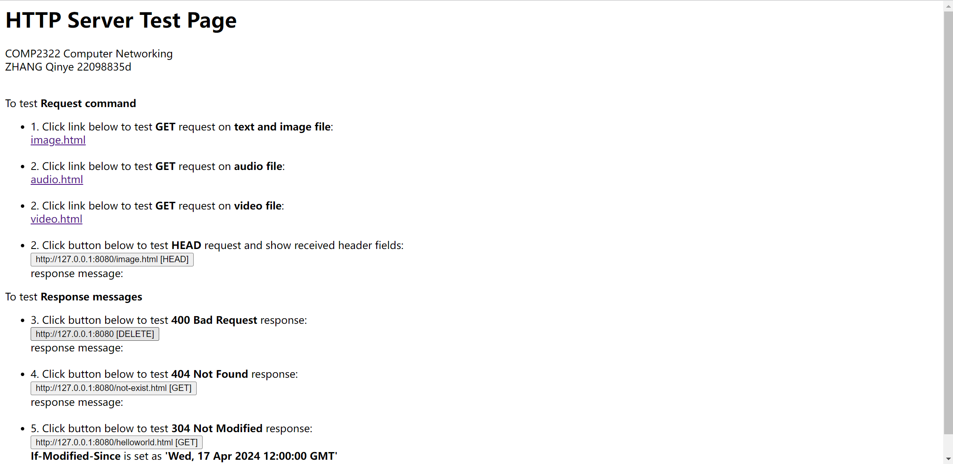

**Overall Design:**

|  |
| --- |
| WebServer |
| + static  + tcp_server_socket |
| + writeToLogSafely()  + getFileType()  + getIfModifiedSince()  + start() |

**Main Functions:**

* **Multi-threaded Web Server:** Utilizes threading to handle multiple client requests concurrently, ensuring efficient management of connections and improving the server's capability to serve several clients at the same time.
* **Persistent Connections:** Supports persistent connections using the Keep-Alive header, allowing multiple requests to be served over a single TCP connection, which can improve the performance by reducing the overhead of setting up and tearing down connections.
* **Request and Response Handling:** Manages proper exchange of HTTP request and response messages. The server parses client requests, identifies the HTTP method, and constructs appropriate HTTP responses.
* **Support for GET and HEAD Commands:** Handles GET requests for fetching resources like text and image files from the server.
* **Supports HEAD requests** to retrieve header information without the corresponding body content, useful for obtaining meta-information about resources.
* **Conditional GET Implementations:** Manages cache control through Last-Modified and If-Modified-Since headers. This allows the server to send a 304 Not Modified response if the client's cached version of a file is up-to-date, reducing unnecessary data transfer.
* **Diverse Response Statuses:** Handles various HTTP response statuses including 200 OK for successful requests, 400 Bad Request for improper requests, 404 Not Found for unavailable resources, and 304 Not Modified for cache-related responses.
* **Logging:** Implements logging of client requests and server responses, capturing essential details such as client IP, request time, requested resource, and the response status. This is crucial for monitoring, debugging, and maintaining the health of the server.

**Implementation:**

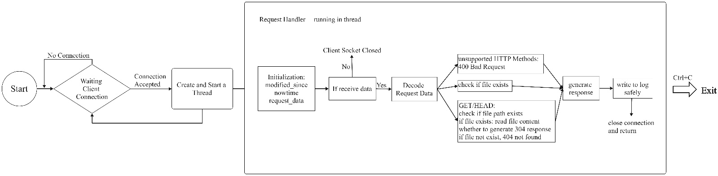

The server program operates as a basic multi-threaded web server utilizing the HTTP protocol and is structured to manage web requests efficiently. It begins by setting up a main listening socket that listens on a designated port, ready to accept incoming TCP connections from clients. Each client connection is managed through a dedicated socket, allowing for simultaneous handling of multiple requests by leveraging Python's threading capabilities. Upon receiving a connection, the server parses the incoming HTTP request to determine the requested resource's URI, then attempts to retrieve the corresponding file from a specified directory, which serves as the server's file system. If the file is found, it constructs an HTTP response with appropriate headers and the file content; if not, it generates a 404 Not Found error message. The server is designed to handle multiple requests concurrently, enhancing scalability and performance, and it includes error handling for non-existent resources or unsupported requests.

**(i) Create a connection socket when contacted by a client (browser):**

The server begins by setting up a TCP/IP socket bound to a specific port (8080). It configures the socket to listen for incoming connections. When a client like a web browser tries to connect, the server accepts the connection and establishes a new socket specifically for interacting with that client. This process effectively sets up a direct line of communication between the server and the client.

**(ii) Receive the HTTP request from this connection:**

Through the newly established client-specific socket, the server then listens for data sent by the client. This data includes the HTTP request, which consists of headers and possibly a body, depending on the request type (e.g., GET, POST). The server reads this data to understand what the client is requesting.

**(iii) Parse the request to determine the specific file being requested:**

Once the HTTP request is received, the server parses it to extract crucial information, primarily the path to the resource the client wants. This parsing involves breaking down the first line of the HTTP request to find the requested path, which indicates which file or resource the client is trying to access.

**(iv) Get the requested file from the server’s file system:**

With the requested resource path identified, the server looks for this file within its file system. If the file exists, the server reads its contents in preparation for sending it back to the client.

**(v) Create an HTTP response message consisting of the requested file preceded by header lines:**

The server prepares an HTTP response message to send back to the client. This response starts with a status line (e.g., "HTTP/1.1 200 OK" for successful requests), followed by headers that provide additional details (like content type and content length). The headers are followed by a blank line, and then the actual content of the file requested.

**(vi) Send the response over the TCP connection to the requesting client:**

After the HTTP response is fully prepared, including the headers and the file content, it is sent through the same socket connection to the client. Once the message is sent, depending on the connection type (persistent vs. non-persistent HTTP), the server may close the connection or keep it open for further requests.

**Handling Errors:**

If at any point the server determines that the requested file does not exist (e.g., when attempting to fetch the file from the system), it constructs a "404 Not Found" response. This response includes a status line indicating the error, headers, and a simple HTML document informing the user that the requested file could not be found. This error handling ensures the client receives meaningful feedback about the request's outcome.

--------------------------------------------------------------------------------------------------------------

**Demonstration of Executing the Program and Screenshots**

Preparation

* *Python3: 3.12.2*
* *Used build-in library: socket, threading, os, datetime*
* *Compile, run and test*

Make sure the abovementioned Preparation is fulfilled.

Open a terminal (cmd), change directory to this folder, then type the following command: *python httpServer.py*

*e.g.*



The server is running at <http://127.0.0.1:8080/index.html> on your localhost, please use your browser to visit <http://127.0.0.1:8080/index.html>.

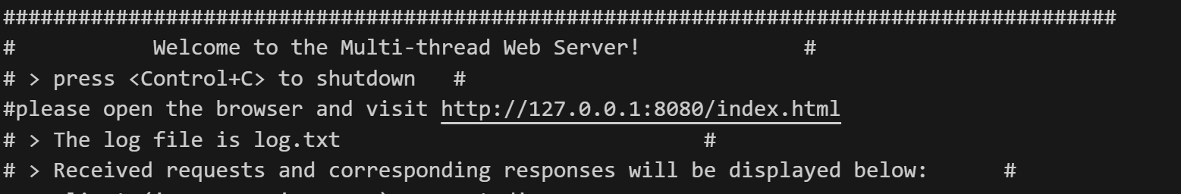

The "HTTP Server Test Page" is displayed in the browser:

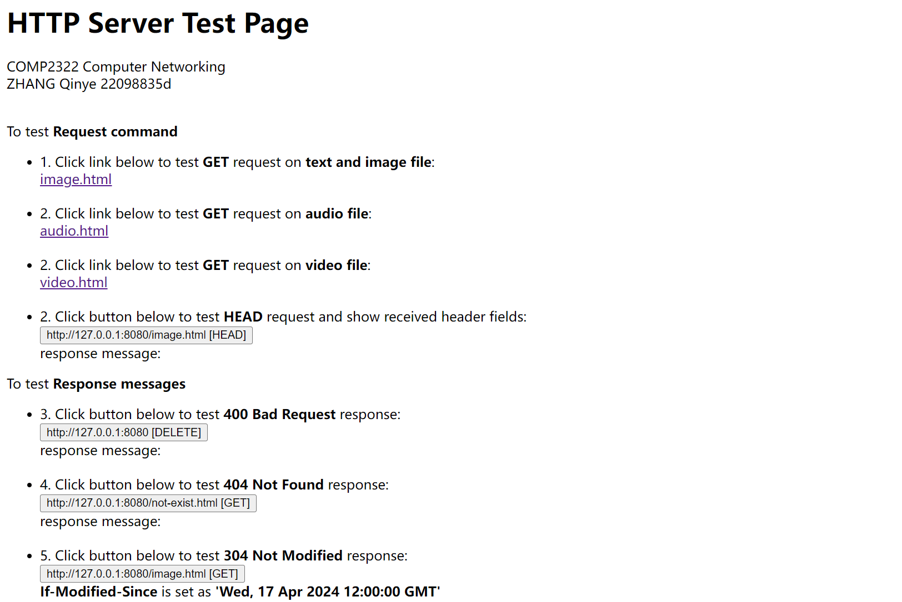

* Following the instructions on the webpage to test server's functions:
  + click the links image.html, audio.html and video.html to test text & image file, audio file and video file respectively.

image.html:

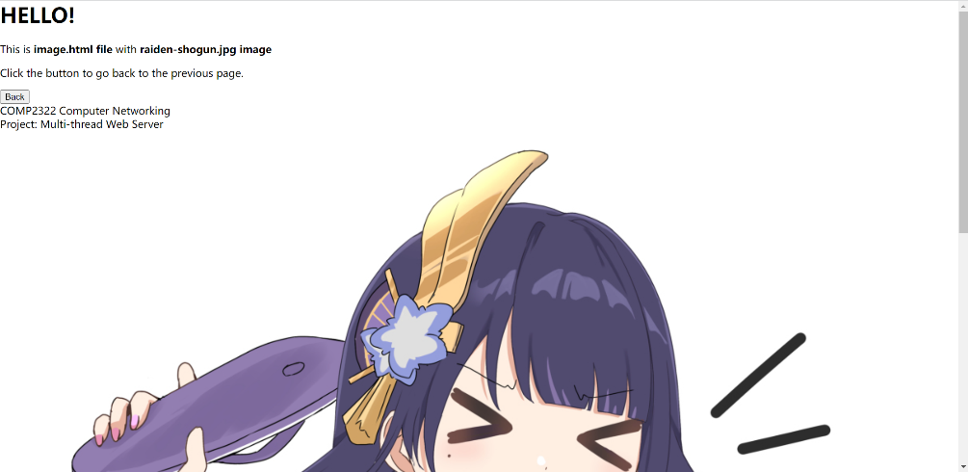

audio.html:

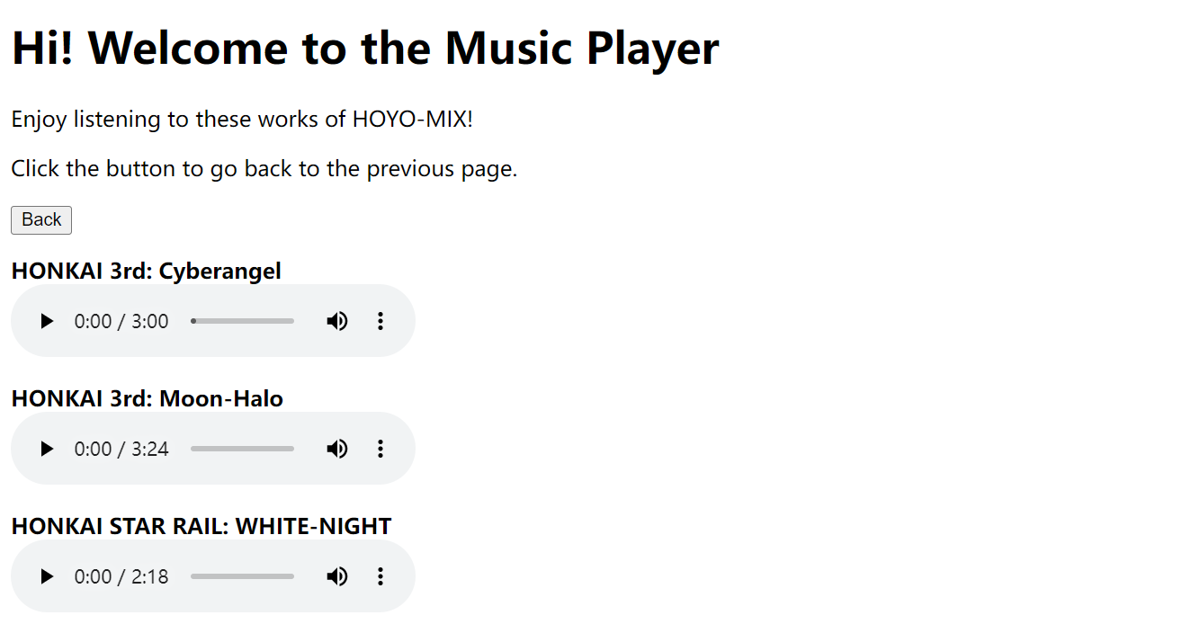

video.html:

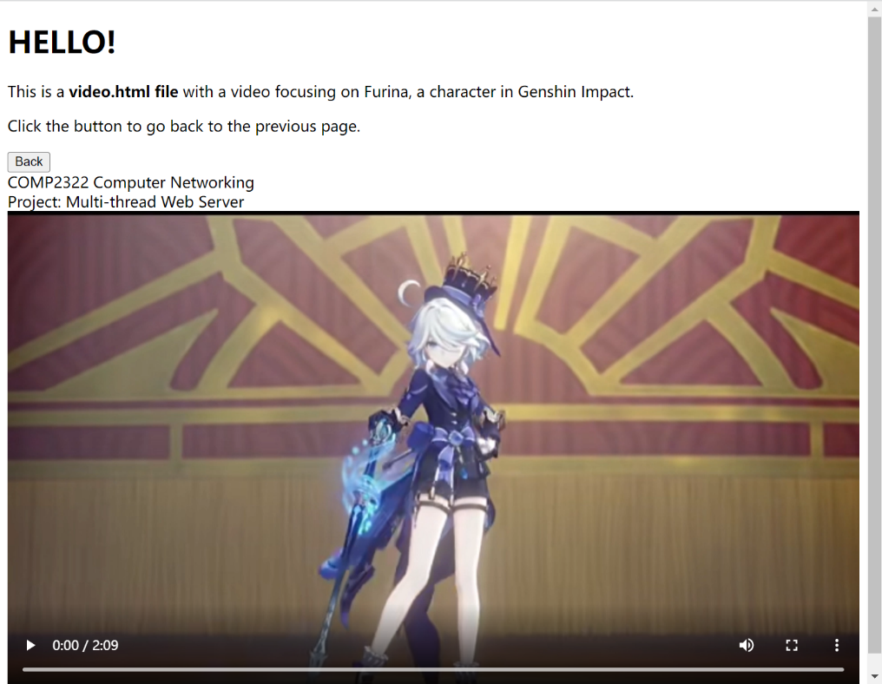

* + click the button to test HEAD request and show received header fields



result:



* + For 3 and 4, if you click the buttons, 400 Bad Request/404 Not Found will first be printed out and then a .html file is opened, reminding you of possible problems.



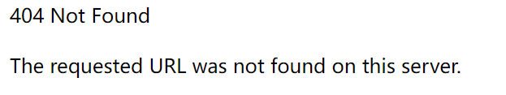

* + Click the button for 5 to test 304 Not Modified Response.

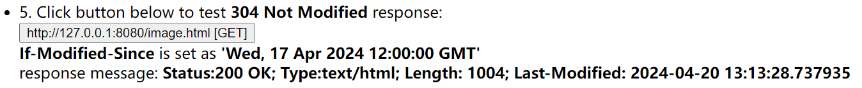

* Received requests and corresponding responses will be printed in the terminal (cmd).

example:

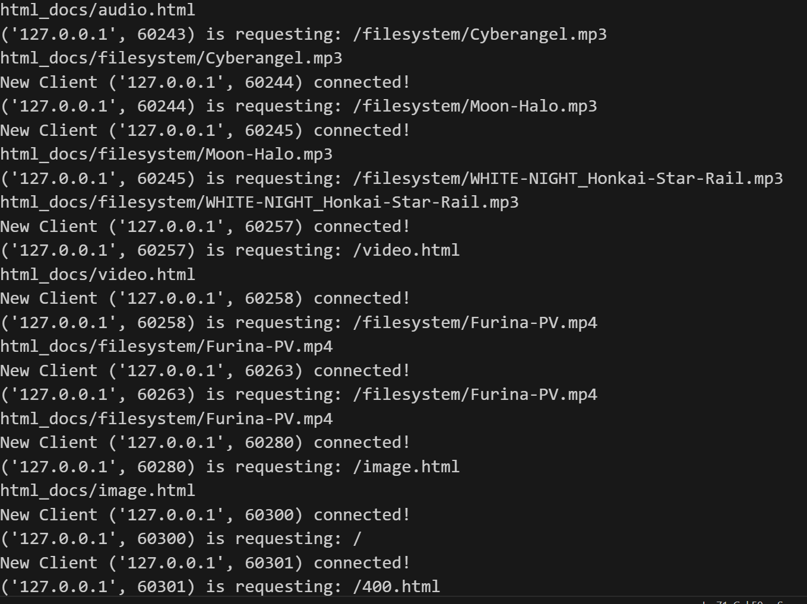

* You may also open browser's console by press F12 (fn+F12) to view the responses.

example: press fn + F12 and then click the link audio.html

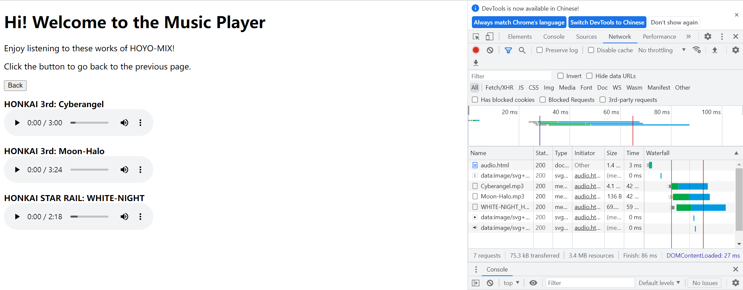

* Press Control+C in the terminal (cmd) to shut down the server and exit the program.
* To Test the handling of HTTP persistent connection:
  + First, open the terminal, find the directory that httpServer.py and keepAliveTest.py are in. input the command:

*python httpServer.py*

Then, open a new terminal, repeat the steps and input the command:

*python keepAliveTest.py*

In the terminal running keepAliveTest.py, you can see the request that has been sent and the response of the HTTP Server.

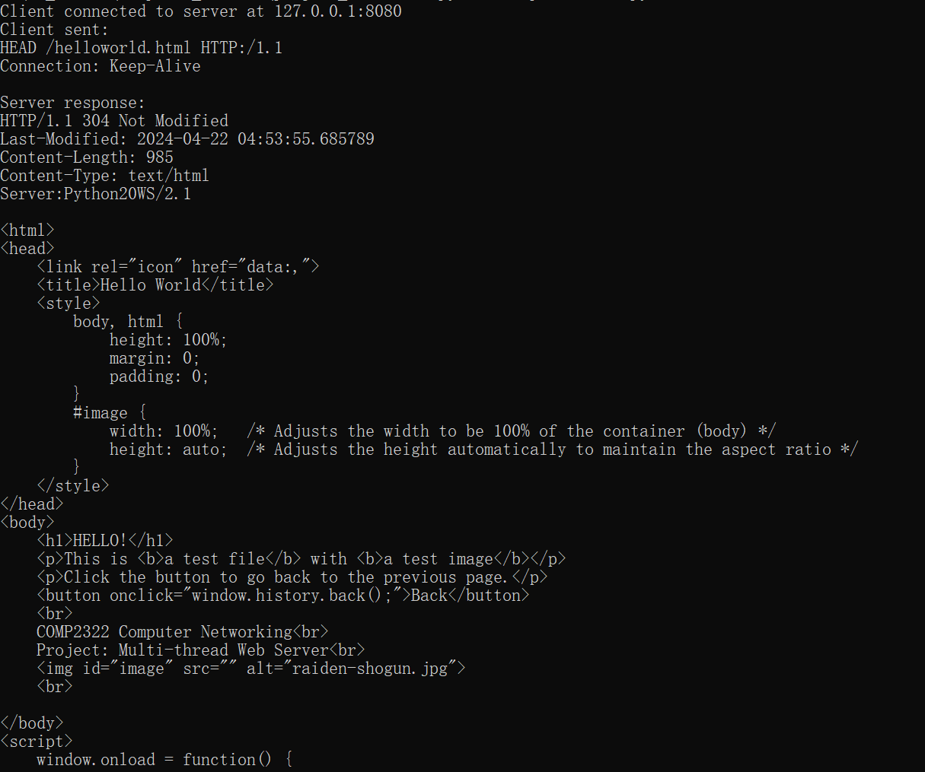

In the terminal running keepAliveTest.py, input 1 for keep-alive test; input 2 for close test, press 0 to exit.

input 1:

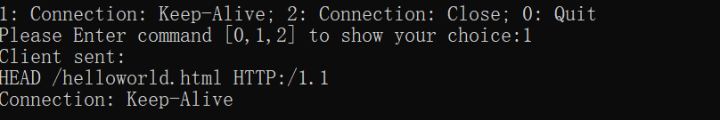

input 2:

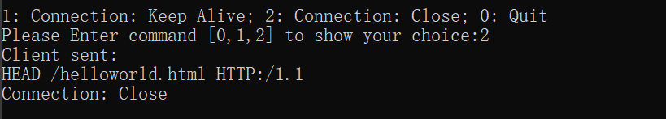

input 0:

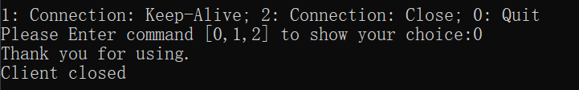

input 3 (invalid input):

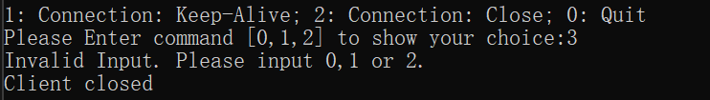

**README.txt**

Preparation

* *Python3: 3.12.2*
* *Used build-in library: socket, threading, os, datetime*
* *Compile, run and test*

Make sure the abovementioned Preparation is fulfilled.

============================================================

Open a terminal (cmd), change directory to this folder, then type the following command: ***python httpServer.py***

The server is running at http://127.0.0.1:8080/index.html on your localhost, please use your browser to visit [**http://127.0.0.1:8080/index.html**](http://127.0.0.1:8080/index.html).

After the "HTTP Server Test Page" is displayed in the browser, please following the instructions on the webpage to test server's functions:

1. click the links image.html, audio.html and video.html to test text & image file, audio file and video file respectively.
2. click the button below the links to test HEAD request and show received header fields

1. (4) Click the buttons for 400 Bad Request/404 Not Found. Both of them will first be printed out and then a .html file is opened, reminding you of possible problems.
2. Click the button for 5 to test 304 Not Modified Response and Last-Modified header fields.

Received requests and corresponding responses will be printed in the terminal (cmd) and logged into log.txt.

You may also open browser's console by press F12 (fn+F12) to view the responses.

Press Control+C in the terminal (cmd) to shut down the server and exit the program.

=============================================

To Test the handling of HTTP persistent connection:

First, open the terminal, find the directory that httpServer.py and keepAliveTest.py are in. input the command:

***python httpServer.py***

Then, open a new terminal, repeat the steps and input the command:

***python keepAliveTest.py***

In the terminal running keepAliveTest.py, input 1 for keep-alive test; input 2 for close test, press 0 to exit. If you input other values, the connection will be closed.

You can see the requests sent and the responses received in the terminal. They will also be logged into log.txt.

--------------------------------------------------------------------------------------------------------

**Log.txt:**

[IP]:('127.0.0.1', 63081) [Time]:2024-04-20 22:56:04.204577 [File]:/ [Response]:404

[IP]:('127.0.0.1', 63241) [Time]:2024-04-20 22:57:37.589951 [File]:/ [Response]:404

[IP]:('127.0.0.1', 63411) [Time]:2024-04-20 23:00:41.158775 [File]:/ [Response]:404

[IP]:('127.0.0.1', 63412) [Time]:2024-04-20 23:00:41.158775 [File]:/ [Response]:404

[IP]:('127.0.0.1', 63480) [Time]:2024-04-20 23:01:00.440111 [File]:/ [Response]:404

[IP]:('127.0.0.1', 63481) [Time]:2024-04-20 23:01:00.440111 [File]:/ [Response]:404

[IP]:('127.0.0.1', 63571) [Time]:2024-04-20 23:01:49.183363 [File]:/ [Response]:404

[IP]:('127.0.0.1', 63572) [Time]:2024-04-20 23:01:49.593427 [File]:/ [Response]:404

[IP]:('127.0.0.1', 63573) [Time]:2024-04-20 23:01:49.776111 [File]:/ [Response]:404

[IP]:('127.0.0.1', 63581) [Time]:2024-04-20 23:01:51.921537 [File]:/ [Response]:404

[IP]:('127.0.0.1', 63587) [Time]:2024-04-20 23:01:54.393194 [File]:/ [Response]:404

[IP]:('127.0.0.1', 63588) [Time]:2024-04-20 23:01:54.591437 [File]:/ [Response]:404

[IP]:('127.0.0.1', 49341) [Time]:2024-04-20 23:25:43.798538 [File]:/index.html [Response]:200

[IP]:('127.0.0.1', 49342) [Time]:2024-04-20 23:25:43.798538 [File]:/image.html [Response]:200

[IP]:('127.0.0.1', 49706) [Time]:2024-04-20 23:26:36.186068 [File]:/filesystem/raiden-shogun.jpg [Response]:200

[IP]:('127.0.0.1', 49715) [Time]:2024-04-20 23:26:44.069927 [File]:/audio.html [Response]:200

[IP]:('127.0.0.1', 49716) [Time]:2024-04-20 23:26:44.070433 [File]:/filesystem/Cyberangel.mp3 [Response]:200

[IP]:('127.0.0.1', 49719) [Time]:2024-04-20 23:26:44.105321 [File]:/filesystem/WHITE-NIGHT_Honkai-Star-Rail.mp3 [Response]:200

[IP]:('127.0.0.1', 49720) [Time]:2024-04-20 23:26:44.106847 [File]:/filesystem/Moon-Halo.mp3 [Response]:200

[IP]:('127.0.0.1', 49732) [Time]:2024-04-20 23:27:03.458471 [File]:/video.html [Response]:200

[IP]:('127.0.0.1', 49733) [Time]:2024-04-20 23:27:03.479519 [File]:/filesystem/Furina-PV.mp4 [Response]:200

[IP]:('127.0.0.1', 49937) [Time]:2024-04-20 23:28:26.621314 [File]:/index.html [Response]:200

[IP]:('127.0.0.1', 49938) [Time]:2024-04-20 23:28:26.621314 [File]:/filesystem/raiden-shogun.jpg [Response]:200

[IP]:('127.0.0.1', 50305) [Time]:2024-04-20 23:31:16.082110 [File]:/index.html [Response]:200

[IP]:('127.0.0.1', 50307) [Time]:2024-04-20 23:31:16.752762 [File]:/image.html [Response]:304

[IP]:('127.0.0.1', 50306) [Time]:2024-04-20 23:31:16.741395 [File]:/ [Response]:400

[IP]:('127.0.0.1', 50335) [Time]:2024-04-20 23:31:31.823850 [File]:/400.html [Response]:200

[IP]:('127.0.0.1', 50336) [Time]:2024-04-20 23:31:31.824350 [File]:/not-exist.html [Response]:404

[IP]:('127.0.0.1', 50342) [Time]:2024-04-20 23:31:38.385757 [File]:/404.html [Response]:200

[IP]:('127.0.0.1', 50360) [Time]:2024-04-20 23:31:50.342929 [File]:/helloworld.html [Response]:404

[IP]:('127.0.0.1', 50363) [Time]:2024-04-20 23:31:52.745773 [File]:/image.html [Response]:304

[IP]:('127.0.0.1', 50418) [Time]:2024-04-20 23:32:29.875967 [File]:/image.html [Response]:304

[IP]:('127.0.0.1', 50542) [Time]:2024-04-20 23:34:16.725496 [File]:/index.html [Response]:200

[IP]:('127.0.0.1', 50543) [Time]:2024-04-20 23:34:16.725905 [File]:/filesystem/Cyberangel.mp3 [Response]:200

[IP]:('127.0.0.1', 50550) [Time]:2024-04-20 23:34:19.824405 [File]:/filesystem/Moon-Halo.mp3 [Response]:200

[IP]:('127.0.0.1', 50554) [Time]:2024-04-20 23:34:22.449023 [File]:/filesystem/WHITE-NIGHT_Honkai-Star-Rail.mp3 [Response]:200

[IP]:('127.0.0.1', 50565) [Time]:2024-04-20 23:34:24.566858 [File]:/filesystem/Furina-PV.mp4 [Response]:200

[IP]:('127.0.0.1', 50568) [Time]:2024-04-20 23:34:25.724512 [File]:/filesystem/Furina-PV.mp4 [Response]:200

[IP]:('127.0.0.1', 50576) [Time]:2024-04-20 23:34:27.959960 [File]:/image.html [Response]:304

[IP]:('127.0.0.1', 50601) [Time]:2024-04-20 23:35:06.335268 [File]:/ [Response]:400

[IP]:('127.0.0.1', 50619) [Time]:2024-04-20 23:35:23.741723 [File]:/not-exist.html [Response]:404

[IP]:('127.0.0.1', 50620) [Time]:2024-04-20 23:35:23.772972 [File]:/helloworld.html [Response]:200

[IP]:('127.0.0.1', 51357) [Time]:2024-04-20 23:45:51.294140 [File]:/index.html [Response]:200

[IP]:('127.0.0.1', 51428) [Time]:2024-04-20 23:46:22.073877 [File]:/filesystem/HOYO-MiX-Liyue%E9%90%A0%E5%86%A9%E6%B9%80.mp3 [Response]:404

[IP]:('127.0.0.1', 51359) [Time]:2024-04-20 23:45:52.018814 [File]:/filesystem/Cyberangel.mp3 [Response]:200

[IP]:('127.0.0.1', 51360) [Time]:2024-04-20 23:45:52.023814 [File]:/filesystem/Moon-Halo.mp3 [Response]:200

[IP]:('127.0.0.1', 51427) [Time]:2024-04-20 23:46:22.073003 [File]:/filesystem/WHITE-NIGHT_Honkai-Star-Rail.mp3 [Response]:200

[IP]:('127.0.0.1', 51445) [Time]:2024-04-20 23:46:32.671588 [File]:/filesystem/Furina-PV.mp4 [Response]:200

[IP]:('127.0.0.1', 51447) [Time]:2024-04-20 23:46:33.709612 [File]:/filesystem/Furina-PV.mp4 [Response]:200

[IP]:('127.0.0.1', 51465) [Time]:2024-04-20 23:46:48.346228 [File]:/ [Response]:400

[IP]:('127.0.0.1', 51475) [Time]:2024-04-20 23:46:58.747022 [File]:/image.html [Response]:304

[IP]:('127.0.0.1', 51485) [Time]:2024-04-20 23:47:06.662268 [File]:/not-exist.html [Response]:404

[IP]:('127.0.0.1', 51495) [Time]:2024-04-20 23:47:14.658726 [File]:/helloworld.html [Response]:200

[IP]:('127.0.0.1', 54903) [Time]:2024-04-21 17:21:03.433862 [File]:/index.html [Response]:200

[IP]:('127.0.0.1', 54904) [Time]:2024-04-21 17:21:03.433862 [File]:/filesystem/Cyberangel.mp3 [Response]:200

[IP]:('127.0.0.1', 54923) [Time]:2024-04-21 17:21:10.059042 [File]:/filesystem/Moon-Halo.mp3 [Response]:200

[IP]:('127.0.0.1', 54924) [Time]:2024-04-21 17:21:10.065043 [File]:/filesystem/WHITE-NIGHT_Honkai-Star-Rail.mp3 [Response]:200

[IP]:('127.0.0.1', 54945) [Time]:2024-04-21 17:21:23.505200 [File]:/filesystem/Furina-PV.mp4 [Response]:200

[IP]:('127.0.0.1', 54947) [Time]:2024-04-21 17:21:24.337743 [File]:/filesystem/Furina-PV.mp4 [Response]:200

[IP]:('127.0.0.1', 54960) [Time]:2024-04-21 17:21:30.622305 [File]:/image.html [Response]:304

[IP]:('127.0.0.1', 54964) [Time]:2024-04-21 17:21:33.557580 [File]:/ [Response]:400

[IP]:('127.0.0.1', 54965) [Time]:2024-04-21 17:21:36.555684 [File]:/not-exist.html [Response]:404

[IP]:('127.0.0.1', 54967) [Time]:2024-04-21 17:21:39.810608 [File]:/helloworld.html [Response]:200

[IP]:('127.0.0.1', 55782) [Time]:2024-04-21 17:34:41.071607 [File]:/index.html [Response]:200

[IP]:('127.0.0.1', 55787) [Time]:2024-04-21 17:34:42.212423 [File]:/filesystem/Cyberangel.mp3 [Response]:200

[IP]:('127.0.0.1', 55788) [Time]:2024-04-21 17:34:42.212423 [File]:/filesystem/Moon-Halo.mp3 [Response]:200

[IP]:('127.0.0.1', 55793) [Time]:2024-04-21 17:34:47.779062 [File]:/filesystem/WHITE-NIGHT_Honkai-Star-Rail.mp3 [Response]:200

[IP]:('127.0.0.1', 55795) [Time]:2024-04-21 17:34:50.620206 [File]:/filesystem/Furina-PV.mp4 [Response]:200

[IP]:('127.0.0.1', 55796) [Time]:2024-04-21 17:34:51.441058 [File]:/filesystem/Furina-PV.mp4 [Response]:200

[IP]:('127.0.0.1', 55799) [Time]:2024-04-21 17:35:00.988856 [File]:/ [Response]:400

[IP]:('127.0.0.1', 55806) [Time]:2024-04-21 17:35:10.095295 [File]:/ [Response]:400

[IP]:('127.0.0.1', 55811) [Time]:2024-04-21 17:35:18.822908 [File]:/not-exist.html [Response]:404

[IP]:('127.0.0.1', 55832) [Time]:2024-04-21 17:35:33.695424 [File]:/helloworld.html [Response]:200

[IP]:('127.0.0.1', 55851) [Time]:2024-04-21 17:35:54.263976 [File]:/image.html [Response]:304

[IP]:('127.0.0.1', 55856) [Time]:2024-04-21 17:36:01.123854 [File]:/filesystem/Furina-PV.mp4 [Response]:200

[IP]:('127.0.0.1', 55857) [Time]:2024-04-21 17:36:01.227124 [File]:/filesystem/Furina-PV.mp4 [Response]:200

[IP]:('127.0.0.1', 55865) [Time]:2024-04-21 17:36:09.350664 [File]:/not-exist.html [Response]:404

[IP]:('127.0.0.1', 55866) [Time]:2024-04-21 17:36:09.366322 [File]:/ [Response]:400

[IP]:('127.0.0.1', 55868) [Time]:2024-04-21 17:36:11.689398 [File]:/helloworld.html [Response]:200

[IP]:('127.0.0.1', 60209) [Time]:2024-04-21 22:17:40.757000 [File]:/index.html [Response]:200

[IP]:('127.0.0.1', 60214) [Time]:2024-04-21 22:17:41.775656 [File]:/image.html [Response]:200

[IP]:('127.0.0.1', 60215) [Time]:2024-04-21 22:17:41.776156 [File]:/filesystem/raiden-shogun.jpg [Response]:200

[IP]:('127.0.0.1', 60242) [Time]:2024-04-21 22:17:52.645846 [File]:/audio.html [Response]:200

[IP]:('127.0.0.1', 60243) [Time]:2024-04-21 22:17:52.645846 [File]:/filesystem/Cyberangel.mp3 [Response]:200

[IP]:('127.0.0.1', 60245) [Time]:2024-04-21 22:17:52.676036 [File]:/filesystem/WHITE-NIGHT_Honkai-Star-Rail.mp3 [Response]:200

[IP]:('127.0.0.1', 60244) [Time]:2024-04-21 22:17:52.675536 [File]:/filesystem/Moon-Halo.mp3 [Response]:200

[IP]:('127.0.0.1', 60257) [Time]:2024-04-21 22:17:56.355716 [File]:/video.html [Response]:200

[IP]:('127.0.0.1', 60258) [Time]:2024-04-21 22:17:56.370866 [File]:/filesystem/Furina-PV.mp4 [Response]:200

[IP]:('127.0.0.1', 60263) [Time]:2024-04-21 22:17:57.345909 [File]:/filesystem/Furina-PV.mp4 [Response]:200

[IP]:('127.0.0.1', 60280) [Time]:2024-04-21 22:18:07.781828 [File]:/image.html [Response]:304

[IP]:('127.0.0.1', 60300) [Time]:2024-04-21 22:18:23.307493 [File]:/ [Response]:400

[IP]:('127.0.0.1', 60301) [Time]:2024-04-21 22:18:23.319558 [File]:/400.html [Response]:200

[IP]:('127.0.0.1', 60311) [Time]:2024-04-21 22:18:29.137686 [File]:/not-exist.html [Response]:404

[IP]:('127.0.0.1', 60312) [Time]:2024-04-21 22:18:29.159088 [File]:/404.html [Response]:200

[IP]:('127.0.0.1', 60315) [Time]:2024-04-21 22:18:34.823161 [File]:/helloworld.html [Response]:200

[IP]:('127.0.0.1', 60548) [Time]:2024-04-21 22:23:38.973438 [File]:/ [Response]:400

[IP]:('127.0.0.1', 60549) [Time]:2024-04-21 22:23:38.985551 [File]:/not-exist.html [Response]:404

[IP]:('127.0.0.1', 60790) [Time]:2024-04-21 22:25:04.549236 [File]:/index.html [Response]:200

[IP]:('127.0.0.1', 60841) [Time]:2024-04-21 22:25:33.359294 [File]:/audio.html [Response]:200

[IP]:('127.0.0.1', 60877) [Time]:2024-04-21 22:26:04.921460 [File]:/filesystem/Cyberangel.mp3 [Response]:200

[IP]:('127.0.0.1', 60878) [Time]:2024-04-21 22:26:04.950465 [File]:/filesystem/Moon-Halo.mp3 [Response]:200

[IP]:('127.0.0.1', 60879) [Time]:2024-04-21 22:26:04.953595 [File]:/filesystem/WHITE-NIGHT_Honkai-Star-Rail.mp3 [Response]:200

[IP]:('127.0.0.1', 61042) [Time]:2024-04-21 22:28:02.959833 [File]:/filesystem/Moon-Halo.mp3 [Response]:200

[IP]:('127.0.0.1', 61054) [Time]:2024-04-21 22:28:10.684718 [File]:/filesystem/WHITE-NIGHT_Honkai-Star-Rail.mp3 [Response]:200

[IP]:('127.0.0.1', 61100) [Time]:2024-04-21 22:28:38.540796 [File]:/image.html [Response]:304

[IP]:('127.0.0.1', 61440) [Time]:2024-04-21 22:32:02.678402 [File]:/helloworld.html [Response]:200

[IP]:('127.0.0.1', 61679) [Time]:2024-04-21 22:34:45.505328 [File]:/audio.html [Response]:200

[IP]:('127.0.0.1', 61680) [Time]:2024-04-21 22:34:45.505829 [File]:/filesystem/Cyberangel.mp3 [Response]:200

[IP]:('127.0.0.1', 61681) [Time]:2024-04-21 22:34:45.525934 [File]:/filesystem/Moon-Halo.mp3 [Response]:200

[IP]:('127.0.0.1', 61682) [Time]:2024-04-21 22:34:45.526434 [File]:/filesystem/WHITE-NIGHT_Honkai-Star-Rail.mp3 [Response]:200

[IP]:('127.0.0.1', 61720) [Time]:2024-04-21 22:35:12.438320 [File]:/filesystem/Furina-PV.mp4 [Response]:200

[IP]:('127.0.0.1', 61721) [Time]:2024-04-21 22:35:12.438320 [File]:/filesystem/Furina-PV.mp4 [Response]:200

[IP]:('127.0.0.1', 62933) [Time]:2024-04-21 22:51:32.407227 [File]:/helloworld.html [Response]:304

[IP]:('127.0.0.1', 63007) [Time]:2024-04-21 22:52:49.331123 [File]:/helloworld.html [Response]:304

[IP]:('127.0.0.1', 63178) [Time]:2024-04-21 22:55:53.974512 [File]:/helloworld.html [Response]:304

[IP]:('127.0.0.1', 63779) [Time]:2024-04-21 23:06:18.869298 [File]:/helloworld.html [Response]:304

[IP]:('127.0.0.1', 63883) [Time]:2024-04-21 23:07:39.018259 [File]:/helloworld.html [Response]:304

[IP]:('127.0.0.1', 64048) [Time]:2024-04-21 23:10:02.660190 [File]:/helloworld.html [Response]:304

[IP]:('127.0.0.1', 64087) [Time]:2024-04-21 23:10:55.080002 [File]:/helloworld.html [Response]:304

[IP]:('127.0.0.1', 64103) [Time]:2024-04-21 23:11:18.792044 [File]:/helloworld.html [Response]:304

[IP]:('127.0.0.1', 64136) [Time]:2024-04-21 23:11:38.679603 [File]:/helloworld.html [Response]:304

[IP]:('127.0.0.1', 64304) [Time]:2024-04-21 23:13:29.356833 [File]:/helloworld.html [Response]:304

**Screenshot:**

