|  |  |  |  |  |  |  |  |
| --- | --- | --- | --- | --- | --- | --- | --- |
| Subject | QPlay Insurance APP - PIS | | Doc.: | S2-PIS | | Rev. | V1.0 |
|  | | | Release Date: | 2018/03/13 | | Revision Status: | |
|  | | | | | |  |  |
|  | | | | | |  |  |
|  | | | | | |  |  |
|  | | | | | |  |  |
|  | | | | | |  |  |
|  | | | | | |  |  |
|  | | | | | |  |  |
|  | | | | | |  |  |
|  | | | | | |  |  |
|  | | | | | |  |  |
|  | | | | | |  |  |
|  | | | | | |  |  |
|  | | | | | |  |  |
|  | | | | | |  |  |
|  |  | | | | |  |  |
|  |  | | | | |  |  |
|  |  | | | | |  |  |
|  |  | | | | |  |  |
|  |  | | | | |  |  |
|  |  | | | | |  |  |
|  |  | | | | |  |  |
|  |  | | | | |  |  |
|  |  | | | | |  |  |
|  | | | | | | | |
|  | | | | | | | |
|  | | | | | | | |
|  | | | | | | | |
|  | | | | | | | |
|  | | | | | | | |
| Approved By: | | Reviewed By: | | | Prepared By: | | |
| PM / | | QA / | | | SD / | | |
|  | | SE / | | | SE / | | |
|  | | SD / | | |  | | |
|  | |  | | |  | | |
|  | |  | | |  | | |
|  | |  | | |  | | |

1.0 系統設計 (System Design) 4

1.1 系統架構圖 (System Framework Diagram) 4

1.2 系統流程圖 (System Flow) 5

1.3 類別圖 (Package/Class Diagram) 6

2.0 資料庫設計 (Database Design) 6

2.1 資料庫物件清單 (Database Object List) 6

2.2 循序圖 (Sequence Diagram) 7

2.3 資料表結構 (Table Layout) 8

3.0 Implementation 8

3.1 公用元件 (Public Component) 8

3.2 共用界面 (Public Interface) 9

# 系統設計 (System Design)

## 系統架構圖 (System Framework Diagram)

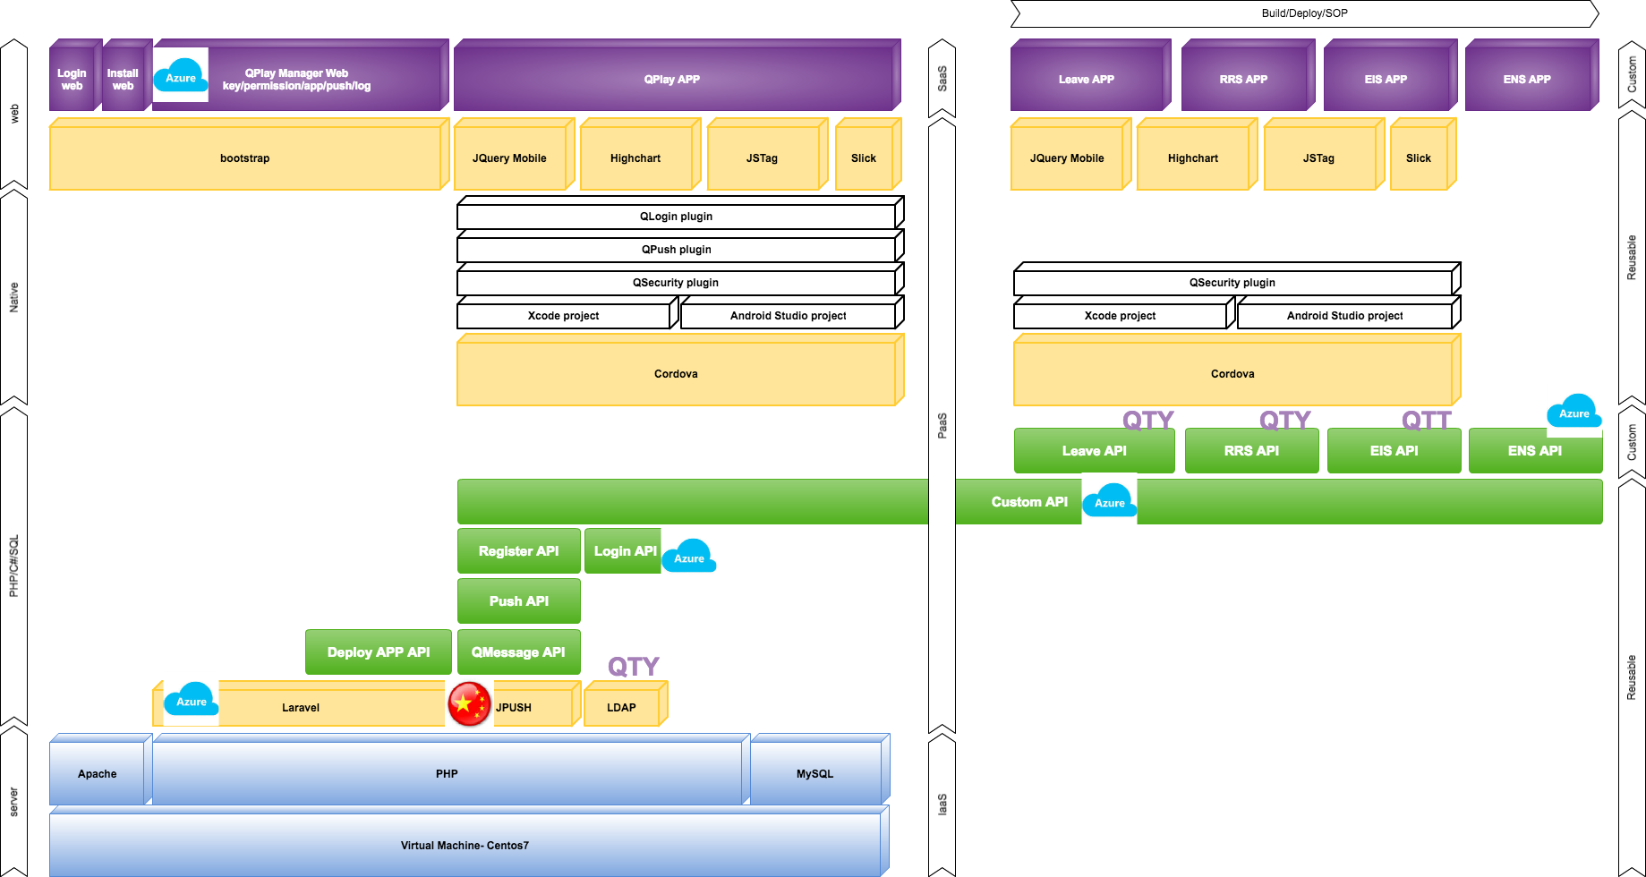

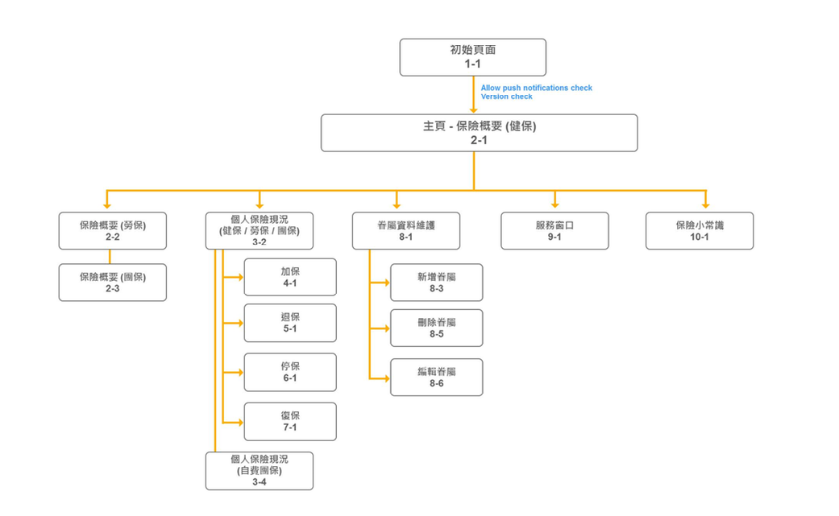

## 系統流程圖 (System Flow)

* 個人保險概要流程圖：
  + - * 1. 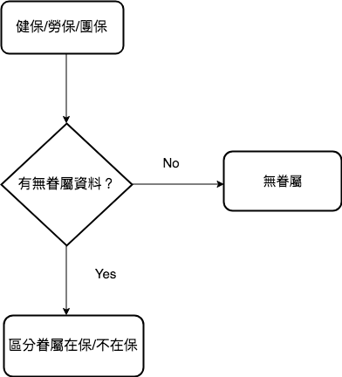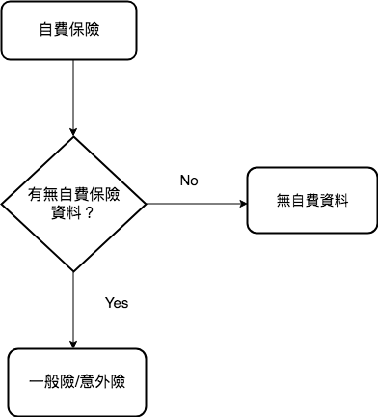眷屬健保資料流程圖 2. 自費保險資料流程圖

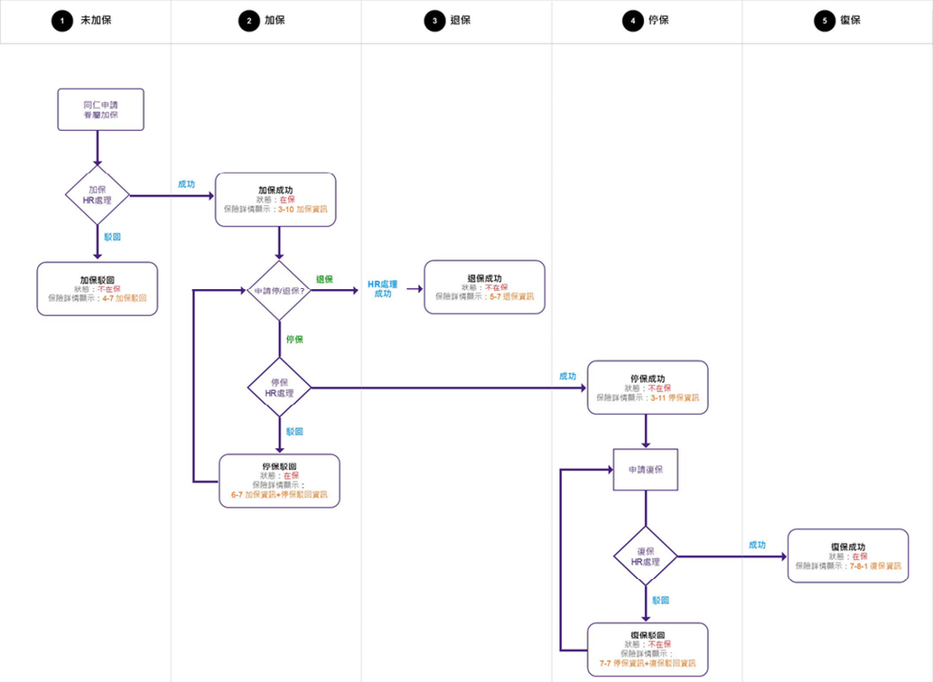 3. 健保保險流程：

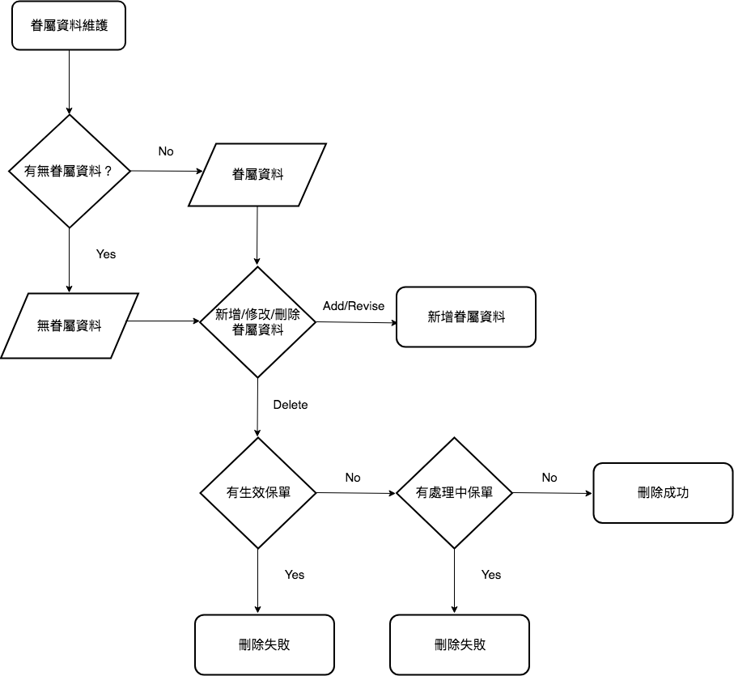* 眷屬資料維護流程圖：

## 類別圖 (Package/Class Diagram)

# 資料庫設計 (Database Design)

## 資料庫物件清單 (Database Object List)

## 循序圖 (Sequence Diagram)

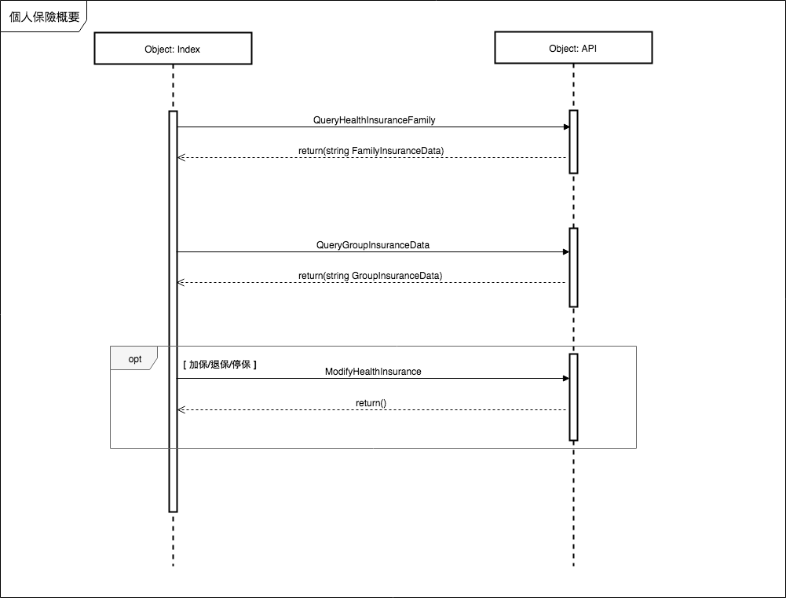

* + - * 1. 個人保險概要: 分成兩個頁籤：(1.) 健保/勞保/團保 (2.) 自費保險
        2. 健保/勞保/團保：透過QueryHealthInsuranceFamily回傳資料，區分眷屬健保在保和不在保，並寫可以選擇眷屬加保，退保，復保和停保功能-> 若有以上行為會觸發ModifyHealthInsurance寫入資料 -> 回到勞健團保頁面再call QueryHealthInsuranceFamily回傳資料

3. 自費保險：透過QueryGroupInsuranceData回傳資料

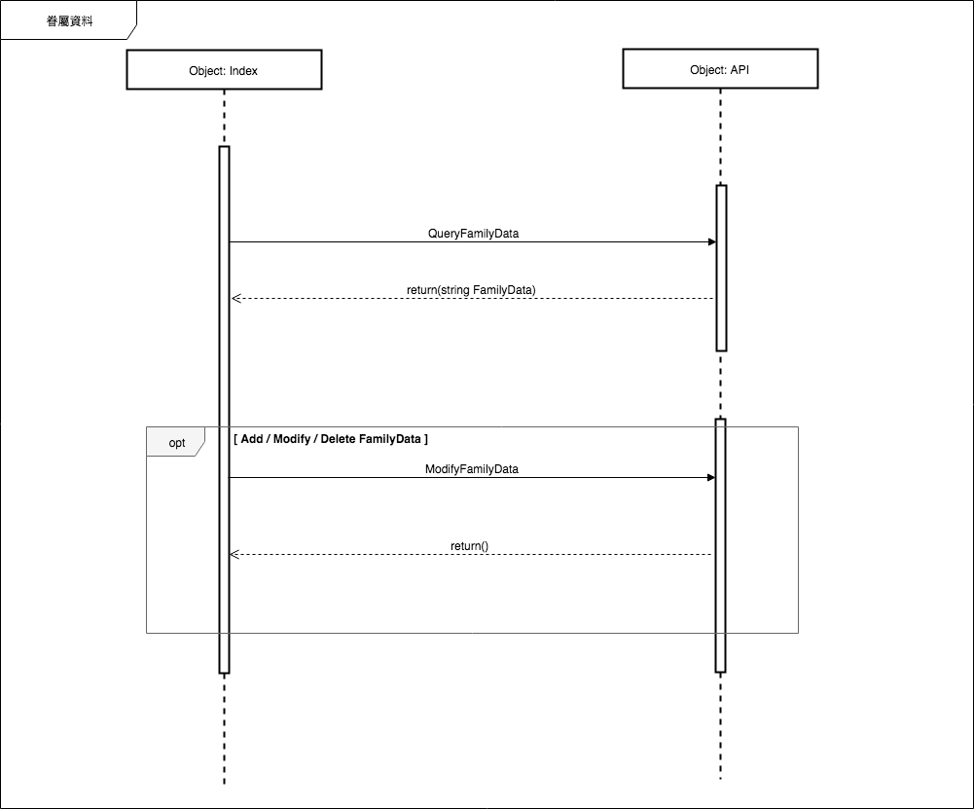

1. 眷屬資料： QueryFamilyData 回傳眷屬資料
2. 若要新增/刪除/修改會觸發 ModifyFamilyData

## 資料表結構 (Table Layout)

# Implementation

* Index.js
  + Define pageList
  + Define appKey, appSecretKey
  + Define window.initialSuccess()
  + Define onBackKeyDown() for android platform
  + Define onPause() / onResume() when APP work in background / foreground
* viewIndex.html
* viewMain.html
* viewMain.js
* viewPanel.html
* viewPanel.js
* viewPersonalInsurance.html : Add/Withdraw/Cancel/ReInsure Application & Family Insurance Detail
* viewPersonalInsurance.js
* viewFamilyData.html : Add/Edit/Delete Family Personal Information
* viewFamilyData.js
* viewContact.html
* viewContact.js
* viewInsuranceInfo.html
* viewInsuranceInfo.js

## 公用元件 (Public Component)

* Calendar
* String Table

## 共用界面 (Public Interface)

* App.min.css
* App.html
* App.min.js