|  |  |  |  |  |  |  |  |
| --- | --- | --- | --- | --- | --- | --- | --- |
| Subject | QPlay Relieve APP - PIS | | Doc.: | S2-PIS | | Rev. | V1.0 |
|  | | | Release Date: | 2017/05/20 | | Revision Status: | |
|  | | | | | |  |  |
|  | | | | | |  |  |
|  | | | | | |  |  |
|  | | | | | |  |  |
|  | | | | | |  |  |
|  | | | | | |  |  |
|  | | | | | |  |  |
|  | | | | | |  |  |
|  | | | | | |  |  |
|  | | | | | |  |  |
|  | | | | | |  |  |
|  | | | | | |  |  |
|  | | | | | |  |  |
|  | | | | | |  |  |
|  |  | | | | |  |  |
|  |  | | | | |  |  |
|  |  | | | | |  |  |
|  |  | | | | |  |  |
|  |  | | | | |  |  |
|  |  | | | | |  |  |
|  |  | | | | |  |  |
|  |  | | | | |  |  |
|  |  | | | | |  |  |
|  | | | | | | | |
|  | | | | | | | |
|  | | | | | | | |
|  | | | | | | | |
|  | | | | | | | |
|  | | | | | | | |
| Approved By: | | Reviewed By: | | | Prepared By: | | |
| PM / | | QA / | | | SD / | | |
|  | | SE / | | | SE / | | |
|  | | SD / | | |  | | |
|  | |  | | |  | | |
|  | |  | | |  | | |
|  | |  | | |  | | |

1.0 系統設計 (System Design) 4

1.1 系統架構圖 (System Framework Diagram) 4

1.2 系統流程圖 (System Flow) 5

1.3 類別圖 (Package/Class Diagram) 6

2.0 資料庫設計 (Database Design) 6

2.1 資料庫物件清單 (Database Object List) 6

2.2 循序圖 (Sequence Diagram) 7

2.3 資料表結構 (Table Layout) 8

3.0 Implementation 8

3.1 公用元件 (Public Component) 8

3.2 共用界面 (Public Interface) 9

3.3 <模組名稱1 (Module Name1) > 9

3.3.1 <模組描述 (Module Description)> 9

3.3.2 使用者界面 (UI) 9

3.3.3 資料流程圖 (Data Flow Diagram) 10

3.3.4 功能描述 (Function Description) 10

3.4 <模組名稱2 (Module Name2) > 10

3.4.1 <模組描述 (Module Description)> 11

3.4.2 使用者界面 (UI) 11

3.4.3 資料流程圖 (Data Flow Diagram) 12

3.4.4 功能描述 (Function Description) 12

# 系統設計 (System Design)

## 系統架構圖 (System Framework Diagram)

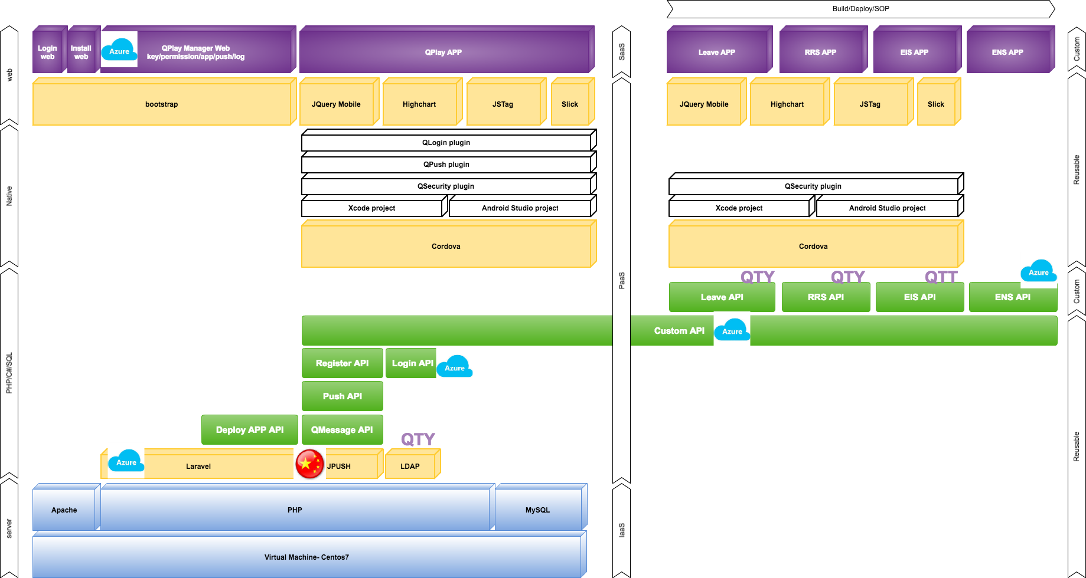

## 系統流程圖 (System Flow)

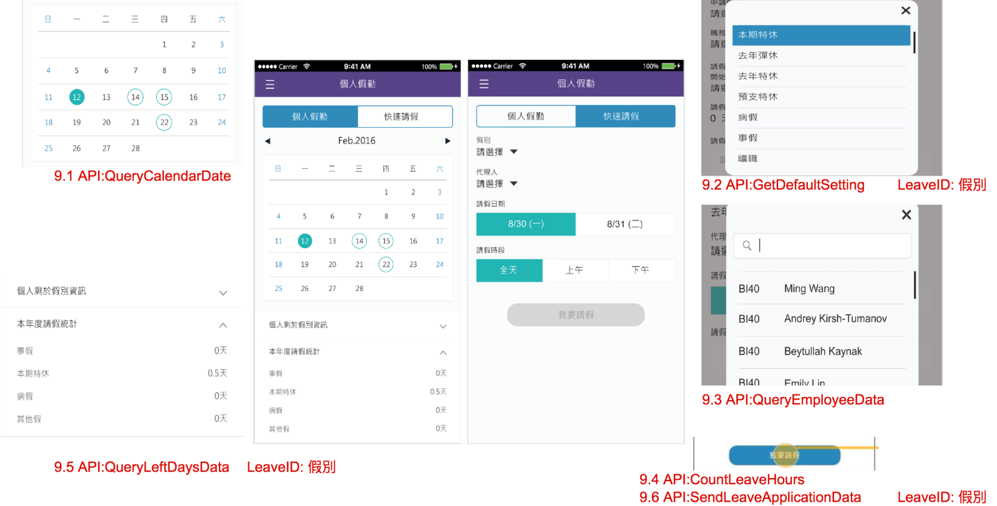

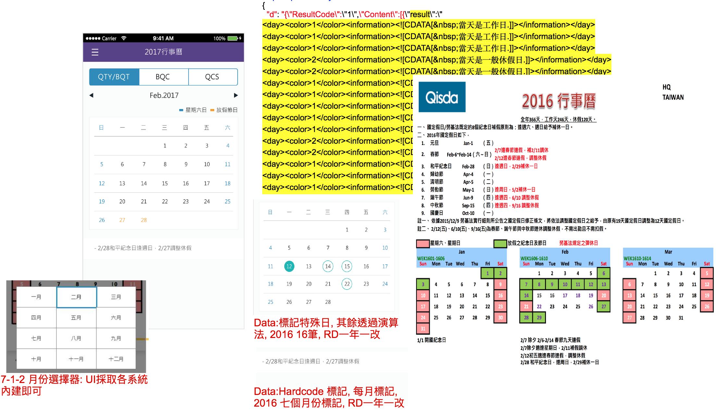

## 類別圖 (Package/Class Diagram)

* [Comment] 程序类图， 建议使用Rose的Class Diagram或Visio的UML图

# 資料庫設計 (Database Design)

* [Comment] Description of database schema design，如果有独立的数据库设计文件存在（ [Database Schema Design](S-System-DbSchema_v2.0.xls)），这里只需保留文件超链即可

## 資料庫物件清單 (Database Object List)

* [Comment] Database Object List, such as: table, view , stored procedure

|  |  |  |  |  |
| --- | --- | --- | --- | --- |
| **No.** | **DB Type** | **Type** | **Object Name** | **Description** |
|  |  |  |  |  |
|  |  |  |  |  |
|  |  |  |  |  |
|  |  |  |  |  |

* + DB Type: 如Oracle, MS-SQL
  + Type: 如 Table, View, Stored Procedure…

## 循序圖 (Sequence Diagram)

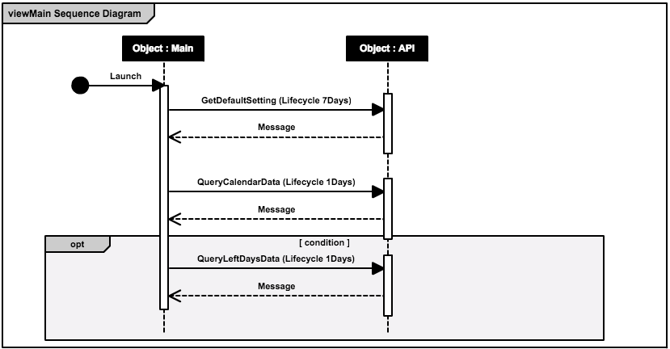

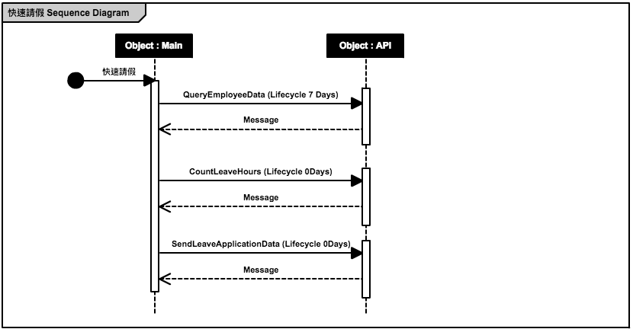

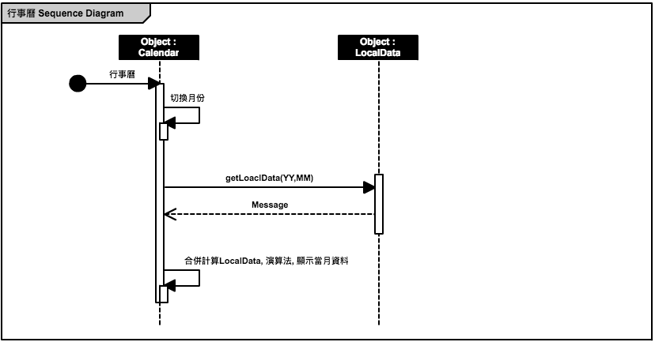

## 資料表結構 (Table Layout)

# Implementation

* *Index.js*
  + *Define pageList*
  + *Define appKey, appSecretKey*
  + *Define window.initialSuccess()*
  + *Define onBackKeyDown() for android platform*
* viewMain.html
* viewMain.js
* viewCalendar.html
* viewCalendar.js

## 公用元件 (Public Component)

* 開發行事曆元件以滿足客製化的需求
* 以下列的開元元件為基礎修改

<https://github.com/zabuto/calendar>

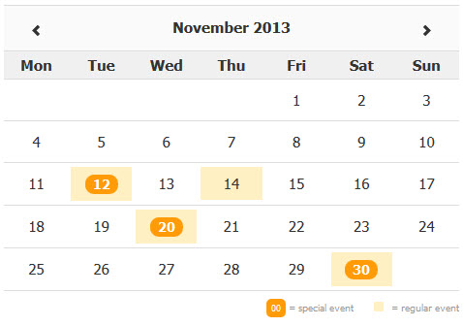

## 共用界面 (Public Interface)

* App.css
* App.html
* App.js

## <模組名稱1 (Module Name1) >

### <模組描述 (Module Description)>

* [Comment] 模块功能描述，输入、输出说明，此处的模块划分依据具体项目变更，不限定需按系统模块进行切分

### 使用者界面 (UI)

* [Comment] 添加UI界面，及相关说明

1. 使用者界面畫面設計 (UI Design)
2. 使用者界面元素說明 (UI Element Description)

[Comment] 描述页面上出现的元素

* 畫面元素與物件表 (Element/Controls Table)

|  |  |  |  |  |  |  |  |
| --- | --- | --- | --- | --- | --- | --- | --- |
| **Element ID** | **Control Type** | **Length** | **Default value** | **Must/Optional** | **Data Source** | **Connection** | **Description** |
|  | Combo Box  Text  Label  List  …  Grid |  | 0 for number  ‘ ‘ for alphabet | Must: 必填  Optional: 非必填 | TableName.ColumnName | 與另一個El  Facility 🡪 W/H  Item No. 🡪 Description |  |
|  |  |  |  |  |  |  |  |

1. 控制規則 (Control Rules)

[Comment] 添加UI的附加说明

[Sample]

|  |  |  |
| --- | --- | --- |
| User | Operation | Response |
| Applyer | When the Purchase Request is invoked | then the applicant’s name and e-mail should be displayed in the Contact Person field and E-mail field (under Shipping Information section) respectively. |
|  |  |  |

### 資料流程圖 (Data Flow Diagram)

* [Comment] 数据流图，表明输入输出及内部数据处理过程

### 功能描述 (Function Description)

* [Comment] 重要方法描述；输入、输出说明；关键算法及关键SQL语句的描述；建议添加程序流程图对方法进行说明

## <模組名稱2 (Module Name2) >

### <模組描述 (Module Description)>

* [Comment] 模块功能描述，输入、输出说明，此处的模块划分依据具体项目变更，不限定需按系统模块进行切分

### 使用者界面 (UI)

* [Comment] 添加UI界面，及相关说明

1. 使用者界面畫面設計 (UI Design)
2. 使用者界面元素說明 (UI Element Description)

[Comment] 描述页面上出现的元素

* 畫面元素與物件表 (Element/Controls Table)

|  |  |  |  |  |  |  |  |
| --- | --- | --- | --- | --- | --- | --- | --- |
| **Element ID** | **Control Type** | **Length** | **Default value** | **Must/Optional** | **Data Source** | **Connection** | **Description** |
|  | Combo Box  Text  Label  List  …  Grid |  | 0 for number  ‘ ‘ for alphabet | Must: 必填  Optional: 非必填 | TableName.ColumnName | 與另一個El  Facility 🡪 W/H  Item No. 🡪 Description |  |
|  |  |  |  |  |  |  |  |

1. 控制規則 (Control Rules)

[Comment] 添加UI的附加说明

[Sample]

|  |  |  |
| --- | --- | --- |
| User | Operation | Response |
| Applyer | When the Purchase Request is invoked | then the applicant’s name and e-mail should be displayed in the Contact Person field and E-mail field (under Shipping Information section) respectively. |
|  |  |  |

### 資料流程圖 (Data Flow Diagram)

* [Comment] 数据流图，表明输入输出及内部数据处理过程

### 功能描述 (Function Description)

* [Comment] 重要方法描述；输入、输出说明；关键算法及关键SQL语句的描述；建议添加程序流程图对方法进行说明