停車位預約 Parking

1. viewReserve

1.1 Component

1.1.1 Title Tab Control：

(1.) Reference：

Relieve/viewReverse.html: 第1行~第19行

Relieve/index.css: 第21行~第25行; 第90 ~ 107 行;

第106行~ 第108行;第152行

Relieve/index.css: 第39行 onBackKeyDown()

Relieve/index.js: 第29行~第36行

(3.) output: android / ios UI : tab & header間的相對位置;

Solution:Relieve/index.js: 第29行~第36行

localization: 繁簡英

(6.) other risk：tab位置跑版(ios/android) Solution:<https://github.com/BenQdigiPages/EnterpriseAPPPlatform/pull/1694/files>

--------------------------------------pageOne------------------------------------------------

* 1. pageOne
     1. Site DDL：

(1.) Reference：viewRelieve.html: 第20行~第24行

Relieve/index.css: 第285行~ 第288行; 第502行~ 第512行

Relieve/index.css: 第106行/第271行~ 第274行

RRS/index.js: RRS Function : getSiteData()

(3.) ouput：localization: 繁簡英

(4.) Action: Logic:

\*Func: 1. change func

2.getSiteData():index.js

當選擇BQT/QTT, 後面出現 \* 僅開放關係企業同仁停車

記憶/顯示 上次預約成功的Site：localStorage.setItem,

localStorage.getItem

(5.) other risk：備註字串位置跑版

* + 1. Reserve Date：

(1.) Reference：viewRelieve.html: 第25行~第26行

Relieve/index.css: 第593行~ 第613行

\* checkLocalDataExpired()裡面包含了：

RRS API: getAPIListAllManager -> ConverToRoleTree

\* setInitialData() 裡面包含了：

1. setRole() -> setDateList(‘reserve’) -> reserveDays

(2.) input：Life cycle：API : 8.4.8 ListAllManager

(3.) ouput：localization: pass

(4.) Action: Logic:

\*Func: 1. on('click') func

2. setRole()

3. setDateList()

4. getAPIListAllManager(): index.js

5. ConverToRoleTree(): index.js

\*API : 8.4.8 ListAllManager()

可預約日期範圍 依照員工權限：一般員工14天/ 管理員120天;

日期預設在今天日期，已過去日期不顯示，不顯示六日

* + 1. Parking Space：

(1.)Reference：RRS/viewRelieve.html

RRS /index.css: 第567~571行

RRS/viewRelieve.js

RRS/index.js:

(2.) input：Life cycle：API :8.4.6 ListAllParkingSpace()

(3.) ouput：localization: 繁簡英

(4.) Action: Logic:

\*Func: 1. on('click') func

2. getSpaceData()

3. getAPIReserveParkingSpace(): index.js

\*API : 8.4.6 ReserveParkingSpace()

\*根據reserveSite自動帶出車位:

RRS/veiwReserve.js: RRS Function: getFloorData(siteIndex) or getRoomData(siteIndex, floorIndex)

RRS/index.js: RRS API: ListAllMeetingRoom()->ConverToMeetingTree

* + 1. Date Reserve List開始使用時間範圍(複選)：

(1.)Reference： RRS/viewRelieve.html

RRS /index.css

RRS/viewRelieve.js

RRS/index.js

(2.) input：Life cycle：API : 8.4.7 ListAllTime() , 8.4.3 QueryReserveDetail()

(3.) ouput：android / ios UI : 跑版問題

localization: pass

(4.) Action:

Perfermance: 當有要用到資料時再去call API

Logic: \*Func: 1. getAPIListAllTime(): index.js

2. getParkingStatus(): index.js

3. getReserveData()

4. getAPIQueryReserveDetail()

5. on('click') func

\*API : 8.4.7 ListAllTime() , 8.4.3 QueryReserveDetail()

(5.) other risk：UI 位置跑版

RRS API: QueryReserveDetail-> getAPIQueryReserveDetail -> getReserveData(roomId, date, data, type) -> getMettingStatus  
RRS API: ReserveMeetingRoom -> getAPIReserveMeetingRoom()

1.2.5 Reserve Button

(1.)Reference：RRS/viewRelieve.html

RRS /index.css

RRS/viewRelieve.js

(2.) input：Life cycle：API : 8.4.4 ReserveParkingSpace()

(3.) ouput：android / ios UI : popup跑版問題

localization: 繁簡英

(4.) Action:

Logic: \*Func: 1. getReserveBtn()

2.reserveBtnDefaultStatus()

3. on('click') func -> QTY點選下一步跳到頁面 2.1

4.getAPIReserveParkingSpace()

\*API : 8.4.4 ReserveParkingSpace()

\* BQT尚未選取任何時段時，「預約」按鈕反灰不可按

\* QTY尚未選取任何時段時，「下一步」按鈕反灰不可按

1.2.6 Popup Message

(1.)Reference：RRS/viewRelieve.html

RRS /index.css

RRS/viewRelieve.js

(3.) ouput：android / ios UI : popup跑版問題

localization: 繁簡英

(4.) Action:

Logic: \*Func: 1. on('click') func

\* Image: viewReserve: 1.2 pageOne

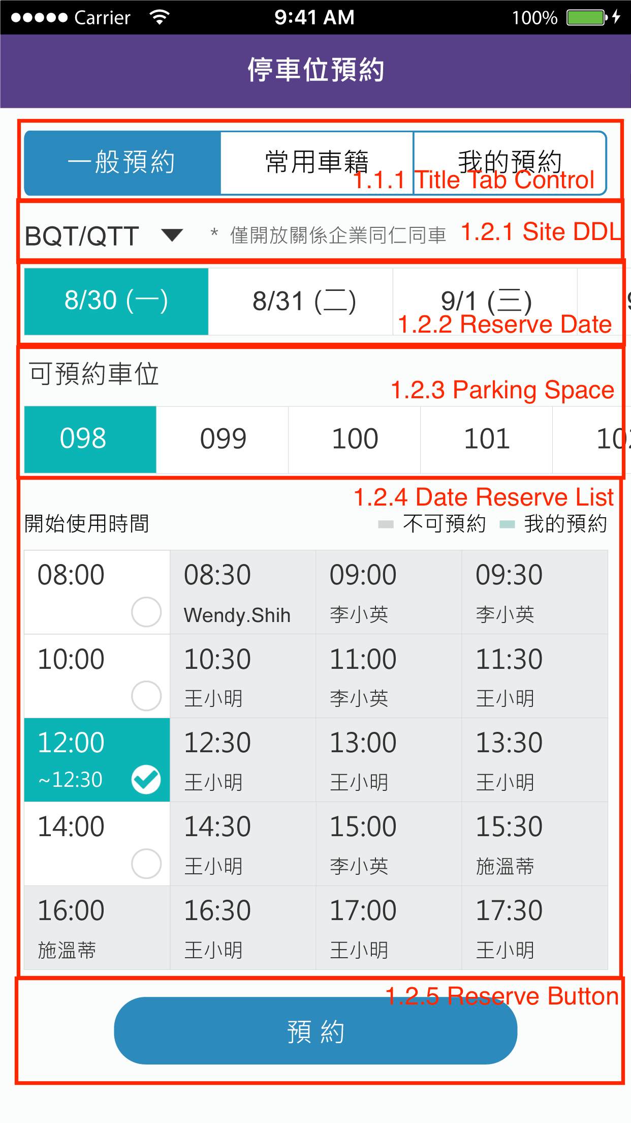

1.3 PageTwo

1.3.1 Parking Informtion

(1.)Reference：ENS/viewEventList.js: 896~900   
 RRS/ viewSettingList.js

(3.) ouput：android / ios UI : Information List跑版問題

localization: 繁簡英

(4.) Action:

Big(O): 需測試多筆常用車籍資料的顯示

Logic: \*Func: 1. delete click

2. querySettingList()

3. button on("click") func ->跳到頁面 3.1

\* Image: viewReserve: 1.3 pageTwo

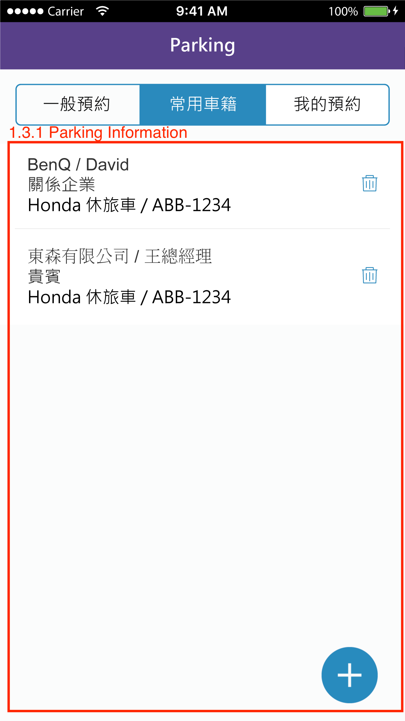

1.4 PageThree

1.4.1 Parking Informtion

(1.)Reference：RRS/viewMyReserve.html   
 RRS/index.css

RRS/ viewMyReserve.js

(2.) input：Life cycle：API : 8.5.2 QueryMyReserve(); 8.5.5 ReserveCancel()

(3.) ouput：localization: 繁簡英

(4.) Action:

Big(O): 需測試多筆常用車籍資料的顯示

Logic: \*Func: 1.getAPIQueryMyReserve()

2.getAPIMyReserveCancel()

3.on("click") func   
 4.cancel click

\*API : 8.5.2 QueryMyReserve(), 8.5.5 ReserveCancel()

\* Image: viewReserve: 1.4 pageThree

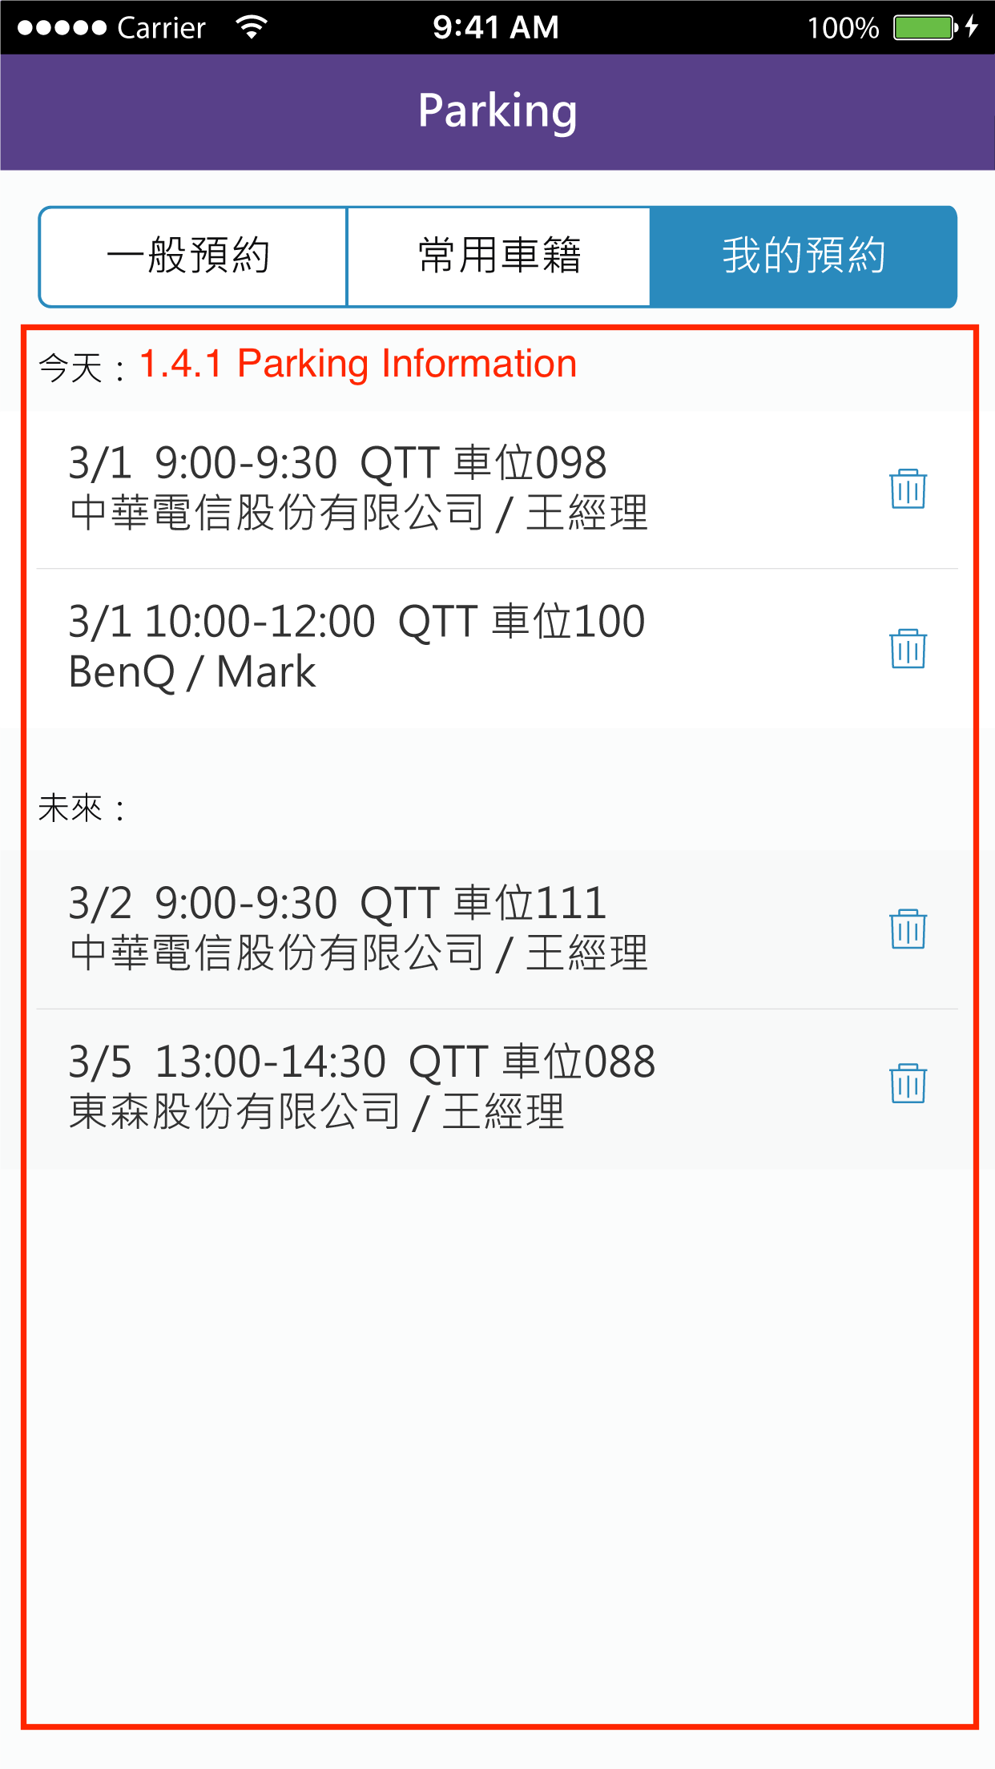

二 viewParkingDetail  
2.1 Set QTY Parking Detail

2.1.1 Set QTY Parking Detail

(2.) input：Life cycle：API : 8.4.4 ReserveParkingSpace()

(3.) ouput：android / ios UI :畫面跑版問題

localization: 繁簡英

(4.) Action:

Logic: \*Func: 1. localStorage.getItem()->get 1.2.4預約時間地點資訊

2. reserve click -> localStorage.setItem()->車籍資訊寫回1.2.4

3.getAPIReserveParkingSpace()

4. cancle click   
 5. back click

6. Popup Message

\*API : 8.4.4 ReserveParkingSpace()

2.1.2 Choose Common Parking Detail

(1.)Reference：Leave/viewPersonalLeave.js

(3.) ouput：android / ios UI : 跳出的popup畫面跑版問題

localization: 繁簡英

(4.) Action: Logic:

Big(O): 需測試多筆常用車籍資料的popup顯示

Logic: \*Func: 1.tplJS.DropdownList() -> show 1.3.1 data

2. on("click") func

3. localStorage.getItem()

\* Image: viewReserve: 2.1 Set QTY Parking Detail

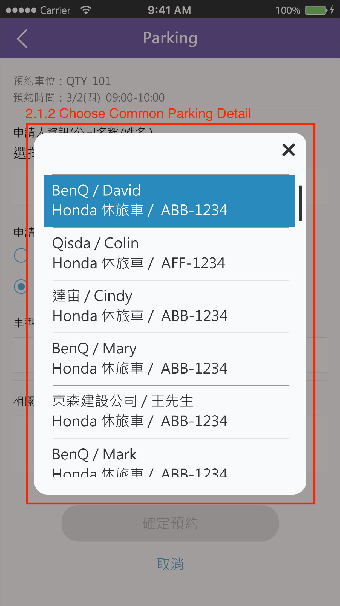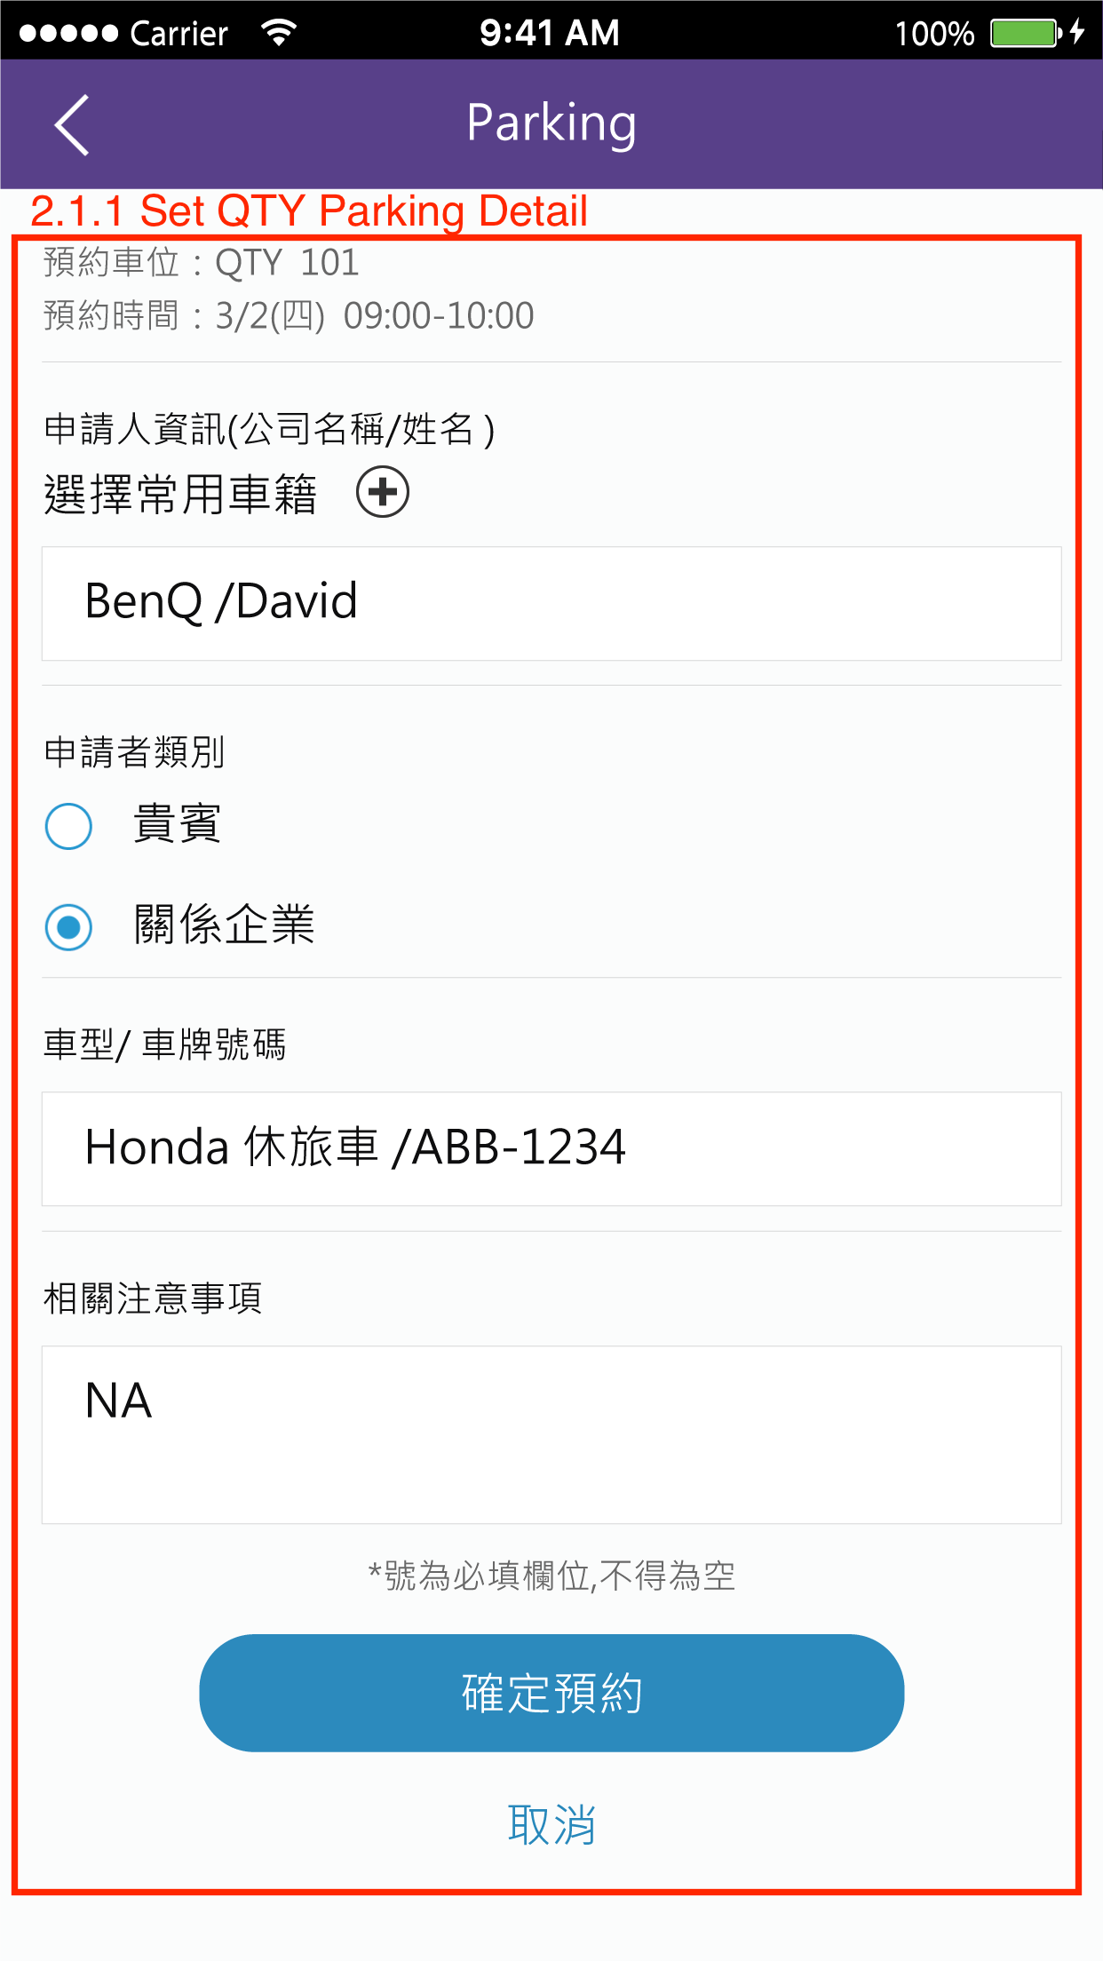

三 viewParkingDetailAdd

3.1 Add Parking Detail

3.1.1 Add Parking Detail

(1.)Reference：RRS/viewNewSetting.js

(3.) ouput：android / ios UI : 跑版問題

localization: 繁簡英

(4.) Action:

Logic: \*Func: 1. setDefaultStatus()

2. changeEditStatus()

3. save click

4. delete click

5. back click

\* Image: viewReserve: 3.1 Add Parking Detail

