|  |  |  |  |  |  |  |  |
| --- | --- | --- | --- | --- | --- | --- | --- |
| Subject | QPlay APP Log - PIS | | Doc.: | S2-PIS | | Rev. | V1.0 |
|  | | | Release Date: | 2017/11/20 | | Revision Status: | |
|  | | | | | |  |  |
|  | | | | | |  |  |
|  | | | | | |  |  |
|  | | | | | |  |  |
|  | | | | | |  |  |
|  | | | | | |  |  |
|  | | | | | |  |  |
|  | | | | | |  |  |
|  | | | | | |  |  |
|  | | | | | |  |  |
|  | | | | | |  |  |
|  | | | | | |  |  |
|  | | | | | |  |  |
|  | | | | | |  |  |
|  |  | | | | |  |  |
|  |  | | | | |  |  |
|  |  | | | | |  |  |
|  |  | | | | |  |  |
|  |  | | | | |  |  |
|  |  | | | | |  |  |
|  |  | | | | |  |  |
|  |  | | | | |  |  |
|  |  | | | | |  |  |
|  | | | | | | | |
|  | | | | | | | |
|  | | | | | | | |
|  | | | | | | | |
|  | | | | | | | |
|  | | | | | | | |
| Approved By: | | Reviewed By: | | | Prepared By: | | |
| PM / | | QA / | | | SD / | | |
|  | | SE / | | | SE / | | |
|  | | SD / | | |  | | |
|  | |  | | |  | | |
|  | |  | | |  | | |
|  | |  | | |  | | |

1.0 系統設計 (System Design) 4

1.1 系統架構圖 (System Framework Diagram) 4

1.2 系統流程圖 (System Flow) 5

1.3 類別圖 (Package/Class Diagram) 6

2.0 資料庫設計 (Database Design) 6

2.1 資料庫物件清單 (Database Object List) 6

2.2 循序圖 (Sequence Diagram) 7

2.3 資料表結構 (Table Layout) 8

3.0 Implementation 8

3.1 公用元件 (Public Component) 8

3.2 共用界面 (Public Interface) 9

3.3 <模組名稱1 (Module Name1) > 9

3.3.1 <模組描述 (Module Description)> 9

3.3.2 使用者界面 (UI) 9

3.3.3 資料流程圖 (Data Flow Diagram) 10

3.3.4 功能描述 (Function Description) 10

3.4 <模組名稱2 (Module Name2) > 10

3.4.1 <模組描述 (Module Description)> 11

3.4.2 使用者界面 (UI) 11

3.4.3 資料流程圖 (Data Flow Diagram) 12

3.4.4 功能描述 (Function Description) 12

# 系統設計 (System Design)

## 系統架構圖 (System Framework Diagram)

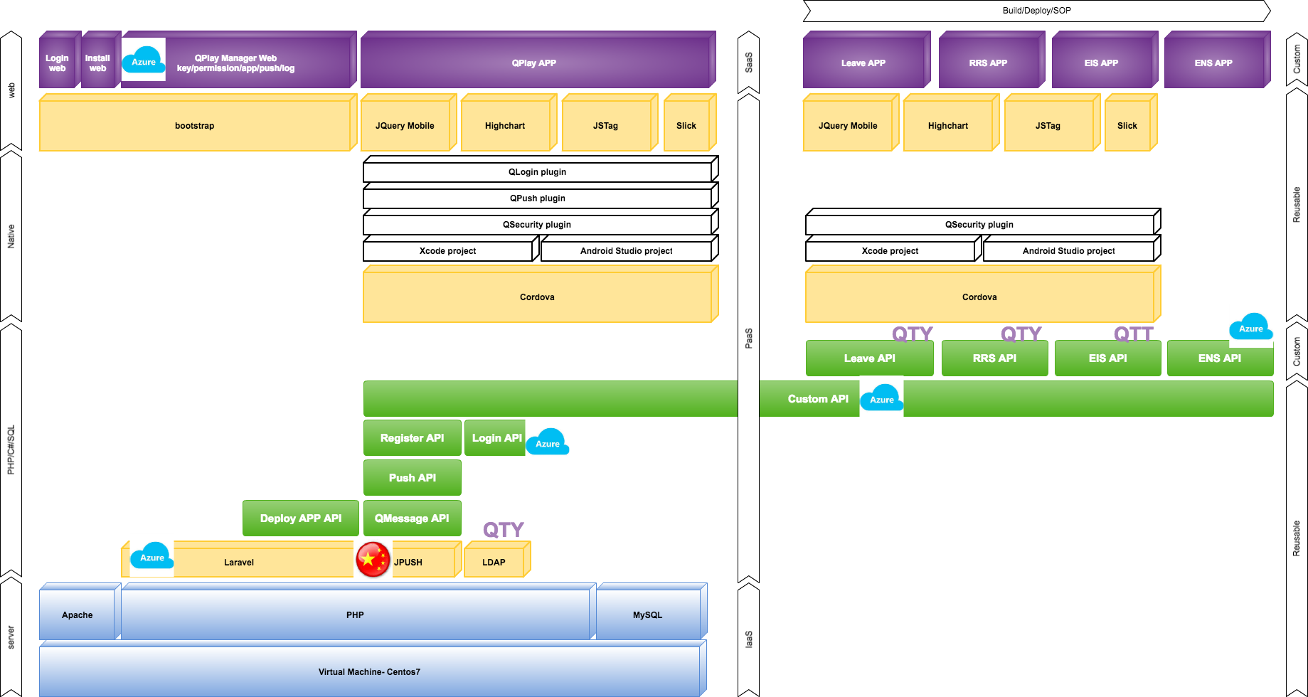

## 系統流程圖 (System Flow)

data

Local

(APP)

Server  
（API）

response

## 

## 類別圖 (Package/Class Diagram)

* [Comment] 程序类图， 建议使用Rose的Class Diagram或Visio的UML图

N/A

## 資料庫物件清單 (Database Object List)

* [Comment] Database Object List, such as: table, view , stored procedure

N/A

|  |  |  |  |  |
| --- | --- | --- | --- | --- |
| **No.** | **DB Type** | **Type** | **Object Name** | **Description** |
|  |  |  |  |  |
|  |  |  |  |  |
|  |  |  |  |  |
|  |  |  |  |  |

* + DB Type: 如Oracle, MS-SQL
  + Type: 如 Table, View, Stored Procedure…

## 循序圖 (Sequence Diagram)

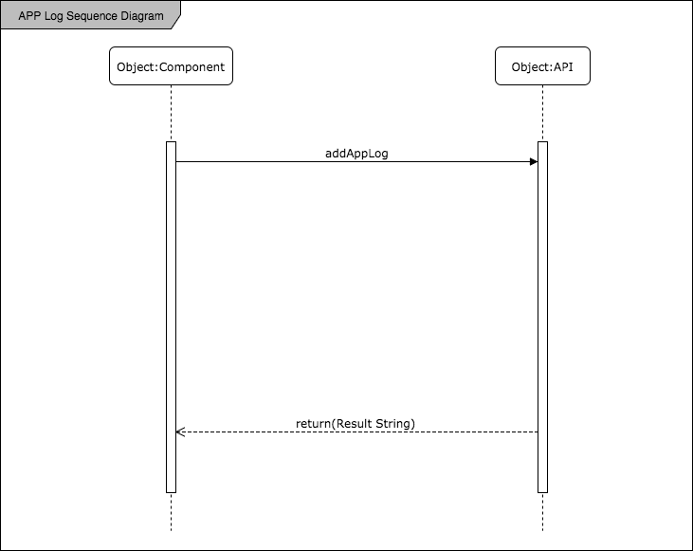

# Implementation

* component.js
  + pageshow Event Listener
  + change Event Listener
  + addAppLog Function

## 公用元件 (Public Component)

N/A

## 共用界面 (Public Interface)

* component.js

## 用戶使用QPlay記錄APP LOG種類(Module Name1)

*必要參數名稱：login_id, package_name, log_list(註1)

*註1: 參數名稱參考: Qplay_API: ch5.19 addAppLog

*註2: 參數名稱page_action = enterPage : APP一開始被載入的動作;

### APP被使用時段

1. APP Log開發細節

|  |  |
| --- | --- |
| Log Detail | Content |
| Add Code List | APP/component/component.js |
| Storage Method | localStorage(不得超過2.5MB) |
| Send Method | 固定N 分鐘, 最多處理M 筆  setTimeout(func, N分鐘*60*1000), data.length=M筆 |
| Queue | FIFO: 1. send data[0]-data[M] to addAppLog() API  2.delete data[0]-data[M] (.shift():刪除陣列頭部的資料) |

1. 資料(傳入addAppLog參數)

|  |  |
| --- | --- |
| 參數名稱(註1) | Content |
| page_name | pageList (App’s view name) |
| page_action | enterPage(註2) |
| start_time | 被載入的時間點（unix/sec） |
| period | N/A |
| *device_type | ios/android |

### 用戶使用APP時間

1. APP Log 開發細節

|  |  |
| --- | --- |
| Log Detail | Content |
| Add Code List | APP/component/component.js |
| Storage Method | localStorage(不得超過2.5MB) |
| Send Method | 固定N 分鐘, 最多處理M 筆  setTimeout(func, N分鐘*60*1000), data.length=M筆 |
| Queue | FIFO: 1. send data[0]-data[M] to addAppLog() API  2.delete data[0]-data[M] (.shift():刪除陣列頭部的資料) |

(2.) 資料(傳入addAppLog參數)

|  |  |
| --- | --- |
| 參數名稱(註1) | Content |
| page_name | pageList (App’s view name) |
| page_action | enterPage (註2) |
| start_time | 被載入的時間點（unix/sec） |
| period | 同一個package_name條件下, 計算間隔時間 |
| *device_type | ios/android |

Problem1: 計算頁籤停留時間(period)

假如有人早上10:00開啟某隻APP mainpage後, 用了２分鐘就把APP收到背景, 過了１小時(11:00)才打開APP切到另一個page, 這樣period計算會是１１：００－１０：００, period = 1 hr

Problem2: 確認tab切換不算入?

要算的話page_name會都是Mainpage

### APP各頁籤訪問數

(1.) APP Log 開發細節

|  |  |
| --- | --- |
| Log Detail | Content |
| Add Code List | APP/component/component.js |
| Storage Method | localStorage(不得超過2.5MB) |
| Send Method | 固定N 分鐘, 最多處理M 筆  setTimeout(func, N分鐘*60*1000), data.length=M筆 |
| Queue | FIFO: 1. send data[0]-data[M] to addAppLog() API  2.delete data[0]-data[M] (.shift():刪除陣列頭部的資料) |

(2.) 資料(傳入addAppLog參數)

|  |  |
| --- | --- |
| 參數名稱(註1) | Content |
| page_name | pageList (App’s view name) |
| page_action | enterPage (註2) |
| start_time | N/A |
| period | N/A |
| *device_type | ios/android |