WeQuote Share Proposal
Option H Developer Handoff
  - Screen layout and interaction specification
28 October 2026 | Product, Engineering and QA
Implement Share Proposal using Option H as the design baseline. Follow its persistent Customer / Project / Deal header, three sharing sections and document-specific actions. This handoff describes the visible controls, the state each action changes and the remaining integration work.
The screen walkthrough is the primary specification. Quote revisions, Change Orders and permissions are explained where the user encounters them. The native Manage Quotes screenshot is background evidence in the appendix.

Read the interface in this order
Area | Implementation responsibility
Header and navigation | Keep document identity and project context visible; provide Open deal and free section switching.
Proposals | Choose exact versions, alternatives, images and default templates.
Customer Portal | Choose visible versions, set each person’s access, preview as a user and select notification recipients.
Web & PDF | Choose content for comparison or individual links and exports.

Option H examples
File | Scenario
alternatives.html / index.html | Four competing Quotes; main review entry.
quote.html | One Quote, with an optional path to alternatives.
variation.html | One standalone Variation.
variation-alternatives.html | Two competing Variations; the customer chooses one.
change-order.html | Quote 24589 with accepted R1 and Change Orders R1.1 to R1.3.

Open Option H quote alternatives
Open Option H Change Order example
Prototype status Settings remain in memory until refresh. Backend persistence, live email, PDF generation and production integration are not connected. The local links above require the original prototype folder on this Mac.
Screenshot status Figures 1 to 3 are existing Option H reference captures with version differences identified. Figure 4 is the native Portal reference. They do not certify the latest rendered UI; current behavior was checked against the Option H source.

Header and navigation
Keep the Share Proposal title and document number, exact revision and status above the Customer / Project / Deal strip. This context remains visible when moving between Proposals, Customer Portal and Web & PDF. Figure 1 shows the established Option H frame.
Control | Required behavior
Open deal | Place beside the Deal name. Open the linked native Deal in a new tab. Hide when no Deal is linked; never reuse a different scenario’s fixture destination.
Details | Open Customer, Project & Deal. Show the linked customer and project; the Quote example exposes Deal Change and Open Deal.
Deal Change | Open Link to Deal. Search/select an eligible Deal or No Deal, then Save link. Validate before applying; unlinking removes the Open deal action and prevents alternative sharing.
Enable Customer Portal | Project-wide switch below the project name. Preserve saved visibility and user settings when turned off; clear selected notification recipients.
Section navigation | Switch freely between the three sections. Retain each section’s scroll position and choices for the page session.
Close and Escape | Close the highest dialog first. Restore focus to the opener. Closing the main prototype shows its reopen state; reopening retains local changes until refresh.

Footer follows the selected section
Section | Footer
Proposals | Proposal and template counts, the one-revision-per-Quote reminder, and Close.
Customer Portal | Recipient count, email-only explanation, Close and Notify Customer Portal users. Hide the notification action while Portal is off.
Web & PDF | Proposal count and sharing explanation, plus Close. Copy and download actions remain with their resources.

Do not add a mandatory Next / Back sequence or a generic Save button. Each settings dialog owns its Save or Confirm action. On narrow screens the section navigation becomes a horizontal row and content stacks below; preserve keyboard navigation and visible focus.
Current connection Open deal now derives its URL from the linked Quote scenario’s Deal ID. The demo destination is the existing native /local-demo/crm/deals/-104024 route. Production must use the current organisation and linked Deal ID. Project reassignment is not connected in this prototype.

Proposal settings
The sidebar label is Proposals and the section heading is Proposal settings. Place the current proposal first and label it Always included in this share. List alternatives below it with Customer chooses one. Values belong to individual options and must not be summed into one offer.
Row control | Scope and behavior
Identity and status | Show proposal name, Quote number, exact revision and status together. A Change Order remains a version of its Quote family.
Revision to share | For Quotes, choose one exact revision per family. Keep the saved choice when a newer revision appears. Show a newer-version hint without replacing it.
Proposal image | Choose image opens the existing image picker for that document. Selection shows a thumbnail, Change image and Remove. Preserve every other document’s image.
Default proposal template | Select a template belonging to this exact document version. This is its default; existing per-user template overrides stay independent.
Preview eye | Preview the clicked row using its selected template. Close preview returns to the same section, scroll position and focus.
Value | Display that option’s own amount and VAT basis. A Variation shows its change value; a Change Order identifies the updated total.

Keep preview types clear
The proposal eye opens the full native proposal only when that Quote version has a valid preview token. The dialog includes Open in new tab and Close preview. A new fixture revision, Variation or Change Order without a native preview must show Full preview unavailable instead of displaying an older document under a new label.
Preview as user is a separate Customer Portal action. It shows an access-aware summary with role restrictions; the row eye previews the selected proposal template.

Image behavior in the prototype
The picker contains one example keypad image. Search, selection, thumbnail display and removal operate locally. Choosing an image does not alter alternatives, templates, access or notification recipients, and remains available while Portal is off. Live image libraries and applying the selected thumbnail to the native full proposal preview still require integration.
Figure 3 The supplied Variation screenshot shows the row layout before the current Proposal settings and Default proposal template labels. Its hardcoded Revision 1 text is not an approved Variation revision workflow.

Alternatives and comparison settings
Place Edit alternatives and Comparison settings together at the top right of Proposal settings, in that order. Use + Add alternatives when no alternatives are included. Comparison settings appears only for two or more Quote options.

Edit alternatives
Open the existing alternative picker. The current Quote is always included and cannot be unchecked. Each other Quote can be included or removed and assigned a template. Show its currently selected revision; change revisions in Proposal settings. Use selected commits valid choices; Cancel discards the picker draft.
Quote alternatives belong to different Quote families in the linked Deal. R1 and R2 of the same Quote cannot become two competing options. Accepted or Complete Quote revisions cannot be selected as competing alternatives. Variation alternatives use their own existing alternative group and remain separate from Quote revision selection.

Comparison settings
Allow inclusion, customer-facing option names, scope summaries, proposal order, visible comparison fields and field order. Support custom fields with add, edit and remove, and an optional recommended proposal. Reordering supports dragging and up/down keys. Save validates and applies the local draft; Cancel discards it.
Integration gap Edited comparison names, summaries, fields and recommendations stay in local state. A native comparison preview URL may identify the chosen documents and templates, but does not prove those presentation edits have been persisted to the native renderer.

Revision choices and draft handling
Case | Expected behavior
Control4 R1 Sent / R2 In Progress | R1 stays selected. R2 can be prepared, but cannot publish Portal access or expose public resources.
Lutron R1 Sent / R2 Sent | User explicitly selects either revision. Price, template options and resource identity update together.
A new revision is created | Do not replace the selected share or copy existing grants automatically. Retain older versions’ settings.
A selected revision is a draft | Block the comparison notification batch and comparison link until the selected drafts are sent.

Review send · Demo lists the exact selected draft revisions. Simulate Send changes only their status to Sent in memory. It does not grant access, publish them on Portal or send an email. Production must connect this review to the native send lifecycle: a sent revision can lead to the next In Progress revision, followed by Change Orders under the native accepted-Quote rules.

Customer Portal visibility and access
Start with Portal visibility, then the document families, Review all access and Preview as user. Keep Notify Customer Portal users below this access area. Portal visibility is independent of the revision selected for the comparison.
Entry point | Documents covered | Commit behavior
Manage access | All revisions and COs of the chosen Quote family. | Save access applies only this family; Cancel discards its draft.
Review all access | All families in the current share, including their other versions. | Review and save access without changing the comparison.
Manage Quotes on Portal | Relevant project proposals, including those outside the current share. | Confirm applies the manager draft; Cancel discards it.
Settings beside a person | That person across the displayed families and versions. | Save only that person’s choices; preserve everyone else.

Visible rows and the access dialog
Group rows by Quote family. List every revision and CO with its status, current viewers and Selected for this share or Not included in this share. Each version has its own Show on Portal checkbox; more than one version can be visible at the same time. Draft rows are listed but publication and access controls are disabled.
Inside Manage access, use an accordion for each version. Show its visibility checkbox, then one row per project person with Can view and Proposal template; disable controls for pending or otherwise ineligible users. Default inherits this version’s template; a custom choice must belong to this same version. CO versions also have per-user Show breakdown.
Hiding a version retains its stored user settings. Show it before editing those settings. Template and breakdown choices never bypass the person’s role, price restrictions or invitation eligibility. Saving access does not send a notification or select a recipient.

Nested manager edits
Manage Quotes on Portal retains the native table fields: visibility, document identity, image, template, status and applicable CO breakdown. Per user opens an editor for that exact record. Saving that child updates only the parent’s pending draft; the parent Confirm commits it. Cancelling the parent discards both parent and nested edits.
Figure 2 The earlier Option H capture shows only Control4 R1. The current specification expands that editor to all revisions in the Quote family while retaining the same per-person controls and Save / Cancel pattern.

Versions and Change Orders on Portal
A Quote can contain several Change Order versions. Keep them under the same Quote family, with the accepted base Quote and each CO stored separately. They are not alternative Quotes competing with one another.
Version | Type | Status | Change | Total
R1 | Accepted Quote | Accepted | Base | £9,700
R1.1 | Change Order | Accepted | +£100 | £9,800
R1.2 | Change Order | Accepted | +£200 | £10,000
R1.3 | Change Order | Sent | +£300 | £10,300

The Option H change-order.html example uses Quote 24589. R1.3 is selected for this share. R1, R1.1 and R1.2 may also be visible on Portal with their own access and template choices. Hiding one row must not hide its siblings or change the shared revision.

Access is per version and per person
Person | R1.2 | R1.3
Jamie | Can view; item breakdown shown. | Can view; summary only.
Morgan | Cannot view. | Can view; prices withheld by role.

Changing Jamie’s R1.2 template or breakdown must leave Morgan, the other COs and the selected comparison unchanged. Sharing R1.3 does not republish earlier versions, transfer their grants or notify people who can see only those older versions.

Preview as user
Choose a Portal user from the dropdown. Show saved accessible proposals with their effective templates and role-filtered prices. Separate Other visible revisions from proposals in the current comparison. For each CO, apply that version’s own breakdown setting. This is a summary preview, not the full customer document renderer.

Breakdown inheritance
The accepted base Quote has no CO breakdown checkbox. Each CO has its own per-user choice. Existing records without an explicit user value fall back to the document-level CO setting; an explicit user boolean takes precedence. Define and migrate this inheritance in production without resetting saved choices.
Open disclosure decision The prototype withholds included-Variation item details when their source is restricted. Confirm the final disclosure rule before release. Standalone Variations retain their separate proposal and access workflow.

Portal notifications and off state
Notify Customer Portal users is an email reminder area, separate from access management. Show each person’s name, email, role, eligibility reason, Settings action and relevant notification history. Access on an older revision alone does not make the person eligible for the current share.
Control or state | Expected result
User checkbox | Select an eligible recipient who can view at least one exact version in this share. Include only the selected versions that person may see.
Select all users | Select only eligible recipients. Do not grant access to unselected or restricted people.
Settings | Open that person’s access editor. Save updates access; it does not send email or select the person for notification.
Invite users | Enter email chips, role and message. Validate addresses and duplicates. Confirm creates pending demo invitees without granting proposal access.
Notify Customer Portal users | Enabled only with recipients, Portal enabled and no selected draft revision. In the prototype, record example notification history and show that no email was sent.
Notification history | Scope by person and exact document version. Distinguish sent, bounced, rejected and failed outcomes; never label a failure as successful.

Changes that require recipient review
Changing a comparison revision clears selected recipients. Revoking access removes invalid selections. Saving access for a newly eligible person does not automatically select them. Production must revalidate the exact recipients and versions at send time.

When Customer Portal is off
Keep the Customer Portal section available, showing the off-state explanation and Turn on Customer Portal beside Go to Web & PDF. Hide access and notification controls. The header switch and the Turn on action change the same project setting.
Turning Portal off preserves version visibility, grants and templates but clears recipients. Turning it back on restores those saved choices, leaves hidden versions hidden and keeps recipients unselected. Web & PDF remains usable independently.
Delivery boundary Invite, Notify and Simulate Send are distinct operations. The current prototype sends no invitation or reminder email and makes no live status changes. Production needs real outcomes and retry behavior, not the demo’s synthetic successful notification result.

Web and PDF sharing
Show a Comparison link when multiple alternatives are selected, followed by Individual documents. With one document, show Document links. The comparison link uses the default templates selected in Proposals. Each individual document has its own Proposal to share choice.
Control | Scope and outcome
Comparison Copy link / Preview | Copy the comparison URL for the exact revisions and defaults. Preview opens a summary with an optional Open full proposal preview link. Block sharing while a selected revision is a draft.
Document accordion | Open the resources for one exact selected document. Keep its identity and chosen proposal visible.
Proposal to share | Choose an existing proposal/template for that document’s individual Web and PDF resources. Do not edit the default template or Portal user settings.
Preview eye | Preview this individual sharing choice. Use the same native-token availability rule as the eye in Proposals.
Copy | Copy that specific resource URL. If clipboard access fails, select the readonly link for manual copying. No notification is sent.
Add to Documents | Review project, document, template, format and URL; allow a document name. Add link · Demo saves a temporary record only.
Download PDF | Open a review of the intended PDF action. The prototype generates and downloads no PDF file.
Include up-to-date payments in PDF | CO-only export choice. It changes the intended PDF variant and is independent of CO breakdown visibility.

View saved links · Demo opens the session’s temporary document records. A different individual sharing template gets its own resource identity; switching templates must not retarget an earlier copied URL. Whether later edits change an existing published link remains a production policy decision.

Public content needs its own breakdown setting
A public link cannot identify its opener as Candy or Builder. If they need different disclosures, create separately configured links. Independent Web / PDF CO breakdown selection is still missing from the current prototype and its resource identity. The payments checkbox does not satisfy this requirement.
Preview boundary Token-backed Quote versions use existing native localhost preview URLs. Missing-token revisions and Variation comparisons use example URLs. Live exports, publication and persistence are not connected; edited comparison presentation is not yet passed to the native renderer.

Acceptance checklist for Option H
Validate these flows through the real native UI after integration. Existing prototype model and controller checks establish state behavior only.
Area | Acceptance case
Header | Open deal opens the linked record in a new tab; unlinking hides both header and Details links.
Navigation | Switch sections and return to the same choices and scroll position. Close the topmost dialog and restore focus.
Proposal row | Change one image or template without changing other documents, user overrides or recipients.
Revision | R1 remains selected when R2 exists. Selecting R2 updates IDs, amount and templates together and clears recipients.
Alternatives | Reject two revisions of the same Quote as two options. Current Quote cannot be removed; Cancel discards picker edits.
Comparison settings | Save applies names, order, fields and recommendation. Cancel leaves saved settings intact.
Draft | Block Portal publication and public resources. Send review lists only selected drafts and does not grant access.
Multiple versions | One user can view R1 and R2 while another sees only R2. Both versions may remain visible.
CO sequence | R1.1, R1.2 and R1.3 have independent visibility, per-user templates and breakdown. Hiding one leaves others unchanged.
Nested Save | Per user Save updates the manager draft. Parent Cancel discards it; Confirm applies all valid changes atomically.
Preview as user | Hide denied versions and restricted prices. Keep older visible versions outside the current comparison.
Notify | Exclude history-only viewers. Revalidate recipients and versions; report real delivery failures separately.
Portal off | Retain saved settings, clear recipients and leave hidden versions hidden after re-enabling.
Web and PDF | Individual Proposal to share changes only its own resources. Public content never inherits Portal identity.

Cross section invariants
The same exact version and saved access state must agree across the family editor, person Settings, Manage Quotes and Preview as user. Saving a scoped edit preserves out-of-scope documents and people. Template ownership, roles and tenant boundaries must be enforced on the server as well as in the UI.
Verification record Saved prototype reports contain 259 checks: 19 model, 16 comparison revision, 15 Portal revision model, 79 controller and 130 static checks. The Open deal update additionally passed linked, unlinked and relinked state checks. No browser rendering, live delivery, persistence or production readiness is asserted by these checks.

Implementation notes and evidence

Preserve native records and entry points
Use main_quote_id, falling back to id, for the Quote family. Each revision or CO is its own quote record. Sort revision and change_order numerically; R1.10 is not a decimal. Store visibility and images against the exact version. Store per-user grants, nullable template overrides and nullable CO breakdown overrides against the exact version and authenticated user.
The current native Manage Quotes payload stores document-level visibility, template, image and breakdown, without per-user overrides. Extend that contract with organisation, project, role and ownership checks. Validate the complete scope before committing, handle concurrent changes and preserve legacy values.

Remaining product and integration work
- Connect settings persistence, comparison presentation, invitation delivery, notification outcomes, PDF generation and Project Documents through the native services.
- Define public CO breakdown variants, link lifetime and whether Web and PDF use one shared or separate disclosure control.
- Resolve cancelled and expired eligibility, staff metadata for drafts, legacy breakdown inheritance and restricted included-Variation disclosure.
- Run browser, narrow-screen, keyboard and end-to-end checks. Capture the updated Option H screens after permitted browser access is available.

Source map
Source | What to inspect
shell.html / layout-h.js | Header, Open deal placement, section layout and footer rules.
controller.js / native-children.js | Context and settings actions, proposal eyes, image picker, alternative picker, comparison settings and invitations.
revision-model.js / revision-ui.js | Exact revision selection, draft blocking, family rows, CO access and other visible revisions.
inline-portal.js / portal-management.js | Notification rows, person Settings, manager draft, nested Per user editor and role-aware access.
sharing-ui.js / sharing-model.js | Individual template choice, resource identity, copy, export review and demo notification history.
Native repository | quote-new-revision-modal; modal-project-manage-portal-quotes; api-quote.php revision and Portal endpoints; class.quote.php revision creation.

Implementation source root: share-proposal-option-h. The local example links on page 1 resolve to the complete prototype. Native repository: wequote-portal. The native Portal list currently includes sent, accepted, complete and cancelled records but excludes drafts; reconcile this with the proposed disabled draft rows.
Screenshot interpretation The following full-size references explain Option H’s frame and control placement. Captions identify superseded behavior. The native table is included last to support revision compatibility, rather than define the overall Share Proposal layout.

Figure 1 Option H screen structure
Earlier local Option H reference: persistent header, left navigation, Portal content and footer. Current behavior adds Open deal, all revision rows and Manage Quotes on Portal. The older Change Order heading and single-row count are superseded; use pages 2, 5 and 6 for implementation.
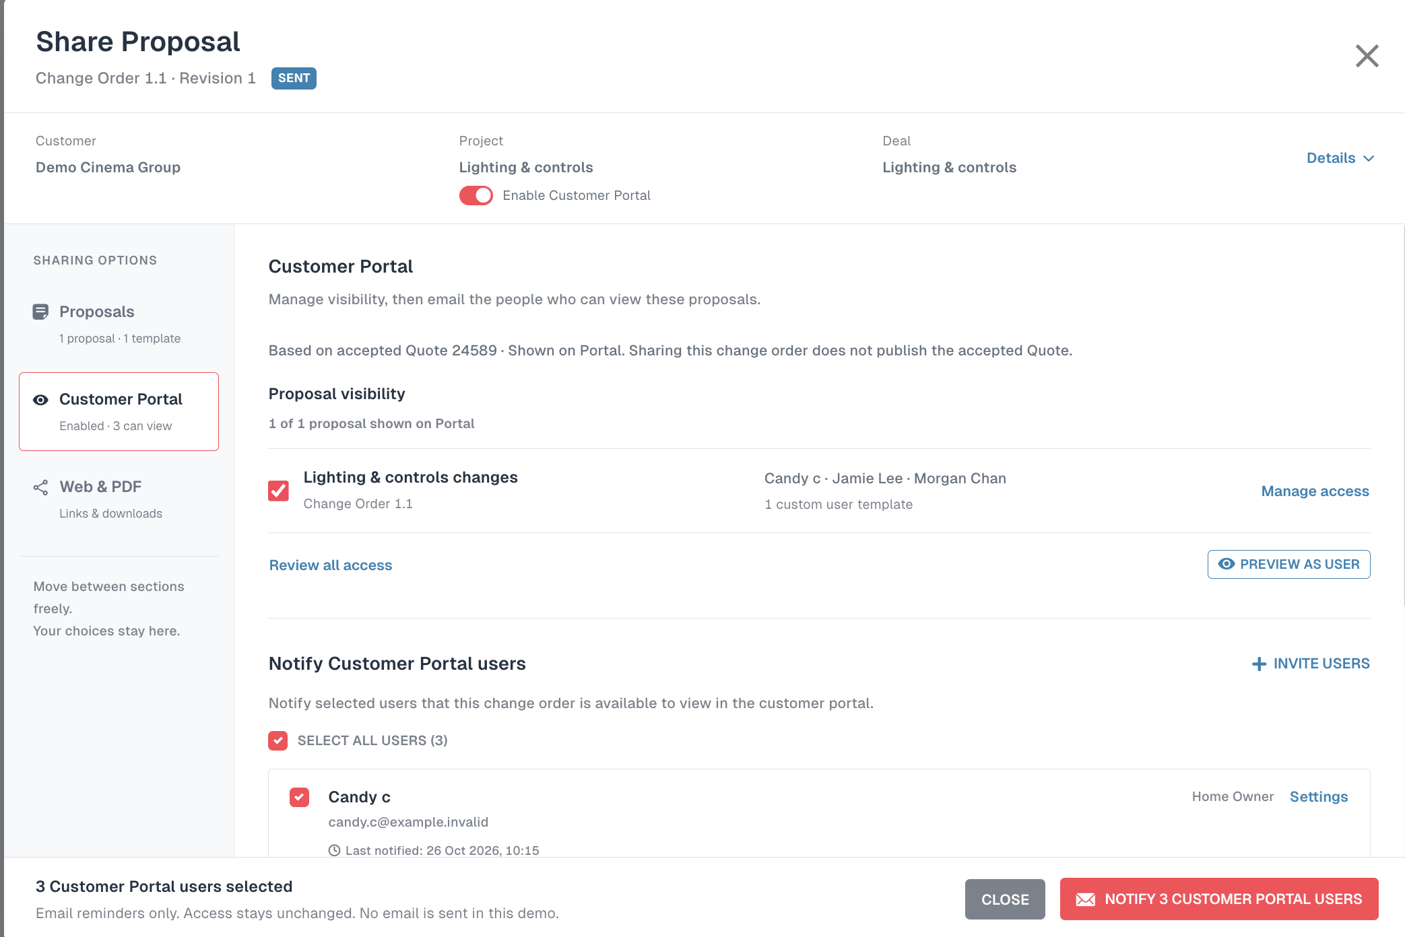

Figure 2 Option H access dialog
User-supplied earlier Option H reference. Retain the per-person Can view and Proposal template pattern and Save access / Cancel actions. Expand this editor from only Control4 R1 to all versions of its Quote family; each CO also has per-user Show breakdown.
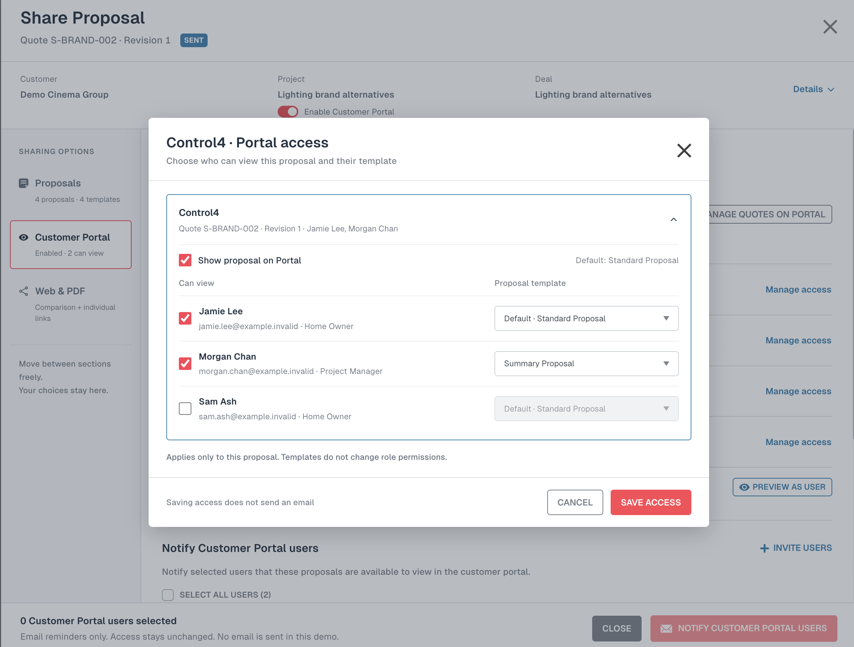

Figure 3 Option H proposal row controls
User-supplied earlier Option H Variation reference: identity, image, template, preview eye and amount. Current labels are Proposal settings and Default proposal template. Quote rows also require Revision to share; do not infer a Variation revision model from this older image.
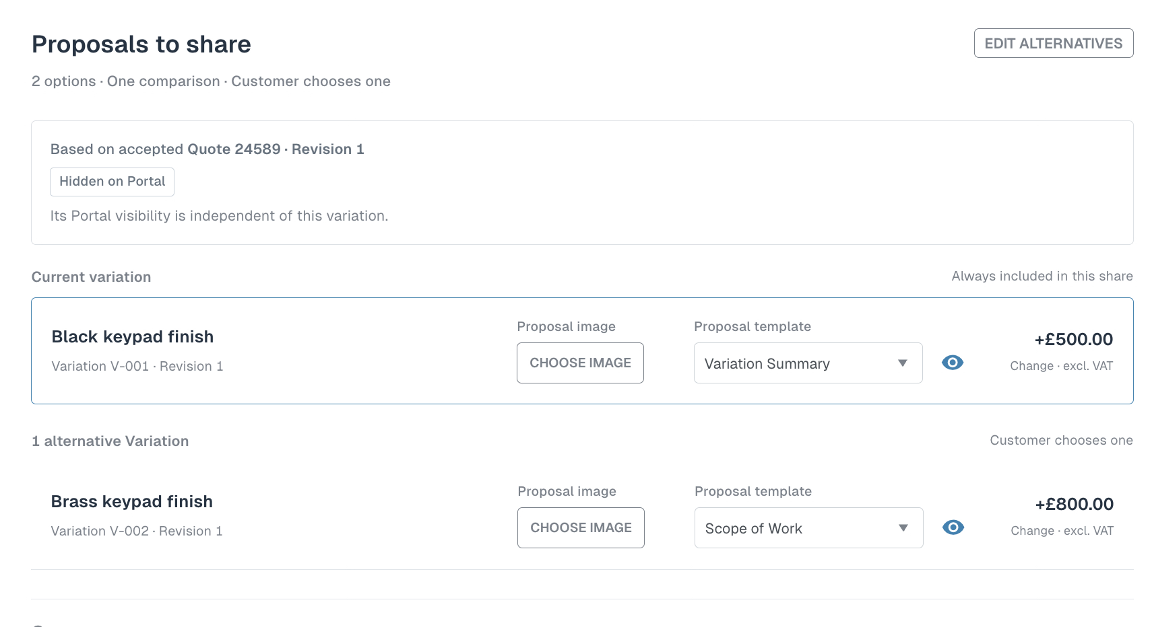

Figure 4 Native Portal compatibility reference
Appendix reference supplied by the user. The native table keeps Quote 23959 and COs R1.1, R1.2 and R1.3 as independent rows. Preserve that version model inside Option H. This is not the design baseline for the whole Share Proposal dialog and does not show new per-user controls.


