# Panda Timesheets

# Project Plan

# Introduction

The purpose of this Software Development Plan is to define the development activities in terms of the phases and iterations required for implementing a project management system. This Software Development Plan describes the overall plan to be used by the team for developing the system. The details of the individual iterations will be described in the Iteration Plans.

This project management system allows employees to record their time worked on each project and allows the project manager to keep track of the status of the current project. Employees are able to keep track of their time by filling in the provided timesheet. In addition to entering the total hours worked on a certain project and work package, the employees must be able to electronically sign the timesheet. Each submitted timesheet must be approved by a timesheet approver (generally a project supervisor or line manager) or be returned for corrections.

# Project Organization

## Organizational Structure

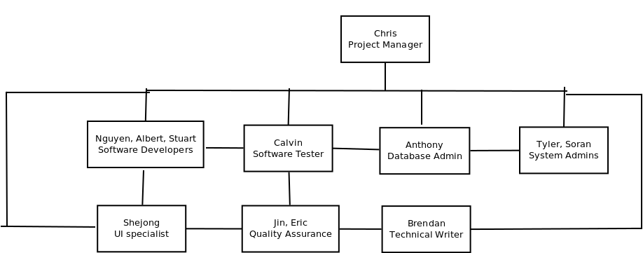

## External Interfaces

This project does not interface with external groups.

## Roles and Responsibilities

|  |  |
| --- | --- |
| **Person** | **Rational Unified Process Role** |
| Chris Bow | Project Manager  Deployment Manager  Requirements Reviewer  Architecture Reviewer  Configuration Manager  Change Control Manager |
| Brendan Voon | Technical Writer |
| Jin An  Eric Lee  Calvin Yee | Quality Assurance  Software Tester |
| Anthony Figueroa | Database Admin |
| Albert Guo  Nguyen Nguyen  Stuart Budd  Shejong Shon | Designer Implementer Code Reviewer Integrator Front End |
| Tyler Hlynsky  Soran Shim | System Administrator |

Anyone on the project can perform the tasks performed by the RUP role called “Any Role”.

# Project Schedule

[Diagrams or tables showing target dates for completion of iterations and phases, release points, demos, and other milestones.] For example:

|  |  |  |  |  |
| --- | --- | --- | --- | --- |
| **Phase** | **Iteration** | **Primary Objective (risks/use cases addressed)** | **Scheduled Start/Stop** | **Effort Estimate (person days)** |
| Inception | I1 |  |  |  |
| Elaboration | E1 |  | End: 02/02 |  |
| Construction | C1 |  | End: 03/23 |  |
|  | C2 |  | End: 04/12 |  |
| Transition | T1 |  |  |  |
|  | T2 |  |  |  |

# Project Resourcing

Project staff is as listed above in section 2.3. Project staff has been chosen and allocated based on the initial applications sent in by each individual. As many of the team members are familiar with the software and technologies we intend to use, there is not much special training required. The only area which the team does not have much experience with is hosting a Java EE solution online with an application server. This part will require additional research, as the deployment of the solution is vital to the success of the project.

# Budget

This project is not budgeted in money. Instead, it is budgeted in hours. For this project, we must budget a certain amount of hours of work per person, per week. If this project is well budgeted, each team member will have around the same amount of hours each week, and no one person will have a significantly larger amount of work than another. The initial estimates are no more than 10 hours per person, per week. If anybody feels that they are overworked, they may bring this up during a team meeting, and the remaining work will be allocated appropriately. This will be monitored during team meetings, when members report the work that they have completed for the past week, and the work they intend to do for the next week.