|  |
| --- |
| logo.pngShades of Shapes |
| By: Eric Lau, Nguyen Nguyen,  Peyman Parsa, Derrick Prasad,  Jan Ycasas |

# **Introduction**

Shades of Shapes is a brain enhancement game designed to strengthen your memory and speed-up cognitive ability.

The player is shown a shade, shape, or shade/shape combination that must be tapped to win the round. However, this information is not available during game play, forcing the player to use working memory during the game.

Once the game starts, the player has to tap on all the game cells that match the game cell they were previously shown and had to remember. However, the player does not have much time as the gird is set to fade to nothing but white. Once the game grid has faded, the player is forced to remember the locations of the game cells that they need to tap on win the game. One wrong move and its game over!

**Game Rules**

1. The player is allowed to tap on multiple game cells
2. Once the grid has faded, the player is to continue taping on the correct game cells
3. Tapping on the wrong game cell will result into making the player lost a life
4. Once the player has ran out of lives, the game will end

**Playing the Game**

In this section we will show you how to play the game.

1. In the main menu page tap **Play** to start a new game
2. The pre-game page will load which shows you what to tap for that level

**NOTE**: Memorize this as i twill not be available during the game

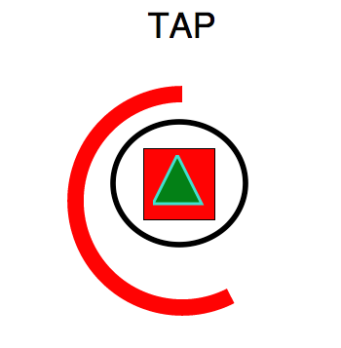

1. Once the timer ends, the game will instantly start
2. Tap on all the game cells that are identical to the game cell shown on the pre-game page

TIP: All the cells will eventually fade; memorize the locations of the cells you need to tap while playing the game

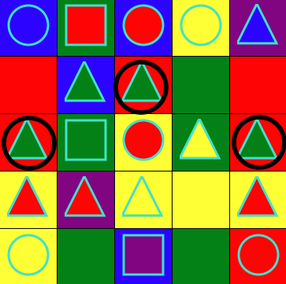

Tap all the game cells with the black circles

1. The round will end once you have taped the correct cells for that round OR if you have lost all your lives
2. Top on **Next Level** to continue onto the next level if you successfully completed the round
3. If not, the tap **Play Again** to try again!

**Submitting a Score**

Once the round has ended, you are able to submit your score allowing you to compete with people around the world

1. On the Level Cleared/Game Over page tap on **Submit Score**
2. Enter your name in the Name field
3. Tap **Submit**
4. On the Main Menu page tap on **Leaderboard** to see where you place

**Frequently Asked Questions**

1. **I cannot see what I need to click on, why did the game grid turn white?**

Unfortunately, this is the main objective of the game. The grid fades to white faster as the levels progress. The best way to get around this is to try to remember the locations of the game cells you need to click on while playing the game or simply click faster.

1. **It says I am suppose to click on a yellow shade with a blue triangle, does this mean I can click on any cell with a yellow shade and/or blue triangle?**

This is a shade/shape combination; you must only click on a game cell that has a yellow shade with a blue triangle inside it. Clicking on anything else will result into a wrong answer and you would lose a life.

**Glossary**

**Game grid**

The game board is made of 25 game cells

**Game cell**

Tap-able game pieces with either a shade, shape or shade/shape combination

**Life**

Chances to continue playing the game in the event of a wrong tap. Each player is allocated three lives.

**Main menu page**

Allows the player to start a new game, view the leaderboard and change the game settings

**Pre-game page**

Shows the player the objective for the round by showing which game cell needs to be clicked

**Shade**

Colors used in the game cell consisting of: Red, Blue, Yellow, Green and Purple

**Shape**

Geometric shapes used in the game cell consisting of : Circles, Squares, Triangle