ATEC

ASSISTANT & INSPECTOR
DETAILED TIMESHEET GUIDE
Login • Job Crew • Automatic Time • Manual Exceptions • Submission • Review

Document control | Value
Document ID | ATEC-TRN-TIME-002
Version | 0.1 DRAFT — LOCAL/REPOSITORY VERIFIED
Date | 10 August 2026
Owner | ATEC Process Owner
Applies to | Assistant, Inspector, Manager/Admin/HR reviewer
Approval | Pending deployed role-based UAT and process-owner approval
CONTROL STATUS: This guide reflects the inspected repository and locally rendered interface. The production website address, final screenshots, mobile layout and deployed role behaviour must be confirmed before controlled issue.

1. Purpose and approved workflow
This guide teaches the exact supported route for getting an assistant’s hours from a job card into a submitted daily timesheet. It also gives the recovery procedure when the assistant was not added to the crew.
Step | Responsible role | System action
1 | Inspector / lead technician | Open the assigned job card and add the assistant under Job Crew.
2 | Inspector / lead technician | Capture the common job timeline: Departed, Arrived, Work Started, Work Completed and Travel Completed.
3 | Inspector / lead technician | Submit the job card. ATEC copies valid timeline segments to every crew member included in time.
4 | Assistant | Log in, open My Day, select the date, review copied entries and correct any unlocked errors with a reason.
5 | Assistant | Select Confirm and submit to manager.
6 | Manager / Admin / HR | Review, return if correction is required, or approve through the authorised review process.
ROLE BOUNDARY: An inspector can add the assistant to the job and can create crew time through the shared job timeline. An inspector cannot submit or approve the assistant’s daily timesheet on the assistant’s behalf. The assistant confirms and submits; management reviews.

2. Before anybody starts
- Use the official ATEC web address supplied by management or the approved company shortcut. The production URL was not verified in the repository and is therefore intentionally not printed here.
- Each employee must use their own username and password. Do not share credentials or let another person sign a timesheet under your login.
- Have the numeric Accelo Job Number available. Job-related manual time will be rejected if the job number contains letters or punctuation.
- Agree the actual event times with the crew before the inspector submits the job card.
- If a timesheet is already submitted, it becomes read-only for the employee. Ask a manager to return it before making corrections.

3. Assistant: open ATEC and log in
- Open Microsoft Edge or the company-approved browser.
- Go to the official ATEC website address supplied by management. If a desktop or favourites shortcut is provided, open that shortcut.
- Check that the address is the official company ATEC address before entering credentials. Do not continue from a link sent by an unknown person.
- In Username, enter your assigned ATEC username exactly as issued.
- In Password, enter your own password. Password characters may be hidden on screen.
- Select Login / Sign in once. Wait for the main ATEC page to load.
- Confirm that you are signed in as yourself. If the displayed identity is wrong, sign out immediately and report it.
- Do not allow the browser to save credentials on a shared device unless company policy explicitly allows it.
[L01 — APPROVED ROLE-BASED SCREENSHOT PENDING]
Login page showing the verified production URL, Username, Password and Login button.

4. Assistant: find and review My Day
- From the main menu, open Jobs & Time if the menu is grouped.
- Select My Day. Assistants do not use Technician Job Cards or Timesheet Approvals.
- At Date, select the date on which the work was performed. Do not assume today if entering yesterday’s hours.
- Read the status. DRAFT, AWAITING EMPLOYEE or RETURNED can be worked on; EMPLOYEE SUBMITTED and later statuses are read-only.
- Review every line: Activity, From, To, Customer / Job, Normal hours and Overtime hours.
- Compare the lines with what actually happened. Look for missing travel, missing work, overlaps, duplicated periods, the wrong job number or incorrect start/end time.
- If a copied line is wrong and the sheet is unlocked, select Edit. Enter the corrected start and end values and a clear reason of at least five characters.
- Only after the day is complete and accurate, select Confirm and submit to manager.
- Open the FBC009-10 PDF if required and verify the day’s record. Submitted history remains available below My Day.
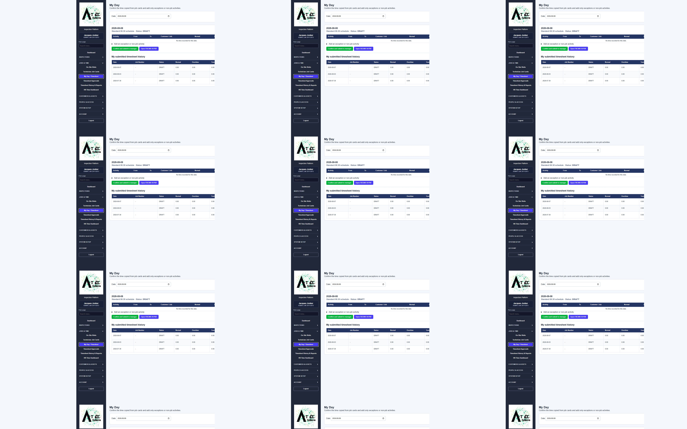
Figure T01 — Locally rendered My Day interface. Use as an orientation image only; approved assistant-role production capture is pending.

5. Assistant: manual entry when omitted from the job crew
EXCEPTION ONLY: Manual job time is the recovery route when the assistant’s time was not copied from a job card. First check the selected date and existing lines so that you do not create a duplicate.
- Open My Day and select the correct work date.
- Confirm that the missing period is not already present. If it is present but wrong, edit the existing line; do not add another overlapping line.
- Open Add an exception or non-job activity.
- Choose the correct Activity. Use WORK for productive job work, TRAVEL for job travel, STANDBY for standby, or WAITING where applicable. Do not label travel as work.
- Enter the numeric Accelo Job Number. For job-related activities this field is compulsory and digits only.
- Enter Started using the actual start date and time.
- Enter Ended using the actual finish date and time. End must be later than start.
- In Details, write a useful description, for example: “Assisted Inspector Smith with visual inspection — omitted from job crew”.
- Select Underground allowance only if the work genuinely qualifies under the approved company rule.
- Select Add time.
- Confirm the new line appears with the correct activity, times and job number. Review total normal and overtime hours.
- Add separate lines for distinct periods. Example: TRAVEL 06:30–07:15, WORK 07:15–12:00, WORK 12:30–15:30 and TRAVEL 15:30–16:15. Do not include an unpaid break inside a work line.
- When the full day is correct, select Confirm and submit to manager.
IMPORTANT: If the assistant manually enters time after being omitted, this fixes the assistant’s timesheet record but does not retroactively make the assistant a crew member on the submitted job card. The inspector/manager should also correct the job record where the current job status and company procedure permit.

6. Inspector: add an assistant before work/time submission
- Log in with your own Inspector account.
- Open Technician Job Cards and select the job assigned to you or created by you. Inspectors cannot edit unrelated job cards.
- Confirm the customer, site, work description and numeric Accelo Job Number are correct.
- Find Job Crew.
- Add/select the employee who actually worked with you.
- Set the crew role to ASSISTANT. Use ADDITIONAL TECHNICIAN only for a person performing that role.
- Keep the assistant included in time. The normal job-card save path stores included crew as included in time.
- Confirm you remain the lead technician and that the assistant appears only once.
- Save the job card / Save & Assign as appropriate to the displayed status.
- Before leaving the crew section, re-open or re-check it and confirm the assistant’s name and role are shown.
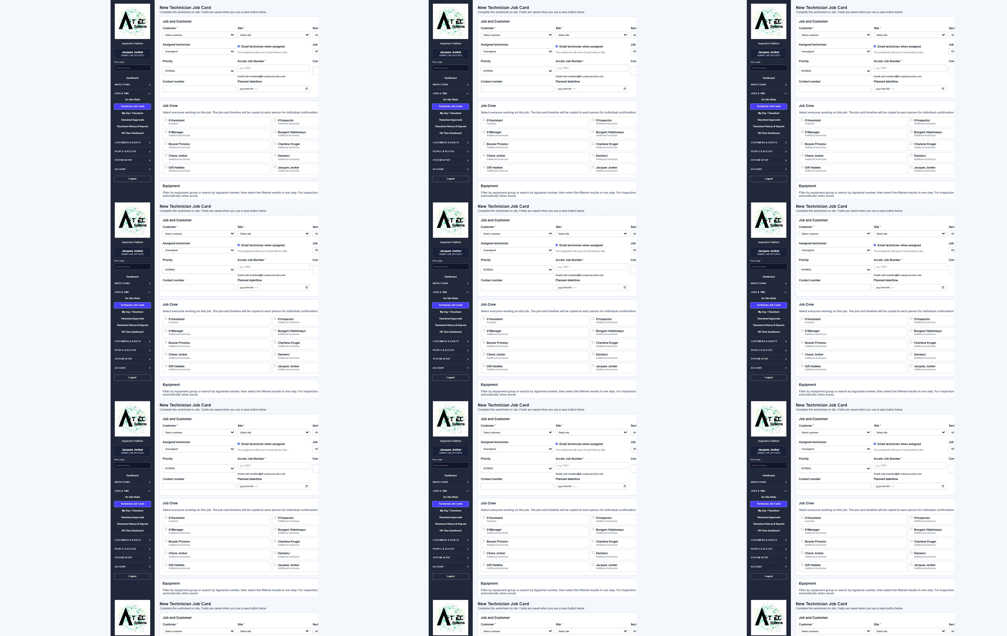
Figure J01 — Locally rendered Job Crew section. Approved inspector-role production capture is pending.
TIMING: Add the assistant before the job changes to SUBMITTED. Automatic copying is triggered when the job moves into SUBMITTED; adding somebody afterwards is not confirmed to backfill time automatically.

7. Inspector: create time for the whole crew from the job timeline
The supported “inspector enters both people’s time” method is not a separate assistant timesheet form. The inspector captures one accurate job timeline on the job card. When submitted, ATEC creates corresponding time entries for the included crew.
Job-card event pair | Time created for each included crew member
Departed → Arrived | TRAVEL
Arrived → Work Started | STANDBY
Work Started → Work Completed | WORK
Work Completed → Travel Completed | TRAVEL
- Open the job card and confirm the correct assistant is listed under Job Crew.
- Enter Departed when the job-related journey started.
- Enter Arrived when the crew reached the site.
- Enter Work Started when productive work began. The period from Arrived to Work Started becomes STANDBY if both timestamps are present.
- Enter Work Completed when productive work ended.
- Enter Travel Completed when the return journey ended.
- Check that every end time is later than its matching start time and that the sequence matches the real day.
- Complete the remaining job information, inspections, deviations, evidence and acknowledgement required for submission.
- Confirm the Accelo Job Number is numeric.
- Change the job status to SUBMITTED and save/submit the job card. On the first transition to SUBMITTED, ATEC copies the valid timeline segments to the lead and included crew.
- Tell the assistant that the job has been submitted and ask them to open My Day for the correct date.
- The assistant reviews the copied lines and selects Confirm and submit to manager. This is the assistant’s confirmation; it is not an inspector approval.
SAME TIMELINE LIMITATION: Automatic crew copying assumes the assistant followed the same timeline. If the assistant started later, left earlier or had different travel/standby periods, the assistant must correct their own unlocked lines with a reason or enter the missing exception accurately.

8. What happens after employee submission
Status | Meaning | Who acts next
DRAFT / AWAITING EMPLOYEE | Time exists but the employee has not submitted it. | Assistant reviews and submits.
EMPLOYEE SUBMITTED | Employee has confirmed the day; it is read-only to the employee. | Manager/Admin/HR reviews.
RETURNED | Reviewer rejected it for correction and supplied a reason. | Assistant corrects and resubmits.
MANAGER APPROVED / HR ACCEPTED / EXPORTED | The record has progressed through controlled review. | Follow company payroll/reporting process.

9. Worked example
Example only — replace names and values with the actual job information.
Item | Example
Accelo Job Number | 11927
Lead | Inspector A
Crew | Assistant B — ASSISTANT
Departed | 06:30
Arrived | 07:15
Work Started | 07:30
Work Completed | 15:30
Travel Completed | 16:15
Expected copied entries for both included people: TRAVEL 06:30–07:15; STANDBY 07:15–07:30; WORK 07:30–15:30; TRAVEL 15:30–16:15. If Assistant B actually joined at 08:00, Assistant B must correct the inaccurate copied entry before submitting and give the reason.

10. Troubleshooting
Problem | Likely cause | Action
No time appears in My Day | Wrong date; assistant omitted; job not yet submitted; incomplete timeline. | Check date and ask inspector to verify crew, numeric job number, timeline and submitted status. If genuinely omitted, use the manual exception procedure.
System rejects the job number | Job-related time requires digits only. | Enter the numeric Accelo Job Number, not a worksheet reference or text.
Cannot edit or add time | Timesheet is submitted/approved/exported. | Ask the manager to return the timesheet. Do not create the time on another date.
Duplicate lines | Time was entered manually and later copied from the job. | While unlocked, delete the incorrect duplicate and provide the required reason. If locked, ask the manager to return it.
Inspector cannot see the job | Job is not assigned to or created by that inspector. | Ask an authorised manager/admin to correct the assignment.
Assistant cannot find Technician Job Cards | This is the designed role boundary. | Assistant uses My Day; inspector manages the job card.
Inspector cannot approve assistant time | Inspectors are not timesheet reviewers in the current system. | Assistant submits; Manager/Admin/HR reviews.
Different crew members worked different hours | Shared job timeline does not represent everyone accurately. | Each employee corrects their own unlocked entries with an audit reason before submission.

11. Quick-reference checklists

Assistant — before submitting
- Correct date selected
- All actual work/travel/standby periods present
- No overlaps or duplicates
- Numeric Accelo Job Number shown for job-related time
- Breaks handled correctly
- Underground selected only when applicable
- Normal/overtime totals reviewed
- Displayed employee identity is your own

Inspector — before submitting the job
- Correct job and numeric Accelo Job Number
- Every actual crew member listed once
- Roles are correct
- Assistant included in time
- Timeline sequence is complete and accurate
- Different working patterns communicated to affected employees
- Inspection, deviations, evidence and customer acknowledgement complete as required

12. Knowledge check and competency sign-off
1. Where does an assistant enter and submit daily time?
Answer: ______________________________________________________________
2. What must an inspector do before submitting the job so assistant time can copy automatically?
Answer: ______________________________________________________________
3. Which job number format is required for job-related manual time?
Answer: ______________________________________________________________
4. Who confirms and submits an assistant’s timesheet?
Answer: ______________________________________________________________
5. Can an inspector approve the assistant’s timesheet in the current system?
Answer: ______________________________________________________________
6. What must happen if a submitted timesheet needs correction?
Answer: ______________________________________________________________
7. What should an assistant do if copied time does not match the assistant’s actual hours?
Answer: ______________________________________________________________
8. What is the risk of entering manual time before checking whether copied time already exists?
Answer: ______________________________________________________________
Practical demonstration | Competent | Retraining required | Assessor initials/date
Assistant logs in and opens My Day | ☐ | ☐
Assistant reviews and manually adds an omitted WORK entry | ☐ | ☐
Assistant corrects a line with an audit reason | ☐ | ☐
Assistant submits to manager | ☐ | ☐
Inspector adds an assistant to Job Crew | ☐ | ☐
Inspector completes the timeline and explains copied segments | ☐ | ☐
Learner explains the approval boundary correctly | ☐ | ☐
Learner name: __________________________ Signature: __________________ Date: __________
Assessor name: _________________________ Signature: __________________ Date: __________
Process owner approval: _________________ Signature: __________________ Date: __________

Appendix A — Verification register
Claim | Evidence level | Release note
Assistant My Day navigation, fields, edit/delete and submit behaviour | Repository verified; locally rendered | Production role screenshot pending
Inspector job-card crew and shared timeline copying | Repository verified | Deployed end-to-end UAT pending
Assistant manual exception validation and locking | Repository verified | Deployed assistant UAT pending
Inspector cannot approve assistant timesheet | Repository role boundary verified | Confirm company approval policy
Production URL and credential issue process | Not verified | Process owner must insert/approve
Mobile/device layout and final screenshots | Not verified | Required before controlled release

