Animal Kingdom

An Animal Guessing Game
Data Structures And Algorithms II

Instructor
Merve ARITÜRK

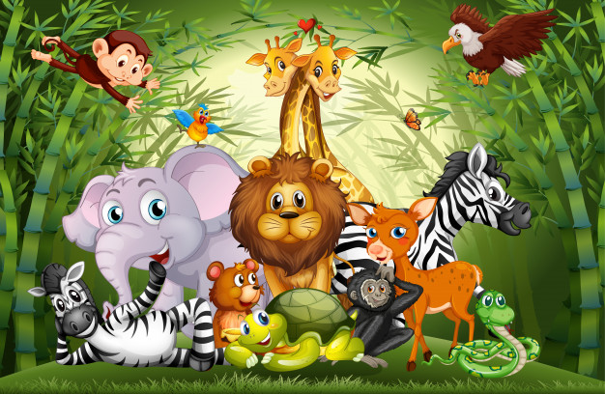

Design & Development
Caner Burç BAŞKAYA
1729098
(Once upon a time, Team 2)

A Brief Introduction To The Project

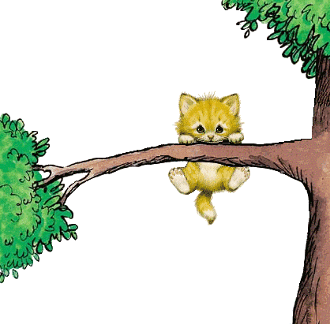
Animal Kingdom is an animal guessing game.

Contrary to expectations, the party to guess the animal is the application itself rather than human player(s).

From this point of view, the main actor is the human player and the app can be categorized as the supporting actor.

The data stored in arrays are processed and sorted in a custom array list and the tree structure is filled with nodes which also includes Animal objects as one of its fields.

The binary decision tree contains questions or animal answers based on its function.
The tree nodes with questions are employed to point to the animal in user’s mind.

The questions reveal the nature of the animals, usually the characteristics related to its class or family as well as its phenotypic appearance.

Animal Kingdom is developed as a cross-platform mobile app based on Flutter Framework.

The application is written in Dart which quite correlates with C family and Java in terms of both syntax and semantics. And flutter has also major similarities with the mobile development frameworks and sdks out there which the developer has a grasp of. So it was not the invention of the wheel for him, even it was the first time within this environment.

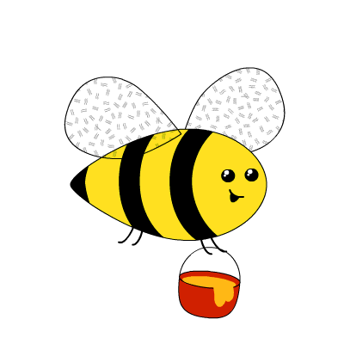
One of the important qualities of Animal Kingdom is its ability to be able to improve itself over time.

Even the guessed animal is not the one as in the user’s mind. Animal Kingdom asks for users contribution and enriches its repertoire even wider and wider according as it is played.

In that manner, we can easily infer that it has an active set of stem cells.

ANIMAL KINGDOM FLOW DIAGRAM

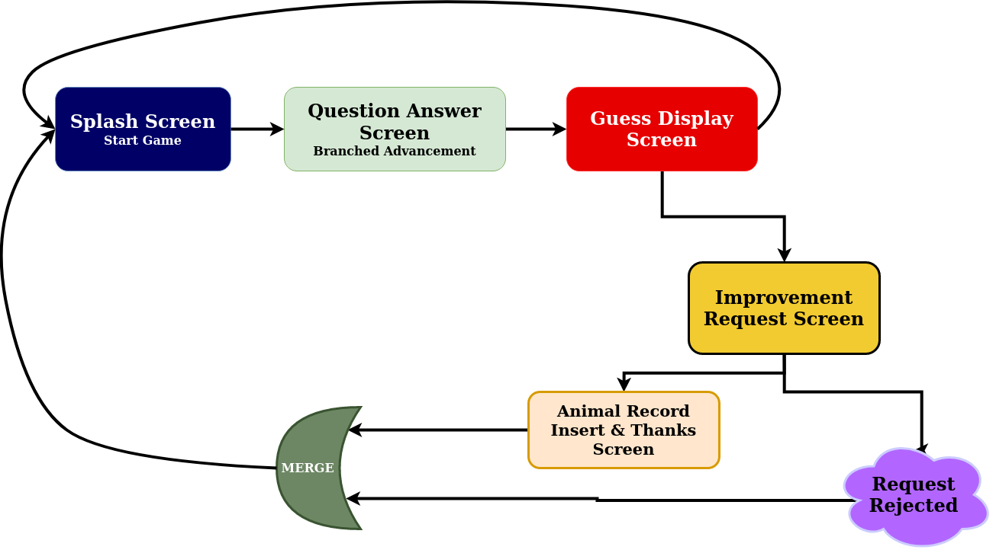
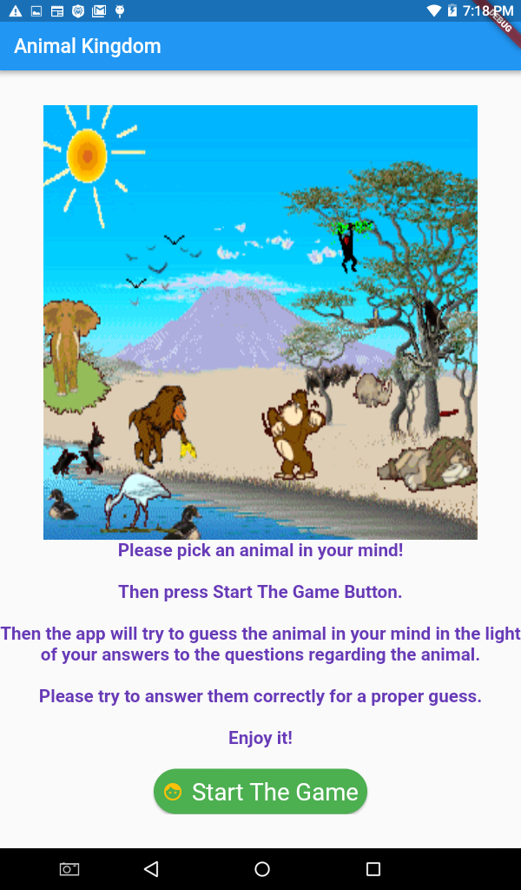
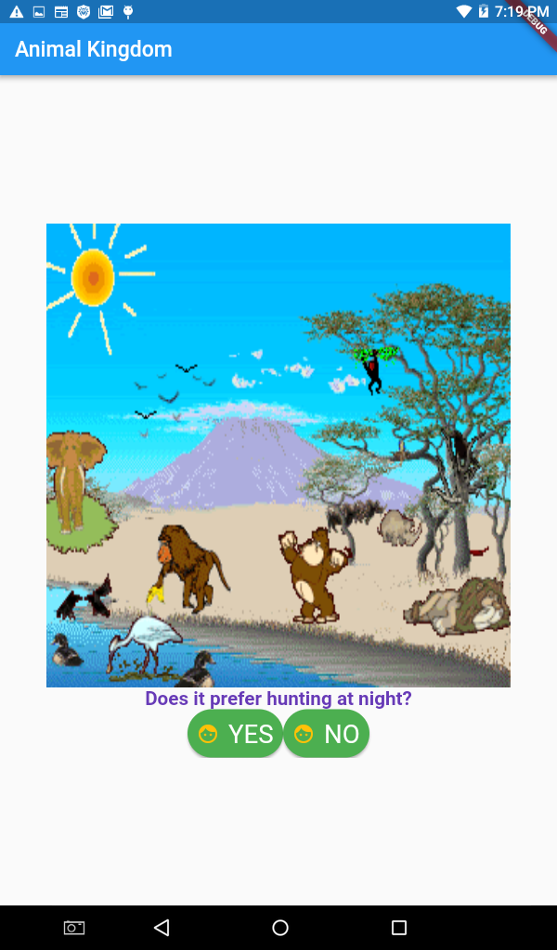

Introduction Screen which welcomes the player and explains the game mechanism. | Questions regarding  The Nature of The Beast
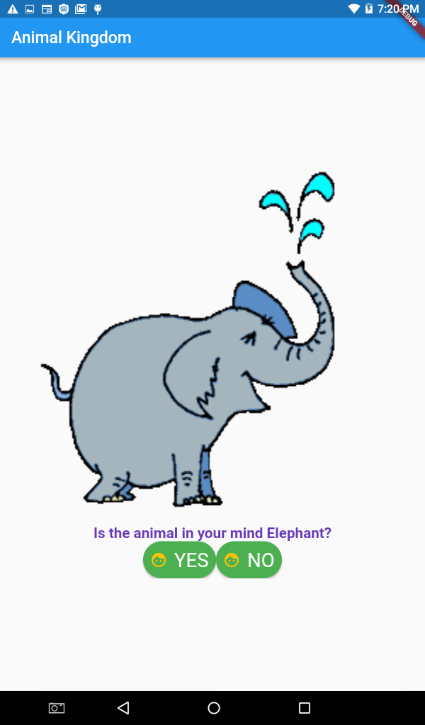
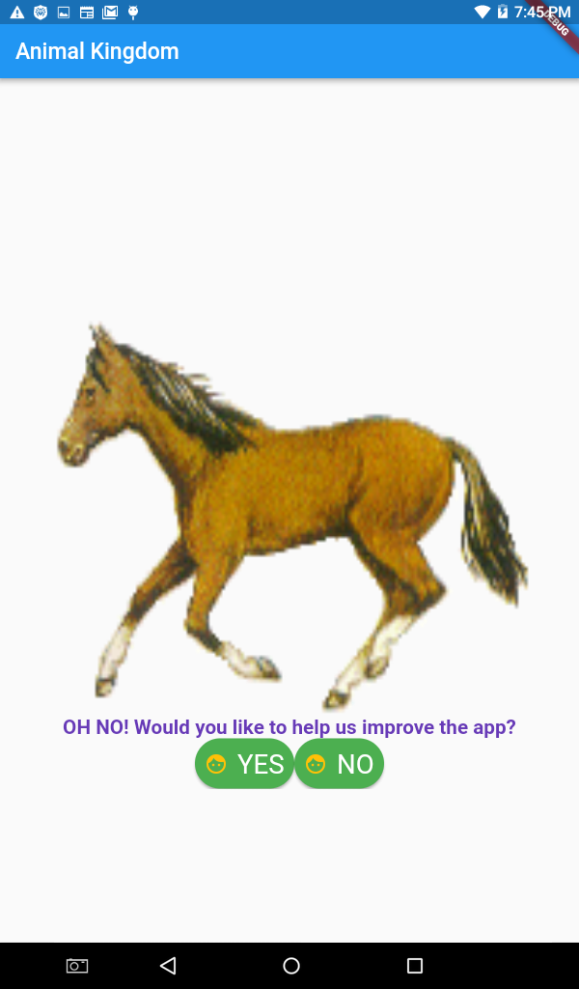

In case the animal is guessed incorrectly, Animal Kingdom asks for help for improvement. | Animal guess is displayed with its characteristic voice.
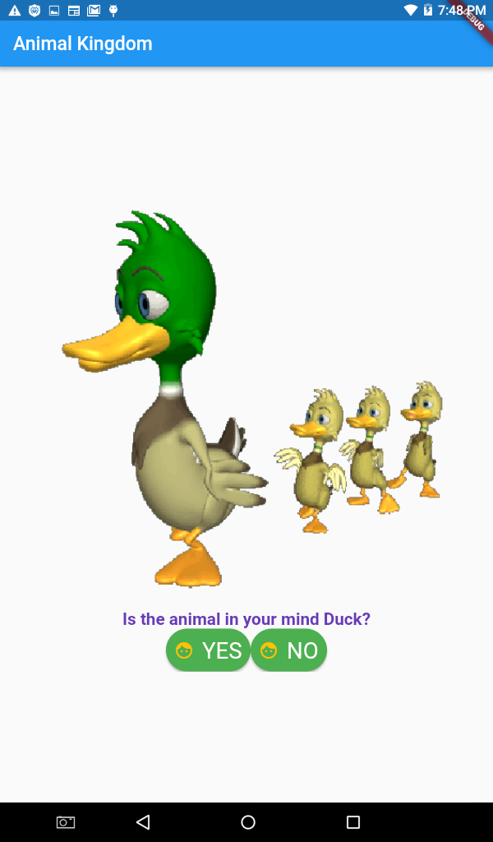
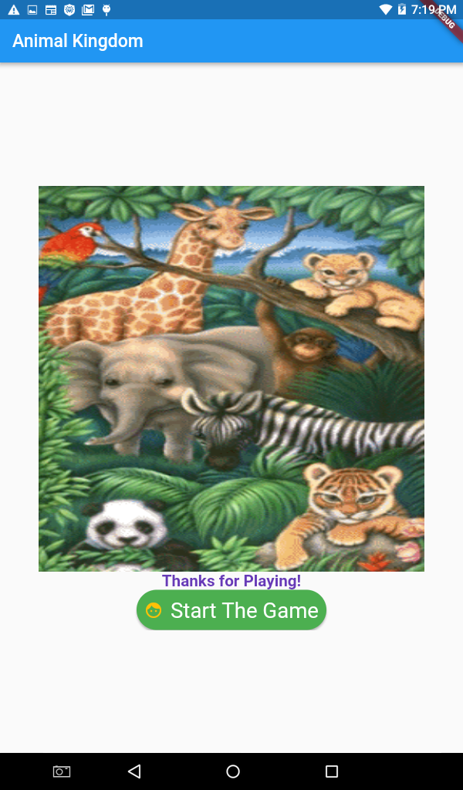

App contains a wide variety of animals alongside their animated images and sounds | App displays a message of appreciation to the human player for the contribution.
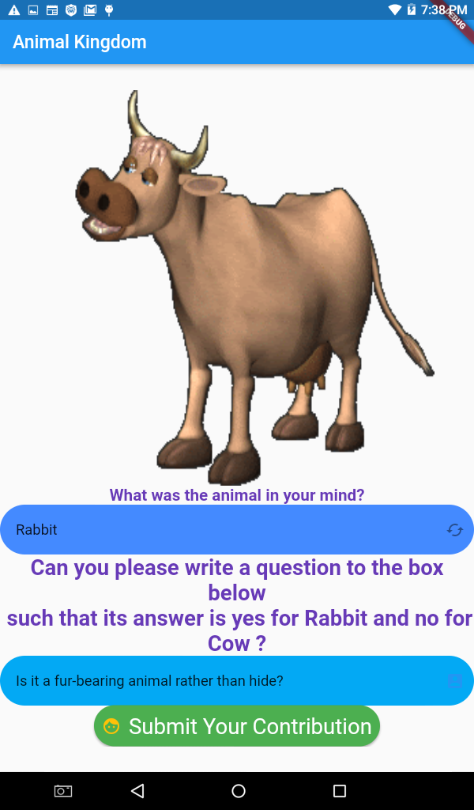
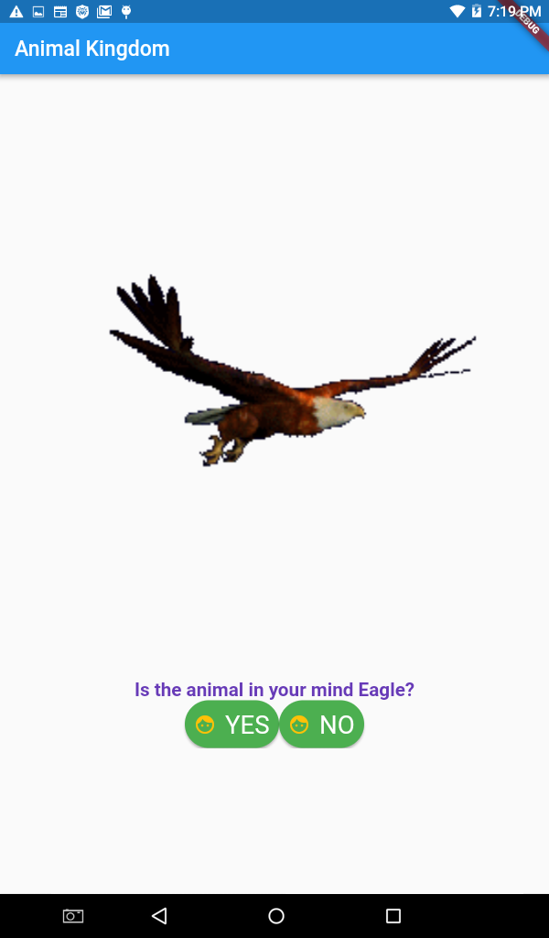

Player types the animal in her/his mind and adds a new question with a (binary) yes/no answer. After submission the tree branches the 2 animals in the light of the disambiguation.
References:

A console app I browsed which also implements a tree structure
https://www.youtube.com/watch?v=OigZqDw8nHo

UI Design Tutorial in Flutter
https://www.youtube.com/watch?v=PkY6Y-dmimE&t=447s

Attended Udemy Courses
https://www.udemy.com/course/pre-google-flutter-and-dart-everything-you-need-to-know/
https://www.udemy.com/course/free-flutter-beginner-tutorial-build-own-app/
https://www.udemy.com/course/learn-flutter-beginners-course/

Stackoverflow Cases And Medium.com Articles, Documentations on flutter.dev etc such as:
https://flutter.dev/docs/development/packages-and-plugins/using-packages
https://flutter.dev/docs/testing/debugging
https://stackoverflow.com/questions/49691163/dart-multiple-constructors
https://stackoverflow.com/questions/44489804/show-hide-widgets-in-flutter-programmatically
https://stackoverflow.com/questions/51007784/android-studio-not-showing-logcat-with-flutter
https://stackoverflow.com/questions/52549440/how-to-call-method-from-another-class-in-flutterdart
https://medium.com/filledstacks/how-to-call-a-function-on-start-in-flutter-stateless-widgets-28d90ab3bf49
https://medium.com/flutterpub/installing-flutter-in-android-studio-ec135911ceea
https://proandroiddev.com/why-flutter-will-change-mobile-development-for-the-best-c249f71fa63c

Multimedia Content Providers such as:
https://freesound.org/
http://soundbible.com/
https://giphy.com
https://www.animatedimages.org/
http://gifgifs.com/

The Specification For The Project

We are willing to run a game project for the mobile platform. The project is to be executed as a "guess what?" style game
which consist of a binary search tree that conducts and organizes the animal data within
as well as a linked list that will store animal objects to be picked efficiently in terms of the data structure scheme.

We also intend to implement a fancy and eye catching user interface in order to ensure the game to be interesting and approachable in addition to being educational and informative.

The guessing process is supposed to be handle by the application itself, in the light of the selections and directives of the human user. And the app will try to predict the animal which is chosen by the user in the first place. Moreover, our game project will be eligible to somehow learn and improve itself based on the data provided by the user.

