**Gebze Technical University**

**Computer Engineering**

**CSE 222 - 2019 Spring**

**HOMEWORK 2 REPORT**

**CANER KARAKAŞ**

**131044061**

Ayşe Serbetçi Turan

# INTRODUCTION

## Problem Definition

Storing experiments that we have in the linkedlist type. This type should depend on the experiments and the days of the experiment. Day nodes should poit to the first experiment of each day and show the next day. At the same time, each experiment should Show itself after the next experiment. This list should be iterable. Additions should be made at the end of the experimental nodes with day nodes.

## System Requirements

For system working requirements, class of experiments and class of experiments list were established. Within the class of experiments, setup day time completed and accuracy informations was included. The class of experiments list has two inner class. These classes are NodeExp and NodeDay. NodeExp class holds Experiment object and the next NodeExp object. Finally, Experiment list class has been to override to be replicable.

# METHOD

## Class Diagrams

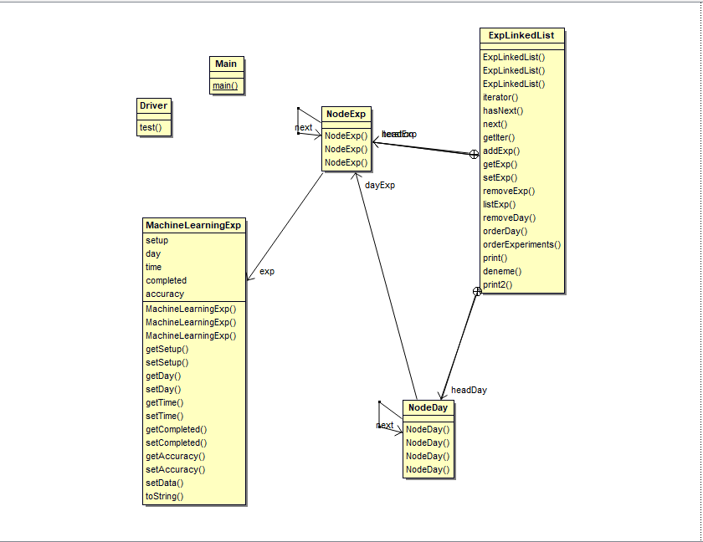

## Problem Solution Approach

**MachineLearningExperiment Class**

This class includes the information of the experiments. This information is like setup day, time, completed and accuracy. Setters and Getters are written for these values. İn addition, the toString method has been override.

**ExperimentList Class**

This class has NodeExp and NodeDay inner classes. This class holds the objects of the inner classes as private member. NodeExp class holds Experiment object and the next NodeExp object. NodeDay class holds NodeExp object and the next NodeDay object. NodeExp objects in NodeDay point the elements of the list. In this way, fast processing can be done over days. We can think of it with the subset logic. If the parent cluster is a NodeDay class, the subset is NodeExp class.

# RESULT

## Test Cases

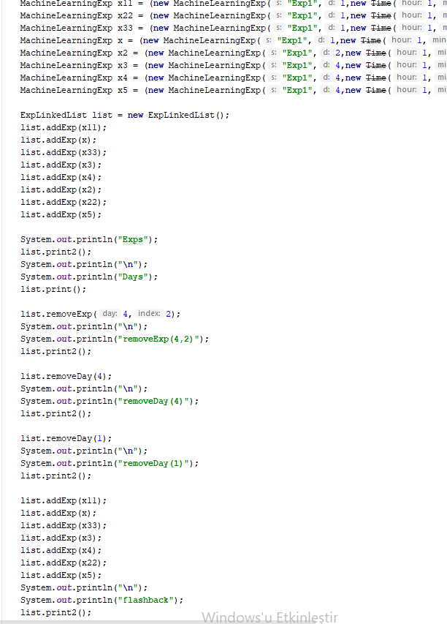

## Running Results

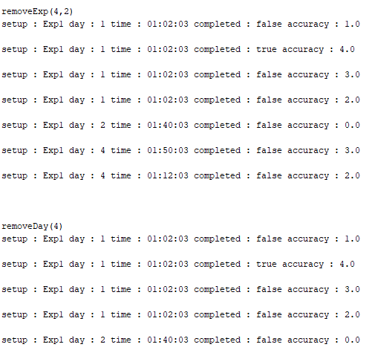



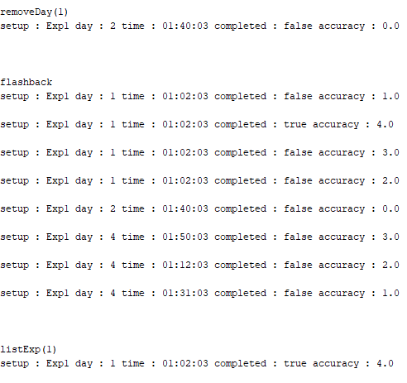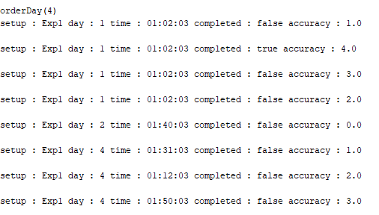



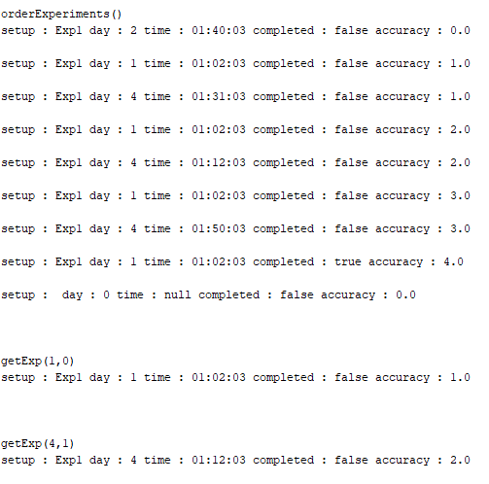

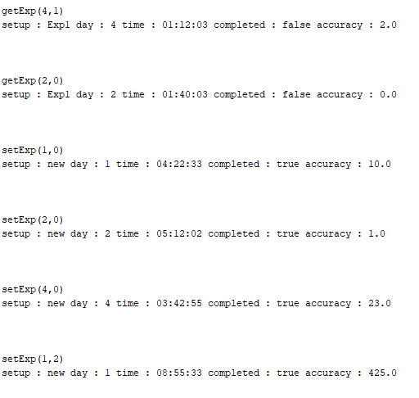

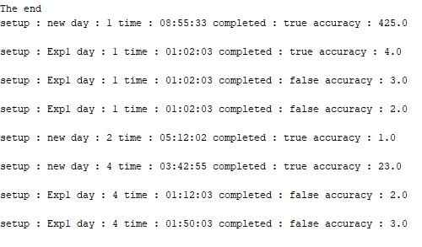

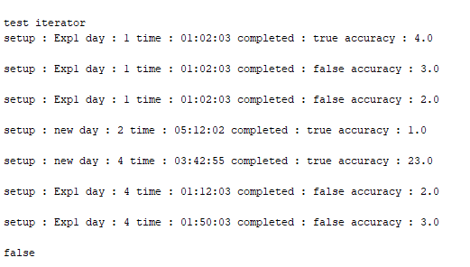

**TIME COMPLEXITY**

|  |  |  |
| --- | --- | --- |
| **Class** | **Method** | **Complexty** |
| MachineLearningExp | All methods | O(1) |
| ExpLinkedList | İterator() | O(1) |
| ExpLinkedList | hasNext() | O(1) |
| ExpLinkedList | next() | O(1) |
| ExpLinkedList | getIter() | O(1) |
| ExpLinkedList | addExp() | O(n3)(While*While*While) |
| ExpLinkedList | getExp() | O(n)(While+For) |
| ExpLinkedList | setExp() | O(n)(While+For) |
| ExpLinkedList | removeExp() | O(n)(While+For) |
| ExpLinkedList | listExp() | O(n)(While) |
| ExpLinkedList | removeDay() | O(n2)(While*While) |
| ExpLinkedList | orderDay() | O(n2)(While*While) |
| ExpLinkedList | orderExperiments | O(n2)(While*While) |
| ExpLinkedList | print() | O(n)(While) |
| ExpLinkedList | print2() | O(n)(While) |