**DEVICES:**

**1)**

5.8Ghz 600mW FPV transmitter and receiver are seen suitable for our project. Only question is, are they supposed to work indoor? But it most probably could work indoor as well because 600mW transmitter gives 1-2 km range in the open area. It has different channels so that the video cannot be mixed with others broadcast.

This is transmitter and receiver kit is about $25 at [aliexpress link](https://tr.aliexpress.com/item/FPV-5-8Ghz-600mW-TS5828-or-TS832-Transmitter-48CH-RC832-plus-Receiver-With-A-V-and/32813251539.html?albbt=Google_7_search&isdl=y&slnk=&src=google&acnt=479-062-3723&crea=64152518596&aff_platform=google&netw=g&plac=&al).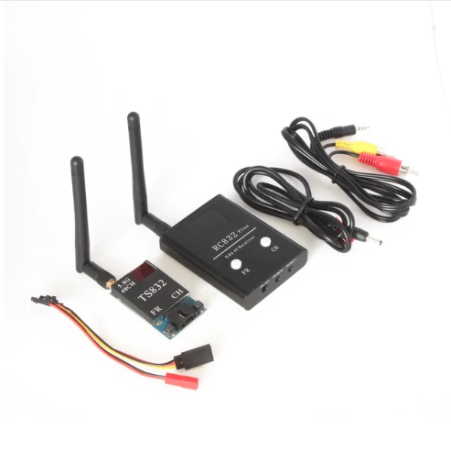

**2) OMNI WHEEL**

We can use omniwheel for our robot to be able to capable for moving all directions. There is some example video and brief introduction below about omniwheel and also a detailed article is attached into the TROY-TECH\Searches folder. There may be some issues by using omniwheel; it increases expenses directly and omni wheels are not cheap. We also should handle controlling them, maybe with a feedback control system.

1st video : <https://www.youtube.com/watch?v=_tmiu1wpp_E>

2nd video : <https://www.youtube.com/watch?v=H29PEOTDFA4>

**Here is brief introduction of omni-wheel technology.**

Omni-directional wheels are unique as they are able to roll freely in two directions .It can ether roll like a normal wheel or roll laterally using the wheels along its circumference.Omni-direction wheels allow a robot to convert from a non-holonomic to a holonomic robot.A non-holonomic robot that uses normal wheels has only 2 out of 3 controllable degrees-of-freedom which are,moving forward/backwards and rotation.Not being able to move side ways makes a robot slower and less efficient in reaching its given goal. The holonomic omni-directional wheels are able to overcome this problem,as it it a highly maneuverable.Unlike normal non-holonomic robot,the holonomic omni-directional robot can move in an arbitrary direction continuously without changing the direction of the wheels.It can move back and forth,slidewaysmand rotates at the same position.

