**EE444 Homework 1**

**Part 1 - Getting Familiar with Wireshark**

**Q1.1.**

UDP (User Datagram Protocol)  
TCP (Transmission Control Protocol)  
ICMPv6(Internet Control Message Protocol)  
SSDP (Simple Service Discovery Protocol)  
IGMPv3(Internet Group Management Protocol)  
IPv6(Internet Protocol)  
STP (Spanning Tree Protocol)

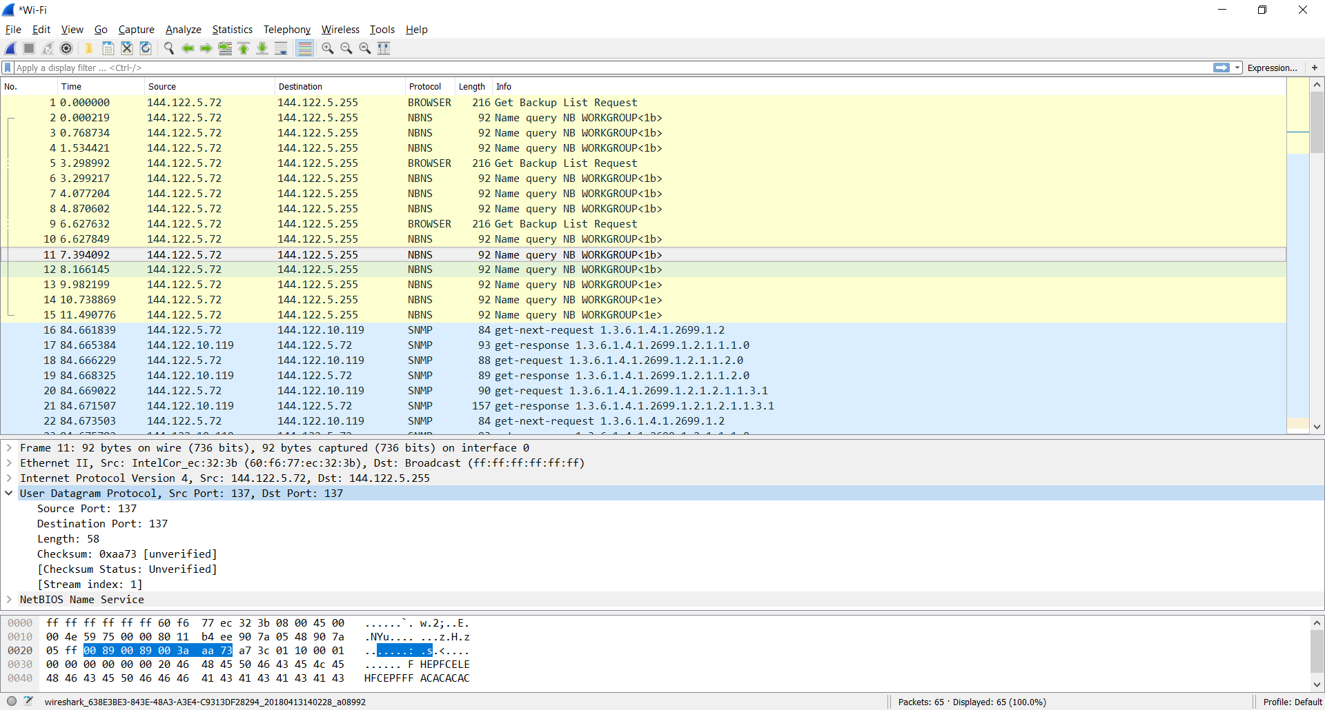

**Part 2 – HTTP, TCP, DNS**

**Q2.1.**

First a TCP connection is done. After that, an HTTP request departs from my computer for the image file with GET request method. Then, the image file packets are started to be sent from the host side and cumulative acknowledgements are sent from my computer. At the end, 200 OK message is received for the JPEG image.

**Q2.2.**

Source IP address: 144.122.145.153

Source Port: 80

My IP address: 144.122.5.72

My port: 50646

Stream Index : 5

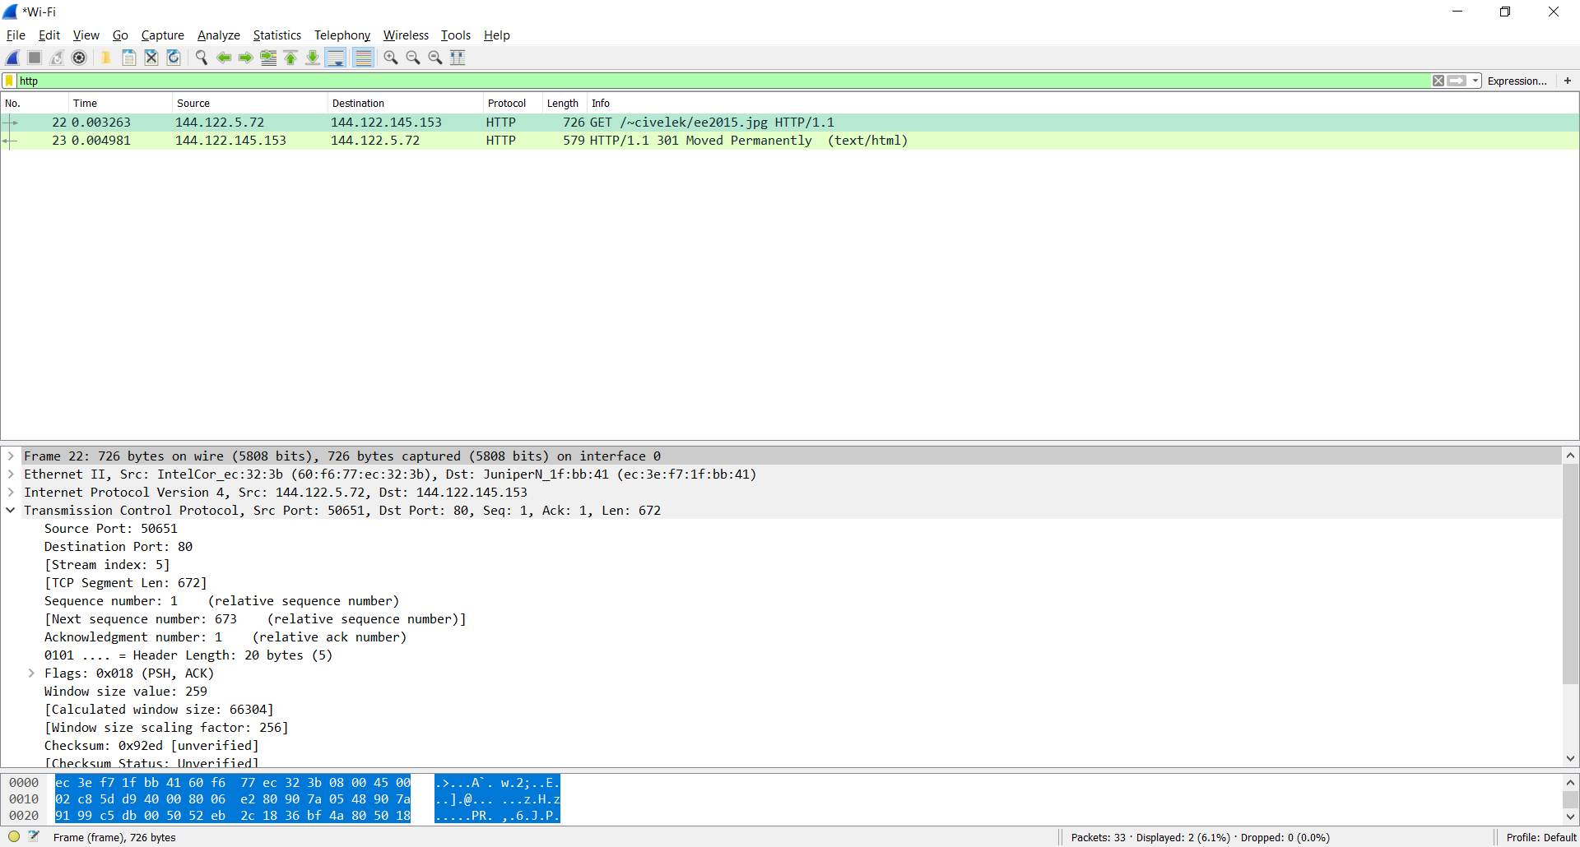

**Q.2.3.**

In the first event, a SYNCRONIZE packet is sent.

In the second one, a SYNCRONIZE-ACKNOWLEDGEMENT packet is received.

In the third one, an ACKNOWLEDGEMENT packet is sent.

TCP Connection is established.

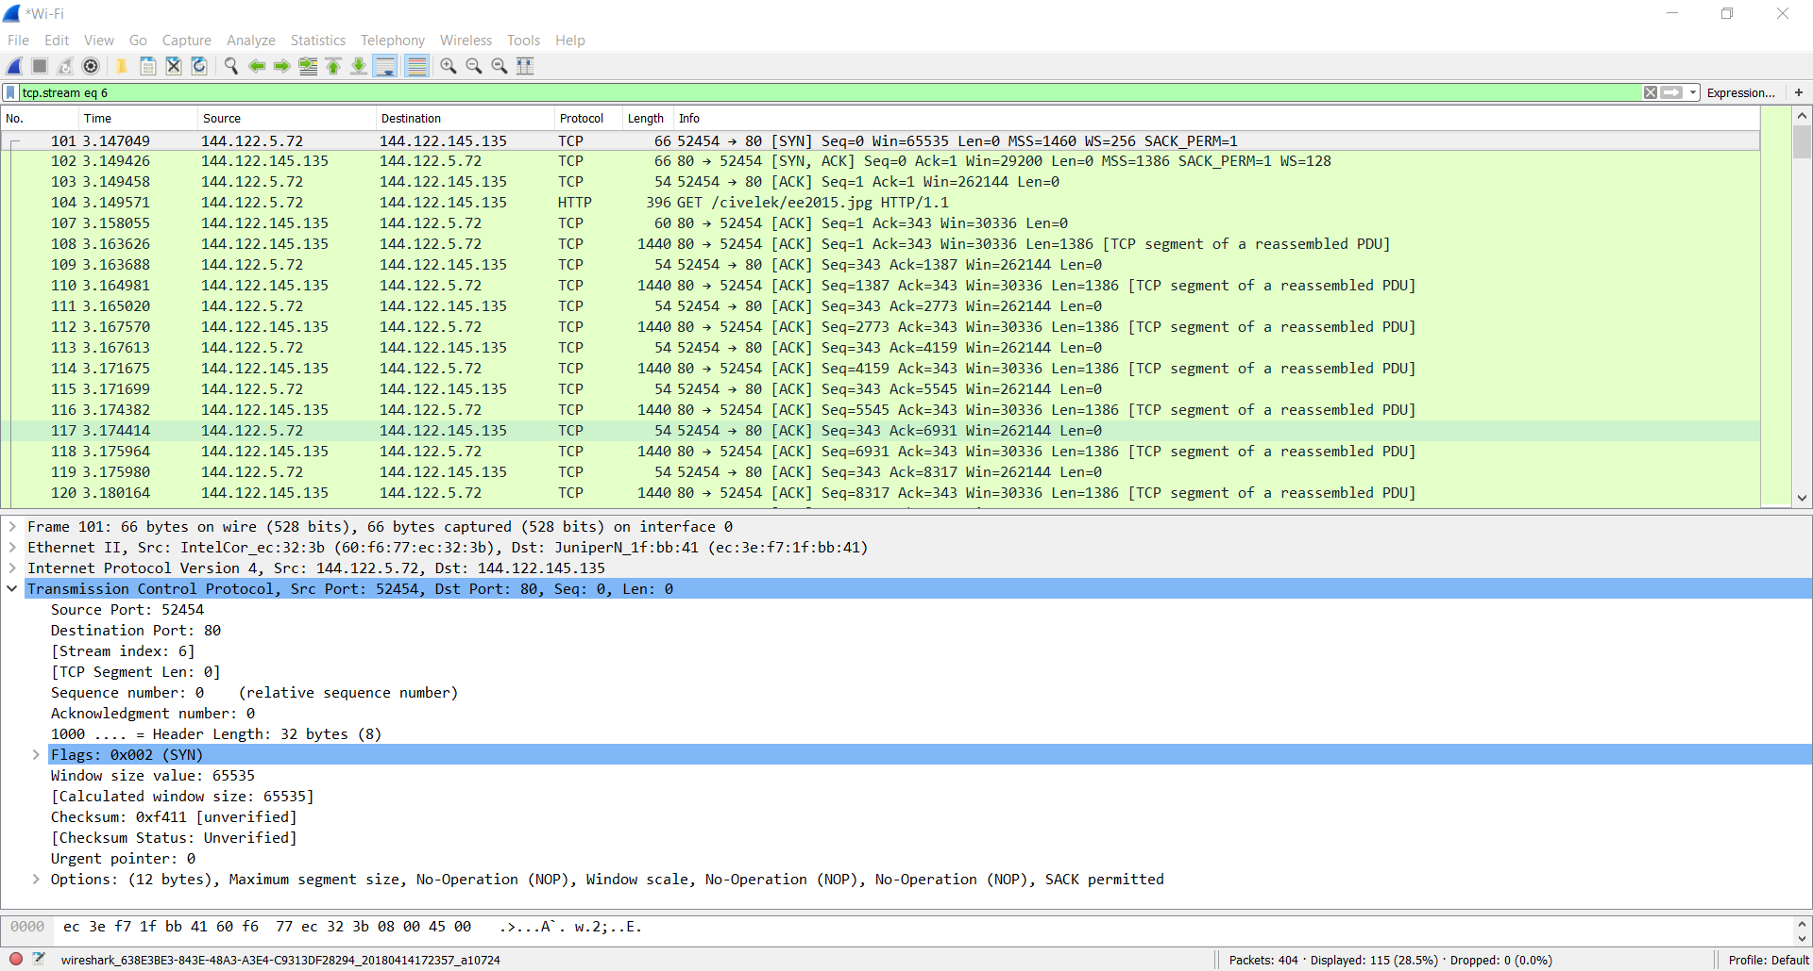

**Q.2.4.**

If we count the TCP requests and replies 66, 66, 54 bytes for the 3-way handshake packets and in average (66+66+54)/3= 61 bytes

If we count the header size its size is 20 bytes.

**Q2.5.**

TCP packet size (P) = 66 bytes = 528 bits

RTT = 3.096041 s-3.093838 s=0.002203 s

TCP Throughput = P/RTT = 239 kbps

**Q.2.6.**

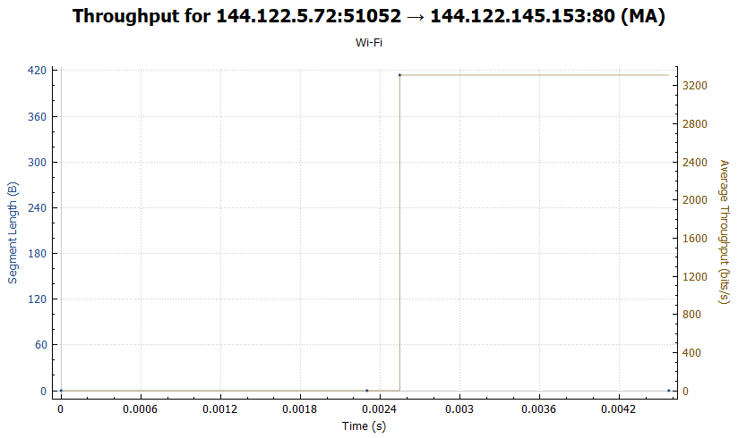

**Q.2.7.**

The HTTP connection is persistent since the connection type is stated as “Keep-Alive” in the HTTP request packet.

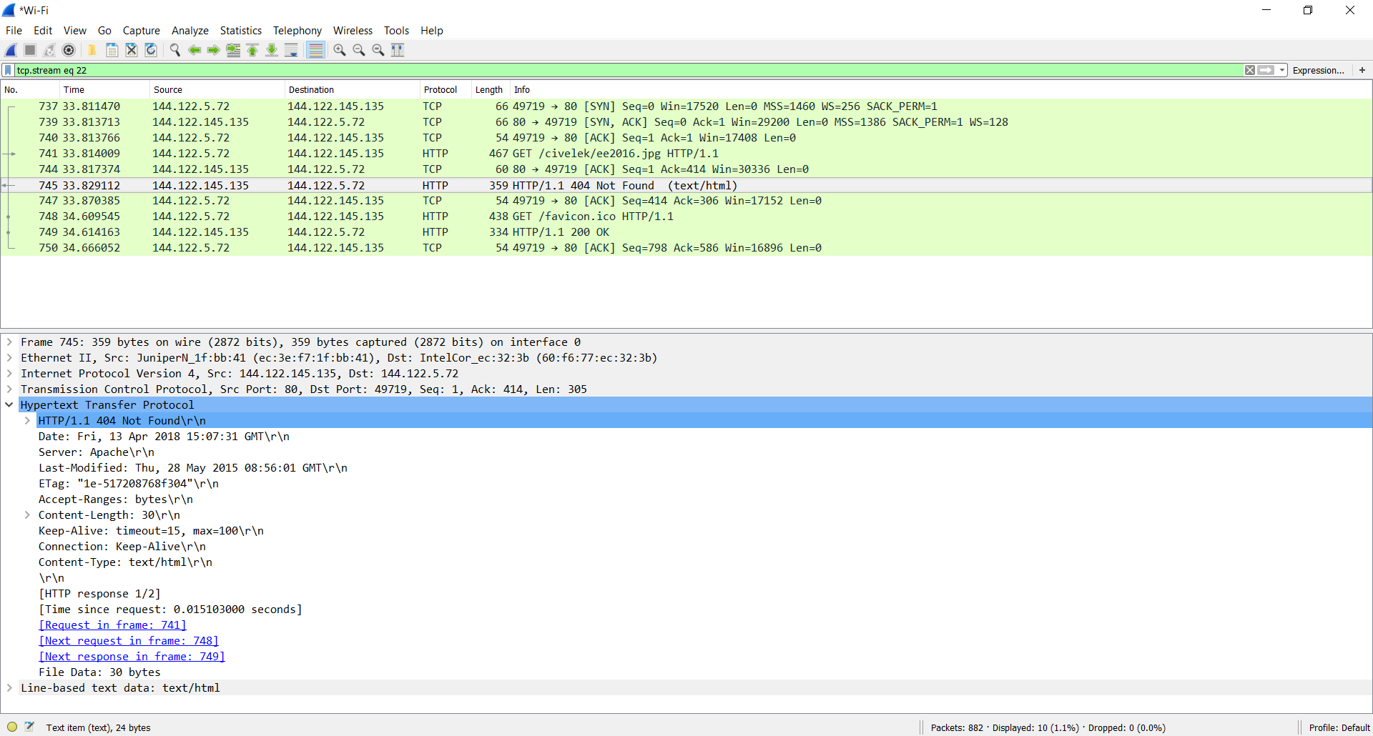

error418.net

Status code: 418 I’m a teapot.

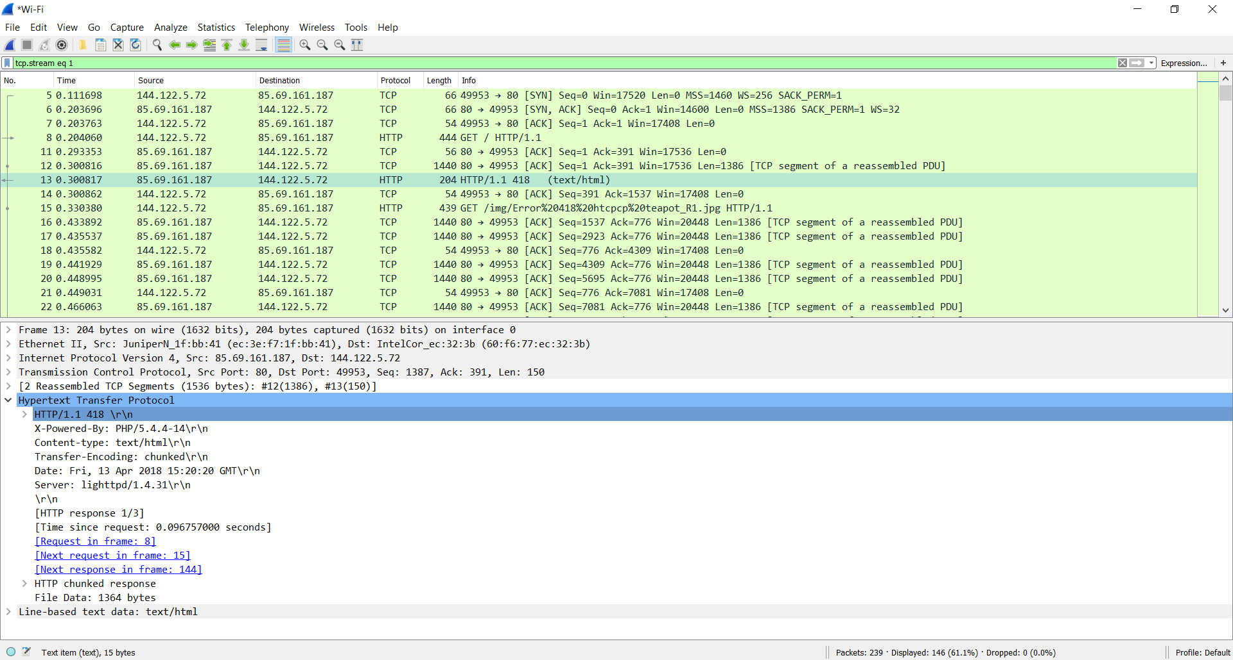

metu.edu.tr/%

Status code: 400 Bad Request

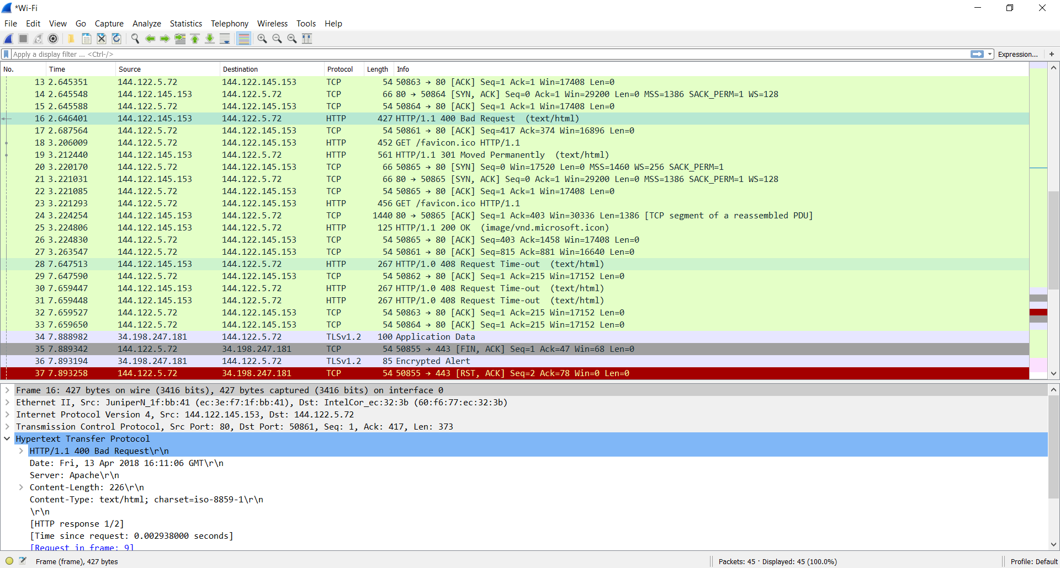

**Q.2.9.**

Cookie ID:

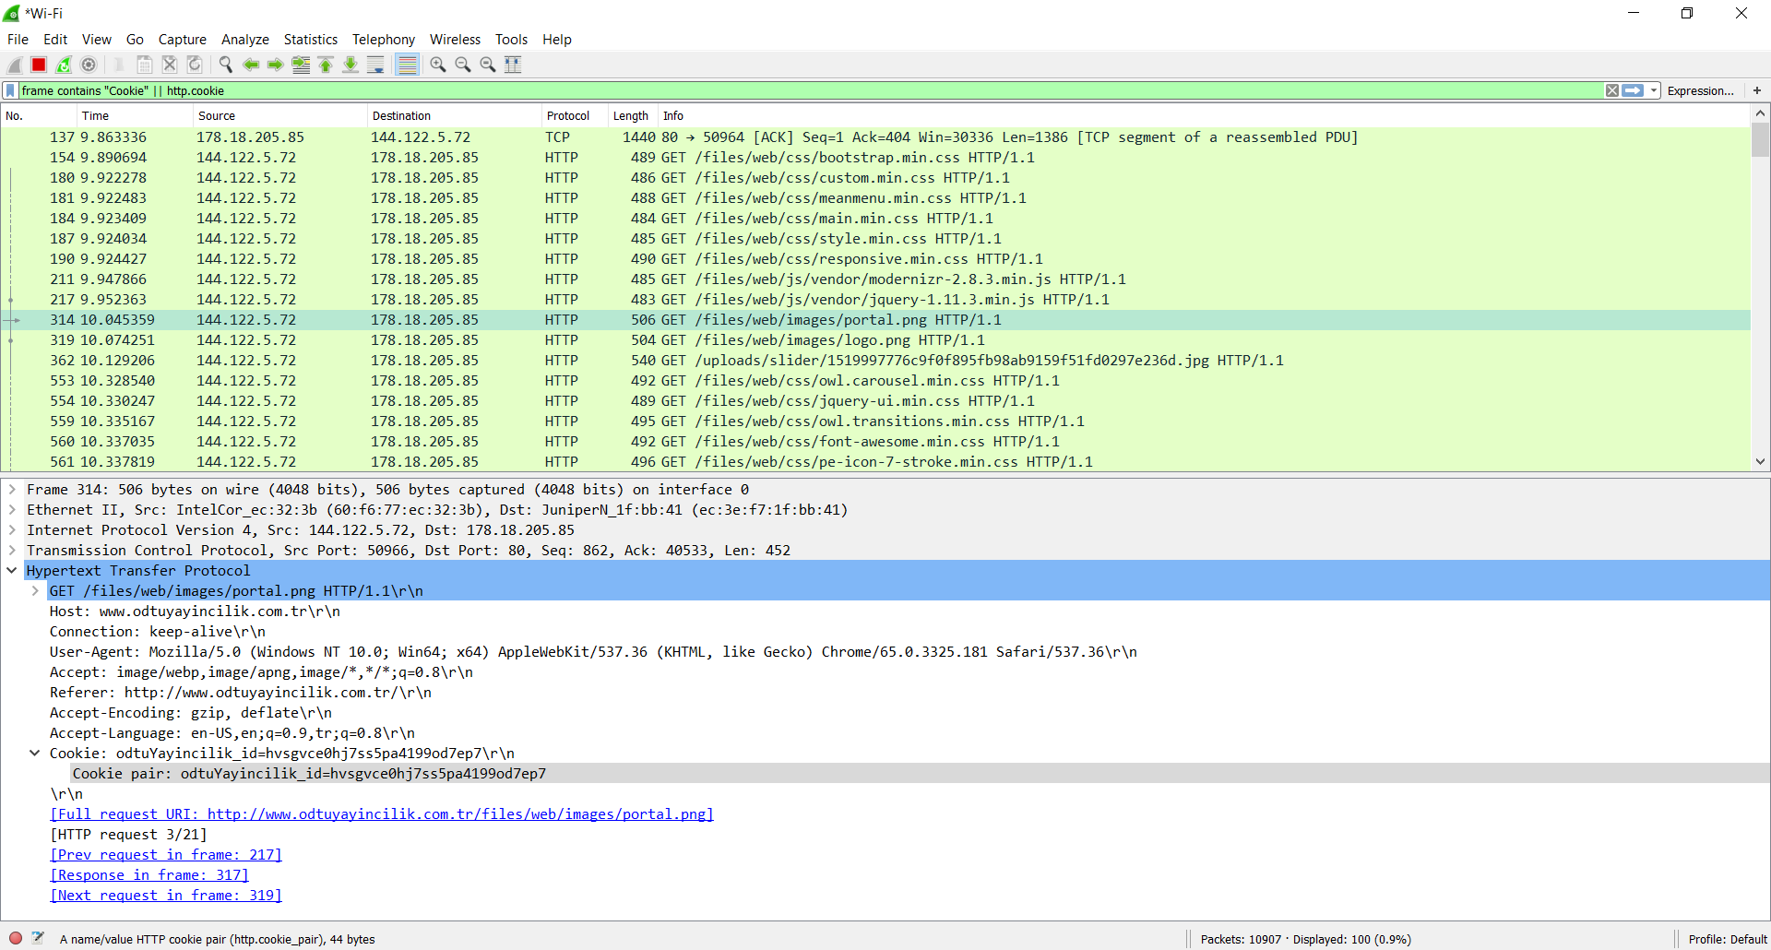

Expiration date:

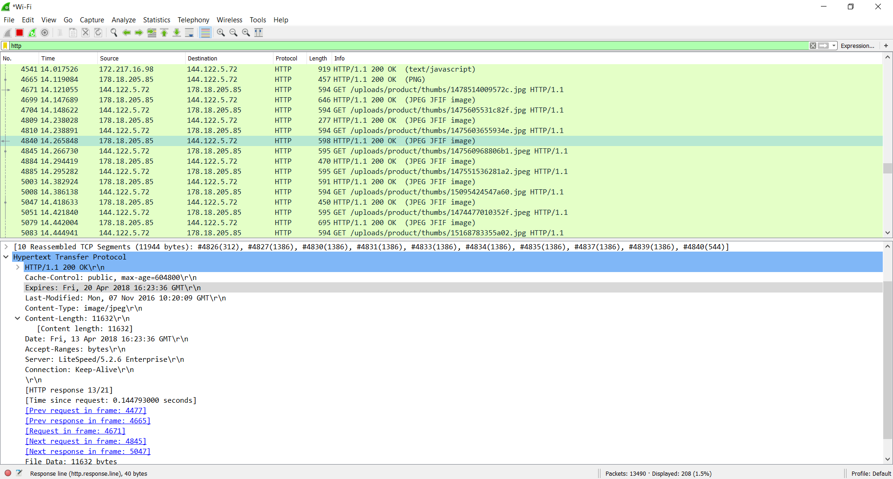

**Part 3 – ICMP**

**Q.3.1.**

Output for: ping –l 1000 8.8.8.8

This command sends a packet with a size of 1000 bytes to the given IP address, namely 8.8.8.8.  
Time to Live of the packets are 43. The Round Trip times for the packets are like the following: 91 ms, 100 ms, 89 ms, 102 ms. Average round trip time is 95 ms.

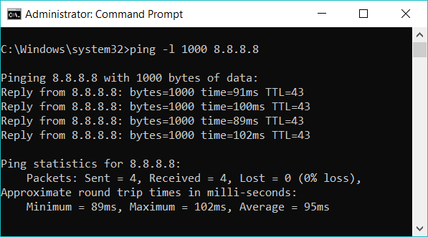

Output for : ping –l 2000 8.8.8.8

This command sends a packet with a size of 2000 bytes to the given IP address, namely 8.8.8.8.

Time to Live of the packets are 57. The Round Trip times for the packets are like the following: 170 ms, 170 ms, 138 ms 171 ms. Average round trip time is 162 ms.

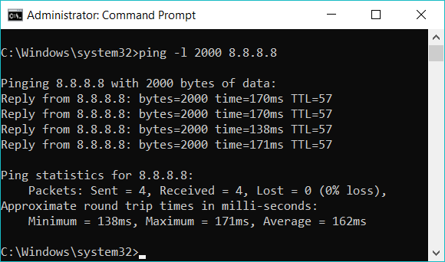

Output for : ping 0.0.0.0

This command tries to send a packet to the given IP address, namely 0.0.0.0. In the Internet Protocol Version 4, the address 0.0.0.0 is a non-routable meta-address used to designate an invalid, unknown or non-applicable target and this generates an error.

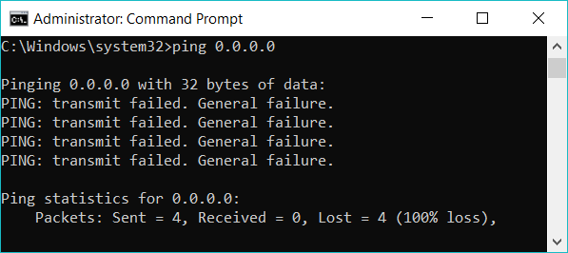

This command tries to send a packet to the given address, namely 127.0.0.0 which is the network address and specifies the whole class starting with 127.x.x.x . Therefore it generates an error.

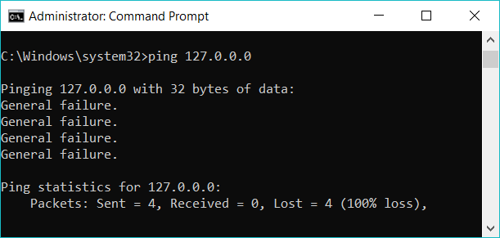

Tracert is a command which traces and shows the route to the given address. It lists all the routers that the packet follows.

This simulation is done within the network of METU campus..

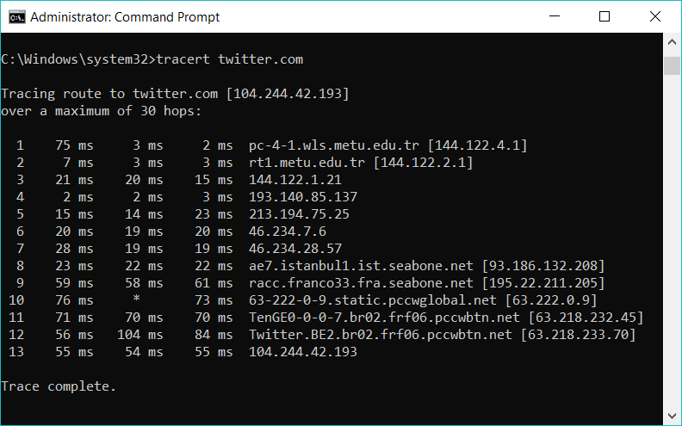

This simulation is done outside of the METU campus.

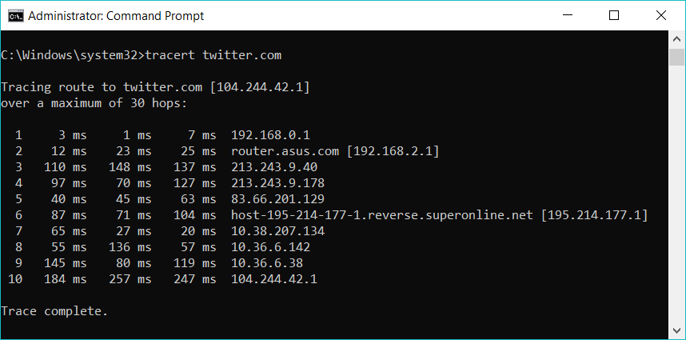

**Q.3.2.**

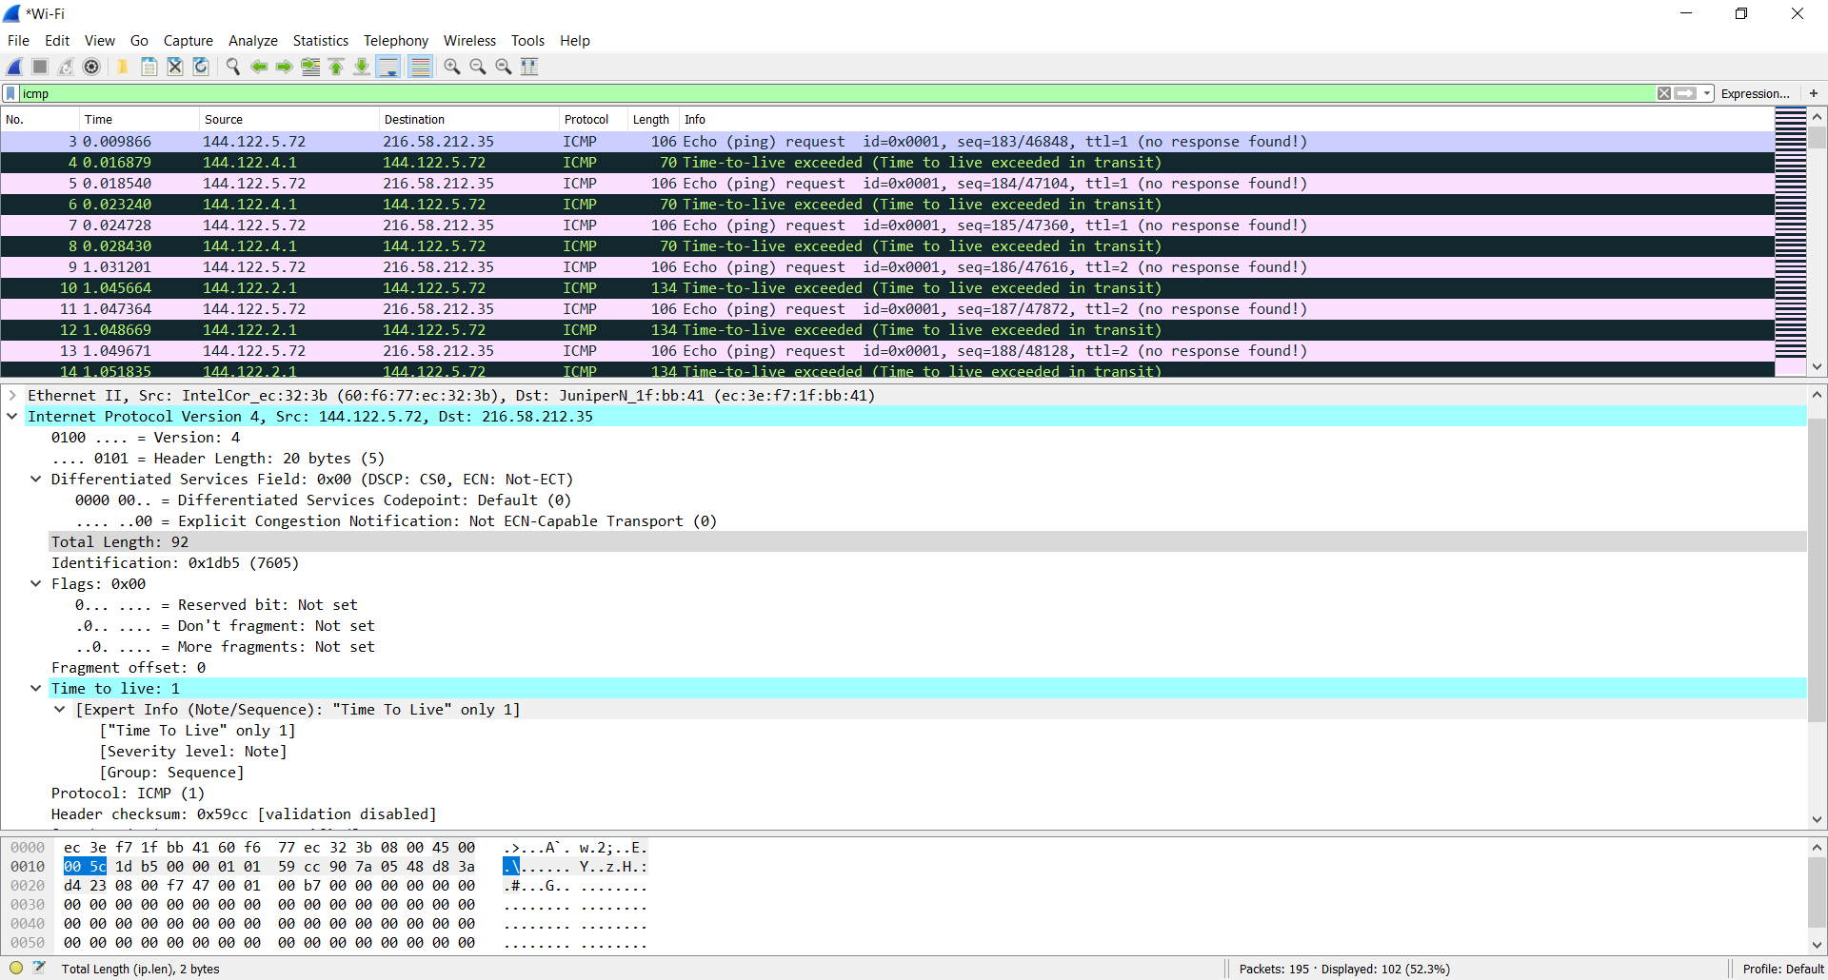

ICMP – Internet Control Message Protocol

Header length: 20 bytes

Payload bytes= Total length – Header length = 92 bytes – 20 bytes = 72 bytes

**Q.3.3.**

Identification of the IP Datagram always change from one to the next.

IP Version, Header length must stay constant.

**Q.3.4.**

3 packets are sent with the same TTL. The reason for sending 3 packets is to get more and noncontradictory information from the network route.

**Q.3.5.**

Identification change with different datagrams.

IP Version, header length, Differentiated Services Codepoint, Total Length, Flags, Time to live, Protocol, header checksum, Source and Destination IP addresses does not change for the same routers’ datagrams.  
Total length, Time to live, header checksum, Source IP addresses change with different routers’ datagrams.  
Time to live changes with different routers because how many routers that a packet can pass over depends on it.  
Total length and the header checksum are different with different routers because each router sends back different information.  
Source IP addresses are different since different routers have different IP addresses.