**EE444 Homework - 2**

**Riverbed Modeler**

**PART 1**

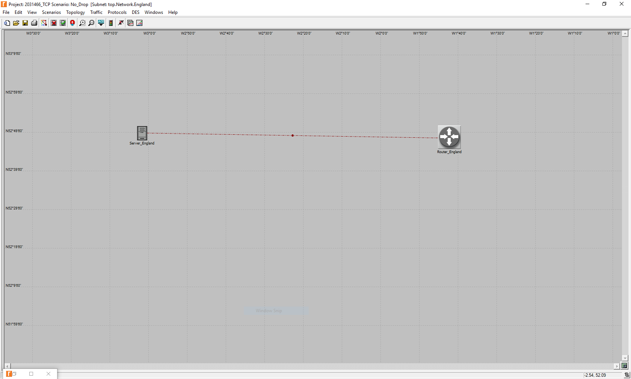

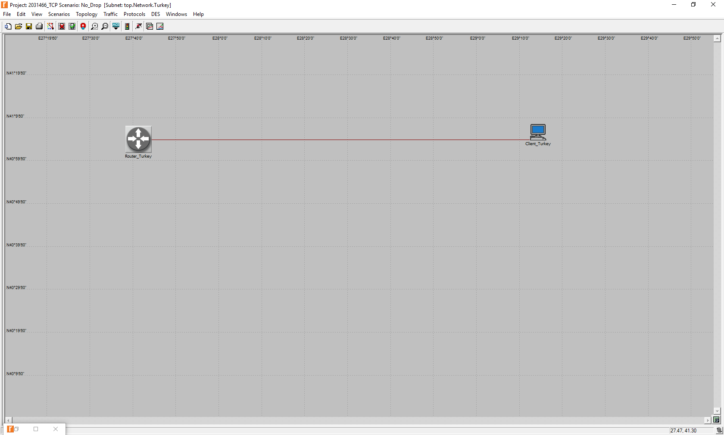

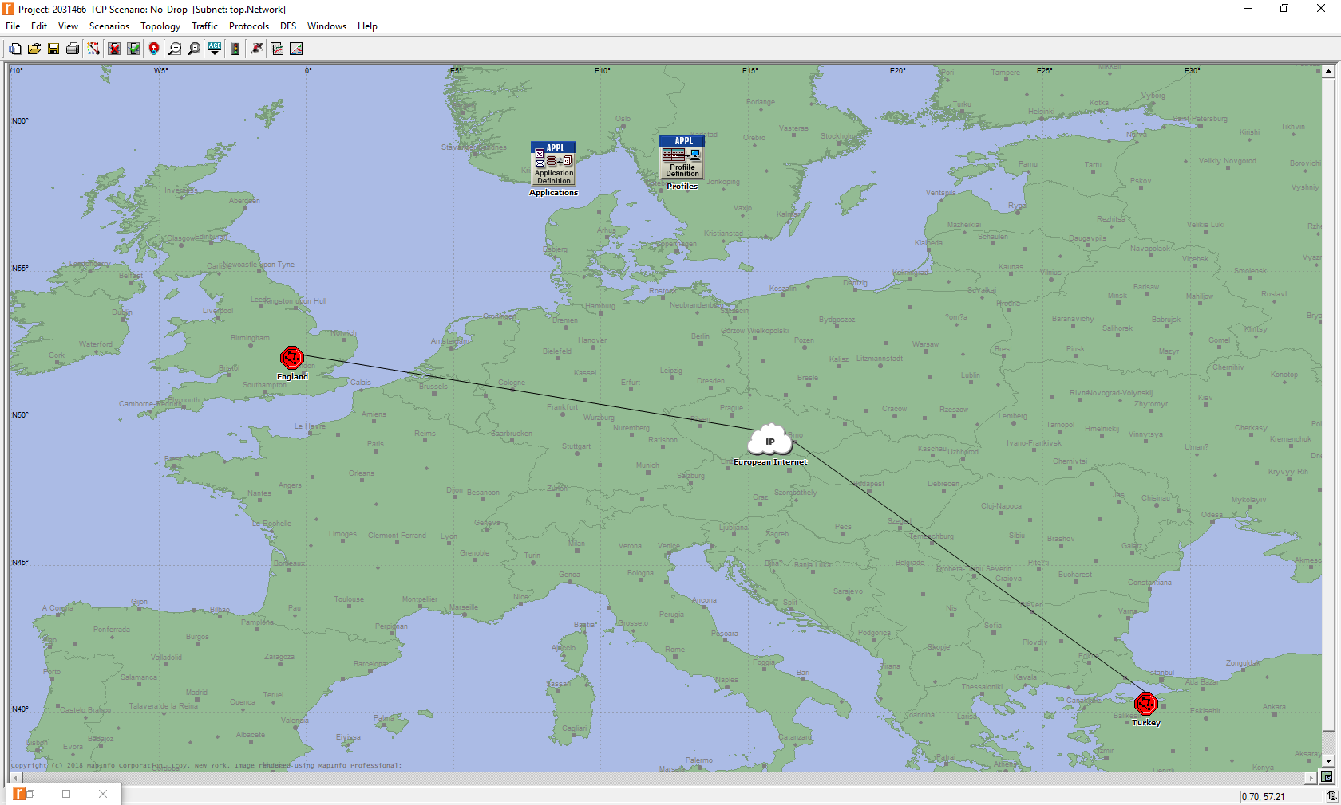

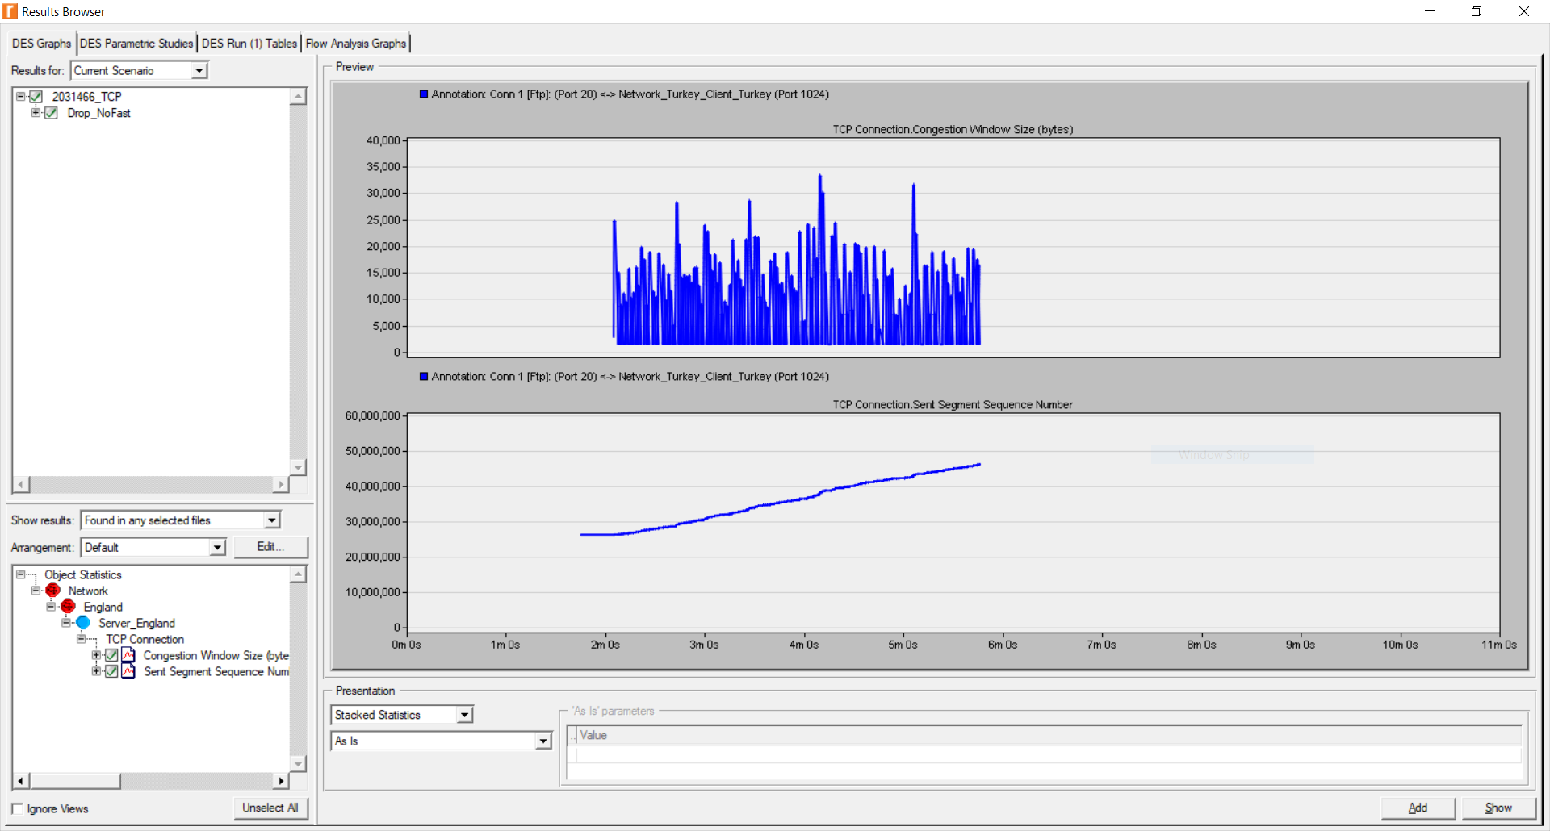

**Q1)** Sequence number remains constant during the congestion since the packets are dropped during this period. Therefore, they must be retransmitted. 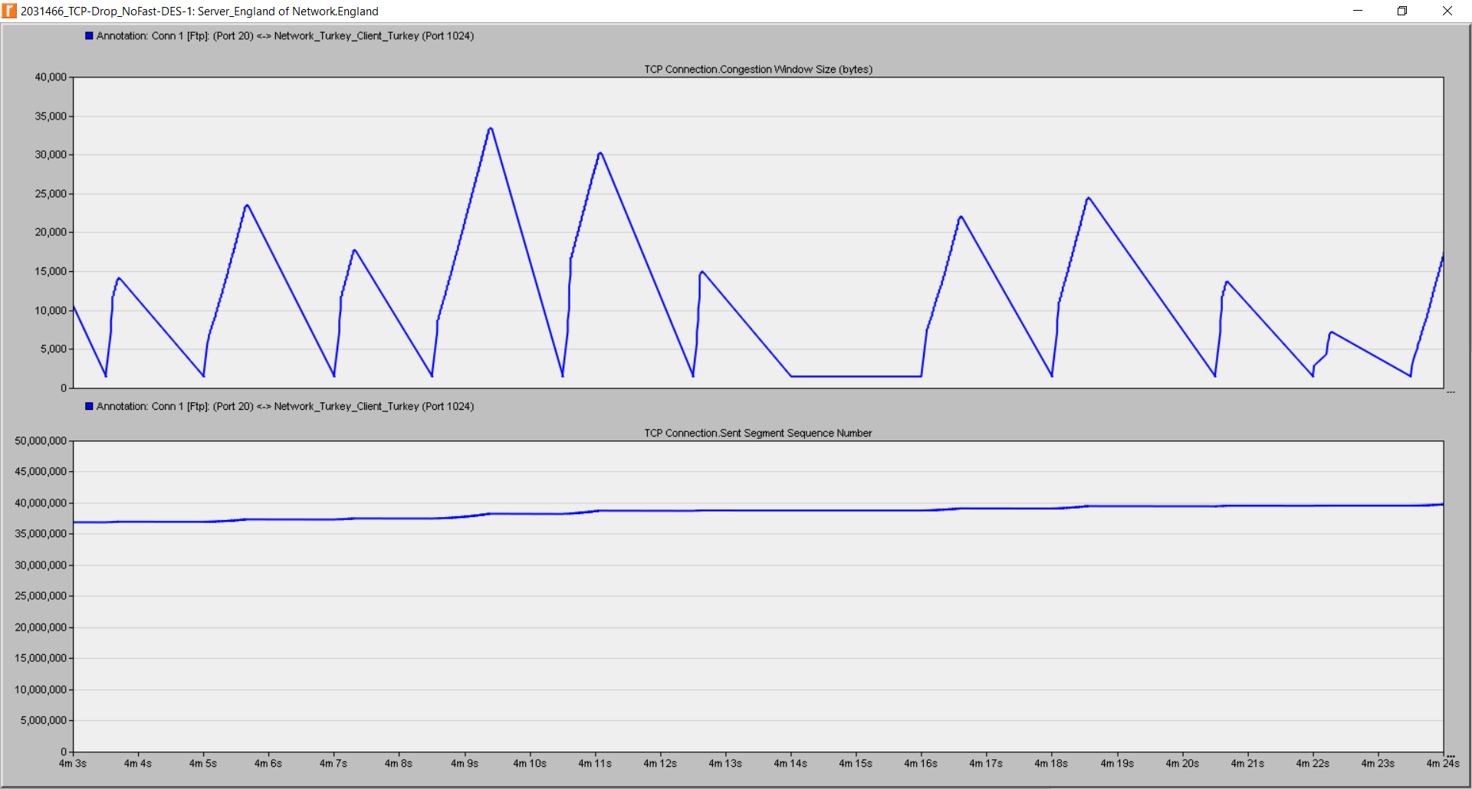

**Q2)** In the Drop_NoFast case, there is 1% packet drop in the transmission path and retransmission is taken place only after 100 ACKs are received. Therefore, there is no fast retransmission and the number of time-outs is much larger than the Drop_Fast and No_Drop cases.

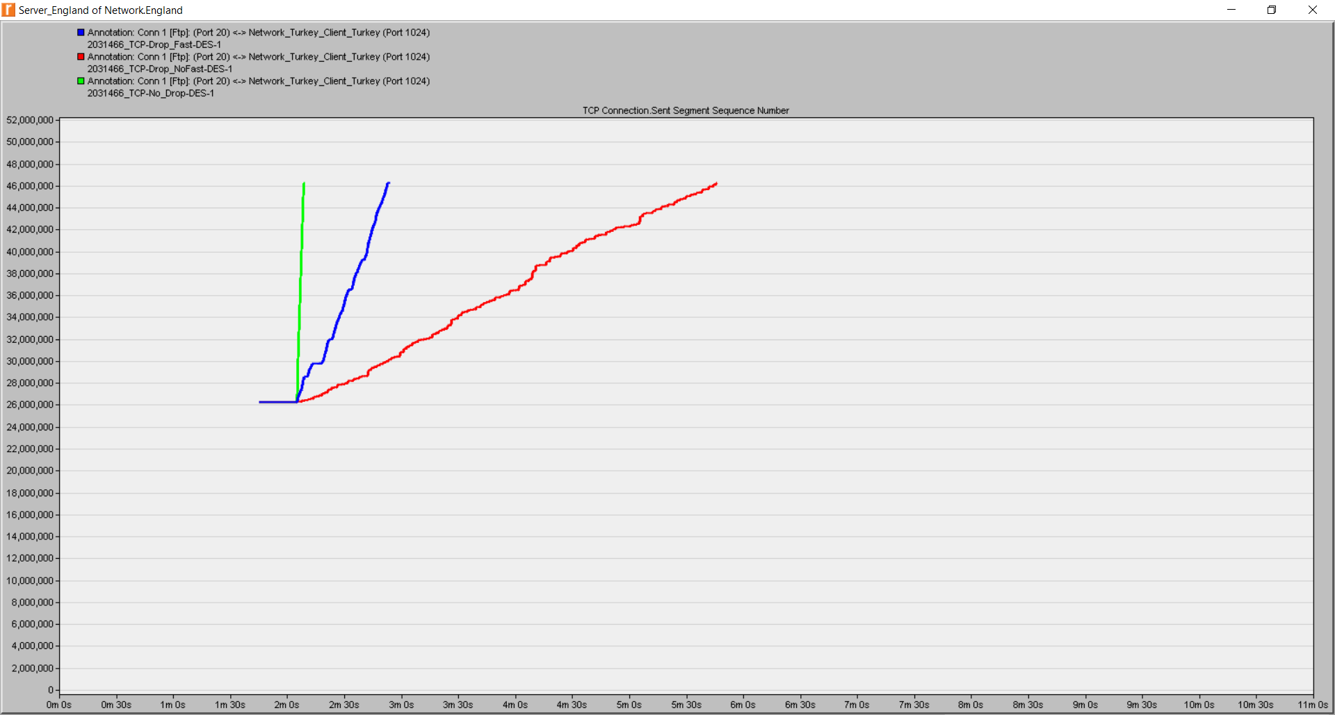

**Q3)** Sent Segment Sequence Number increases only after a certain amount of ACKs are received. As it can be seen on the graphs below, when the received ACKs are not increasing, SSSN is non-increasing.

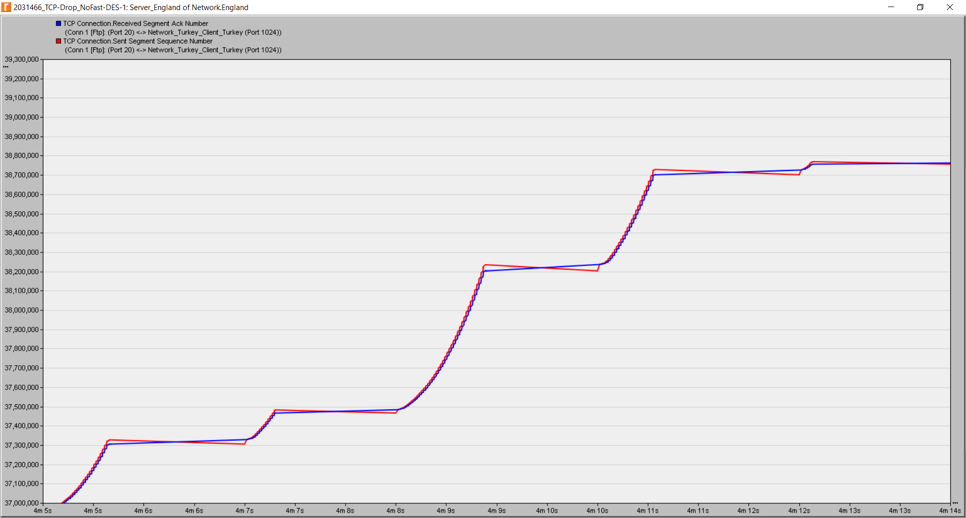

**Q4)** The TCP connection between two clients can be said to be fair to a certain extend. Although Client_Turkey_2 has a greater throughput, the difference between them is not large.

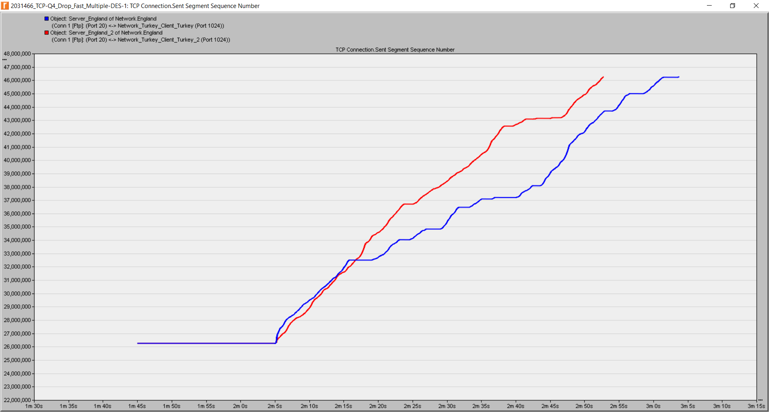

**PART 2**

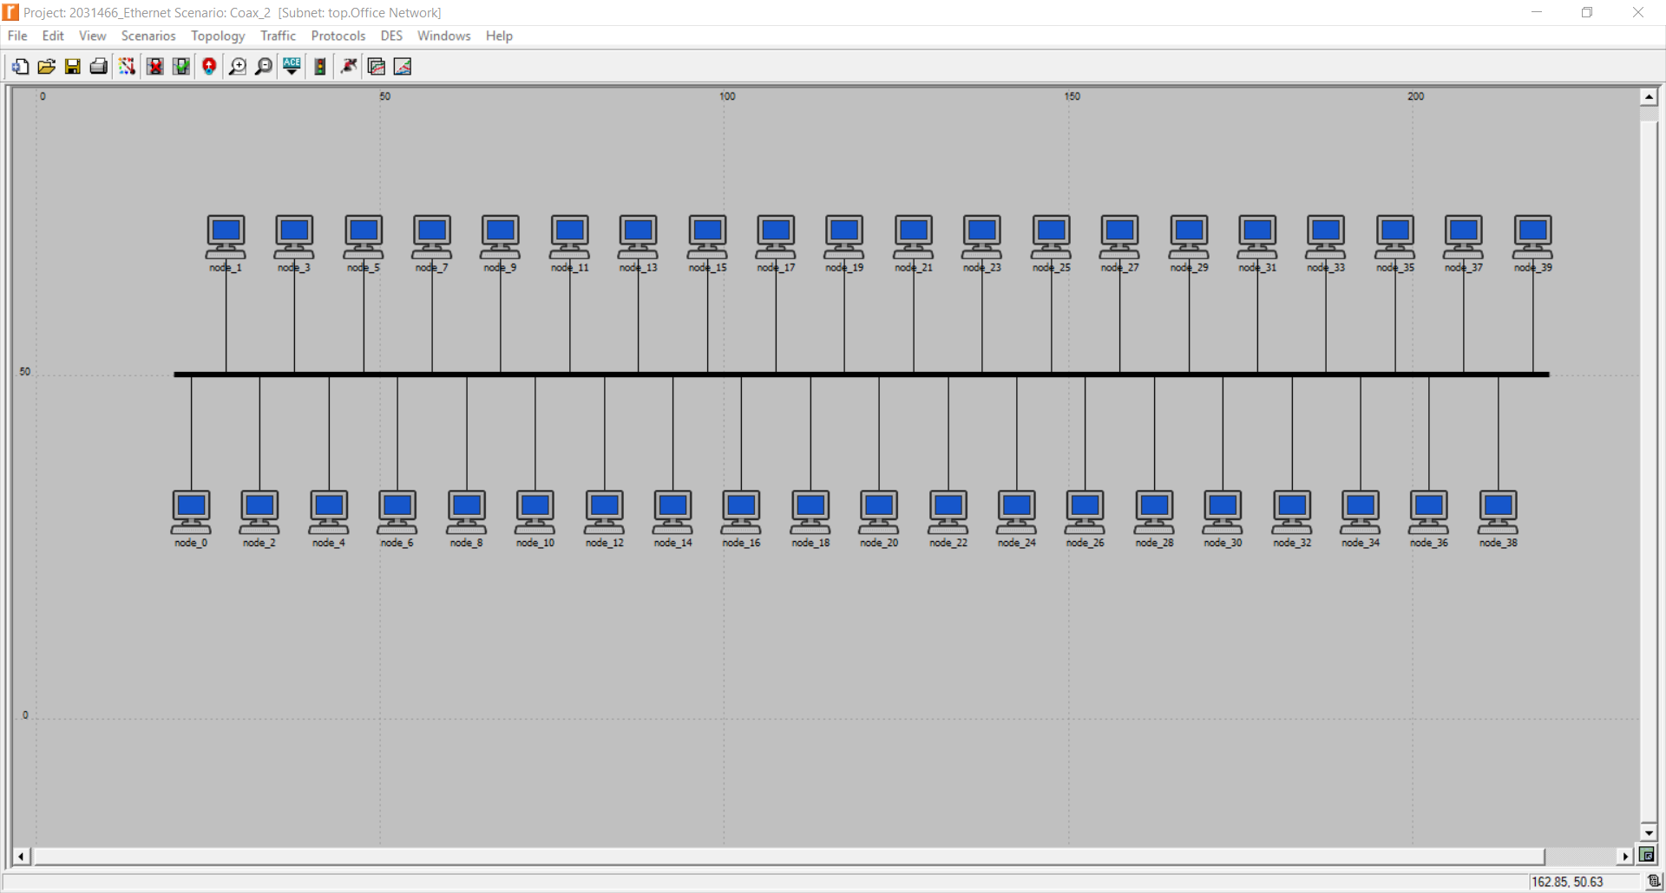

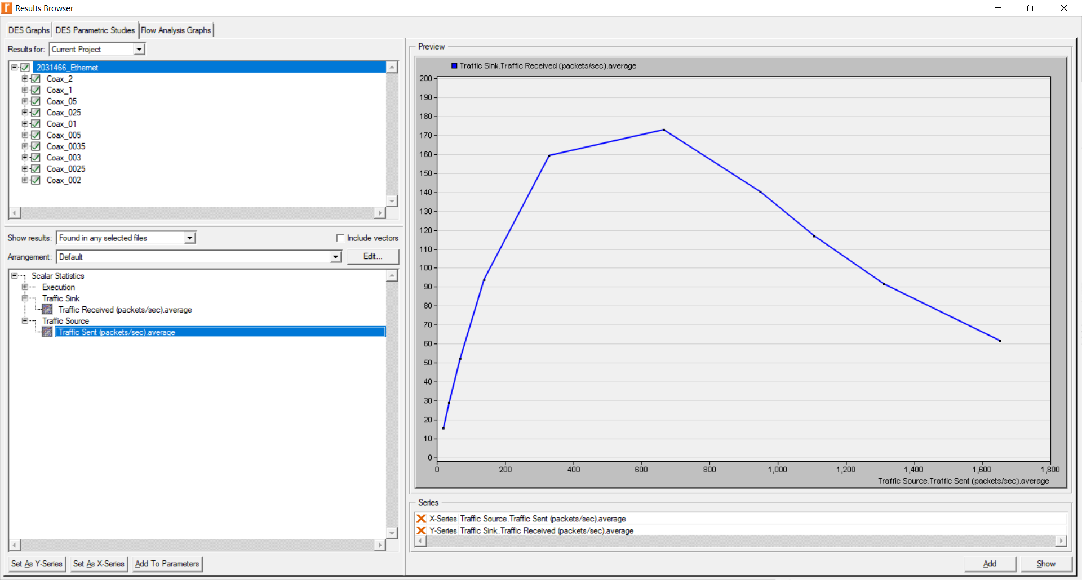

**Q1)** When the load is very light, there is idle times in the transmission line. When the load is too high, the number of collisions increase. Therefore, throughput is lower than the optimum in these two cases.

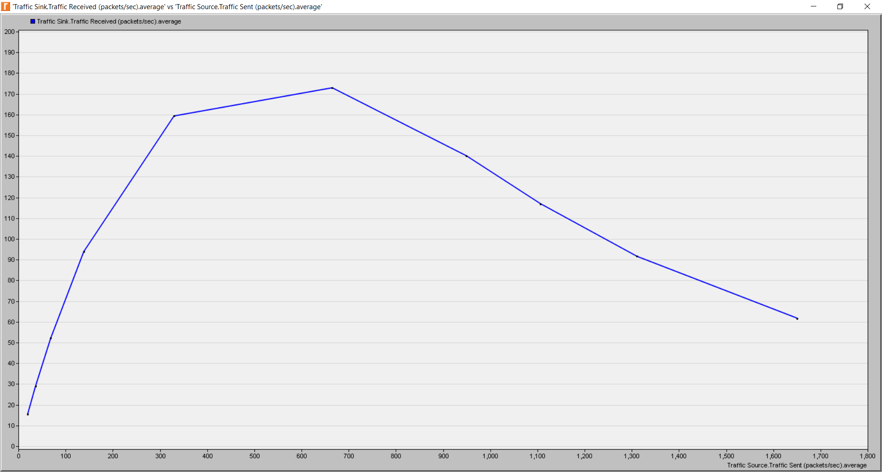

**Q2)** According to the two graphs below Coax_Q2_01 has the best throughput**.** Coax_Q2_0025 has the greatest collision number and the smallest Traffic Received. Thus, Coax_Q2_0025 has the worse throughput. Coax_Q2_005 have larger Traffic Received than Coax_Q2_01. On the other hand, Coax_Q2_01 has less collision number than Coax_Q2_005. Therefore, Coax_Q2_01 has the best throughput.

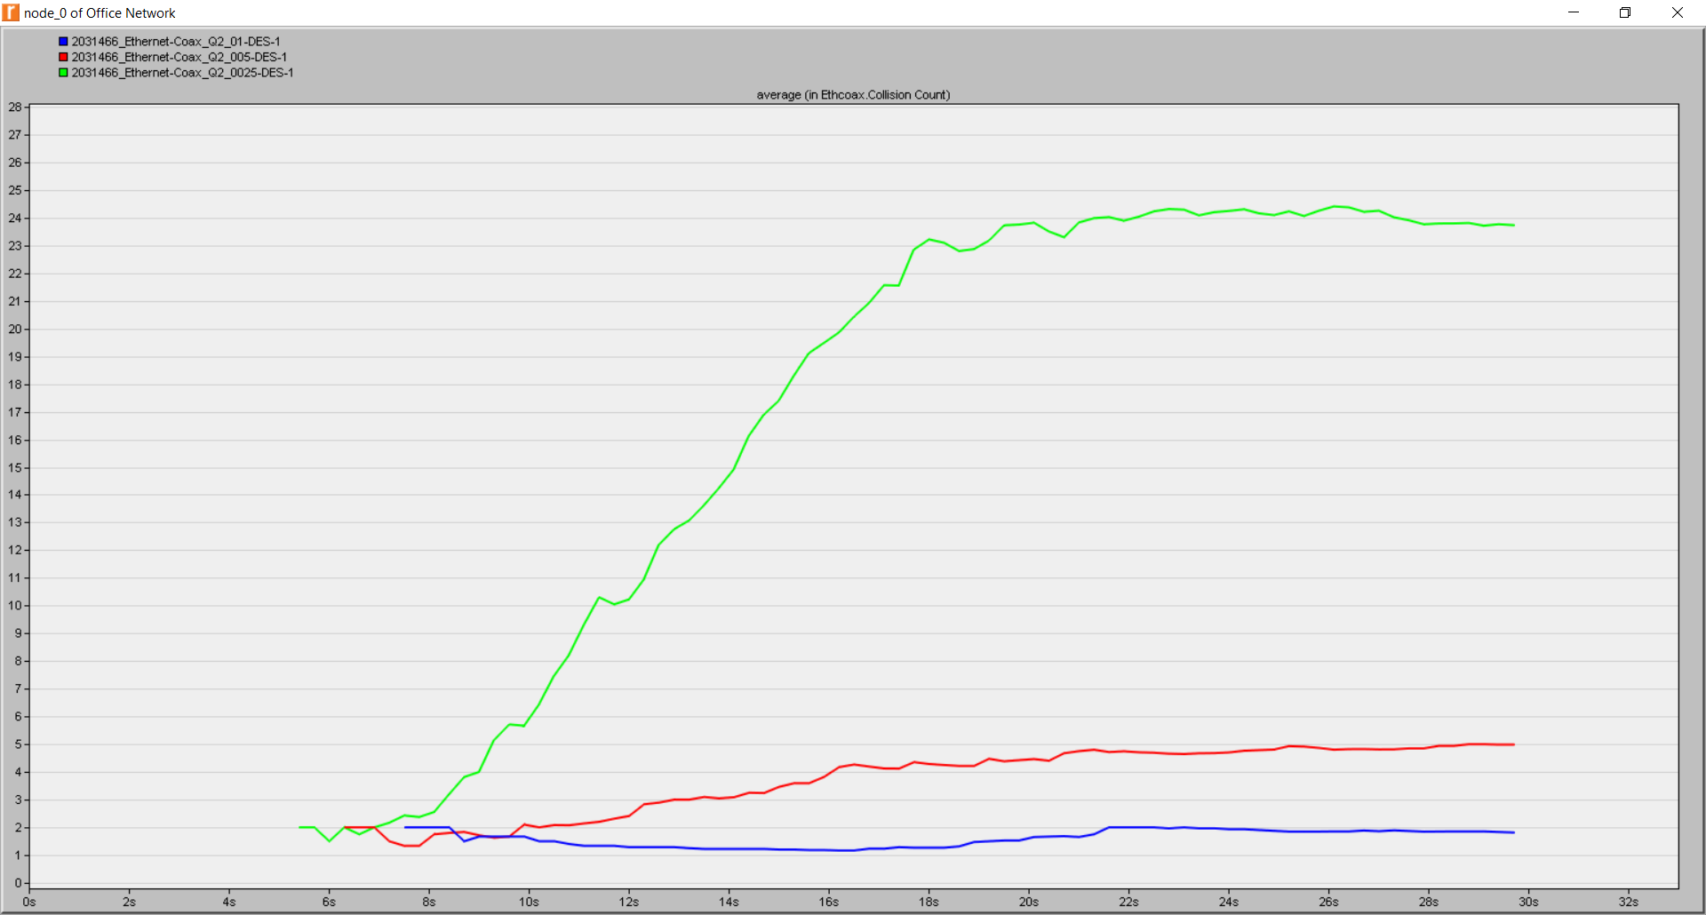

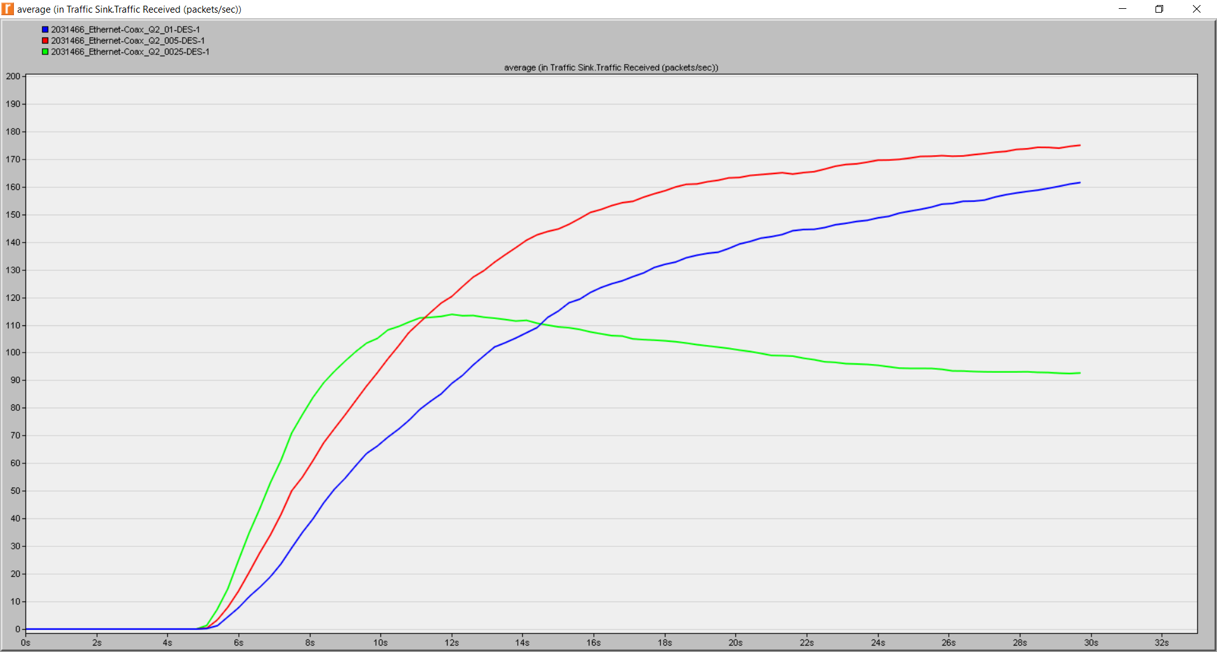

**Q3)** Number of collisions is decreased to its one-third, from 24 to 8. The decrease in the collision amount is already expected because the contention decreases as the number of opponents decreases.

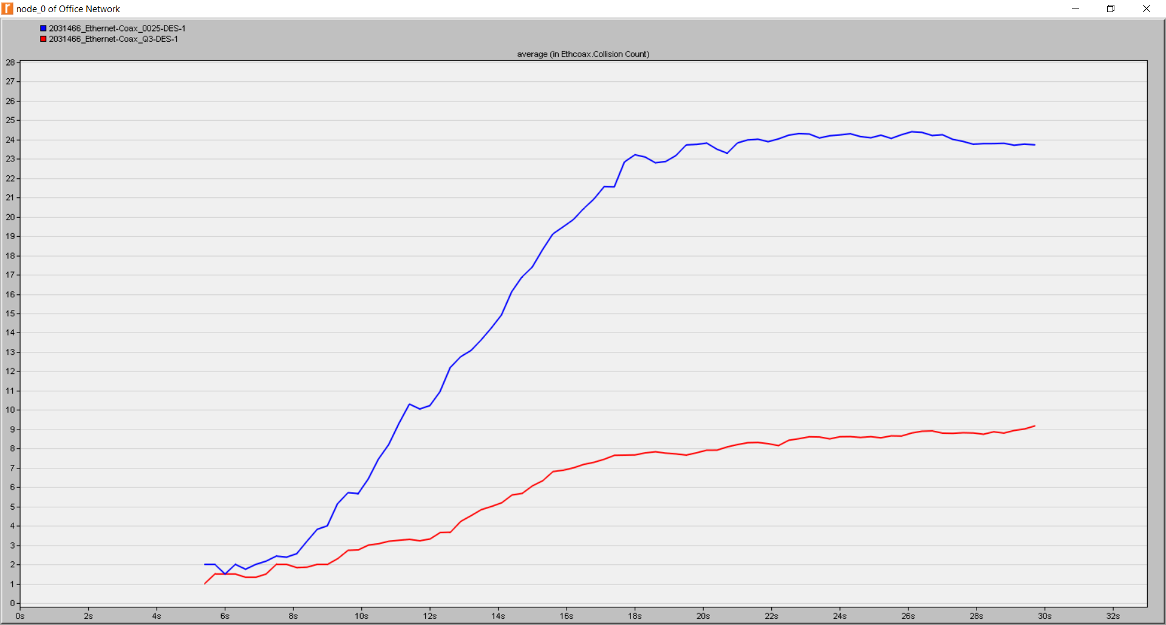

**Q4)** Coax_Q4 has a better throughput and less number of collisions than Coax_0025. Therefore, Coax_Q4 performs better than the Coax_0025.