**Data Structures**   
Prof. Dr. Aybars UĞUR

Course 1 : 02.10.2023

**1. Data Structures Course**

• **Data Structures** is one of the most important courses in **Computer**

|  |  |  |  |  |  |
| --- | --- | --- | --- | --- | --- |
| **Engineering**, | Computer | Science, | and | Software | Engineering |

Departments.

• Data Structures Course is about how data is organized and stored in

memory.

• Data Structures is taken generally after the basic algorithms and

programming courses.

**2. What is Data Structure (DS)**

• *A data structure is a data organization and storage format and*  *is a collection of data values.*

• *Stack*  
• *Queue*  
• *Linked List*  
• *Tree*  
• *Graph*  
• *Hash Table*

• *…*

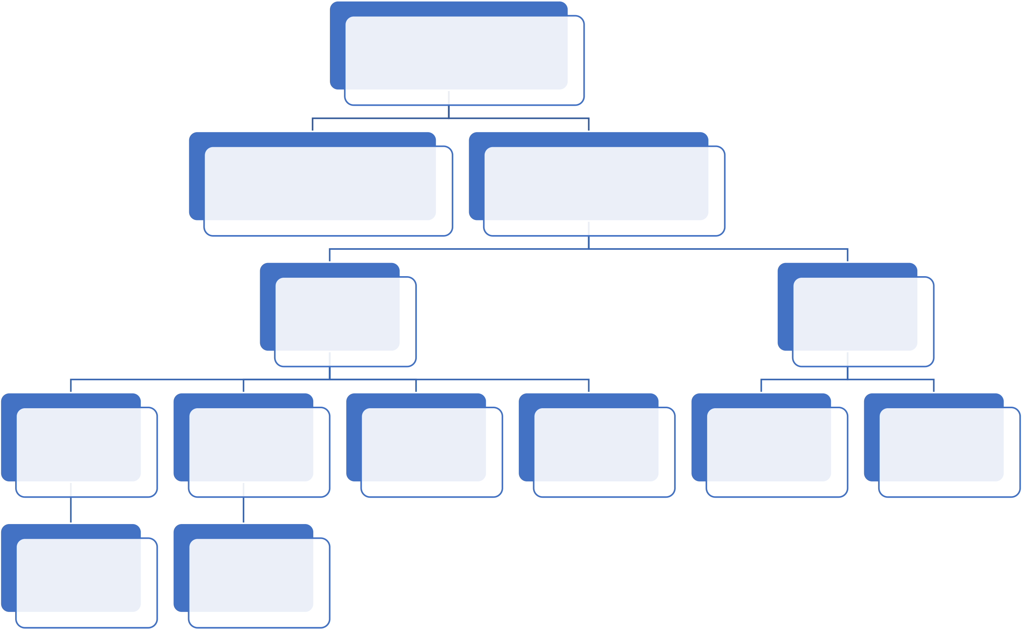

**3. Classification of Data Structures**

Data Structures

|  |  |
| --- | --- |
| Primitive DS  (int, char, float, pointer…) | Non-primitive DS |

Linear Nonlinear

|  |  |  |  |  |  |
| --- | --- | --- | --- | --- | --- |
| Static | Dynamic | **Stack** | **Queue** | **Tree** | **Graph** |

**Array Linked List**

**Primitive Data Types (~Structures)**• Character

• Integer

• Floating Point Number

• Boolean  
…

**Composite Types (Non-primitive Types)**

|  |  |  |  |  |  |  |  |  |  |
| --- | --- | --- | --- | --- | --- | --- | --- | --- | --- |
| • **Array :** Data structure consisting of elements of | | | | | | | | | • **Structure :** Data structure consisting |
| homogeneous | | | data | type. | Elements | | | are | of elements of heterogeneous data |
| identified | | by | indices | (index). | | Dimension: | | | type. |
| number of indices needed to get or set value, etc.  • One-dimensional Arrays ( for example int A[5] ) | | | | | | | | | |  | | --- | | **Age : 73** | | **Name: Charles** | | **Height: 1.78** | | **Title : King** | |
| A | |  |  |  |  |  | | --- | --- | --- | --- | --- | | **5** | **0** | **13** | **-4** | **2** | | | | | | | | |
| • Multidimensional Arrays (for example two-dimensional array is called matrix -> float B[5,3] ) | | | | | | | |  |  |  | | --- | --- | --- | | -1.2 | 13.7 | … | | 60.8 | 49.5 | … | | … | … | … | | … | … | … | | … | … | … | | | |

**Stack and Queue**

|  |  |  |
| --- | --- | --- |
| **Stack DS** | **Queue DS** | |
| • To access the stack items, • Implements FIFO “**First-In-**  the LIFO “**Last-In-First-Out**“ **First-Out**“ principle  principle • Items are removed in the  • Most recent item added is first same order that they are  item to be removed. added.  • Examples:  • Dinner of plates • Examples:  • Ticket queue or line | | |
| • CD Stack |  | • Cashier lines in any store |
| • … | • Access the shared resources (e.g. printer) … |

**Linked List and Tree**

|  |  |
| --- | --- |
| **Linked List** • Linear Data Structure • Dynamic DS • Each node contains data and a pointer / reference to the next node (for singly link list) | Tree  • Nonlinear two-dimensional data structure  • Dynamic DS  • Represents Hierarchical tree structure |

• And also used for searching

• Nodes can be connected to

many children.

**Graphs**   
• Non-linear DS made up of a finite number of nodes or vertices and links that connect the vertices are called edges.

• Application Areas:   
 • Shortest Path Algorithms

• Minimum Spanning Tree

• …