**A Modified Critical Decay Rate Model for Predicting the Critical Energy of Direct Detonation Initiation in Gaseous Mixtures**

Yuen Liua, Remy Mévelb, Qing Xie*c, Zhuyin Ren*c

a School of Aerospace Engineering, Tsinghua University, Beijing 100084, China

b Center for Combustion Energy, Tsinghua University, Beijing 100084, China

c Institute for Aero Engine, Tsinghua University, Beijing 100084, China

Submitted to **Combustion and Flame**

**Article type: Full length**

*Corresponding authors: Qing Xie, Zhuyin Ren

Address: Mengminwei Science and Technology Building, N317, Tsinghua University, Beijing 100084, China

Email Addresses: [xieq2020@mail.tsinghua.edu.cn](mailto:xieq2020@mail.tsinghua.edu.cn), [zhuyinren@tsinghua.edu.cn](mailto:zhuyinren@tsinghua.edu.cn)

**Abstract**

An empirical criterion is proposed to estimate the critical energy of direct initiation of gaseous detonations. That is, the energy input should at least allow the decaying shock speed stay in a specific range below Chapman–Jouguet (CJ) speed during a critical decay time. Inspired by the numerical observations of the re-initiation process in various one-dimensional detonation simulations, it is discovered that a critical shock speed, which indicates when the re-initiation would most likely occur, can be estimated with the Zel'dovich–von Neumann–Döring (ZND) simulations. In the view of a Lagrangian particle, the local relative Mach number of the flow behind the shock must reach unity to allow the re-initiation to develop. Therefore, admitting that the ZND simulations could approximately reflect the evolution of Lagrangian particle behind the shock in the decaying process, the critical shock speed can be identified with the minimum time spent for the local relative Mach number to reach unity in the ZND simulations below CJ speed. The minimum time spent is identified as the critical decay time. Hence this model is referred as the modified critical decay rate (MCDR) model. The critical shock speed is taken as the upper bound of the speed range required by the empirical criterion. The lower bound is chosen as the shock speed when the local relative Mach number reach unity with slower time. The MCDR model is then applied to estimate the potential range of the critical energy with the point-blast theory (PBT). It is found to give improved results for H2-air mixture compared to the original critical decay rate model. For the stable and weakly unstable mixtures of the H2-O2-Ar, C2H2-O2-Ar, and CH4-C2H6-air, the predicted critical energy agrees well with both experimental data and one-dimensional simulations. The MCDR model does not need to solve any type of additional structure equations, nor does it need assumptions on the curvature or unsteadiness of the flow, and it is free of the experimentally determined parameters. It requires only the properly calibrated reaction mechanisms for the given gaseous mixtures.

**Keywords**: direct detonation initiation, ZND model, critical shock speed, critical decay time

1. Introduction

Assessments of the detonation hazard of hydrogen and hydrocarbon mixtures is of supreme importance for developing the safety measures to prevent severe casualty and loss of property during the process of production, transportation and use of fuels in industry and daily life. The critical energy of direct detonation initiation is one of the major characterizations of the conditions whereby detonations can be initiated [1]. The direct detonation initiation refers to the immediate coupling of destructive shock wave and strong energy release of the combustible mixture in the decay of the strong blast induced by powerful ignition sources, such as exploding wire [2], electric spark [3], and laser [4] etc.

The accurate prediction of the critical initiation energy has been a continuous pursuit since the pioneering work of Zel’dovich et al. [5], where they proposed that for successful direct initiation, the time during which the shock speed is above the CJ speed should be at least equal to the induction time. Combining with the self-similar solution for strong blast wave, one can conclude that the critical initiation energy for spherical detonation scales with the cubic induction time or equivalently to the cubic induction-zone length. Verifications of such qualitative relation can be found from recent experiments [6] and numerical simulations [7]. Inspired by the initiation theory put forward by Zel'dovich et al., numerous efforts have been made to formulate quantitative models to predict the critical initiation energy, such as the work done model [3], piston model [8], and the surface energy model [9], which are developed notably by Lee and coworkers [10], and also the multipoint initiation [11] and diffraction re-initiation [12] models, which are proposed by Vasil’ev and his colleagues [13]. All of these models still require some more easily measured dynamic parameters [14] from experiments, such as the cell size from the trajectories of triple points of the multi-dimensional detonation waves, or the critical tube diameter from the experiments where the planar detonation wave emerges from the tube to unconfined space. The feasibility of these semi-empirical models have been thoroughly discussed in a recent review [15].

Nevertheless, a theory, without empirical parameters, that provides more detailed insights into the physio-chemical process of the direct detonation initiation and gives more reliable prediction of the critical energy in a wider range would still be desired, especially when experiments are difficult to carry out and to save the cost for detonation hazard assessment. The first attempt at such theory was made by He and Clavin [16]. They argue that, in the moving frame attached to the leading shock, the unsteady terms are negligible compared to the curvature terms, if the characteristic evolution time of the curved detonation are much longer than the instant reaction time. Using a square-wave model of the detonation structure, marginal quasi-steady solutions that show C-shaped form can be obtained in the $D$- $R_{s}$ phase plane of shock speed ($D$) and shock radius ($R_{s}$). It is further argued that any decaying blast, whose trajectory intersects with the upper branch of the C-shaped curve in the phase plane, will be attracted by the marginal solutions and develop into a self-sustained detonation, indicating a successful direct initiation. The critical shock radius and the critical shock speed that is below CJ speed can be identified as the upper turning point of the C-shaped curve. And these critical parameters can be used with the self-similar solutions of point-blast waves [17-19] to compute the critical initiation energy. He and Clavin’s theory is referred to as the critical curvature model. However, such model tends to over predict the critical energies by orders of magnitude compared to the experimental results. As pointed out by Mazaheri [20] and Lee and Higgins [10], unsteady effects can be significant in the direct initiation process. Eckett et al. [21] demonstrated the importance of unsteadiness using the one-dimensional detonation simulations. Consequently, assuming the unsteady terms to be constant and setting them equal to their initial values immediately after the leading shock, a temperature-reaction-zone structure equation can be deduced to describe the state evolution of Lagrangian particles. Analytic induction time can be computed through standard large-activation-energy asymptotic expansion. And a characteristic shock decay time can be correlated with the induction time to form a dimensionless initiation parameter, that indicates ‘explosion’ of the solution when the parameter reaches unity. Such model is referred to as the critical decay rate (CDR) model. However, a critical shock speed has to be carefully selected to compute the characteristic shock decay time. Then, He and Clavin’s expression for critical shock speed [16] is used, in combine with the point-blast solution [17-19], to compute the critical initiation energy, which yields more accurate agreement with experiments within one order of magnitude. Furthermore, a general, rational theory of the self-sustained detonation waves was developed by Kasimov and Stewart [22,23]. Such theory is an unsteady generalization of the detonation shock dynamics proposed by Stewart and coworkers [24,25]. With the assumptions of small curvature and slow evolution, a functional relationship between the shock speed ($D$), shock acceleration ($\dot{D}$) and curvature ($κ$) can be established utilizing the Riemann invariant on forward-facing characteristics and the conditions for sonic locus [26] in the rear of reaction zone. An ignition separatrix on the $D$- $R_{s}$ phase plane, that separate the initial states that lead to successful ignition from those that lead to failure, can thus be obtained by solving the second order ordinary differential equation defined by the $\dot{D}$- $D$- $κ$ relation. The critical states are identified on the ignition separatrix where the shock speed equals to CJ speed. The computed critical energy agrees very well with experimental data even with one-step chemical kinetics. In addition, a $\dot{D}$- $D$- $κ$ relation that is based on the detailed chemical kinetics is also developed by Soury and Mazaheri [27].

To sum up, the theoretical prediction of the critical initiation energy requires some reduced mathematical expressions for the structure of the detonation wave. From these structure equations, the critical parameters, such as the critical shock radius and critical shock speed, can be computed to indicate a representative point where the successful initiation is expected. Additionally, these critical parameters need to be combined with the self-similar solution of the decaying process of the initiation blast to give a reasonable estimation of the critical initiation energy. However, as already pointed out by Ng and Lee [7], current available structure equations are limited to describing the quasi-steady period [28] as the initiation blast decays below CJ speed, but they are incapable of capturing the rapid shock amplification process being governed by the mechanism of shock wave amplification by coherent energy release (SWACER) [29], which is featured with the formation of a strong pressure pulse catching up with the leading shock very rapidly as observed in numerical simulations [10]. The occurrence of SWACER is clearly not dependent on the curvature effect since it is also responsible for the planar detonation initiation, and it is a highly transient process from the end of the quasi-steady period. The re-initiation of the sub-CJ blast relies on enough energy input to allow the blast decay slowly and ensure sufficiently long duration of the SWACER mechanism [7].

In this work, a critical sub-CJ speed, as the single parameter to indicate when the SWACER would mostly likely to occur, is identified using the ZND simulations with detailed chemical kinetics. Essentially, such critical speed corresponds to the minimum time spent for the local relative Mach number to reach unity in the sub-CJ ZND simulations. And this time spent is identified as the minimum time duration, for the blast to decay from the critical speed to an extinction speed, to allow successful direct detonation initiation.

The remainder of the paper is organized as follows. In Section 2, the numerical methods for detonations simulations are given briefly. And the ZND model is revisited in the Lagrangian view. Then the idea of how to estimate the potential range of the critical initiation energy is introduced. In Section 3, the significance of the sub-CJ ZND simulation is demonstrated by comparing the evolution of the Lagrangian particles from both the ZND simulations and the one-dimensional simulations. Then, computations of the critical parameters are elaborated. Section 4 contains the detailed discussion of the predicted critical initiation energy in various gaseous mixtures with the comparisons against both the experiments and the one-dimensional simulations. Conclusions are in Section 5.

1. Methodology

2.1 Numerical methods for one-dimensional simulations

Unified one-dimensional Euler equations in planar, cylindrical, spherical coordinates

$$\left\{\begin{aligned}\frac{∂ρ}{∂t}+\frac{∂\left(r^{m}ρu\right)}{r^{m}∂r}&=0 \\ \frac{∂\left(ρu\right)}{∂t}+\frac{∂\left(r^{m}ρu^{2}\right)}{r^{m}∂r}&=-\frac{∂p}{∂r} \\ \frac{∂\left(ρe_{t}\right)}{∂t}+\frac{∂\left(r^{m}ρuh_{t}\right)}{r^{m}∂r}&=0 \\ \frac{∂ρ_{k}}{∂t}+\frac{∂\left(r^{m}ρ_{k}u\right)}{r^{m}∂r}&=M_{k}ω_{k}\end{aligned}\right.$$

Brief introduction of spatial and temporal discretization

Brief introduction of Adaptive Mesh Refinement technique

Detailed introduction of how the detonation simulations are initialized

2.2 A revisit of the ZND model in Lagrangian view

First give the Lagrangian view of Euler equations

$$\left\{\begin{aligned}\frac{Dp}{Dt}&=-γp∙S+Ω_{p} \\ \frac{Dρ_{k}}{Dt}&=-ρ_{k}∙S+ρΩ_{k} \\ ρ\frac{Du}{Dt}&=-∂_{r}p \\ \frac{Dr}{Dt}&=u\end{aligned}\right.;\left\{\begin{aligned}ρc_{v}\frac{DT}{Dt}&=-p∙S-Ω_{T} \\ \frac{Dρ}{Dt}&=-ρ∙S \\ \frac{DY_{k}}{Dt}&=Ω_{k}\end{aligned}\right.$$

$$\left\{\begin{aligned}Ω_{p}&=\sum_{k}{\left[\left(h_{k}-γe_{k}\right)∙M_{k}ω_{k}\right]} \\ Ω_{T}&=\sum_{k}{\left(e_{k}∙M_{k}ω_{k}\right)} \\ ρΩ_{k}&=M_{k}ω_{k}\end{aligned}\right.;\left\{\begin{aligned}S&≡∂_{r}u+m\frac{u}{r} \\ ∂_{r}u&≡\frac{∂u}{∂r} \\ ∂_{r}p&≡\frac{∂p}{∂r}\end{aligned}\right.$$

Then derive the ZND equations using the travelling wave condition and Rankine-Hugoniot conditions

Steady detonation waves are travelling with the characteristic speed $σ$.

Any observable $ϕ$ satisfy the equation below

$$\frac{∂ϕ}{∂t}+σ\frac{∂ϕ}{∂x}=0$$

So we have

$$\frac{Dϕ}{Dt}=\left(u-σ\right)\frac{∂ϕ}{∂x}$$

For any functional $ψ$ and $Ψ$ that satisfy

$$\frac{∂ψ}{∂t}+\frac{∂Ψ}{∂x}=0$$

We have

$$\begin{aligned}\frac{DΨ}{Dt}&=\left(u-σ\right)∙\frac{∂Ψ}{∂x}=-\left(u-σ\right)∙\frac{∂ψ}{∂t}=-\left(u-σ\right)∙\left(\frac{Dψ}{Dt}-u∙\frac{∂ψ}{∂x}\right) \\ &=σ\frac{Dψ}{Dt}-u∙\left[\frac{Dψ}{Dt}-（u-σ）\frac{∂ψ}{∂x}\right] \\ &=σ\frac{Dψ}{Dt}\end{aligned}$$

In planar coordinates, we have

$$\left\{\begin{aligned}\frac{D\left(ρu\right)}{Dt}&=σ∙\frac{D\left(ρ\right)}{Dt} \\ \frac{D\left(ρu^{2}+p\right)}{Dt}&=σ∙\frac{D\left(ρu\right)}{Dt} \\ \frac{D\left(ρuh_{t}\right)}{Dt}&=σ∙\frac{D\left(ρe_{t}\right)}{Dt}\end{aligned}\right.$$

It can be verified that only two of them are independent

Using the first two relations, we have the closure of the velocity divergence and pressure gradient

$$\left\{\begin{aligned}∂_{r}u&=\frac{Ω_{p}}{γp-ρ{\left(u-σ\right)}^{2}} \\ ∂_{r}p&=-ρ\left(u-σ\right)\frac{Ω_{p}}{γp-ρ{\left(u-σ\right)}^{2}}\end{aligned}\right.$$

Then we have the ZND equations in Lagrangian view

$$\left\{\begin{aligned}\frac{Dp}{Dt}&=Ω_{p}∙\frac{{\left(\frac{u-σ}{s}\right)}^{2}}{{\left(\frac{u-σ}{s}\right)}^{2}-1} \\ \frac{Dρ_{k}}{Dt}&=-\frac{ρ_{k}}{γp}∙\left[\frac{Ω_{p}}{1-{\left(\frac{u-σ}{s}\right)}^{2}}\right]+M_{k}ω_{k} \\ \frac{Du}{Dt}&=\frac{\left(u-σ\right)}{γp}∙\left[\frac{Ω_{p}}{1-{\left(\frac{u-σ}{s}\right)}^{2}}\right] \\ \frac{Dr}{Dt}&=u\end{aligned}\right.;\left\{\begin{aligned}ρc_{v}\frac{DT}{Dt}&=-\frac{1}{γ}∙\left[\frac{Ω_{p}}{1-{\left(\frac{u-σ}{s}\right)}^{2}}\right]-\sum_{k}{\left(e_{k}∙M_{k}ω_{k}\right)} \\ \frac{Dρ}{Dt}&=-\frac{1}{s^{2}}∙\left[\frac{Ω_{p}}{1-{\left(\frac{u-σ}{s}\right)}^{2}}\right] \\ ρ\frac{DY_{k}}{Dt}&={M_{k}ω}_{k}\end{aligned}\right.$$

$$s^{2}=\frac{γp}{ρ};Ma^{2}={\left(\frac{u-σ}{s}\right)}^{2}$$

Make some comments compared to the original ZND equations

Emphasize that ZND model is a constant wave speed model.

Evolution of Lagrangian particles in one-dimensional simulations will be analyzed in the view of dynamic wave speed

2.3 The modified critical decay rate model

First, briefly introduce the point-blast theory. Spherically:

$$R={\left(\frac{E_{s}}{A_{2}ρ_{0}}\right)}^{\frac{1}{5}}t^{\frac{2}{5}}$$

$$U=\frac{dR}{dt}=\frac{2}{5}{\left(\frac{E_{s}}{A_{2}ρ_{0}}\right)}^{\frac{1}{5}}∙t^{-\frac{3}{5}}$$

$$A=0.31246{\left(γ-1\right)}^{-1.1409-0.11735\log_{10}\left(γ-1\right)}$$

Then present the modified critical decay rate model

An empirical criterion is proposed to estimate the critical energy of direct initiation of gaseous detonations. That is, the energy input should at least allow the decaying shock speed stay in a specific range below Chapman–Jouguet (CJ) speed during a critical decay time.

$$τ_{cr}={\left(\frac{5}{2}\right)}^{-\frac{5}{3}}{\left(\frac{E_{cr}}{Aρ_{0}}\right)}^{\frac{1}{3}}∙\left(U_{ex}^{-\frac{5}{3}}-U_{cr}^{-\frac{5}{3}}\right)$$

$$E_{cr}=Aρ_{0}∙{\left[\frac{{\left(\frac{5}{2}\right)}^{\frac{5}{3}}τ_{cr}}{U_{ex}^{-\frac{5}{3}}-U_{cr}^{-\frac{5}{3}}}\right]}^{3}$$

Determination of $U_{cr}$, $U_{ex}$ and $τ_{cr}$ will be elaborated in the following section

1. Estimating critical parameters with ZND simulations

3.1 The significance of ZND simulations below CJ speed

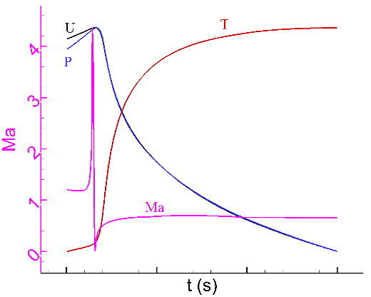 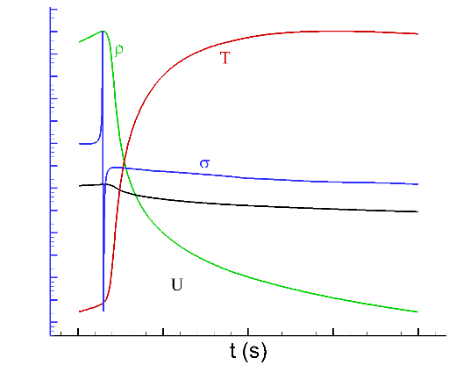

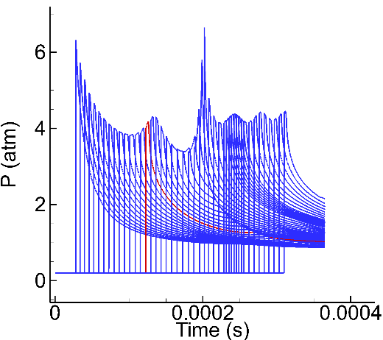

Use the dynamic wave speed $σ\left(t\right)$ and the ZND model to simulate the evolution of Lagrangian particles and compare with the actual observations.

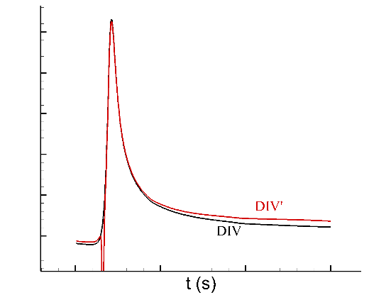 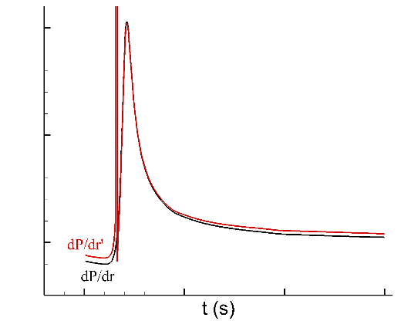

Prove that the closure of velocity divergence and pressure gradient is sound.

And the ZND model can actually partially describe the particle evolution when D<Dcj

Refer to the SWACER (Shock Wave Amplification by Coherent Energy Release) mechanism

And emphasize that the ZND model have the potential to be extended to a dynamic wave speed model that better describe the evolution of particles

3.2 The critical shock speed and the critical decay time

First, show the Ma vs. time for ZND simulations below CJ speed. And do some analysis about the features when D>Dcj, D=Dcj and D<Dcj

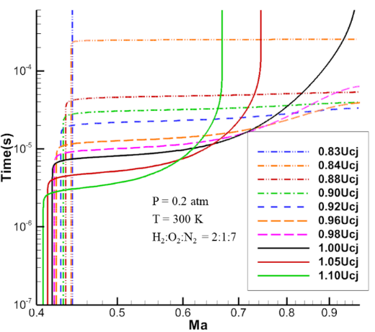

Then explain how to obtain $U_{cj}$, $U_{ex}$, and $τ_{cr}$ with ZND simulations. Show D vs. $τ$ and use the data on the lower branch

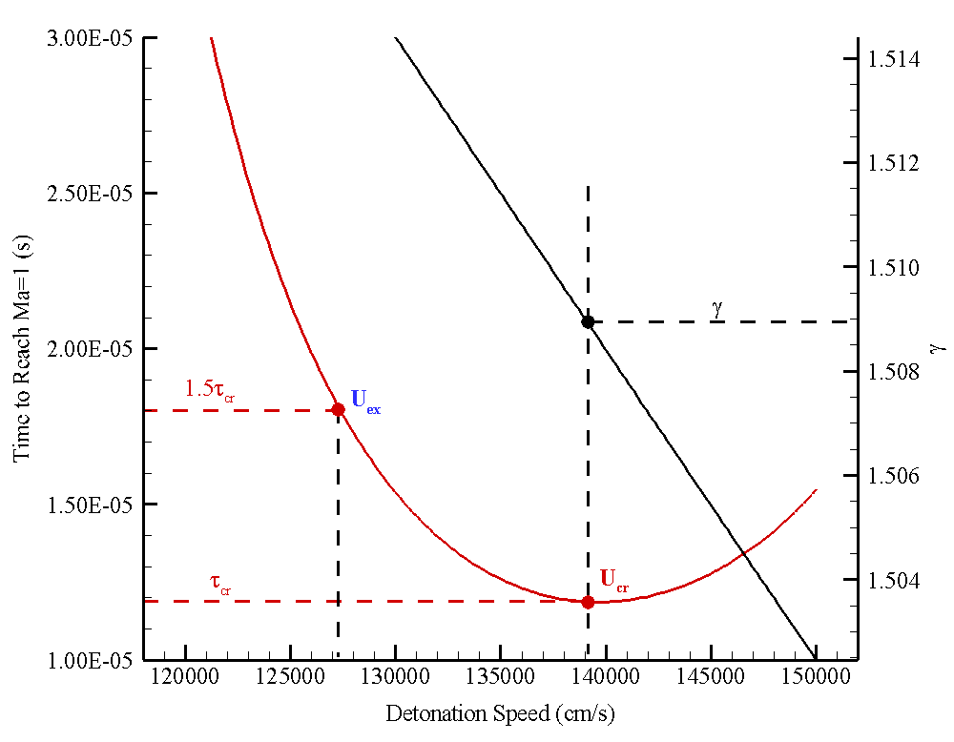

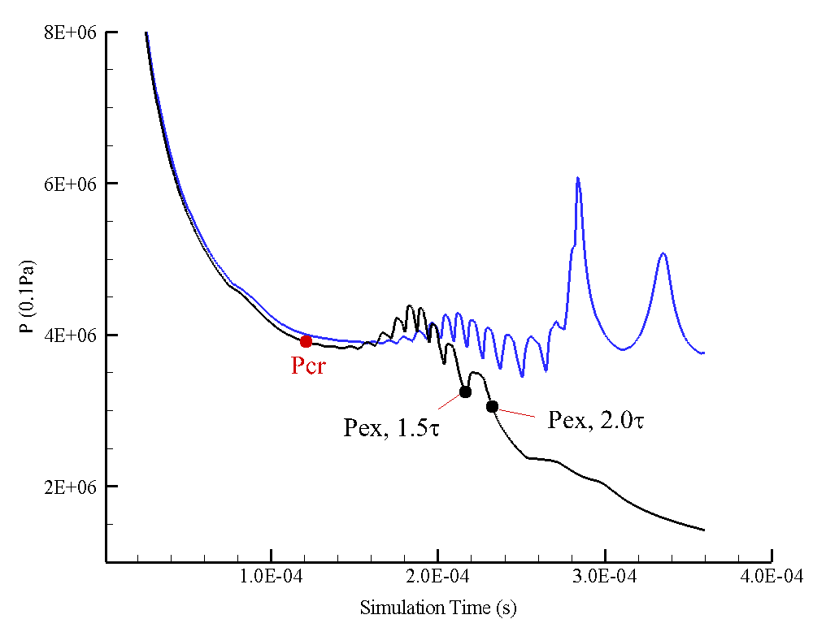

Compare the shock pressure $p_{cr}$ (with the shock speed $U_{cr}$), $p_{ex}$ ( with the shock speed $U_{ex}$) with the one-dimensional simulations.

Show that the $p_{cr}$ determine by ZND simulations well captures the critical point when the re-initiation occurs. And as long as $p<p_{ex}$ the direct initiation fails

1. Estimating the critical initiation energy

4.1 Critical energy of H2-O2-Ar, H2-O2 and H2-air mixtures

H2-O2-Ar

Burke

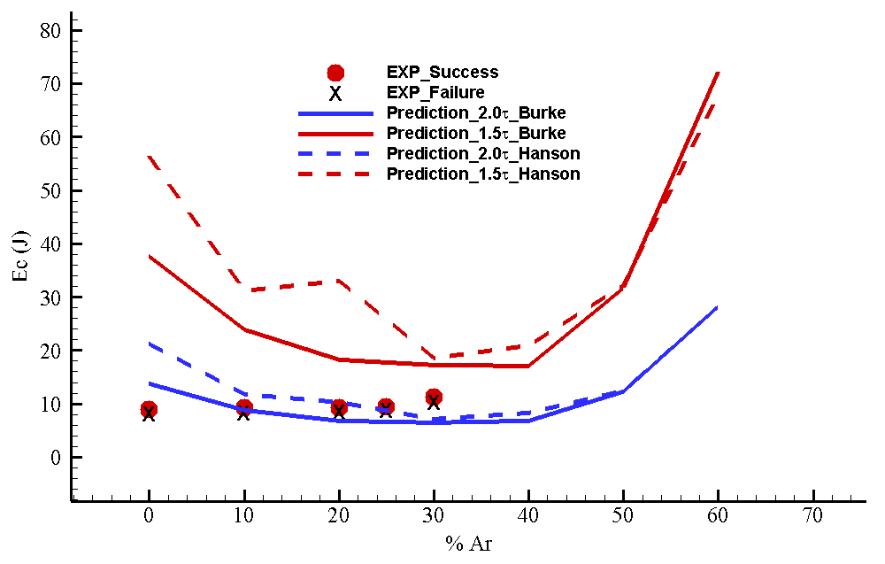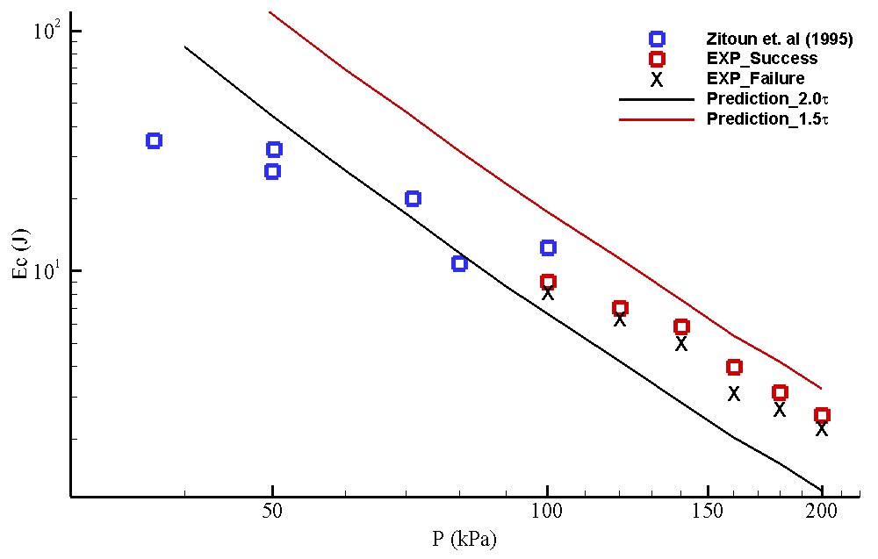

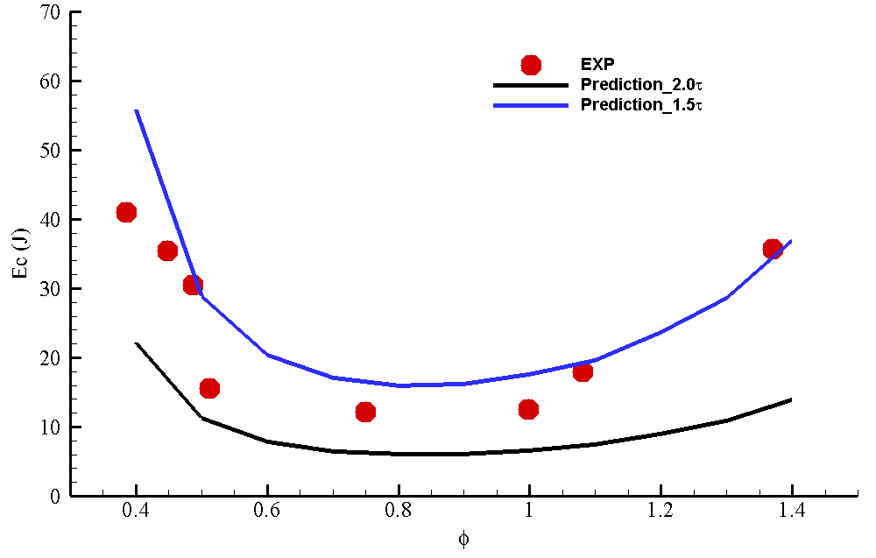

H2-O2

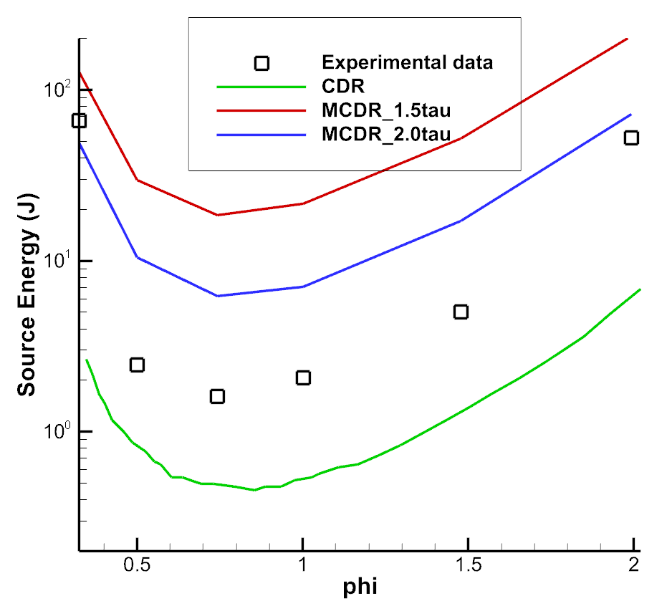

H2-air

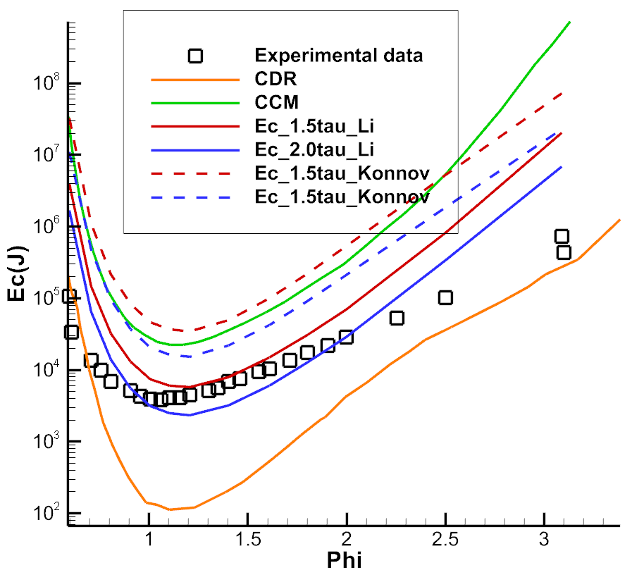

4.2 Critical energy of CH4-O2-N2 and CH4-C2H6-air mixtures

CH4-O2-N2

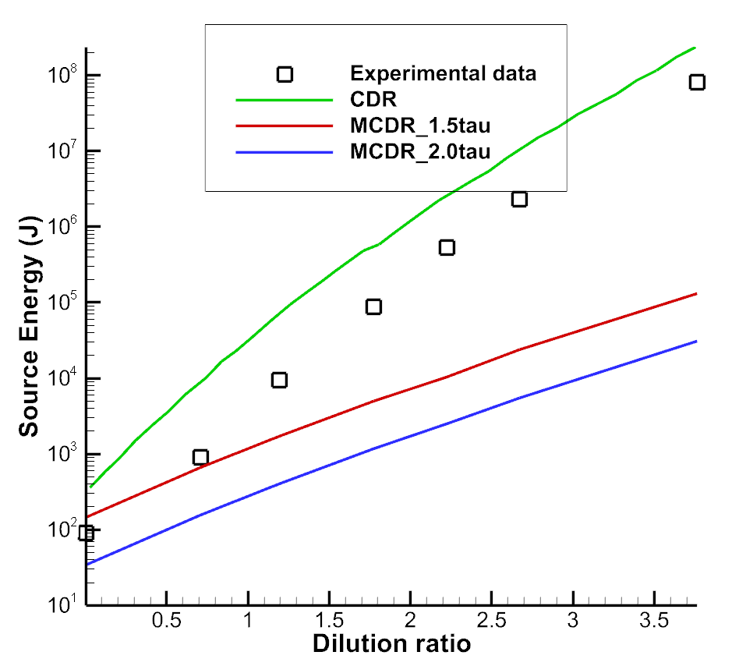

CH4-C2H6-air

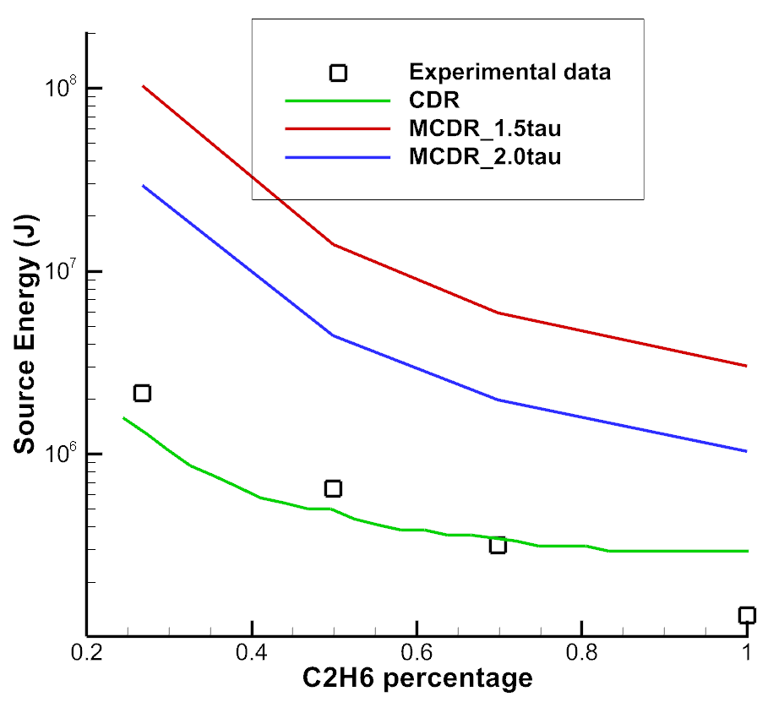

4.3 Critical energy of C2H2-O2-Ar mixtures

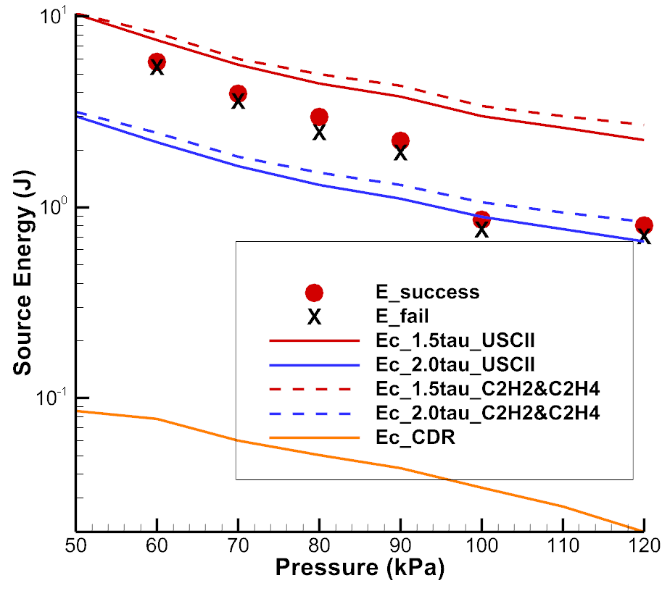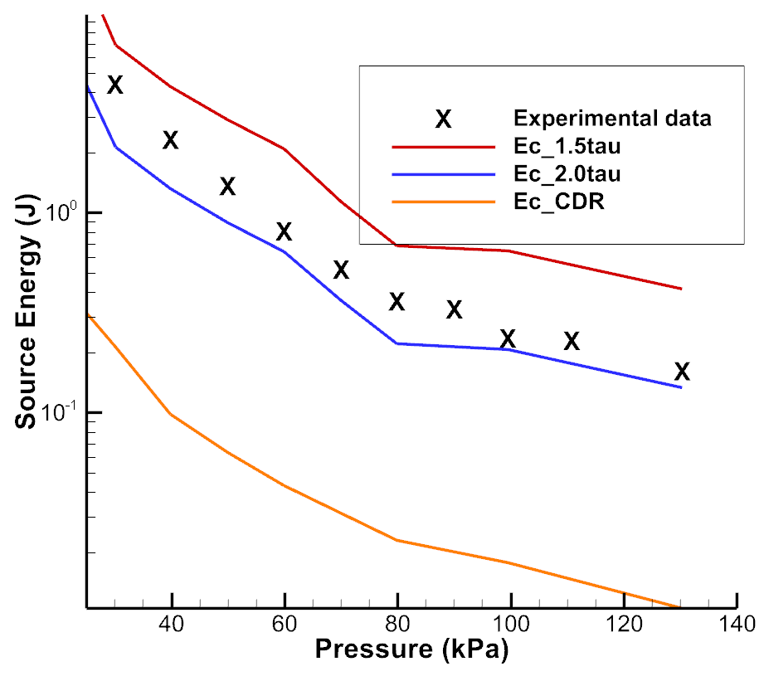

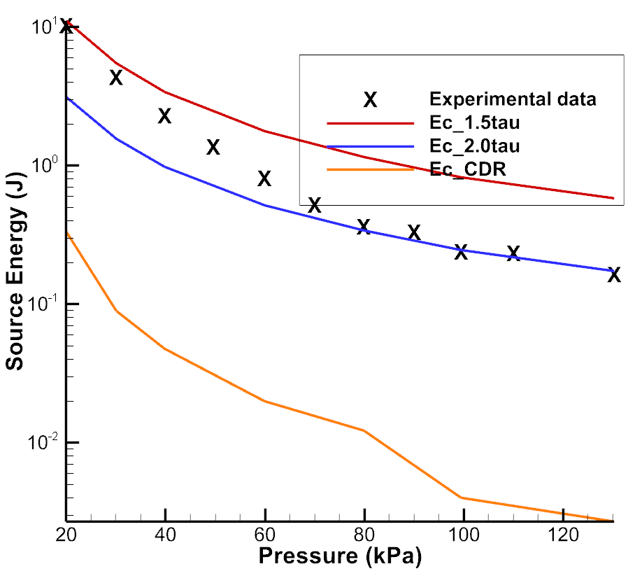

4.4 Discussions

1. Conclusions

**Acknowledgement**

The work is supported by National Natural Science Foundation of China No. XXXXX.

**References**

1. J.H.S Lee. Initiation of gaseous detonation. Ann. Rev. Phys. Chem. 28 (1977) 75–104.
2. S.M. Kogarko, V.V. Adushkin, A.G. Lyamin. Investigation of spherical detonation of gas mixtures. Combust. Explos. Shock Waves 1 (1965) 22-34.
3. J.H.S. Lee, H. Matsui. A comparison of the critical energies for direct initiation of spherical detonations in acetylene-oxygen mixtures. Combust.Flame 28 (1977) 61-66.
4. V.F. Klimkin, R.I. Soloukhin, P. Wolansky. Initial stages of a spherical detonation directly initiated by a laser spark. Combust. Flame 21 (1973) 111-117.
5. Y.B. Zel'dovich, S.M. Kogarko, N.N. Simonov. An experimental investigation of spherical detonation in gases. Sov. Phys. Tech. Phys. 1 (1957) 1689-1713.
6. B. Zhang, V. Kamenskihs, H.D. Ng, J.H.S. Lee. Direct blast initiation of spherical gaseous detonations in highly argon diluted mixtures. Proc. Combust. Inst. 33 (2011) 2265-2271.
7. H.D. Ng, J.H.S. Lee. Direct initiation of detonation with a multi-step reaction scheme. J. Fluid Mech. 476 (2003) 179-211.
8. H. Matsui, J.H.S. Lee. On the measure of the relative detonation hazards of gaseous fuel–oxygen and air mixtures. 17th Symp. Int. Combust. (1979) 1269–80.
9. J.H.S. Lee, R. Knystautas, C.M. Guirao. The link between cell size, critical tube diameter, initiation energy and detonability limits. Fuel-air explosions. Waterloo: University of Waterloo Press (1982).
10. J. H. S. Lee, A. J. Higgins. Comments on criteria for direct initiation of detonation. Phil. Trans. R. Soc. Lond. A 357 (1999) 3503-3521.
11. A.A. Vasil'ev, Y.A. Nikolaev, V.Y. Ul'yanitskii. Critical energy of initiation of a multifront detonation. Combust. Explos. Shock Waves 15 (1979) 768-775.
12. A.A. Vasil’ev. Diffraction estimate of the critical energy for initiation of gaseous detonation. Combust. Explos. Shock Waves 34 (1998) 433–437.
13. A.A. Vasil’ev, V.V. Mitrofanov, M.E. Topchiyan. Detonation waves in gases. Combust. Explos. Shock Waves 23 (1987) 605-623.
14. J.H.S. Lee. Dynamic parameters of gaseous detonations. A. Rev. Fluid Mech. 16 (1984) 311–336.
15. B. Zhang, C. Bai. Methods to predict the critical energy of direct detonation initiation in gaseous hydrocarbon fuels–an overview. Fuel 117 (2014) 294-308.
16. L. He, P. Clavin. On the direct initiation of gaseous detonation by an energy source. J. Fluid Mech. 277 (1994) 227–248.
17. G.I. Taylor. The formation of a blast wave by a very intense explosion I. Theoretical discussion. Proc. R. Soc. Lond. A 201 (1950) 159-174.
18. L. I. Sedov. Similarity and dimensional methods in mechanics. 4th edn. Academic (1959).
19. V.P. Korobeinikov. Problems of point-blast theory. American Institute of Physics (1991).
20. K. Mazaheri. Mechanism of the onset of detonation in blast initiation, PhD thesis. McGill University, Canada (1997).
21. C.A. Eckett, J.J. Quirk, J.E. Shepherd. The role of unsteadiness in direct initiation of gaseous detonations. J. Fluid Mech. 421 (2000) 147-183.
22. A.R. Kasimov, D.S. Stewart. Theory of direct initiation of gaseous detonations and comparison with experiment. Theoretical and Applied Mechanics (UIUC) Report No. 1043. (2004).
23. A.R. Kasimov, D.S Stewart. Asymptotic theory of evolution and failure of self-sustained detonations. J. Fluid Mech. 525 (2005) 161-192.
24. D.S. Stewart, J.B. Bdzil. The shock dynamics of stable multi-dimensional detonation. Combust. Flame 72 (1988) 311–323.
25. J. Yao, D.S. Stewart. On the dynamics of multi-dimensional detonation. J. Fluid Mech. 309 (1996) 225–275.
26. D.S. Stewart, A.R Kasimov. Theory of detonation with an embedded sonic locus. SIAM J. Applied Math. 66 (2005) 384-407.
27. H. Soury, K. Mazaheri. Utilizing unsteady curved detonation analysis and detailed kinetics to study the direct initiation of detonation in H2-O2 and H2-Air mixtures. Int. J. Hydrogen Energy 34 (2009) 9847–9856.
28. D.H. Edwards, G. Hooper, J.M. Morgan, G.O. Thomas. The quasi-steady regime in critically initiated detonation waves. J. Phys. D11 (1978) 2103–2117.
29. J.H. Lee, R. Knystautas, N. Yoshikawa. Photochemical initiation of gaseous detonations. Acta Astronaut. 5 (1978) 971–982.