**P1 (in “fashion_dnn.py”)**

1. Import the dataset using Keras API.
2. Brief exploration of the dataset:

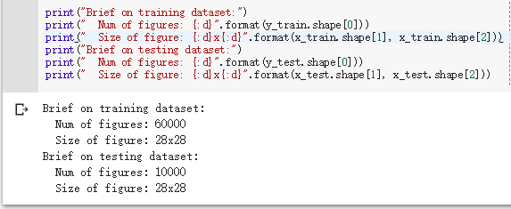

1. Model summary output:

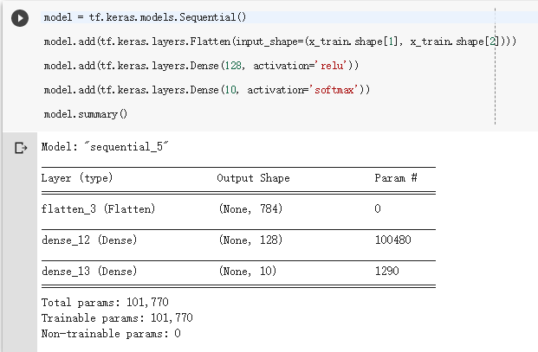

1. Using Adam optimizer with learning rate set to 0.001;

Take sparse categorical cross-entropy as loss function;

Take sparse categorical accuracy as metric.

1. Training using 16 epochs and batch size set to 128.

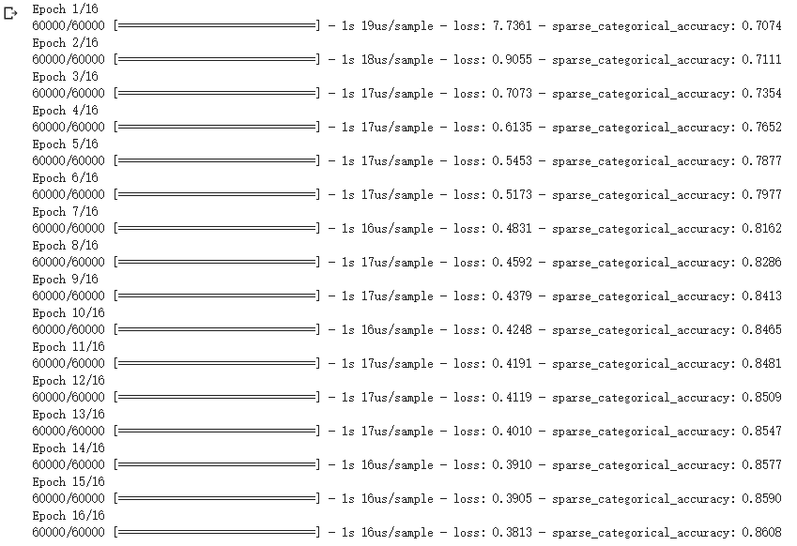

1. Model evaluation:



Take 10 random predictions from testing dataset:

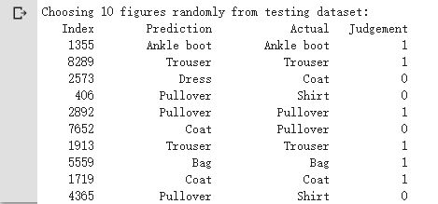

**P2 (in “fashion_cnn.py”)**

1. Import the dataset using Keras API.
2. Brief exploration of the dataset:

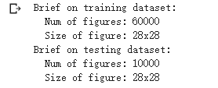

Add color dimension in each image using Numpy:



1. Summary of model:

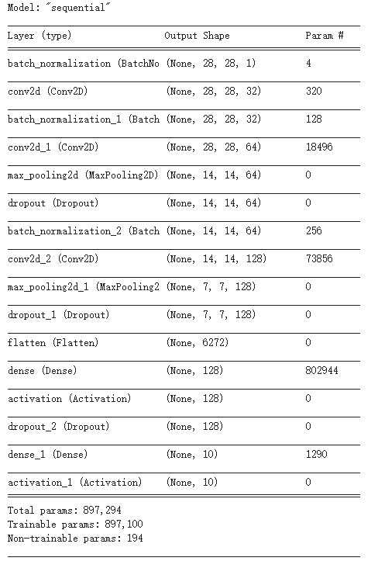

1. Using Adam optimizer with learning rate set to 0.001;

Take sparse categorical cross-entropy as loss function;

Take sparse categorical accuracy as metric.

1. Training with 16 epochs and batch size set to 128.

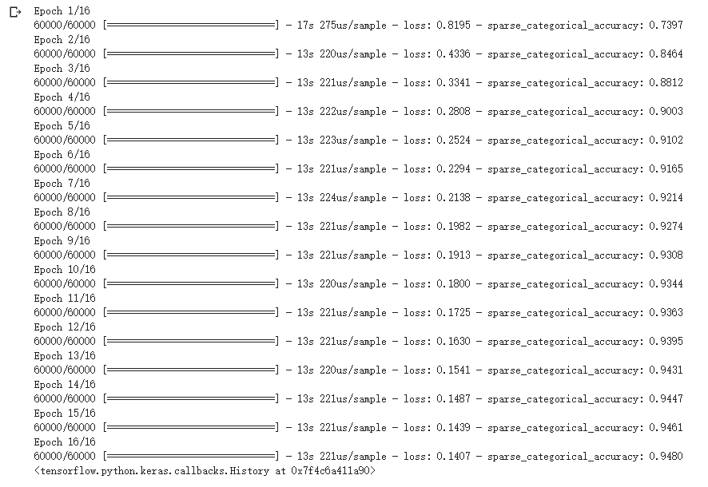

1. Model evaluation:



Take 10 random predictions from testing dataset:

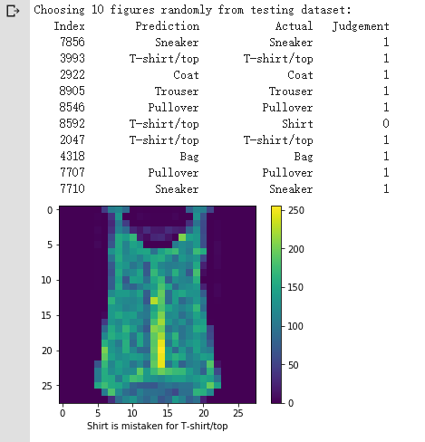

1. Error analysis

Using Confusion Matrix to find details of errors.

Suggestions:

* Using regularization
* Reduce some parameters