**Q1**:

Find equivalent digital plant transfer functions for the following analog plant transfer functions:

Verify the accuracy of approximation with sample time of 0.1s, 0.01s, and 0.001s, respectively, through comparing frequency responses.

**A1**: Using the Tustin approximation and with the help of MATLAB, the equivalent digital plant transfer functions are calculated as follows:

|  |  |  |  |
| --- | --- | --- | --- |
|  | T=0.1 | T=0.01 | T=0.001 |
|  |  |  |  |
|  |  |  |  |
|  |  |  |  |

The frequency response are plotted separately as follows, where triangle is 0.1s, circle is 0.01s, and star is 0.001s.

* For :

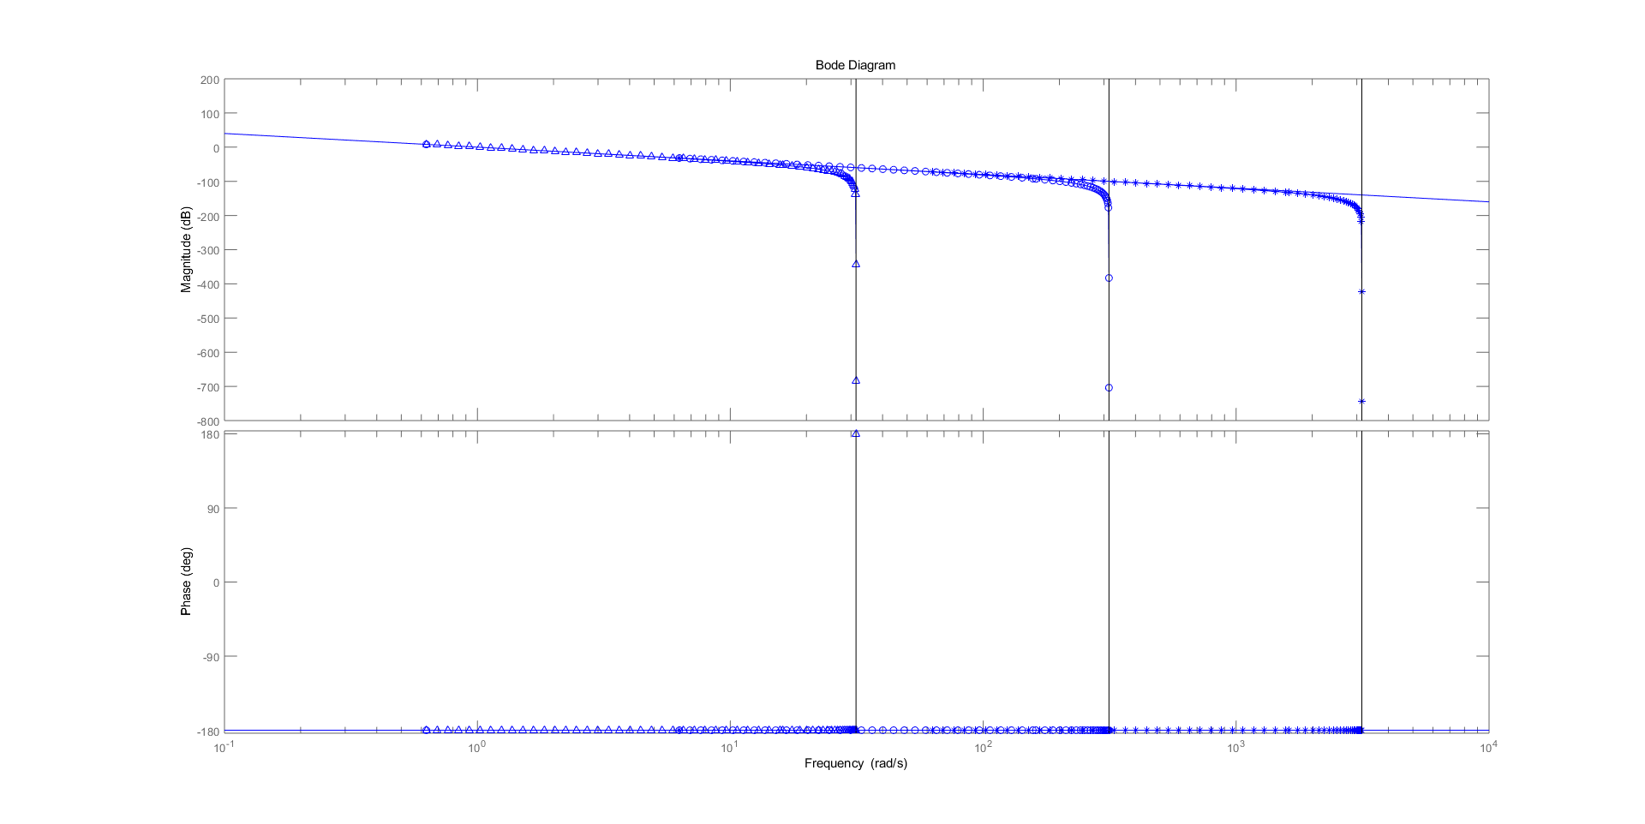

* For :

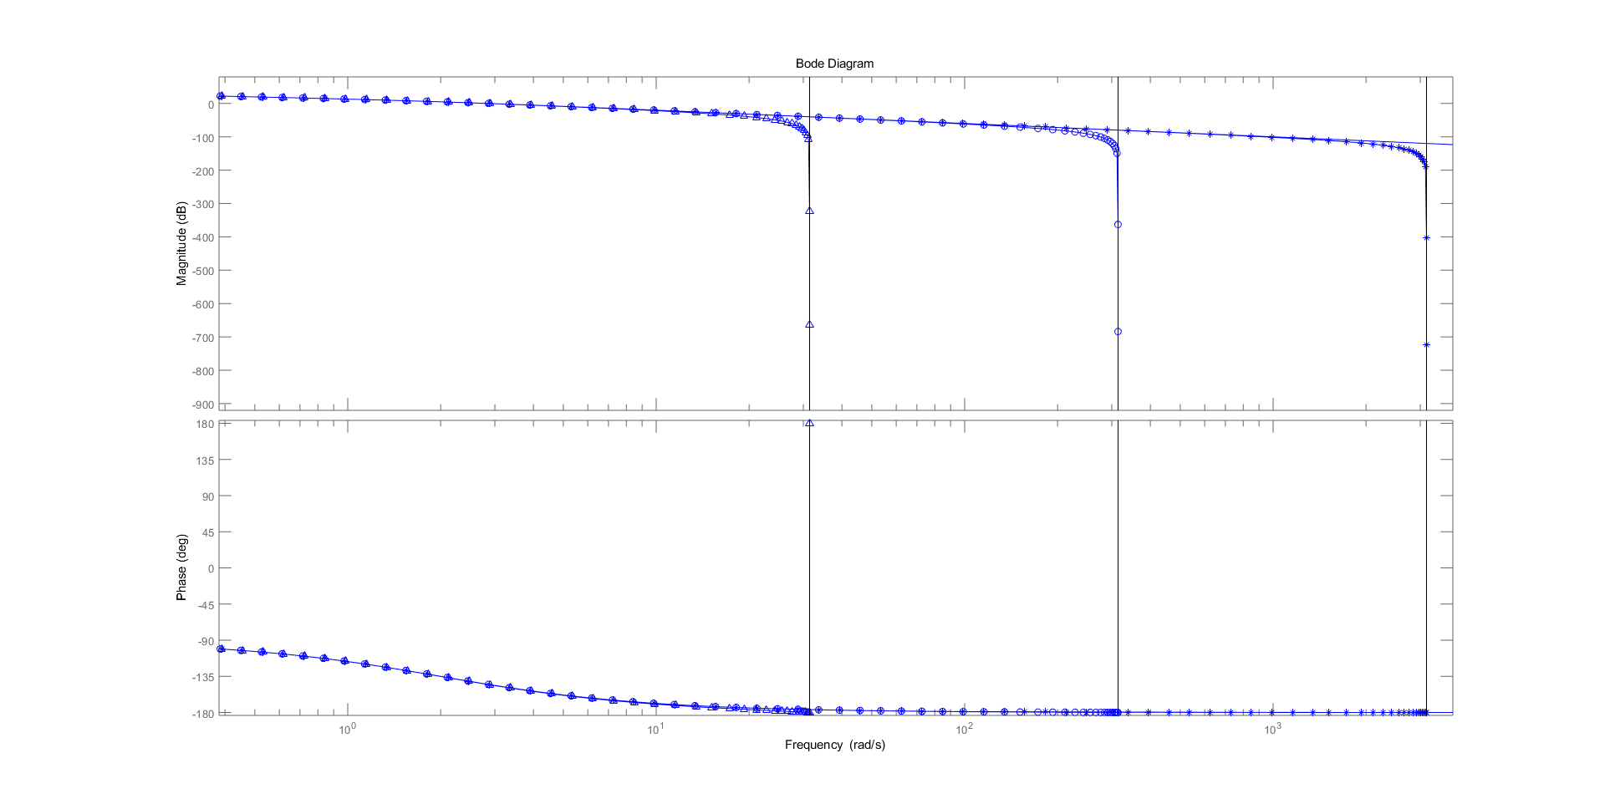

* For :

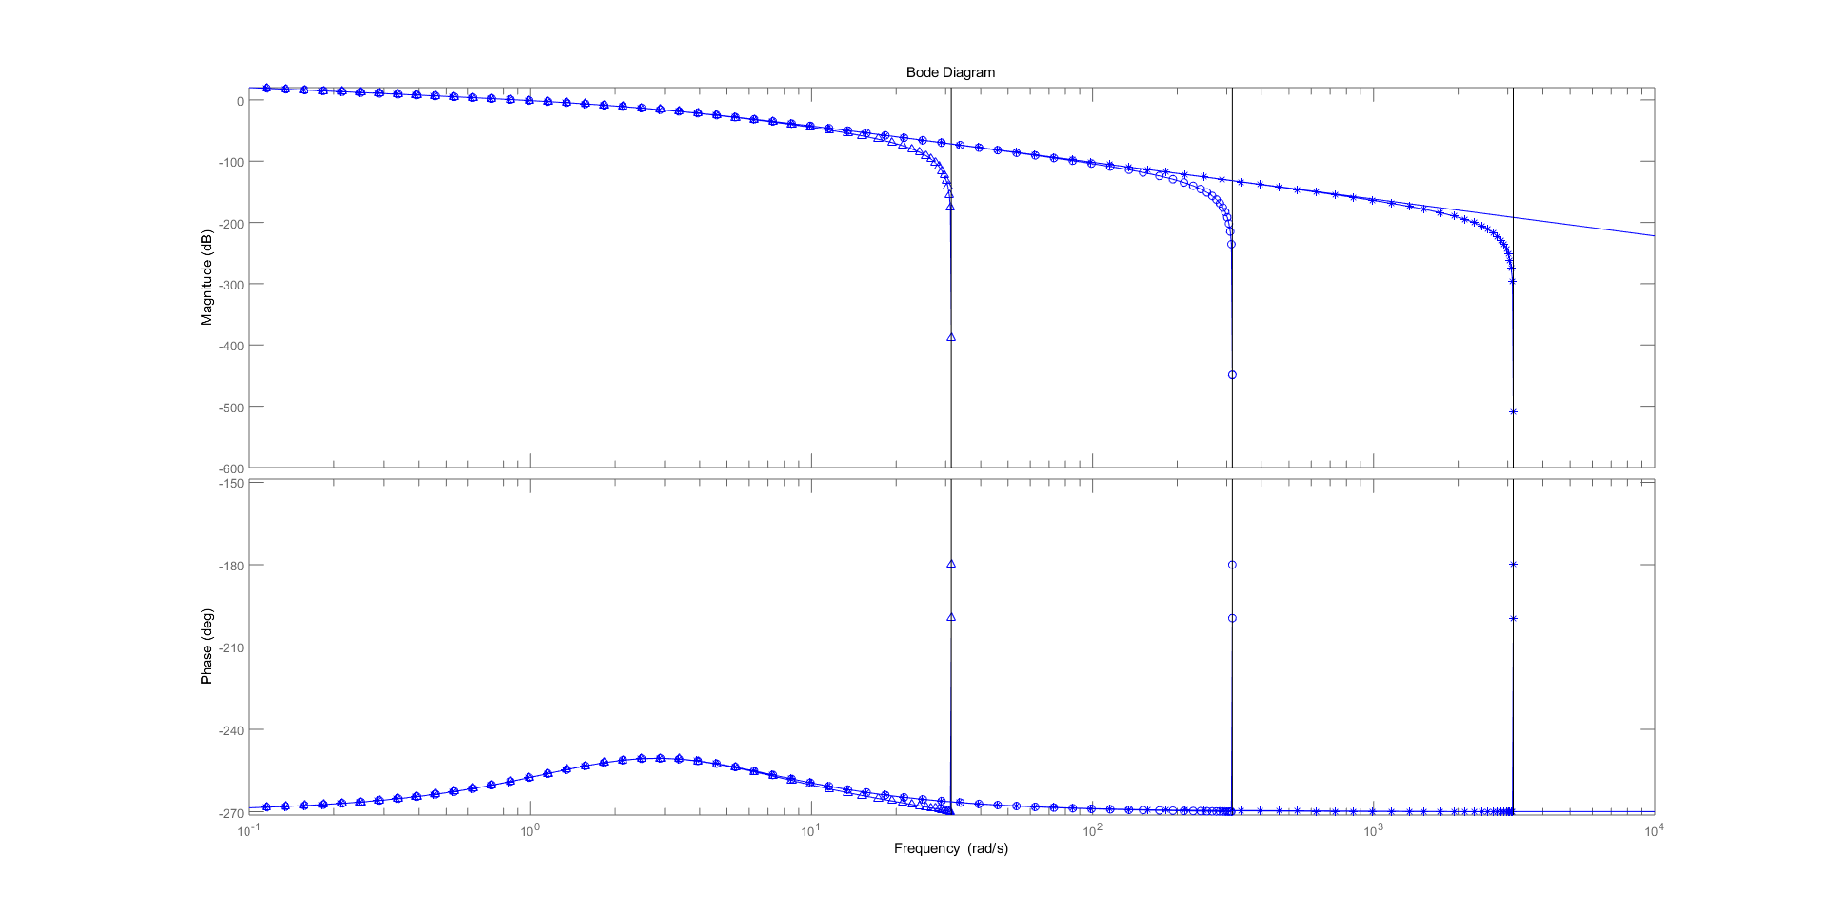

**Q2**: For the below typical position control configuration, derive and compare he transfer functions with and without feedforward gain respectively.

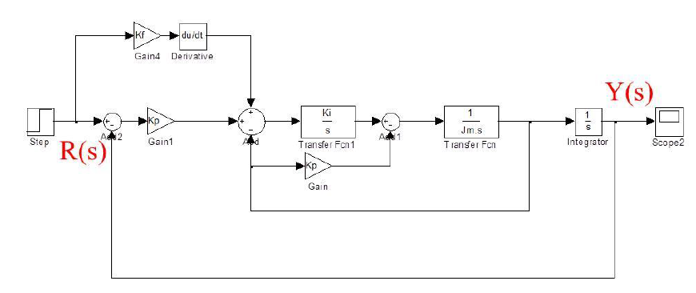

A2:

* When the feedforward gain is neglected, the transfer function can be derived from:

After simplification:

* When the feedforward gain is included, assuming , the derivative in temporal domain is , then, the transfer function can be derived from:

After simplification yields:

It can be seen that the difference lies in the numerator, with an extra term when feedforward gain is included, this adds a zero point of the system, which helps improve the response performance.