**Q**:

A classical feedback configuration is shown in below figure, in which P is plant, K is controller, r is command, n is sensor nose, di is plant input disturbance and d is plant output disturbance, respectively.

* Find the transfer functions between y and r, di and y, d and y and n and y, respectively (y is output).
* Explain why a bigger K leads to better robustness against the input and output disturbances (di and d), but worse robustness again (n) using the relationships described by the transfer functions.

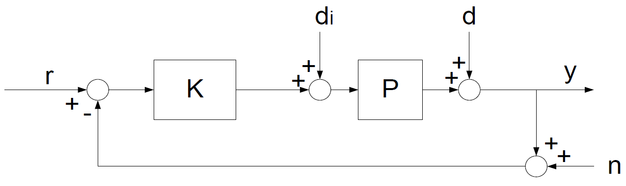

**A**: The transfer functions are calculated as follows:

1. For the transfer function between y and r:

Since

Thus

1. For the transfer function between y and di:

Since

Thus

1. For the transfer function between y and d:

Since

Thus

1. For the transfer function between y and n:

Since

Thus

For robustness analysis:

There’s no K(s) component in the numerator of the transfer function for Di(s) and D(s), thus, the steady error will be eliminated as K(s) increases.

However, for transfer function of N(s), the limit of the transfer function tends to be independent of K(s) as K(s) goes towards infinity. Thus, the steady error can’t be eliminated however the K(s) changes.