**Q1**:

For a two-mass system,

1) Build the Simulink model and plot the Bode plots for the 5 cases of , , and the inertia ratio , respectively;

2) Explain why the two-mass system is difficult to control when q is large (Hint: pole-zero cancelation leads to poor robustness).

**A1**:

1. As , the Simulink model of the two-mass system is simplified as below:

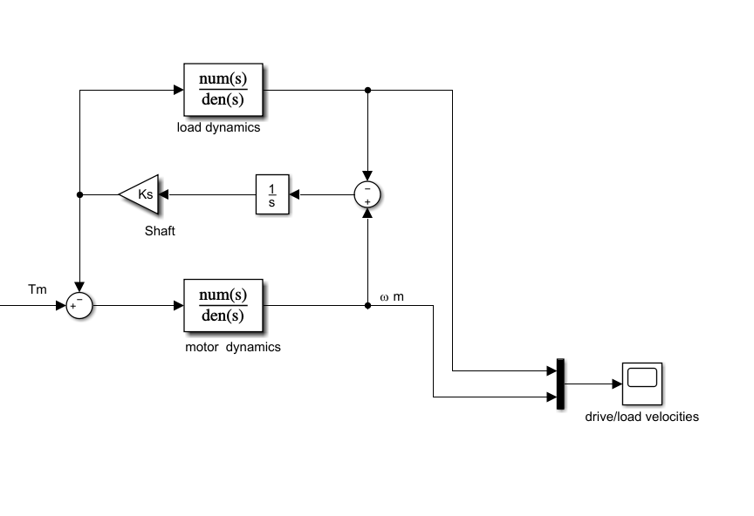

The transfer function between motor torque and motor angular velocity is given as:

And the transfer function between motor torque and load angular velocity is given as:

The Bode plots of these 2 transfer function under different q are shown as:

|  |  |  |
| --- | --- | --- |
| q |  |  |
| 0.1 |  |  |
| 0.3 |  |  |
| 0.5 |  |  |
| 0.7 |  |  |
| 0.9 |  |  |

1. Taking the control configuration as follows:

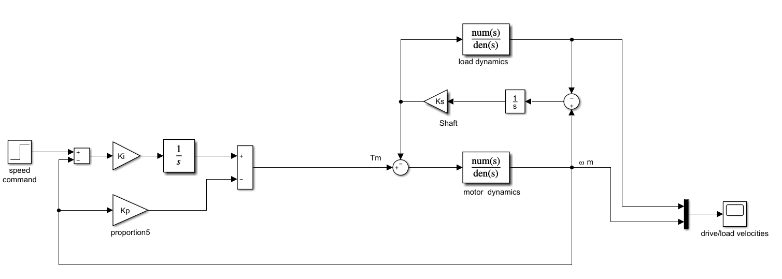

The response of motor angular velocity and load angular velocity under step signal of motor torque are plotted as below.

|  |  |
| --- | --- |
| q | Response of and |
| 0.1 |  |
| 0.3 |  |
| 0.5 |  |
| 0.7 |  |
| 0.9 |  |

It can be seen from the table above that the larger is, the more unstable the system is. This is due to large inertia makes the pole and zero points get much closer, which leads to unstable mode of the system.

**Q2**:

1. Derive the transfer function for the three-mass system;
2. Build the Simulink model and plot its Bode plot suppose Ks=100Nm/rad, Kg=1000Nm/rad, Jm=1Nm, Jl=1Nm Jg=0.1Nm, respectively. (The dead zone nonlinearity should be neglected because transfer function can only describe linear systems);
3. Compare with the frequency response of the two-mass model when the dynamics of the gear is neglected.

**A2**:

1. The transfer function between motor torque and motor angular velocity is derived as:

And the transfer function between motor torque and load angular velocity is derived as:

1. The Bode plot of these 2 transfer function under given parameters are shown as below:

|  |  |
| --- | --- |
|  |  |
|  |  |

Follow the similar procedure, the IP controller is constructed as follows:

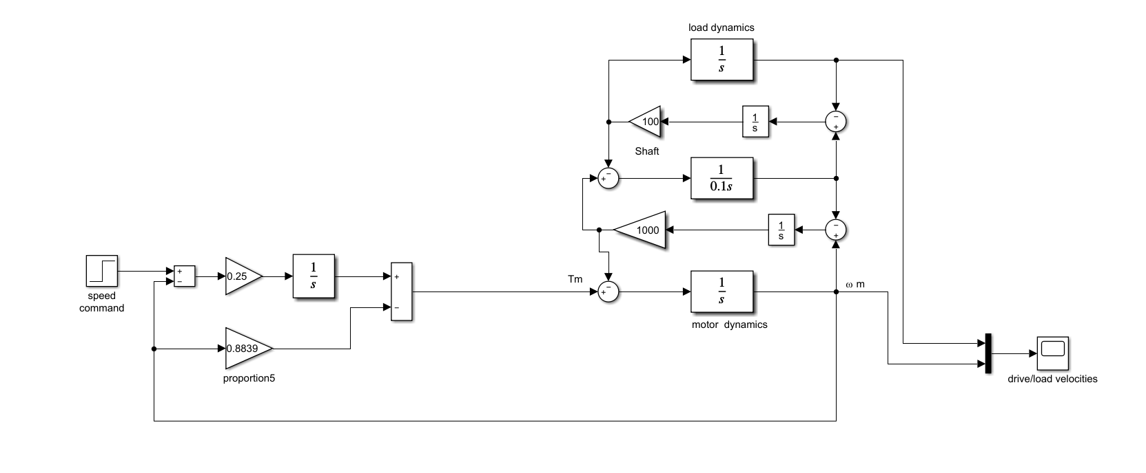

And the response under step signal is given as:

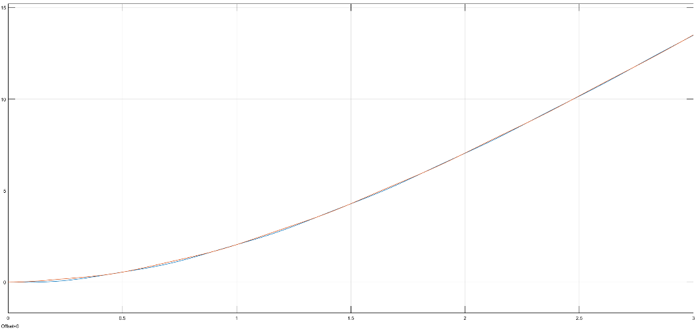

1. Compared with the 2-mass model, there is an extra peek around 100rad/s, which is the frequency due to gear.