Q: Investigate and explain the popular field-weakening control of PMSM motors from the following aspects:

–Purpose;

–Working principle;

–Control algorithm;

–Pros and Cons;

–One typical example of applications.

(Note: Proper figures, block diagrams, equations, and references are expected.)

A: Field-weakening aims at improving the high-speed performance of an electric motor.

1. Purpose:

To increase motor speed above rated speed.

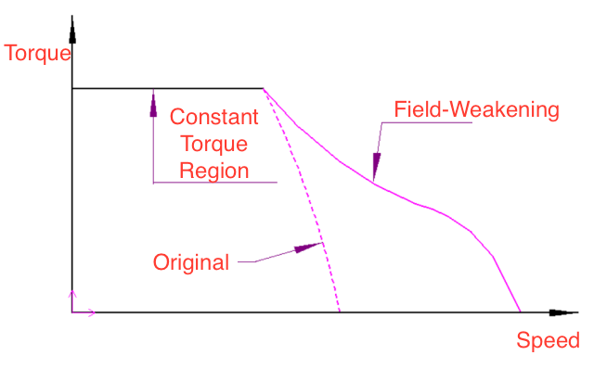

1. Working principle:

Since the voltage is governed [1] by

$$u_{e}=ω\sqrt{{\left(L_{d}i_{d}+ϕ_{f}\right)}^{2}+{\left({L_{q}i}_{q}\right)}^{2}}$$

As $u_{e}$ is limited, in order to increase $ω$, a feasible way is to lower current $i_{d}$ and $i_{q}$. The voltage balance equation reads

$$E=E_{b}+I_{a}R_{a}$$

Where $E_{b}$ is the back-e.m.f. governed by

$$E_{b}=k_{a}⋅ϕ⋅ω$$

With $k_{a}$ is the armature constant, $ϕ$ is the stator flux and $ω$ is rotor speed.

As the field flux is weakened, the motor has to rotate faster to generate the back-e.m.f necessary to regulate armature current flow.

By controlling the phase of stator current, the field flux is weakened [2]. This is illustrated as follows:

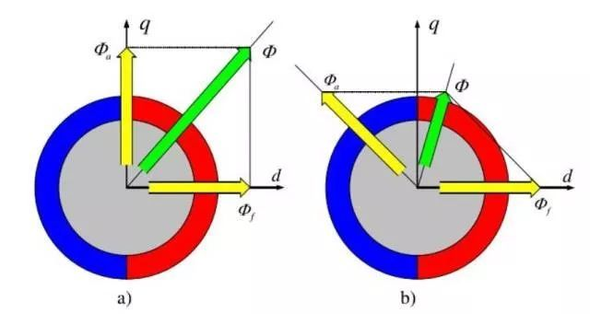

1. Control algorithm:

The control loop is illustrated as following diagram:

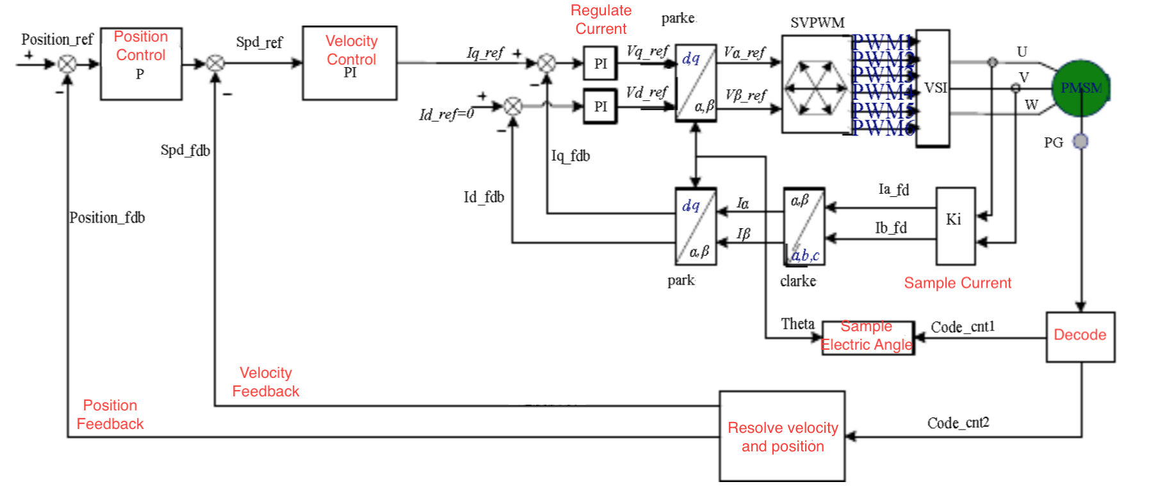

1. Pros & Cons:
2. On the one hand, it helps to extend the speed range.
3. On the other hand, the torque is reduced, and for PMSM, demagnetization of the PM will do harm to the motor. Also, temperature may increase due to larger current.
4. One typical example of applications:

In propulsion system, the motor sometimes needs to operate at speeds higher than rated one.

Reference

1. Ji Xuewu and Lv Yingchao, "Field weakening control of PMSM used in an electric power steering system," *2011 International Conference on Electric Information and Control Engineering*, Wuhan, 2011, pp. 2194-2199.
2. L. Harnefors, K. Pietilainen and L. Gertmar, "Torque-maximizing field-weakening control: design, analysis, and parameter selection," in *IEEE Transactions on Industrial Electronics*, vol. 48, no. 1, pp. 161-168, Feb. 2001.