Q: Investigate and explain the below aspects of MOEFET and IGBT, the two most important switching devices in today’s power electronics systems:

–Configuration and materials;

–Working principle;

–Key specifications;

–New developments;

–An example of application and circuit used.

A: These 2 switching device will be introduced separately.

1. **MOSFET**
2. **Configuration and materials**

Usually, it has 4 terminals: Gate, Source, Drain, and Body. The configuration looks like follows:

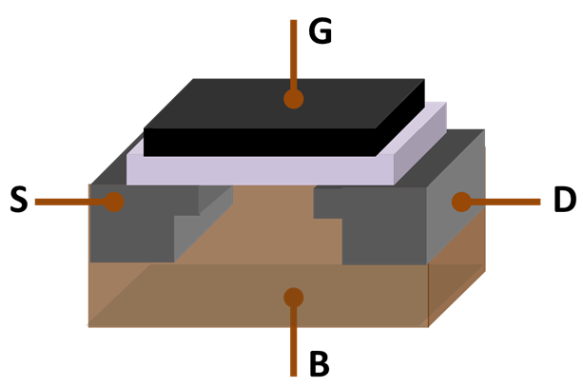

* Gate is often made of aluminum, insulated from the body by an insulating layer, which is typically chosen as SiO2.
* Body is also made of SiO2.
* Source and Drain are electrodes separated by the body. They are metals embedded in highly doped area.

1. **Working principle**

Take an enhanced MOSFET for example.

When a voltage level is exerted onto the gate, electrons are attracted from the source and drain. If the gate voltage is high enough, current between source and drain can flow freely as the concentration of electrons is sufficiently high. In this way, gate functions as a switch to determine the connectivity status between source and drain.

1. **Key specifications**

* FET type: N or P channel, enhancement or depletion mode.
* Drain-to-Source voltage: $V_{dss}$
* Gate threshold voltage: $V_{gs}$
* On-resistance: $R_{ds}$
* Gate charge
* Input capacitance
* Current、Voltage、Power ratings
* Package
* Junction operating temperature range
* Rising、Falling time

1. **New developments**

Using new materials like SiC, which provides lower on-resistance and higher current/voltage ratings.

1. **Example**

* Function as switch used in power electronics: inverter, rectifier, dc-dc converter and so on.
* Function as amplifier used in signal processing.

1. **IGBT**
2. **Configuration and materials**

Typically, it is made of SiO2 and consists of 4 alternating layers (P-N-P-N) that are controlled by a metal-oxide-semiconductor (MOS) gate structure without regenerative action.

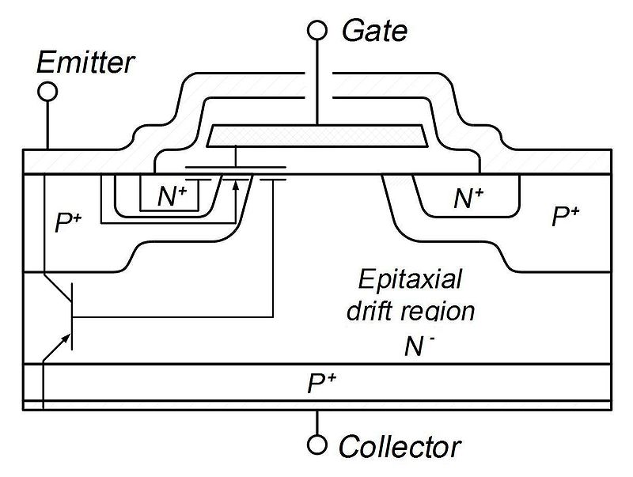

1. **Working principle**

The equivalent circuit of an IGBT is shown as follows:

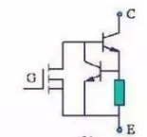

When $V_{ge}$ is on, the MOSFET is on, thus transistor at collector is on, resulting the on status of the whole module.

When $V_{ge}$ is off, the MOSFET is off, thus the base of transistor at collector is off, resulting the off status of the whole module.

1. **Key specifications**

* DC-collector current: $I_{C}$
* Repetitive peak collector current: $I_{crm}$
* Short-circuit current: $I_{SC}$
* Collector-emitter voltage: $V_{CEs}$
* Collector-emitter saturation voltage: $V_{CEsat}$
* Internal gate resistor: $R_{Gint}$
* External gate capacitance: $C_{Gext}$
* Gate charge: $Q_{G}$
* Turn-on/turn-off/Rise/Fall time

1. **New developments**

* Higher operating temperature
* Higher power density
* Faster switching speed

1. **Example**

* High voltage/current/power switch used for power conversion
* Electric Vehicle
* High-speed train
* Metro